ABSTRACT
The Pragati Bus Management System is a software-based application designed to manage and monitor the operations of buses efficiently. It helps in maintaining details such as bus information, routes, drivers, schedules, and maintenance records. The system reduces manual work, improves accuracy, and saves time by storing data digitally. This project aims to provide an organized, reliable, and user-friendly solution for bus management in institutions or transport organizations like Pragati Engineering College.

INTRODUCTION
Transportation plays an important role in educational institutions and organizations. Managing buses manually becomes difficult when the number of buses, drivers, and routes increases. To overcome these problems, the Pragati Bus Management System is developed.
This system helps administrators to easily add, update, search, and manage bus details, driver assignments, route information, and maintenance status. By using this system, errors caused by manual records are minimized. The application improves efficiency, transparency, and proper utilization of transport resources.

SOFTWARE REQUIREMENTS
The following software tools are required to develop and run the Pragati Bus Management System:
Operating System: Windows / LinuxProgramming Language: C
Compiler: GCC / Turbo C
Database: File handling (Text or Binary files)
Editor/IDE: Code::Blocks / Dev-C++ / Turbo C
Documentation Tool: MS Word / PDF reader

HARDWARE REQUIREMENTS
The minimum hardware requirements are:
Processor: Intel Core i3 or above
RAM: 4 GB (minimum)
Hard Disk: 250 GB or above
Input Devices: Keyboard, Mouse
Output Devices: Monitor, Printer (optional)

CODE
#include <stdio.h>
#include <stdlib.h>
#include <string.h>
#include <time.h>

#define MAX_BUSES 100
#define MAX_DRIVERS 50
#define MAX_ROUTE_LEN 50
#define MAX_NAME_LEN 30

typedef struct {
char bus_id[10];
char model[20];
int capacity;
char reg_no[15];
char status[20];
char driver[30];
char route[MAX_ROUTE_LEN];
char last_maintenance[11];
float fuel_level;
} Bus;

typedef struct {
char driver_id[10];
char name[MAX_NAME_LEN];
char license[15];
char phone[15];
char assigned_bus[10];
} Driver;

typedef struct {
char bus_id[10];
char route[MAX_ROUTE_LEN];
char start_time[6];
char date[11];
} Trip;

Bus buses[MAX_BUSES];
Driver drivers[MAX_DRIVERS];
Trip trips[100];

int bus_count = 0, driver_count = 0, trip_count = 0;

void clear_screen() {
system("cls || clear");
}

void initialize_sample_data() {
strcpy(buses[0].bus_id, "HR001");
strcpy(buses[0].model, "Tata");
buses[0].capacity = 40;
strcpy(buses[0].reg_no, "HR55AB1234");
strcpy(buses[0].status, "Available");
strcpy(buses[0].driver, "None");
strcpy(buses[0].route, "None");
strcpy(buses[0].last_maintenance, "None");
buses[0].fuel_level = 100.0;

strcpy(buses[1].bus_id, "HR002");
strcpy(buses[1].model, "Leyland");
buses[1].capacity = 32;
strcpy(buses[1].reg_no, "HR55AB5678");
strcpy(buses[1].status, "Available");
strcpy(buses[1].driver, "None");
strcpy(buses[1].route, "None");
strcpy(buses[1].last_maintenance, "None");
buses[1].fuel_level = 95.5;

bus_count = 2;

strcpy(drivers[0].driver_id, "D001");
strcpy(drivers[0].name, "Rajesh");
strcpy(drivers[0].license, "DL123456");
strcpy(drivers[0].phone, "9876543210");
strcpy(drivers[0].assigned_bus, "None");

driver_count = 1;
}

void display_fleet_status() {
printf("\n=== PRAGATI FLEET STATUS ===\n");
printf("%-8s %-10s %-6s %-12s %-10s %-15s %-15s %-6s\n",
"BusID","Model","Seats","RegNo","Status","Driver","Route","Fuel");
printf("-----------------------------------------------------------------------------\n");

for(int i = 0; i < bus_count; i++) {
printf("%-8s %-10s %-6d %-12s %-10s %-15s %-15s %.1f%%\n",
buses[i].bus_id, buses[i].model, buses[i].capacity,
buses[i].reg_no, buses[i].status, buses[i].driver,
buses[i].route, buses[i].fuel_level);
}
}

void add_bus() {
if(bus_count >= MAX_BUSES) {
printf("Fleet full!\n");
return;
}

printf("Enter Bus ID: ");
scanf("%s", buses[bus_count].bus_id);

printf("Enter Model: ");
scanf("%s", buses[bus_count].model);

printf("Enter Capacity: ");
scanf("%d", &buses[bus_count].capacity);

printf("Enter Registration No: ");
scanf("%s", buses[bus_count].reg_no);

strcpy(buses[bus_count].status, "Available");
strcpy(buses[bus_count].driver, "None");
strcpy(buses[bus_count].route, "None");
strcpy(buses[bus_count].last_maintenance, "None");
buses[bus_count].fuel_level = 100.0;

bus_count++;
printf("Bus added successfully!\n");
}

void add_driver() {
if(driver_count >= MAX_DRIVERS) {
printf("Driver limit reached!\n");
return;
}

printf("Enter Driver ID: ");
scanf("%s", drivers[driver_count].driver_id);

printf("Enter Name: ");
scanf("%s", drivers[driver_count].name);

printf("Enter License: ");
scanf("%s", drivers[driver_count].license);

printf("Enter Phone: ");
scanf("%s", drivers[driver_count].phone);

strcpy(drivers[driver_count].assigned_bus, "None");
driver_count++;

printf("Driver added successfully!\n");
}

void assign_driver() {
char bid[10], did[10];
printf("Enter Bus ID: ");
scanf("%s", bid);
printf("Enter Driver ID: ");
scanf("%s", did);

int b = -1, d = -1;

for(int i=0;i<bus_count;i++)
if(strcmp(buses[i].bus_id, bid)==0) b=i;

for(int i=0;i<driver_count;i++)
if(strcmp(drivers[i].driver_id, did)==0) d=i;

if(b==-1 || d==-1) {
printf("Bus or Driver not found!\n");
return;
}

strcpy(buses[b].driver, drivers[d].name);
strcpy(buses[b].status, "Assigned");
strcpy(drivers[d].assigned_bus, bid);

printf("Driver assigned successfully!\n");
}

void main_menu() {
int choice;
initialize_sample_data();

while(1) {
clear_screen();
printf("\n=== PRAGATI BUS MANAGEMENT SYSTEM ===\n");
printf("1. Fleet Status\n");
printf("2. Add Bus\n");
printf("3. Add Driver\n");
printf("4. Assign Driver\n");
printf("5. Exit\n");
printf("Choice: ");
scanf("%d", &choice);

clear_screen();

switch(choice) {
case 1: display_fleet_status(); break;
case 2: add_bus(); break;
case 3: add_driver(); break;
case 4: assign_driver(); break;
case 5: exit(0);
default: printf("Invalid choice!\n");
}

printf("\nPress Enter to continue...");
getchar(); getchar();
}
}

int main() {
main_menu();
return 0;
RESULTS

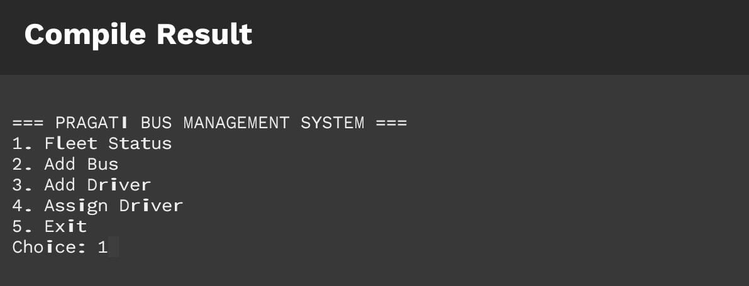
Fleet status
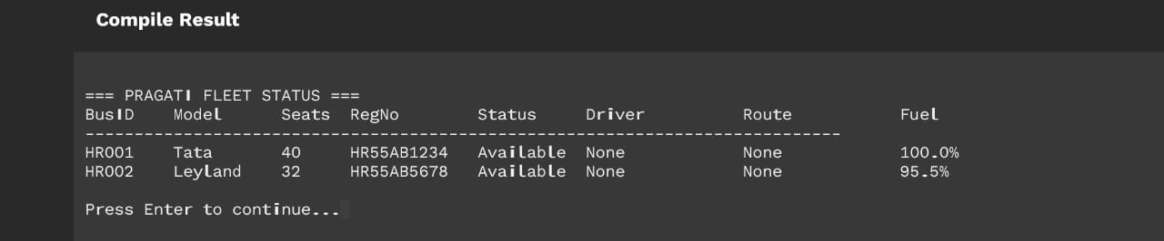
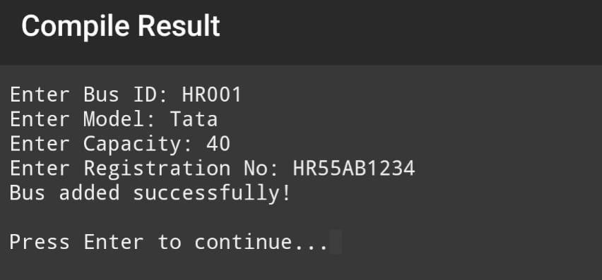
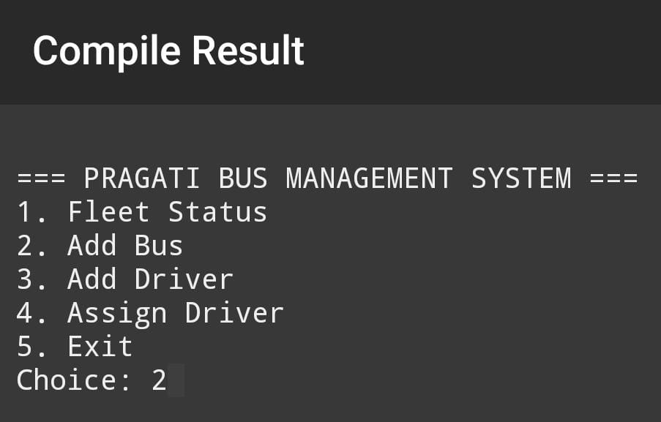
Add Bus
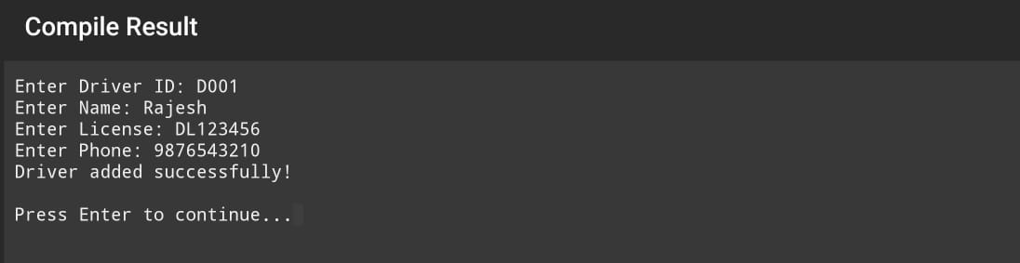

Add Driver

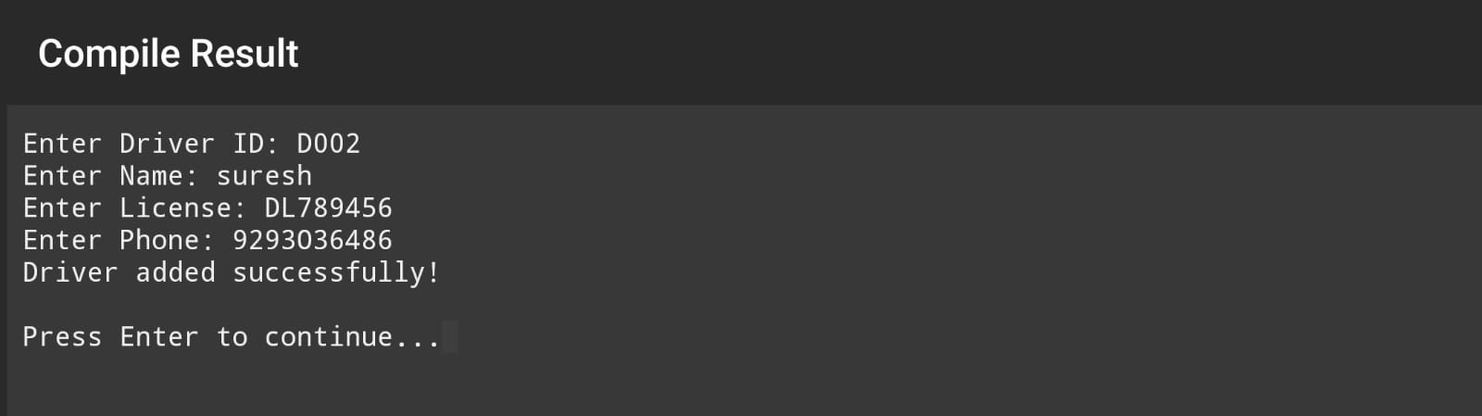
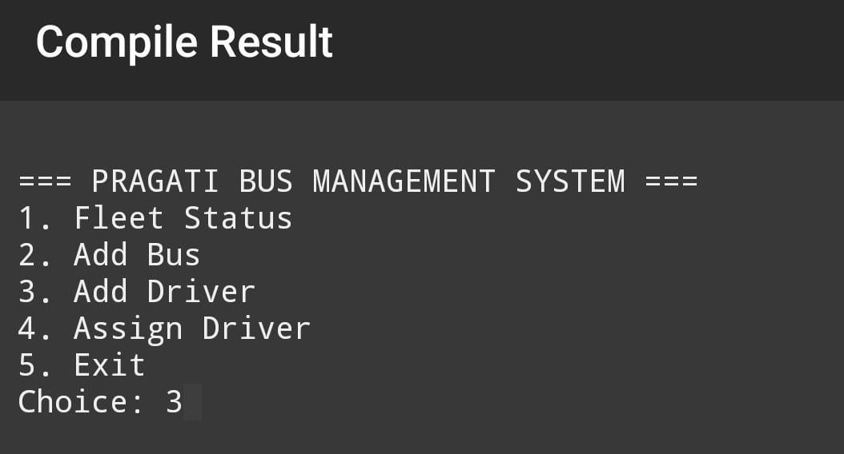

Assign Driver
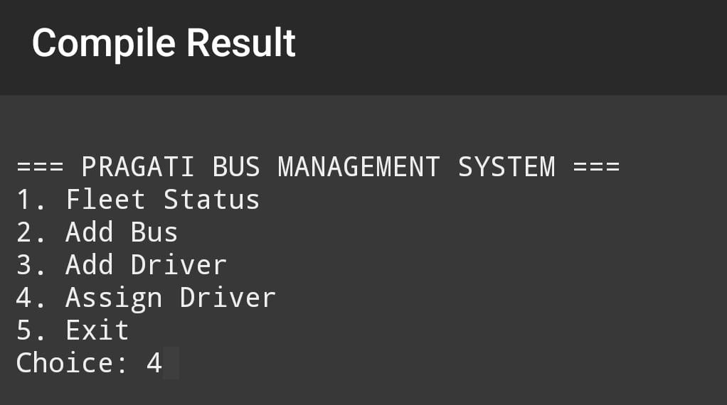

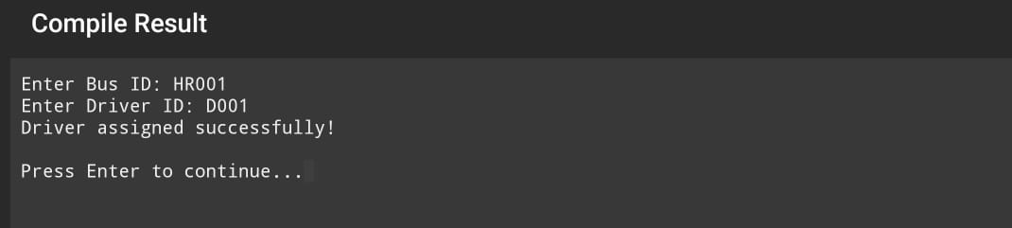

Exit
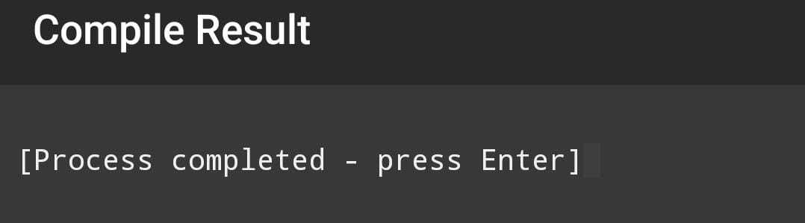
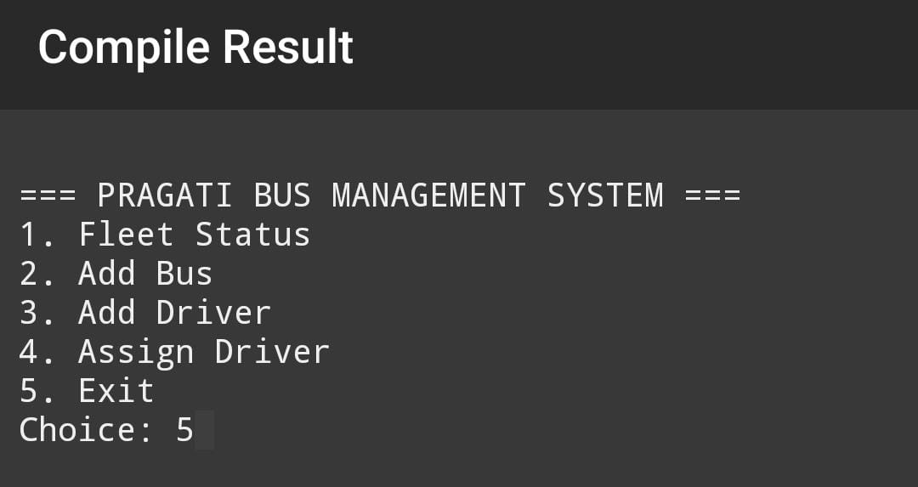

CONCLUSION
The Pragati Bus Management System provides an effective and systematic way to manage bus-related activities. It reduces paperwork and manual errors while ensuring fast and accurate sdata processing. The system is easy to use and can be further enhanced by adding features like GPS tracking, online access, and database integration. Overall, this project is useful for improving transportation management and operational efficiency in organizations.

