Abstract
The Guess The Word Game is a simple C program designed to test the user’s knowledge in General Knowledge (GK) and C programming concepts. The program displays hints and partially hidden words, and the user has to guess the correct word within limited attempts. It helps improve logical thinking and subject knowledge in an interactive way.

Introduction
Games are an effective way to learn concepts easily. This program is a word guessing game developed using the C programming language. It presents questions with hints and partially hidden words. The user must identify the correct word based on the hint. Each correct answer increases the score. This program combines learning with fun and improves both GK and programming knowledge
Software Requirements
- Operating System: Windows / Linux / macOS
- Programming Language: C
- Compiler: GCC / Turbo C / CodeBlocks / Dev C++
- Text Editor / IDE: Notepad / VS Code / CodeBlocks

Hardware Requirements
- Processor: Minimum Intel i3 or above
- RAM: 2 GB or above
- Hard Disk: Minimum 100 MB free space
- Input Device: Keyboard
- Output Device: Monitor

Code:
#include <stdio.h>
#include <string.h>

int main()
{
/* 7 words: GK + C Programming */
char words[7][25] = {
"democracy", // GK
"photosynthesis", // GK
"equator", // GK
"compiler", // C
"pointer", // C
"recursion", // C
"structure" // C
};

char hints[7][100] = {
"Government of the people, by the people, for the people",
"Process by which green plants make food",
"Imaginary line dividing Earth into two hemispheres",
"Program that converts source code into machine code",
"Variable that stores the address of another variable",
"Function calling itself in programming",
"User-defined data type in C"
};

/* Exactly 6 hidden letters in each word */
char hidden[7][50] = {
"d _ m _ c r _ _ y", // democracy
"p _ o _ o s y n t _ _ s _ s", // photosynthesis
"e _ u _ t _ r", // equator
"c _ m _ i _ e r", // compiler
"p _ i n _ e r", // pointer
"r _ c u r _ _ o n", // recursion
"s _ r u _ t _ r e" // structure
};

char guess[25];
int score = 0;

printf("🎮 GUESS THE WORD GAME (GK + C PROGRAMMING) 🎮\n");
printf("------------------------------------------------\n");

for (int i = 0; i < 7; i++)
{
int attempts = 3;
int correct = 0;

printf("\nQuestion %d\n", i + 1);
printf("Hint: %s\n", hints[i]);
printf("Word: %s\n", hidden[i]);

while (attempts > 0)
{
printf("Enter your guess (Attempts left %d): ", attempts);
scanf("%s", guess);

if (strcmp(guess, words[i]) == 0)
{
printf("✅ Correct Answer!\n");
score++;
correct = 1;
break;
}
else
{
attempts--;
printf("❌ Wrong guess!\n");
}
}

if (!correct)
{
printf("Correct word is: %s\n", words[i]);
}
}

printf("\n------------------------------------------------\n");
printf("Final Score: %d / 7\n", score);

if (score >= 6)
printf("🏆 Excellent Knowledge!\n");
else if (score >= 4)
printf("👍 Good Performance!\n");
else
printf("🙂 Keep practicing GK and C concepts.\n");

return 0;
}

Output:
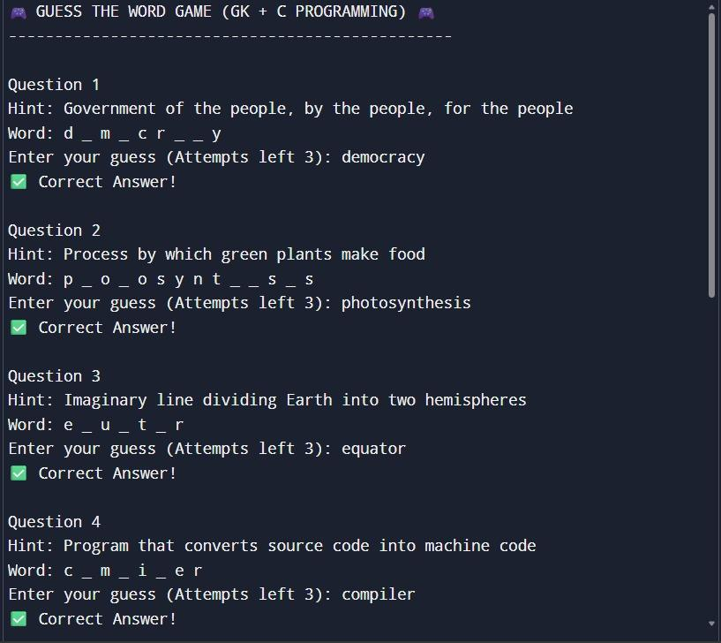

Conclusion
The Guess The Word Game was successfully implemented using C programming. It helps users improve their knowledge through an interactive method. The program is simple, user-friendly, and useful for beginners to understand concepts like arrays, loops, and strings in C. It can be further enhanced by adding more levels and features.

