DOCUMENTATION

Abstract
Payroll management is an essential process in every organization to ensure accurate and timely payment of employee salaries. This project focuses on developing a Payroll Calculation System using the C programming language. The system takes basic employee details such as employee ID, name, department, and basic salary as input. Based on predefined rules, it calculates salary components like House Rent Allowance (HRA), Dearness Allowance (DA), and Provident Fund (PF). Using these values, the program computes the gross salary and net salary of an employee. The main objective of this project is to understand the practical application of C programming concepts such as variables, input/output operations, arithmetic calculations, and control structures. This project provides a simple, efficient, and user-friendly approach to salary calculation and helps beginners gain hands-on experience in programming.

Introduction
Payroll management is a vital function in any organization, as it ensures that employees are paid accurately and on time. Manual payroll calculation is time-consuming and prone to errors. To overcome these issues, computerized payroll systems are widely used. This project, Payroll Calculation using C Programming, is designed to automate the calculation of employee salaries. The program accepts basic employee information and salary details, calculates allowances and deductions, and generates the gross and net salary. This project helps in understanding fundamental programming concepts and demonstrates how C can be used to solve real-world problems efficiently.

Software Requirements
The following software is required to develop and run the payroll calculation program
- Operating System: Windows / Linux
- Programming Language: C
- Compiler: GCC / Turbo C / Dev-C++
- Text Editor or IDE: Dev-C++, Code::Blocks, or any C editor

Hardware Requirements
The hardware requirements for this project are minimal and easily available:
- Processor: Intel or compatible processor
- RAM: Minimum 2 GB
- Hard Disk: Minimum 100 MB free space
- Keyboard and Mouse
- Monitor
Code:
#include <stdio.h>

int main() {
char name[50], department[50];
int id;
float basic, hra, da, pf, gross, net;

printf("Enter Employee ID: ");
scanf("%d", &id);

printf("Enter Employee Name: ");
scanf("%s", name);

printf("Enter Department: ");
scanf("%s", department);

printf("Enter Basic Salary: ");
scanf("%f", &basic);

// Salary Calculations
hra = basic * 0.20; // 20% of basic
da = basic * 0.10; // 10% of basic
pf = basic * 0.08; // 8% deduction
gross = basic + hra + da;
net = gross - pf;

// Output
printf("\n------------------------------\n");
printf(" EMPLOYEE SALARY SLIP\n");
printf("------------------------------\n");
printf("Employee ID : %d\n", id);
printf("Employee Name : %s\n", name);
printf("Department : %s\n", department);
printf("------------------------------\n");
printf("Basic Salary : %.2f\n", basic);
printf("HRA (20%%) : %.2f\n", hra);
printf("DA (10%%) : %.2f\n", da);
printf("PF Deduction (8%%): %.2f\n", pf);
printf("------------------------------\n");
printf("Gross Salary : %.2f\n", gross);
printf("Net Salary : %.2f\n", net);
printf("------------------------------\n");

return 0;
}

Output:
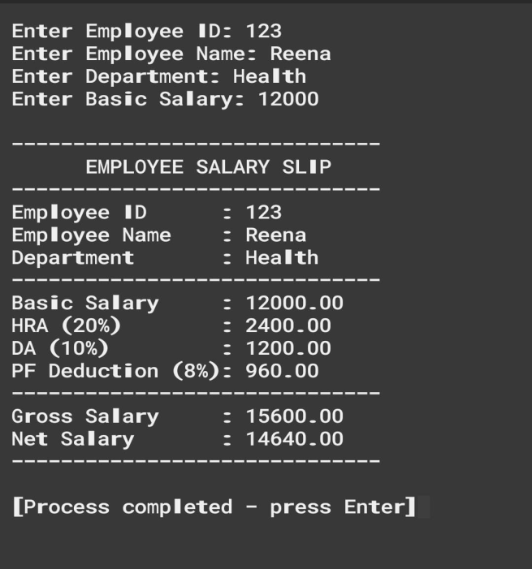

Conclusion
The Payroll Calculation System using C successfully automates the process of salary computation by accurately calculating allowances and deductions. This project reduces manual effort and minimizes calculation errors. It also provides a practical understanding of C programming concepts such as input/output operations, variables, and arithmetic calculations. The project serves as a foundation for developing more advanced payroll management systems and is useful for beginners to enhance their programming skills.

