📄 Title: Student Result Management System using C
🔹 Abstract
This project is a simple Student Result Management System developed using the C programming language. The program uses a structure to store student details such as roll number, name, and marks in three subjects. It calculates the total and average marks and assigns a grade based on predefined conditions.
The main objective of this program is to demonstrate the use of structures, conditional statements, and input/output operations in C. It provides an efficient way to process and display student academic performance in a structured format.
💻 Software Requirements
Operating System: Windows / Linux / macOS
Programming Language: C
Compiler: GCC (GNU Compiler Collection) or any C compiler
Editor/IDE:
Turbo C
Code::Blocks
VS Code
🖥️ Hardware Requirements
Processor: Intel i3 or above
RAM: Minimum 2 GB
Hard Disk: At least 100 MB free space
Input Devices: Keyboard
Output Devices: Monitor
Code
#include <stdio.h>
Struct Student {
Int roll;
Char name[50];
Int m1, m2, m3;
Int total;
Float average;
Char grade;
};

Int main() {
Struct Student s;

Printf(“Enter Roll Number: “);
Scanf(“%d”, &s.roll);

Printf(“Enter Name: “);
Scanf(“%s”, s.name);

Printf(“Enter marks of 3 subjects:\n”);
Scanf(“%d %d %d”, &s.m1, &s.m2, &s.m3);

s.total = s.m1 + s.m2 + s.m3;
s.average = s.total / 3.0;

if (s.average >= 90)
s.grade = ‘A’;
else if (s.average >= 75)
s.grade = ‘B’;
else if (s.average >= 60)
s.grade = ‘C’;
else if (s.average >= 50)
s.grade = ‘D’;
else
s.grade = ‘F’;

printf(“\n--- Student Result ---\n”);
printf(“Roll No : %d\n”, s.roll);
printf(“Name : %s\n”, s.name);
printf(“Total : %d\n”, s.total);
printf(“Average : %.2f\n”, s.average);
printf(“Grade : %c\n”, s.grade);

return 0;
}
Output

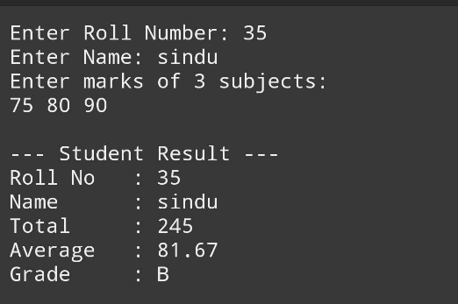
Conclusion
The Student Result Management System successfully demonstrates how basic programming concepts can be applied to solve real-world problems. It simplifies the process of calculating total marks, average, and grade assignment.
This program helps in understanding structures and decision-making in C, making it useful for beginners. It can be further enhanced by adding features like multiple student records, file handling, and user-friendly interfaces.

