Abstract
The Student Detail Management System is a mini project developed using the C programming language to manage student information efficiently. The system stores essential student details such as name, Aadhar number, APAAR ID, email ID, and phone number. It provides basic operations like adding new records, displaying existing records, and searching for a student using different identifiers. The project demonstrates the use of structures, arrays, and functions in C programming and follows a menu-driven approach for easy interaction.

Introduction
Managing student details manually is time-consuming and error-prone. The Student Detail Management System is designed to simplify this process by storing student information in an organized and structured manner. This project helps beginners understand fundamental concepts of C programming such as structures, arrays, functions, and conditional statements. The system runs in a console environment and stores data temporarily during program execution, making it suitable for academic learning and practice.

Software Requirements
- Operating System: Windows / Linux
- Programming Language: C
- Compiler: GCC / Turbo C / Dev-C++
- Code Editor or IDE: VS Code / Code::Blocks / Dev-C++

Hardware Requirements
- Processor: Intel or AMD processor
- RAM: Minimum 2 GB
- Hard Disk: Minimum 500 MB free space
- Keyboard and Monitor

Code:

#include <stdio.h>

#include <string.h>

struct Student {

char name[50];

char aadhar[20]; // dummy number

char apaar[20];

char email[50];

char phone[20];

};

struct Student students[100];

int count = 0;

void addStudent() {

printf("\nEnter Name: ");

scanf(" %[^\n]", students[count].name);

printf("Enter Aadhar Number (dummy): ");

scanf(" %[^\n]", students[count].aadhar);

printf("Enter APAAR ID: ");

scanf(" %[^\n]", students[count].apaar);

printf("Enter Email: ");

scanf(" %[^\n]", students[count].email);

printf("Enter Phone: ");

scanf(" %[^\n]", students[count].phone);

count++;

printf("\nStudent Added Successfully!\n");

}

void displayStudents() {

printf("\n--- Student Records ---\n");

for (int i = 0; i < count; i++) {

printf("\nStudent %d:\n", i + 1);

printf("Name : %s\n", students[i].name);

printf("Aadhar : %s\n", students[i].aadhar);

printf("APAAR : %s\n", students[i].apaar);

printf("Email : %s\n", students[i].email);

printf("Phone : %s\n", students[i].phone);

}

}

void searchStudent() {

char apaarSearch[20];

printf("\nEnter APAAR ID to search: ");

scanf(" %[^\n]", apaarSearch);

for (int i = 0; i < count; i++) {

if (strcmp(students[i].apaar, apaarSearch) == 0) {

printf("\nRecord Found:\n");

printf("Name : %s\n", students[i].name);

printf("Aadhar : %s\n", students[i].aadhar);

printf("APAAR : %s\n", students[i].apaar);

printf("Email : %s\n", students[i].email);

printf("Phone : %s\n", students[i].phone);

return;

}

}

printf("No student found with that APAAR ID.\n");

}

void updateStudent() {

char apaarSearch[20];

printf("\nEnter APAAR ID to update: ");

scanf(" %[^\n]", apaarSearch);

for (int i = 0; i < count; i++) {

if (strcmp(students[i].apaar, apaarSearch) == 0) {

printf("\nRecord Found. Enter new details:\n");

printf("New Email: ");

scanf(" %[^\n]", students[i].email);

printf("New Phone: ");

scanf(" %[^\n]", students[i].phone);

printf("Updated successfully!\n");

return;

}

}

printf("No record found.\n");

}

void deleteStudent() {

char apaarSearch[20];

printf("\nEnter APAAR ID to delete: ");

scanf(" %[^\n]", apaarSearch);

for (int i = 0; i < count; i++) {

if (strcmp(students[i].apaar, apaarSearch) == 0) {

for (int j = i; j < count - 1; j++) {

students[j] = students[j + 1];

}

count--;

printf("Record deleted successfully!\n");

return;

}

}

printf("No student found.\n");

}

int main() {

int choice;

while (1) {

printf("\n===== Student Management System =====");

printf("\n1. Add Student");

printf("\n2. Display Students");

printf("\n3. Search by APAAR ID");

printf("\n4. Update Email/Phone");

printf("\n5. Delete Student");

printf("\n6. Exit");

printf("\nEnter your choice: ");

scanf("%d", &choice);

switch (choice) {

case 1: addStudent(); break;

case 2: displayStudents(); break;

case 3: searchStudent(); break;

case 4: updateStudent(); break;

case 5: deleteStudent(); break;

case 6: return 0;

default: printf("Invalid choice!\n");

}

}

}

Output:

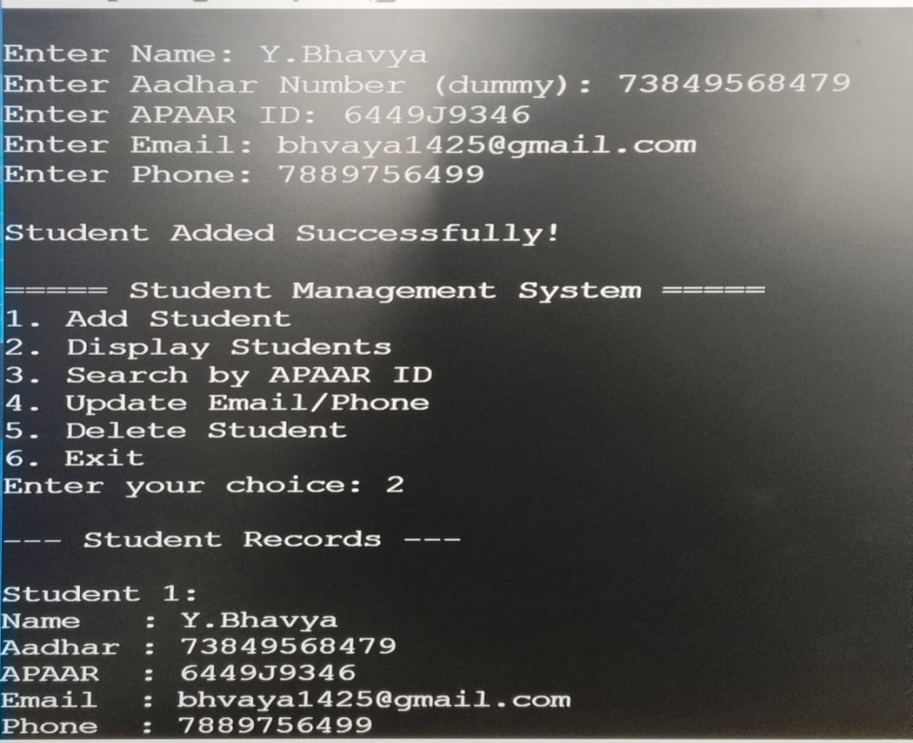

Conclusion
The Student Detail Management System successfully demonstrates how student information can be managed using C programming. The project implements basic operations such as adding, displaying, and searching student records using structures and arrays. It improves understanding of menu-driven programs and data handling techniques. This system can be further enhanced by adding features such as file storage, update and delete operations, and improved user interface.

