DOCMENTATION
Abstract
The Internet is a global network that connects millions of computers and devices worldwide. It plays an important role in daily life by providing fast communication, easy access to information, online education, entertainment, and various digital services. This presentation explains the uses of the Internet and how it helps people in different fields such as education, business, and communication.

Introduction
The Internet is one of the greatest inventions of modern technology. It allows people to share information and communicate with others across the world within seconds. Today, the Internet is widely used in homes, schools, offices, and businesses. It has made life easier by providing online services such as email, video calls, online shopping, banking, and learning platforms.

Software Requirements
The following software is required to use the Internet effectively:

Operating System (Windows, Android, iOS, Linux)

Web Browser (Google Chrome, Mozilla Firefox, Microsoft Edge)

Internet Applications (Email apps, Online meeting apps, Learning apps)

Antivirus Software (for security)

Hardware Requirements
The following hardware components are required:

Computer, Laptop, Tablet, or Smartphone

Internet Connection (Wi-Fi, Broadband, or Mobile Data)

Modem or Router

Keyboard and Mouse (for computers)

Headphones / Webcam (optional, for online meetings)
CODE
#include <stdio.h>
#include <string.h>

Struct Attendance {
Int roll;
Char name[30];
Char date[15];
Char day[10];
Char status[10];
};

Int main() {
Struct Attendance s[50];
Int n, I, choice;

Printf(“Enter number of students: “);
Scanf(“%d”, &n);

For(I = 0; I < n; i++) {
Printf(“\nEnter details for student %d\n”, I + 1);

Printf(“Roll Number: “);
Scanf(“%d”, &s[i].roll);

Printf(“Name: “);
Scanf(“%s”, s[i].name);

Printf(“Date (DD/MM/YYYY): “);
Scanf(“%s”, s[i].date);

Printf(“Day: “);
Scanf(“%s”, s[i].day);

Printf(“Status (Present/Absent): “);
Scanf(“%s”, s[i].status);
}

Printf(“\n--- Attendance Record ---\n”);
Printf(“Roll\tName\tDate\t\tDay\tStatus\n”);

For(I = 0; I < n; i++) {
Printf(“%d\t%s\t%s\t%s\t%s\n”,
S[i].roll,
S[i].name,
S[i].date,
S[i].day,
S[i].status);
}

Return 0;
}

OUTPUT
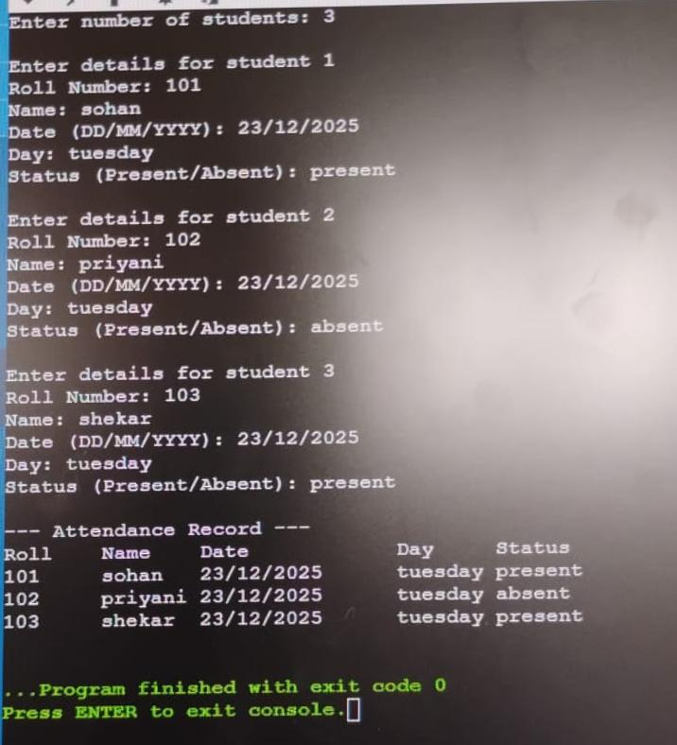
Conclusion
The Internet has become an essential part of modern life. It helps people communicate quickly, learn new things, access information, and perform online services easily. From education to entertainment and business to banking, the Internet has transformed the way people live and work. Proper and safe use of the Internet can greatly improve knowledge .

