DOCUMENTATION

CASIO SCIENTIFIC CALCULATOR PROJECT

Aim
The aim of this project is to design and implement a Casio-like scientific calculator using the C programming language that performs basic arithmetic, advanced mathematical operations, matrix calculations, and equation solving through a menu-driven interface.

Abstract
This project implements a Casio-style Scientific Calculator using the C programming language. It supports arithmetic operations, trigonometric and logarithmic functions, factorials, permutations and combinations, statistical calculations, matrix operations, and equation solvers. The calculator includes an Ans memory feature to store and reuse previous results.

Introduction
The Scientific Calculator project simulates the functionality of a real Casio scientific calculator. It is developed using fundamental C programming concepts such as functions, loops, arrays, conditional statements, and mathematical libraries. This project helps students enhance programming logic and mathematical problem-solving skills.

Software Requirements
Operating System: Windows or Linux
Programming Language: C
Compiler: GCC or Turbo C
IDE: VS Code or Dev C++

Hardware Requirements
Processor: Intel i3 or higher
RAM: Minimum 4 GB
Storage: At least 100 MB free space
Input Device: Keyboard
Output Device: Monitor

Methodology
The project uses a modular programming approach where each operation is handled by a separate function. A menu-driven system allows easy user interaction. Mathematical operations are implemented using standard C libraries.

Code:
#include <stdio.h>
#include <math.h>
#include <stdlib.h>
#include <string.h>

double Ans = 0; // Global storage for the last calculated result

double get_value(const char* prompt) {
char input[50];
printf("%s (type 'ans' to use %.4lf): ", prompt, Ans);
scanf("%s", input);

if (strcasecmp(input, "ans") == 0) {
return Ans;
}
return atof(input);
}

int get_int_value(const char* prompt) {
char input[50];

printf("%s (type 'ans' to use %d): ", prompt, (int)Ans);
scanf("%s", input);

if (strcasecmp(input, "ans") == 0) {
return (int)Ans;
}
return atoi(input);
}

void matrix_add() {
int r, c;
printf("Enter rows and cols: ");
scanf("%d %d", &r, &c);

double A[10][10], B[10][10];

printf("\nEnter Matrix A elements:\n");
for (int i = 0; i < r; i++) {
for (int j = 0; j < c; j++) {

printf("A[%d][%d]: ", i + 1, j + 1);
scanf("%lf", &A[i][j]);
}
}

printf("\nEnter Matrix B elements:\n");
for (int i = 0; i < r; i++) {
for (int j = 0; j < c; j++) {
printf("B[%d][%d]: ", i + 1, j + 1);
scanf("%lf", &B[i][j]);
}
}

printf("\nMatrix Addition Result (Sum):\n");
for (int i = 0; i < r; i++) {
for (int j = 0; j < c; j++) {
double sum = A[i][j] + B[i][j];
printf("%.2lf ", sum);
Ans = sum; // Stores the very last calculated cell in Ans
}
printf("\n");
}
}

void matrix_multiply() {
int r1, c1, r2, c2;
printf("Enter rows & cols of Matrix A: ");
scanf("%d %d", &r1, &c1);
printf("Enter rows & cols of Matrix B: ");
scanf("%d %d", &r2, &c2);

if (c1 != r2) {
printf("\nInvalid! Columns of A must equal rows of B for multiplication.\n");
return;
}

double A[10][10], B[10][10], C[10][10];

printf("\nEnter elements for Matrix A:\n");
for (int i = 0; i < r1; i++) {
for (int j = 0; j < c1; j++) {
printf("A[%d][%d]: ", i + 1, j + 1);
scanf("%lf", &A[i][j]);
}
}

printf("\nEnter elements for Matrix B:\n");
for (int i = 0; i < r2; i++) {
for (int j = 0; j < c2; j++) {
printf("B[%d][%d]: ", i + 1, j + 1);
scanf("%lf", &B[i][j]);
}
}

for (int i = 0; i < r1; i++) {
for (int j = 0; j < c2; j++) {
C[i][j] = 0;
for (int k = 0; k < c1; k++)
C[i][j] += A[i][k] * B[k][j];
}
}

printf("\nMatrix Multiplication Result (Product):\n");
for (int i = 0; i < r1; i++) {
for (int j = 0; j < c2; j++) {
printf("%.2lf ", C[i][j]);
Ans = C[i][j];
}
printf("\n");
}
}

void inverse2x2() {
double a, b, c, d;
printf("Enter elements of 2x2 matrix:\n");

printf("Element [1][1]: "); scanf("%lf", &a);
printf("Element [1][2]: "); scanf("%lf", &b);
printf("Element [2][1]: "); scanf("%lf", &c);
printf("Element [2][2]: "); scanf("%lf", &d);

double det = a * d - b * c;

if (det == 0) {
printf("\nMatrix is singular! Inverse not possible.\n");
return;
}

printf("\nInverse matrix results:\n");
printf("%.4lf %.4lf\n", d / det, -b / det);
printf("%.4lf %.4lf\n", -c / det, a / det);

Ans = det;
}

void quadratic() {
double a, b, c;
printf("Equation format: ax^2 + bx + c = 0\n");
a = get_value("Enter a");
b = get_value("Enter b");
c = get_value("Enter c");

if (a == 0) {
printf("\nNot a quadratic equation (a cannot be 0).\n");
return;
}

double D = b * b - 4 * a * c;

if (D > 0) {
double r1 = (-b + sqrt(D)) / (2 * a);
double r2 = (-b - sqrt(D)) / (2 * a);
printf("\nReal and distinct roots found:\n");
printf("Root 1: %.4lf\n", r1);
printf("Root 2: %.4lf\n", r2);
Ans = r1;
}
else if (D == 0) {
double r = -b / (2 * a);
printf("\nReal and equal roots found:\n");
printf("Root: %.4lf\n", r);
Ans = r;
}
else {
double real = -b / (2 * a);
double imag = sqrt(-D) / (2 * a);
printf("\nComplex roots found:\n");
printf("%.4lf + %.4lfi\n", real, imag);
printf("%.4lf - %.4lfi\n", real, imag);
Ans = real;
}
}

double cubic_f(double a, double b, double c, double d, double x) {
return a * x * x * x + b * x * x + c * x + d;
}

double cubic_df(double a, double b, double c, double x) {
return 3 * a * x * x + 2 * b * x + c;
}

void cubic() {
double a, b, c, d;
printf("Equation: ax^3 + bx^2 + cx + d = 0\n");
a = get_value("Enter a");
b = get_value("Enter b");
c = get_value("Enter c");
d = get_value("Enter d");

double x = 1.0;
for (int i = 0; i < 10000; i++) {
double fx = cubic_f(a, b, c, d, x);
double fdx = cubic_df(a, b, c, x);
if (fdx == 0) break;
x = x - fx / fdx;
}

printf("\nNumerical Analysis Result:\n");
printf("One real root (approx) = %.6lf\n", x);
printf("Remaining roots may be complex or require further analysis.\n");
Ans = x;
}

long long factorial(int n) {
if (n < 0) return 0;
long long fact = 1;
for (int i = 1; i <= n; i++)
fact *= i;
return fact;
}

int main() {
int choice;
char buffer[100];

while (1) {
printf("\n=================================================\n");
printf(" CASIO SCIENTIFIC CALCULATOR \n");
printf("=================================================\n");
printf(" Current Memory (Ans) = %.4lf\n", Ans);
printf("-------------------------------------------------\n");
printf(" 1. Addition (Summation)\n");
printf(" 2. Subtraction\n");
printf(" 3. Multiplication\n");
printf(" 4. Division\n");
printf(" 5. Power Chain (x^y^z...)\n");
printf(" 6. Square Root\n");
printf(" 7. Factorial (!)\n");
printf(" 8. Logarithm (base 10)\n");
printf(" 9. Natural Logarithm (ln)\n");
printf(" 10. Trigonometry: Sin\n");
printf(" 11. Trigonometry: Cos\n");
printf(" 12. Trigonometry: Tan\n");
printf(" 13. Permutations (nPr)\n");
printf(" 14. Combinations (nCr)\n");
printf(" 15. Statistical Mean\n");
printf(" 16. Find Maximum\n");
printf(" 17. Find Minimum\n");
printf(" 18. Matrix Addition\n");
printf(" 19. Matrix Multiplication\n");
printf(" 20. Matrix Inverse (2x2)\n");
printf(" 21. Quadratic Solver\n");
printf(" 22. Cubic Solver (Real Root)\n");
printf(" 23. View Last Answer\n");
printf(" 0. Exit System\n");
printf("-------------------------------------------------\n");
printf("Select an operation: ");

if (scanf("%d", &choice) != 1) {
printf("\nInvalid input type detected. Restarting menu...\n");
while(getchar() != '\n');
continue;
}

if (choice == 0) {
printf("\nShutting down calculator. Goodbye!\n");
break;
}

int n;
double num, result;

switch (choice) {
case 23:
printf("\nThe last calculated result in memory is: %.4lf\n", Ans);
break;

case 1:
printf("How many numbers to add? ");
scanf("%d", &n);
result = 0;
for (int i = 1; i <= n; i++) {
sprintf(buffer, "Number %d", i);
result += get_value(buffer);
}
Ans = result;
printf("\nTotal Sum = %.4lf\n", result);
break;

case 2:
printf("How many numbers in the sequence? ");
scanf("%d", &n);
result = get_value("Starting number");
for (int i = 2; i <= n; i++) {
sprintf(buffer, "Subtract number %d", i);
result -= get_value(buffer);
}
Ans = result;
printf("\nFinal Difference = %.4lf\n", result);
break;

case 3:
printf("How many numbers to multiply? ");
scanf("%d", &n);
result = 1;
for (int i = 1; i <= n; i++) {
sprintf(buffer, "Factor %d", i);
result *= get_value(buffer);
}
Ans = result;
printf("\nProduct = %.4lf\n", result);
break;

case 4:
printf("How many numbers in the division chain? ");
scanf("%d", &n);
result = get_value("Dividend");
for (int i = 2; i <= n; i++) {
sprintf(buffer, "Divisor %d", i);
num = get_value(buffer);
if (num == 0) {
printf("\nMath Error! Division by zero is undefined.\n");
goto next_loop;
}
result /= num;
}
Ans = result;
printf("\nQuotient = %.4lf\n", result);
break;

case 5: {
printf("How many stages in the power chain? ");
scanf("%d", &n);
double arr[20];
for (int i = 0; i < n; i++) {
sprintf(buffer, "Base/Exp %d", i + 1);
arr[i] = get_value(buffer);
}
double p = arr[0];
for (int i = 1; i < n; i++)
p = pow(p, arr[i]);
Ans = p;
printf("\nChain Result = %.4lf\n", p);
break;
}

case 6:
num = get_value("Enter number for square root");
if (num < 0) {
printf("\nError: Negative input for real square root.\n");
} else {
Ans = sqrt(num);
printf("\nSquare Root = %.4lf\n", Ans);
}
break;

case 7:
num = get_value("Enter integer for factorial");
Ans = (double)factorial((int)num);
printf("\nFactorial Result = %.0lf\n", Ans);
break;

case 8:
num = get_value("Enter value for log10");
if (num <= 0) {
printf("\nLog Error: Value must be positive.\n");
} else {
Ans = log10(num);
printf("\nLog10 = %.4lf\n", Ans);
}
break;

case 9:
num = get_value("Enter value for ln");
if (num <= 0) {
printf("\nLog Error: Value must be positive.\n");
} else {
Ans = log(num);
printf("\nNatural Log (ln) = %.4lf\n", Ans);
}
break;

case 10:
num = get_value("Enter angle in degrees");
Ans = sin(num * M_PI / 180.0);
printf("\nSin(%.2lf) = %.4lf\n", num, Ans);
break;

case 11:
num = get_value("Enter angle in degrees");
Ans = cos(num * M_PI / 180.0);
printf("\nCos(%.2lf) = %.4lf\n", num, Ans);
break;

case 12:
num = get_value("Enter angle in degrees");
Ans = tan(num * M_PI / 180.0);
printf("\nTan(%.2lf) = %.4lf\n", num, Ans);
break;

case 13: {
int n_val = get_int_value("Enter n");
int r_val = get_int_value("Enter r");
if (n_val < r_val) {
printf("\nError: n cannot be less than r.\n");
} else {
Ans = (double)factorial(n_val) / factorial(n_val - r_val);
printf("\nnPr Result = %.0lf\n", Ans);
}
break;
}

case 14: {
int n_val = get_int_value("Enter n");
int r_val = get_int_value("Enter r");
if (n_val < r_val) {
printf("\nError: n cannot be less than r.\n");
} else {
Ans = (double)factorial(n_val) / (factorial(r_val) * factorial(n_val - r_val));
printf("\nnCr Result = %.0lf\n", Ans);
}
break;
}

case 15:
printf("How many numbers for mean calculation? ");
scanf("%d", &n);
result = 0;
for (int i = 1; i <= n; i++) {
sprintf(buffer, "Data point %d", i);
result += get_value(buffer);
}
Ans = result / n;
printf("\nCalculated Mean = %.4lf\n", Ans);
break;

case 16:
printf("Comparing how many numbers? ");
scanf("%d", &n);
result = get_value("Number 1");
for (int i = 2; i <= n; i++) {
sprintf(buffer, "Number %d", i);
num = get_value(buffer);
if (num > result) result = num;
}
Ans = result;
printf("\nMaximum Value = %.4lf\n", Ans);
break;

case 17:
printf("Comparing how many numbers? ");
scanf("%d", &n);
result = get_value("Number 1");
for (int i = 2; i <= n; i++) {
sprintf(buffer, "Number %d", i);
num = get_value(buffer);
if (num < result) result = num;
}
Ans = result;
printf("\nMinimum Value = %.4lf\n", Ans);
break;

case 18: matrix_add(); break;
case 19: matrix_multiply(); break;
case 20: inverse2x2(); break;
case 21: quadratic(); break;
case 22: cubic(); break;

default:
printf("\nSelection Error: %d is not a valid menu option.\n", choice);
}
next_loop:;
}
return 0; }

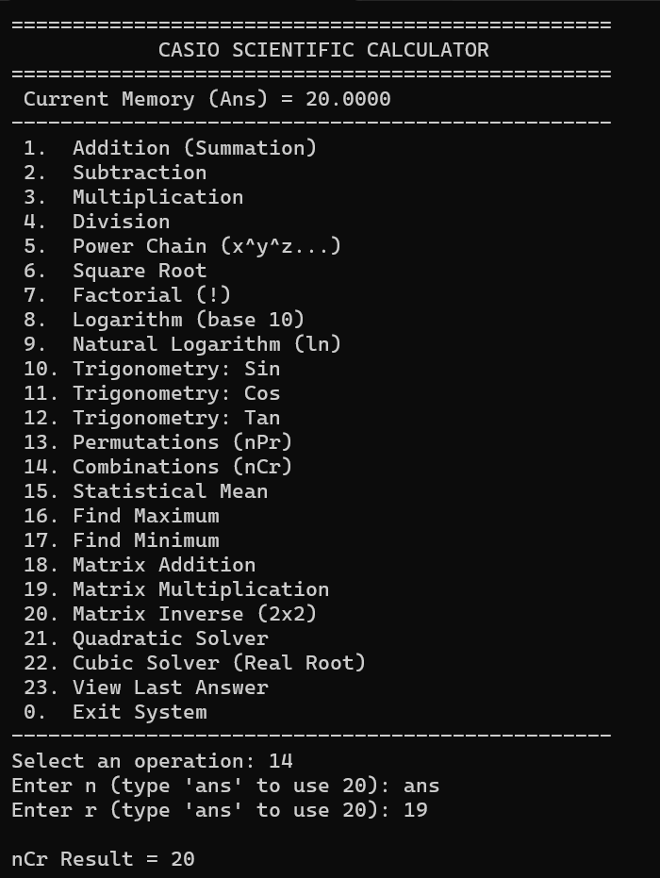
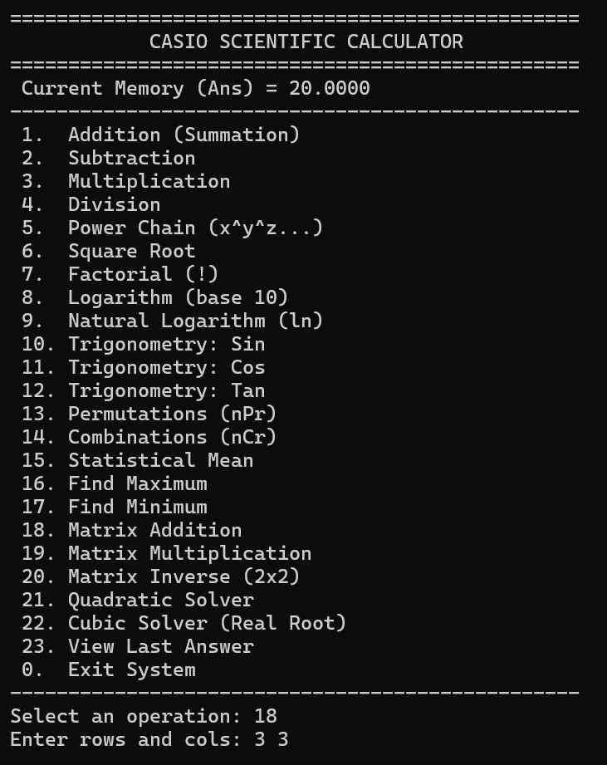
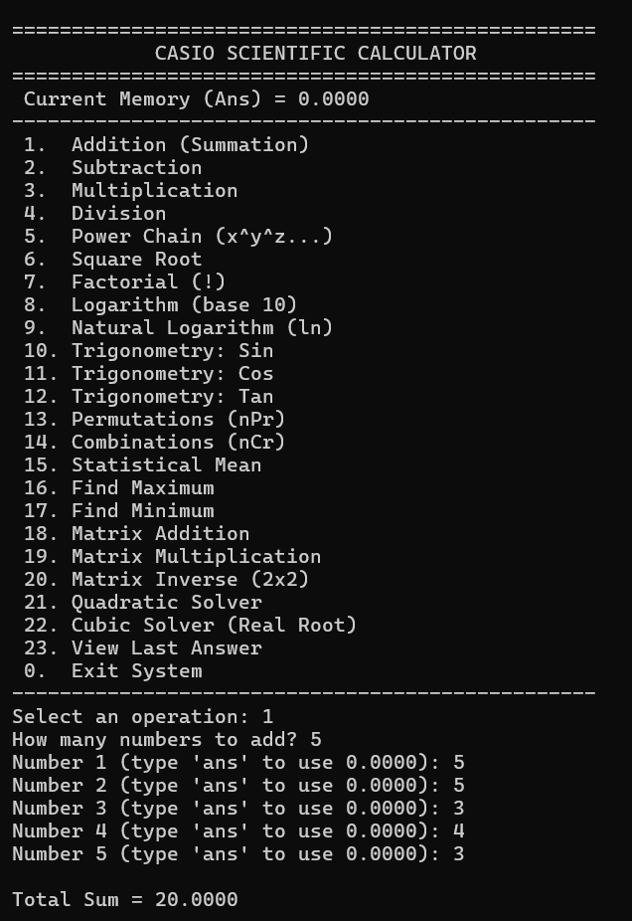
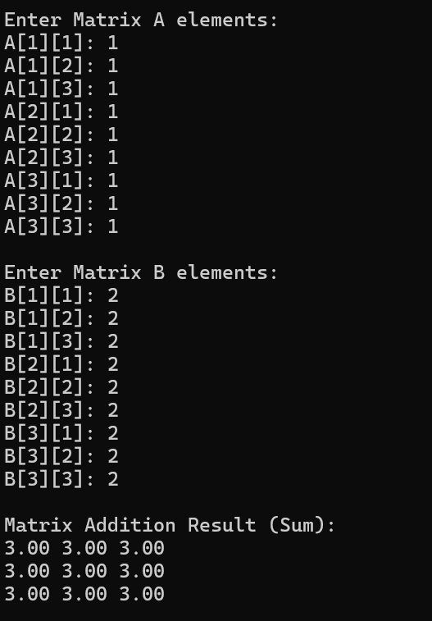
Ouput:

Advantages
Easy to use
Wide range of operations
Reusable Ans memory
Well-structured modular code

Future Enhancements
Graphical user interface
Support for larger matrices
File-based input and output
Mobile or web-based version

Conclusion
The Scientific Calculator project successfully demonstrates mathematical computation using C programming. It improves logical thinking and coding skills and serves as a strong foundation for advanced applications.

