NOTEPAD APPLICATION PROJECT

Aim
The aim of the project is to design and develop a simple NOTEPAD application using C language that allows users to create ,open ,edit and save text files. This project helps in understanding file handling concepts ,menu-driven programming and basic user interaction in C.

Abstract
This project focuses on the development of a simple NOTEPAD application using the C programming language. The application provides basic text editing features such as creating a new file, opening an existing text file, editing content, and saving files. The main purpose of this project is to understand the concepts of file handling menu driven programming and input/output operations in C. By implementing this project, users can efficiently manage text data through a simple command line interface. This project also helps in improving logical thinking and problem solving skills while working with real-time applications in C.

Introduction
A notepad application is a basic text editor used to create, edit, and save text files. This project develops a simple notepad application using the C programming language. It helps users perform basic file operations through a simple menu-driven interface. The project is useful for understanding file handling and basic programming concepts in C.

Software Requirements
Operating system: Windows or Linux
Programming Language: C
Compiler: GCC or Turbo C
IDE: VS Code or Dev C++

Hardware Requirements
Processor: Intel i3 or higher
RAM: Minimum 4 GB
Storage: At least 100 MB free space
Input Device: Keyboard
Output Device: Monitor

Methodology
First, the required features of the notepad application are identified.
Next, a simple menu-driven design is created using C programming concepts.
Then, file handling functions are used to create, open, edit, and save text files.
Finally, the program is tested to ensure proper working of all operations.

Code
#include <stdio.h>
#include <stdlib.h>
#include <string.h>

void writeFile();
void readFile();
void appendFile();
void searchWord();
void countFile();
void renameFile();
void deleteFile();

int main() {
int choice;

while (1) {
printf("\n========== ADVANCED NOTEPAD ==========\n");
printf("1. Create & Write File\n");
printf("2. Read File\n");
printf("3. Append File\n");
printf("4. Search Word\n");
printf("5. Count Characters / Words / Lines\n");
printf("6. Rename File\n");
printf("7. Delete File\n");
printf("8. Exit\n");
printf("Enter your choice: ");
scanf("%d", &choice);
getchar(); // clear buffer

switch (choice) {
case 1: writeFile(); break;
case 2: readFile(); break;
case 3: appendFile(); break;
case 4: searchWord(); break;
case 5: countFile(); break;
case 6: renameFile(); break;
case 7: deleteFile(); break;
case 8:
printf("Exiting Notepad... 👋\n");
exit(0);
default:
printf("Invalid choice!\n");
}
}
return 0;
}

void writeFile() {
FILE *fp;
char filename[50], ch;

printf("Enter file name: ");
gets(filename);

fp = fopen(filename, "w");
if (!fp) {
printf("Error opening file!\n");
return;
}

printf("Enter text (CTRL+Z then Enter to save):\n");
while ((ch = getchar()) != EOF)
fputc(ch, fp);

fclose(fp);
printf("File saved successfully!\n");
}

void readFile() {
FILE *fp;
char filename[50], ch;

printf("Enter file name to read: ");
gets(filename);

fp = fopen(filename, "r");
if (!fp) {
printf("File not found!\n");
return;
}

printf("\n------ File Content ------\n");
while ((ch = fgetc(fp)) != EOF)
putchar(ch);

fclose(fp);
printf("\n--------------------------\n");
}

void appendFile() {
FILE *fp;
char filename[50], ch;

printf("Enter file name to append: ");
gets(filename);

fp = fopen(filename, "a");
if (!fp) {
printf("Error opening file!\n");
return;
}

printf("Enter text (CTRL+Z then Enter):\n");
while ((ch = getchar()) != EOF)
fputc(ch, fp);

fclose(fp);
printf("Text appended successfully!\n");
}

void searchWord() {
FILE *fp;
char filename[50], word[50], temp[50];
int found = 0;

printf("Enter file name: ");
gets(filename);

printf("Enter word to search: ");
gets(word);

fp = fopen(filename, "r");
if (!fp) {
printf("File not found!\n");
return;
}

while (fscanf(fp, "%s", temp) != EOF) {
if (strcmp(temp, word) == 0) {
found = 1;
break;
}
}

fclose(fp);

if (found)
printf("Word FOUND in file ✅\n");
else
printf("Word NOT FOUND ❌\n");
}

void countFile() {
FILE *fp;
char filename[50], ch;
int chars = 0, words = 0, lines = 0;

printf("Enter file name: ");
gets(filename);

fp = fopen(filename, "r");
if (!fp) {
printf("File not found!\n");
return;
}

while ((ch = fgetc(fp)) != EOF) {
chars++;
if (ch == ' ')
words++;
if (ch == '\n') {
lines++;
words++;
}
}

fclose(fp);

printf("Characters: %d\n", chars);
printf("Words: %d\n", words);
printf("Lines: %d\n", lines);
}

void renameFile() {
char oldname[50], newname[50];

printf("Enter old file name: ");
gets(oldname);

printf("Enter new file name: ");
gets(newname);

if (rename(oldname, newname) == 0)
printf("File renamed successfully!\n");
else
printf("Error renaming file!\n");
}

void deleteFile() {
char filename[50];

printf("Enter file name to delete: ");
gets(filename);

if (remove(filename) == 0)
printf("File deleted successfully!\n");
else
printf("Error deleting file!\n");
}

Output
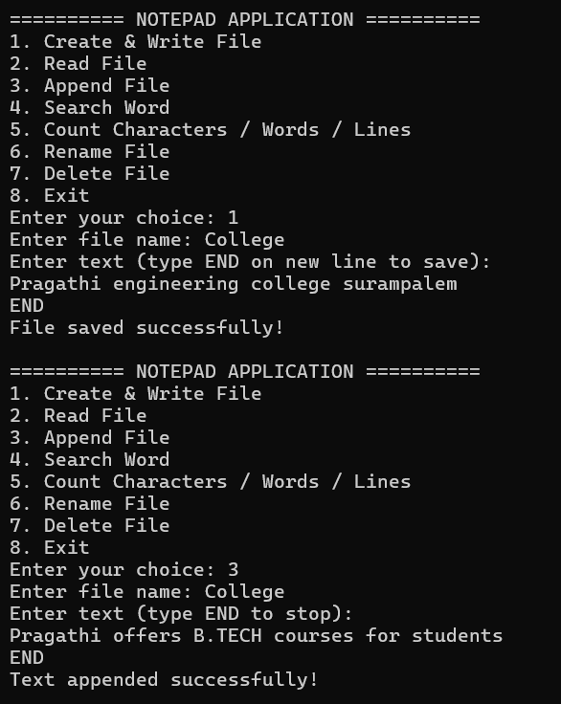
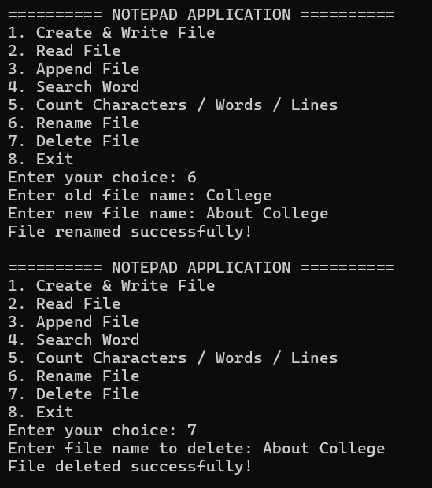

Advantages
- Easy to use and understand
- Helps in learning file handling in C
- Requires less memory and system resources
- Useful for creating and editing simple text files
- Improves programming and logical skills

Future Enhancements
Add GUI for better user interaction
Include advanced features like search, replace, and copy-paste
Support multiple file formats
Add security features like password protection for files
Improve performance and error handling

Conclusion
The NOTEPAD application developed using the C programming language successfully performs basic text editing operations such as creating, opening, editing, and saving files. This project helps in understanding file handling and fundamental programming concepts in C, It provides practical experience in developing a simple real-world application and improves logical and problem-solving skills.

