PRAGATI-BUS-MANAGEMENT
📄 Abstract
The Bus Management System is a simple console-based application developed in C to manage bus details efficiently. It allows users to add and display bus records such as bus number, source, destination, and available seats. The system demonstrates the use of structures, functions, and arrays in C programming. This project is useful for understanding basic data handling and menu-driven program design.
📘Introduction
Transportation systems require proper management of buses and their routes. Manual record keeping is time-consuming and error-prone. This project provides a simple digital solution using C programming.
The system is designed to:
- Store bus details
- Display available buses
- Provide a structured way of managing data
It is a beginner-level implementation of a real-world system.
🎯 Objectives
- To implement a menu-driven program
- To understand and use structures in C
- To manage data using arrays
- To perform operations like:
  - Adding bus details
  - Displaying records
- To improve problem-solving and coding skills
📋 Requirements
🔹 Hardware Requirements
- Computer/Laptop
- Minimum 4GB RAM
🔹 Software Requirements
- C Compiler (GCC / Turbo C)
- Code Editor (VS Code / Dev C++)
⚙️ Methodology
The system follows a simple procedural approach:
- Data Structure Design
  - A struct Bus is created to store:
    - Bus Number
    - Source
    - Destination
    - Seats
- Menu-Driven Approach
  - User selects options:
    - Add Bus
    - Display Bus
    - Exit
- Functions Used
  - addBus() → Adds new bus details
  - displayBus() → Displays all records
- Data Storage
  - Uses an array to store up to 10 bus records
- Execution Flow
  - Loop runs until user chooses exit

ALGORITHM

Step 1: Start
Step 2: Initialize
- Create an array of structure Bus
- Set number of buses n = 0

Step 3: Display Menu
Show options:
- Add Bus
- Display Bus Details
- Exit

Step 4: Read User Choice

Step 5: Check Choice using Switch
Case 1: Add Bus
- Check if n < 10
- Input:
  - Bus Number
  - Source
  - Destination
  - Number of Seats
- Store data in array b[n]
- Increment n = n + 1
- Print "Bus Added Successfully"

Case 2: Display Bus Details
- If n == 0
  - Print "No Bus Records Available"
- Else
  - For each bus from i = 0 to n-1
    - Display:
      - Bus Number
      - Source
      - Destination
      - Seats

Case 3: Exit
- Print "Program Terminated"
- Stop execution

Default Case
- Print "Invalid Choice"

Step 6: Repeat
- Go back to Step 3 until user selects Exit

Step 7: End

FLOWCHART
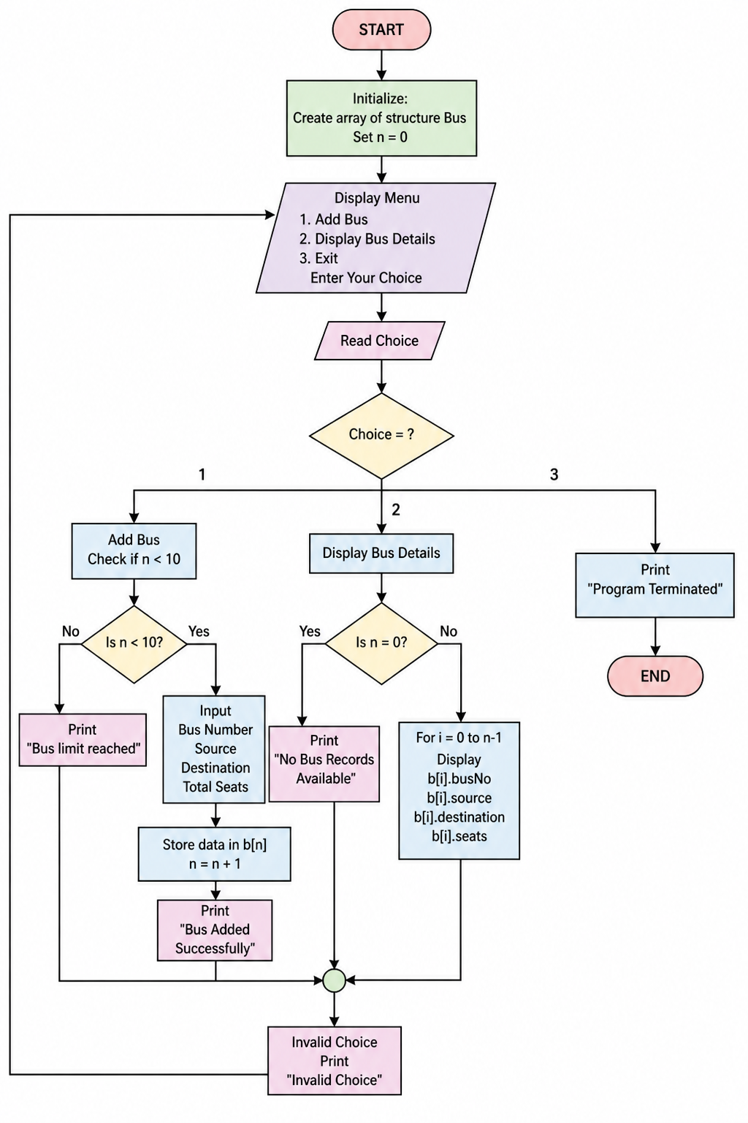
CODE
#include <stdio.h>
#include <string.h>

struct Bus {
int busNo;
char source[20];
char destination[20];
int seats;
};

void addBus(struct Bus b[], int *n) {
printf("Enter Bus Number: ");
scanf("%d", &b[*n].busNo);

printf("Enter Source: ");
scanf("%s", b[*n].source);

printf("Enter Destination: ");
scanf("%s", b[*n].destination);

printf("Enter Total Seats: ");
scanf("%d", &b[*n].seats);

(*n)++;
printf("Bus Added Successfully\n");
}

void displayBus(struct Bus b[], int n) {
if (n == 0) {
printf("No Bus Records Available\n");
return;
}

printf("\nBusNo Source Destination Seats\n");
for (int i = 0; i < n; i++) {
printf("%d %s %s %d\n",
b[i].busNo, b[i].source, b[i].destination, b[i].seats);
}
}

int main() {
struct Bus b[10];
int n = 0, choice;

do {
printf("\n--- Pragati Bus Management System ---\n");
printf("1. Add Bus\n");
printf("2. Display Bus Details\n");
printf("3. Exit\n");
printf("Enter Your Choice: ");
scanf("%d", &choice);

switch (choice) {
case 1:
addBus(b, &n);
break;
case 2:
displayBus(b, n);
break;
case 3:
printf("Program Terminated\n");
break;
default:
printf("Invalid Choice\n");
}
} while (choice != 3);

return 0;
}

SAMPLE OUTPUT
--- Pragati Bus Management System ---
1. Add Bus
2. Display Bus Details
3. Exit
Enter Your Choice: 1

Enter Bus Number: 101
Enter Source: Vizag
Enter Destination: Hyderabad
Enter Total Seats: 40
Bus Added Successfully

--- Pragati Bus Management System ---
1. Add Bus
2. Display Bus Details
3. Exit
Enter Your Choice: 1

Enter Bus Number: 102
Enter Source: Vijayawada
Enter Destination: Chennai
Enter Total Seats: 35
Bus Added Successfully

--- Pragati Bus Management System ---
1. Add Bus
2. Display Bus Details
3. Exit
Enter Your Choice: 2

BusNo Source Destination Seats
101 Vizag Hyderabad 40
102 Vijayawada Chennai 35

--- Pragati Bus Management System ---
1. Add Bus
2. Display Bus Details
3. Exit
Enter Your Choice: 3

Program Terminated
FUTURE SCOPE
This project can be improved by adding:
- ✅ Seat booking system
- ✅ Bus search functionality
- ✅ File handling (permanent storage)
- ✅ Login system (admin/user)
- ✅ GUI using advanced languages
- ✅ Database integration (MySQL)
REFERENCES
C Programming by Dennis Ritchie
Let Us C by Yashavant Kanetkar
GeeksforGeeks (C Programming Concepts)

