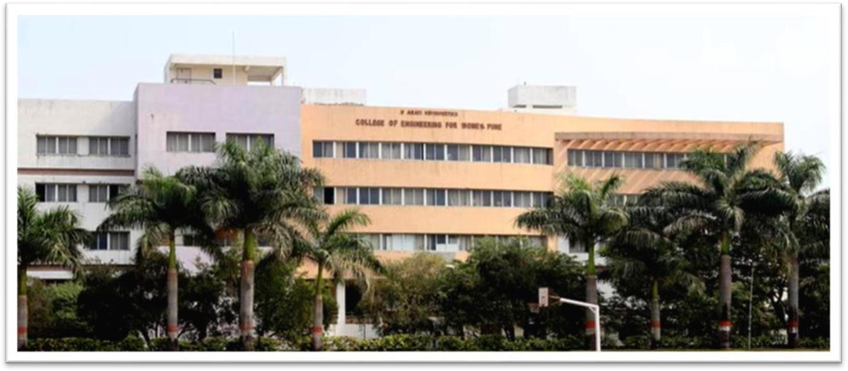

**BHARATI VIDYAPEETH'S COLLEGE OF ENGINEERING FOR**

**WOMENS , PUNE-43**

DEPARTMENT OF ENGINEERING SCIENCES AND ALLIED ENGINEERING

**PROJECT BASED LEARNING**

**1**

**BHARATI VIDYAPEETH'S COLLEGE OF ENGINEERING FOR**

**WOMENS , PUNE-43**

DEPARTMENT OF ENGINEERING SCIENCES AND ALLIED ENGINEERING

**PROJECT BASED LEARNING (110013)**

**Project Title : PARICAL IN A RIGID BOX**

**IFINITE POTENTIAL WELL**

Academic Year 2022-23 Semester-II

**Name of the Student : Suryavanshi Nikita Manoj**

**Roll No. : 258**

**Examination No. : F190340269**

**PRN No. : 72237774G**

2



BHARATI VIDYAPEETH'S COLLEGE OF ENGINEERING FOR WOMEN’S, PUNE 43

DEPARTMENT: ENGINEERING SCIENCES AND ALLIED ENGINEERING

CERTIFICATE OF ORIGINALITY

Year : 2022-2023 date 08/07/2023

This is to certify, that the project ( Particle in Rigid Box ) submitted by me is an outcome of my own work. I have duly acknowledged all the sources from which the ideas and extracts have been taken. The project has not been copied from anywhere and all data has been collected by me.

Name of Student :- Suryavanshi Nikita Manoj

Class / Sem / :- FE Div- 2 (C2-Batch) / 2nd SEM )

Exam no. :- F190340269

Signature of student Signature of Guide

**3**



**BHARATI VIDYAPEETH’S COLLEGE OF ENGINEERING FOR WOMEN PUNE-SATARA RD., PUNE – 411043**

**Department of Engineering Sciences and Allied Engineering Academic Year 2020-21 (Semester II)**

|  |  |  |  |
| --- | --- | --- | --- |
| **Subject:**  **Course Code: Class:** | Project Based Learning **(Course 2019)**  Subject Code: 110013  **First Year Engineering** | **Examination Scheme:** | |
| **Theory:** | **04 Hrs/Week** | **PR :** | **50 Marks** |

**Course Objectives:**

* 1. To provide a comprehensive overview of environmental pollution and the science and technology associated with the monitoring and control.
  2. To understand the evolution of environmental policies and laws.
  3. To explain the concepts behind the interrelations between environment and the development.
  4. To examine a range of environmental issues in the field, and relate these to scientific theory

**Course Outcomes:**

**After successful completion of this course the student will be able to**

|  |  |
| --- | --- |
| 101014**.1** | CO1: Have an understanding of environmental pollution and the science behind those problems and potential solutions. |
| 101014**.2** | CO2: Have knowledge of various acts and laws and will be able to identify the industries that are violating these rules. |
| 101014**.3** | CO3: Assess the impact of ever increasing human population on the biosphere: social, economic issues and role of humans in conservation of natural resources |
| 101014.4 | CO4: Learn skills required to research and analyze environmental issues scientifically and learn how to use those skills in applied situations such as careers that may involve environmental problems and/or issues. |

**4**

**Course Attainment methods:**

* Evaluation and Continuous Assessment
* **Assignment / Presentation report**

**Prof. M.A.Patwardhan H.O.D Principal Subject Teacher Engg. Sciences and Allied Engg.**

**5**



|  |  |  |  |  |
| --- | --- | --- | --- | --- |
| **INDEX** | | | | |
|  | | | | |
|  | | | | |
|  | **Sr. No.** | **Particulars** | **Page No.** |  |
| 1. | Introduction | 1 |
| 2. | Objectives and Scope of the study | 2 |
| 3. | Theoretical Background | 3 to 4 |
| 4. | Methodology | 5 |
| 5. |  | 6 to 7 |
| 6. | Interpretation of Data | 8 to 9 |
| 7. | Findings | 10 to 12 |
| 8. | Conclusion | 13 to 14 |
| 9 | References | 15 |

**Student Signature & Name Course Teacher Signature**

**Ms. Suryavanshi Nikita Prof.M.A.Patwardhan**

**6**

### **INTRODUCTION**

* Applications of Schroedinger's Time Independent Wave Equation

In wave mechanics a moving material particle is associated with a wave system and the wave function y gives description of the system . Schroedinger's time independent wave equation when applied to a system determines the possible wave function.

It can also determine the possible energy states of the system.

We discuss the solution of Schroedinger's equation when applied to

(i) Particle in a rigid box

(ii) Particle in a non-rigid box

In all these cases we will form and solve the Schroedinger's equation when the motion of particle is subject to restrictions.

The predictions of quantum mechanics can be compared with those of classical mechanics.

Here in this project we are going to discuss about a particle in a rigid box and energy levels corresponding to it.

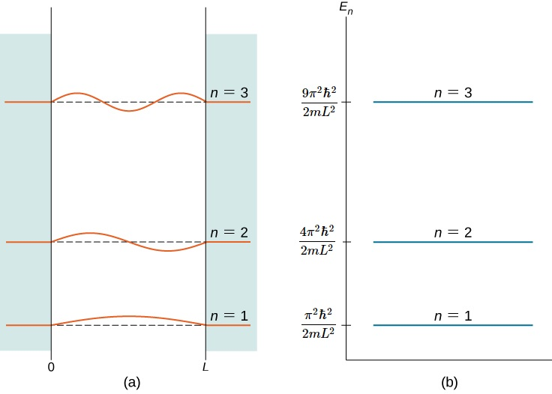

Figure: Energy levels of a Particle in a Rigid Box

**OBJECTIVES**

By the end of this section, you will be able to:

* Describe how to set up a boundary-value problem for the stationary Schrӧdinger equation
* Explain why the energy of a quantum particle in a box is quantized
* Describe the physical meaning of stationary solutions to Schrӧdinger’s equation and the connection of these solutions with time-dependent quantum states
* Explain the physical meaning of Bohr’s correspondence principle

In this section, we apply Schrӧdinger’s equation to a particle bound to a one-dimensional box. This special case provides lessons for understanding quantum mechanics in more complex systems. The energy of the particle is quantized as a consequence of a standing wave condition inside the box.

### THERIOTICAL BACKGROUND

If a particle is in a potential well and the total energy of the particle is less than the height of the potential well, it is considered as trapped inside the well. In classical mechanics this particle can vibrate back and forth due to collision with walls but cannot leave the well. In quantum mechanics, it is called as bound state.

Consider a particle is enclosed in a potential well of rigid box having infinite potential. Inside the box motion of particle is restricted between x=0 and x=L. Assuming the collision of the particle with walls as elastic, total energy of the particle E remains constant.

The potential energy of the particle is infinite outside the box and it can be considered as zero inside the box. Thus, the boundary conditions for potential energy are: ( 𝑥) = ∞ for 𝑥 ≤ 0 And 𝑥 ≥ 𝐿

𝑉 (𝑥) = 0 for 0 < 𝑥 < 𝐿

The wave function ψ is associated with the particle. As particle cannot leave the box, its probability outside the box is zero. Thus, boundary conditions for wave function are: ψ (𝑥) = 0 for 𝑥 ≤ 0

And ψ (𝑥) = 0 for 𝑥 ≥ 𝐿

To find out the wave function of the particle inside the box, we have to apply Schrödinger’s time independent equation.

**Step-I: Setting up Schrödinger’s equation**

Schrödinger’s time independent equation is

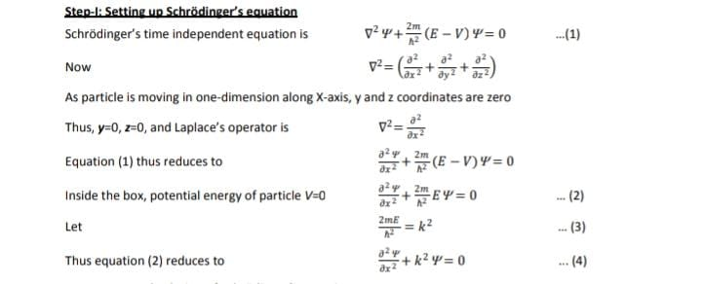



**Step-II: General solution of Schrödinger’s equation**

Equation (4) is a second order differential equation.

Its general solution can be written as Ψ 𝑥 = 𝐴 sin 𝑘𝑥 + 𝐵 cos 𝑘𝑥 --- (5)

Where A and B are constants

**At x=0**, the particle would be present on the boundary and its energy would be infinite i.e. equal to the energy of the potential well. Hence it cannot be present at x=0, and thus its wave function ψ =0 at x=0. By applying boundary condition ψ 𝑥 = 0 for 𝑥 ≤ 0, we get

0 = 𝐴 sin 𝑘𝑥 + 𝐵 cos 𝑘𝑥

And 0 = 𝐴 sin(𝑘 × 0) + 𝐵 cos( 𝑘 × 0)

As sin(𝑘 × 0) = 0, and 𝐵 cos(𝑘 × 0) = 1 𝐵 = 0

Putting B=0 in equation (5), Ψ 𝑥 = 𝐴 sin 𝑘𝑥 --- (6)

**At x=L**, the particle would be present on the boundary and its energy would be infinite i.e. equal to the energy of the potential well. Hence it cannot be present at x=L, and thus its wave function ψ =0 at x=L. By applying boundary condition ψ 𝑥 = 0 for 𝑥 ≥ 𝐿, we get

Ψ 𝑥 = 0 at 𝑥 = 𝐿

Putting this in equation (6) 0 = 𝐴 sin 𝑘𝐿

But A≠0 since Ψ will become zero. Thus sin 𝑘𝐿 = 0

Above equation implies 𝑘𝐿 = 𝑛𝜋, where n is integer and n≠0

This equation is known as **quantization condition**.

In the equation, 𝑘𝐿 = 𝑛𝜋, n≠0 as it may lead to either

(a) L=0. As L is the width box the box, L cannot be zero

(b) k=0. As k depends on total energy E of the system, k cannot be zero.

**A Energy of particle**

Thus, quantization conidian is 𝑘𝐿 = 𝑛𝜋, where 𝑛 = 1,2,3

.. but 𝑛 ≠ 0

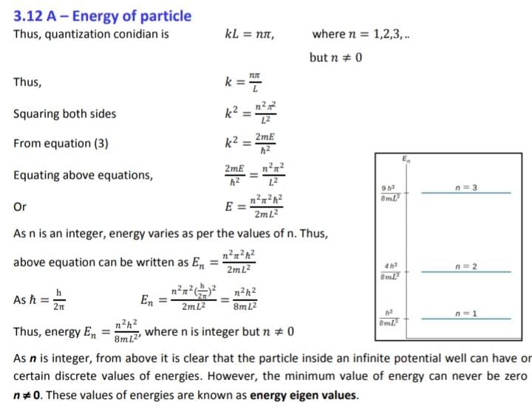

As n is an integer, energy varies as per the values of n. Thus, above equation can be written as,



**Thus energy,**



where n is integer but 𝑛 ≠ 0

As n is integer, from above it is clear that the particle inside an infinite potential well can have only certain discrete values of energies. However, the minimum value of energy can never be zero as **n ≠ 0**. These values of energies are known as **energy eigen values**.

### METHODOLOGY

# CONCLUSION

## REFERENCES