Radar System using Python, Arduino, and OpenCV
A compact and interactive real-time radar interface for object detection and visualization.
This repository showcases a radar-style detection system that utilizes Python, Arduino, and an ultrasonic sensor to identify and visually represent objects within a certain range. Here, you'll find everything you need to get started—from setting up the hardware to running the radar interface using OpenCV.
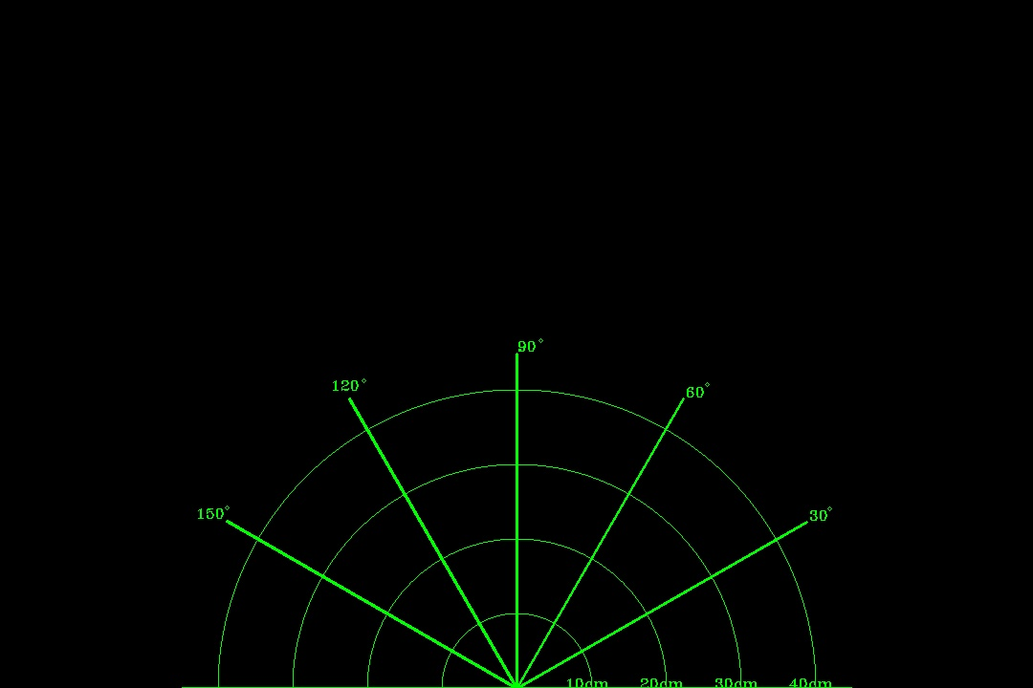

Features
- - Detects objects using an ultrasonic sensor
- - Displays the detected objects on a graphical interface using OpenCV
- - Provides real-time information about the objects' distance and position
- - Adjustable scanning range and rotation speed
- - Supports data logging for further analysis

Getting Started
To get started with the Radar System, follow these steps:

Prerequisites
- - Python 3.x installed (https://www.python.org/downloads/)
- - Arduino IDE installed (https://www.arduino.cc/en/software)
- - Required Python packages: pyserial, opencv-python, numpy

Hardware Setup
1. Connect the ultrasonic sensor to the Arduino board following the manufacturer's instructions.
2. Connect the Arduino board to your computer using a USB cable.

Software Setup
1. Clone or download this repository to your local machine.
2. Open the Arduino IDE and upload the Arduino_Radar.ino sketch from the arduino directory to your Arduino board.
3. Install the required Python packages by running the following command:
pip install pyserial opencv-python

Usage
1. Open a terminal or command prompt and navigate to the project directory.
2. Clone the repo:
git clone https://github.com/25Anurag/Radar_System.git
3. Navigate to the project directory:
cd Radar-System-Python-Arduino
4. Check the Port before running the code and edit the COM in the line #35.
5. Run the Python script using the following command:
python Radar_Graph_File.py
6. The radar system interface will open, displaying the scan area and detected objects in real-time using OpenCV.
7. Adjust the scanning range and rotation speed as desired by modifying the corresponding variables in the Python script.
8. Press Ctrl+C in the terminal or command prompt to stop the program.

Data Logging
1. Create a data directory within the project directory.
2. Uncomment the lines related to data logging in the Radar_Graph_File.py script.
3. Run the script as described in the 'Usage' section.
4. The detected object data will be logged to a CSV file in the data directory.

Contributing
Contributions to this project are welcome! If you find any issues or have suggestions for improvements, please open an issue or submit a pull request.

Contact
If you have any questions or feedback, please feel free to contact me.
We hope you find this Radar System project both interesting and useful! Thank you for your interest and support.
Happy coding!

