PRACTICAL – 2
Smart thermostat (Thermostat.java, main in this file)
(a) Create class Thermostat with private String location, private int temperature, private
static final int MIN=16 and MAX=30, and private static int activeCount=0.
(b) Constructor(location, startTemp): store location; set temperature to startTemp if it is
within MIN..MAX else 22; increment activeCount.
(c) Constructor(location): chain with this(location, 22).
(d) raise(): if temperature < MAX add 1, else print “Already at maximum (30)”.
(e) lower(): if temperature > MIN subtract 1, else print “Already at minimum (16)”.
(f) Add getTemperature() (no setter) and static getActiveCount().
(g) In main: create two thermostats, call raise() 10 times then lower() 20 times in loops
(printing the temperature each time), then print getActiveCount().

Code :
class Thermostat {
private String location;
private int temperature;

private static final int MIN = 16;
private static final int MAX = 30;

private static int activeCount = 0;

Thermostat(String location, int startTemp) {
this.location = location;

if (startTemp >= MIN && startTemp <= MAX) {
temperature = startTemp;
} else {
temperature = 22;
}

activeCount++;
}

Thermostat(String location) {
this(location, 22);
}

void raise() {
if (temperature < MAX) {
temperature++;
} else {
System.out.println("Already at maximum (30)");
}
}

void lower() {
if (temperature > MIN) {
temperature--;
} else {
System.out.println("Already at minimum (16)");
}
}

int getTemperature() {
return temperature;
}

static int getActiveCount() {
return activeCount;
}

public static void main(String[] args) {

Thermostat t1 = new Thermostat("Living Room", 25);
Thermostat t2 = new Thermostat("Bedroom");

System.out.println("Raising temperature of Living Room:");

for (int i = 0; i < 10; i++) {
t1.raise();
System.out.println("Temperature: " + t1.getTemperature());
}

System.out.println("\nLowering temperature of Living Room:");

for (int i = 0; i < 20; i++) {
t1.lower();
System.out.println("Temperature: " + t1.getTemperature());
}

System.out.println("\nActive Thermostats: " + Thermostat.getActiveCount());
}
}

OUTPUT :
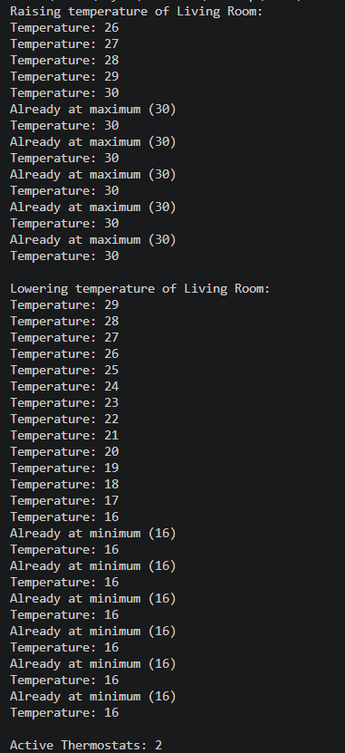

Cinema show (CinemaShow.java, main in this file)
(a) Create class CinemaShow with private String title, private int seatsAvailable, private
final int capacity, and private static int totalBooked=0.
(b) Constructor(title, capacity): set both and seatsAvailable = capacity.
Constructor(title): chain with this(title, 100).
(c) book(int n): if n ≤ seatsAvailable, reduce seatsAvailable by n, add n to totalBooked,
return true; else return false unchanged.
(d) cancel(int n): increase seatsAvailable by n but never above capacity.
(e) Add getSeatsAvailable() and static getTotalBooked().
(f) In main: run a sequence of book and cancel calls, printing the result and seats after
each, then print getTotalBooked().

Code :
class CinemaShow {
private String title;
private int seatsAvailable;
private final int capacity;
private static int totalBooked = 0;

CinemaShow(String title, int capacity) {
this.title = title;
this.capacity = capacity;
this.seatsAvailable = capacity;
}

CinemaShow(String title) {
this(title, 100);
}

boolean book(int n) {
if (n <= seatsAvailable) {
seatsAvailable -= n;
totalBooked += n;
return true;
}
return false;
}

void cancel(int n) {
seatsAvailable += n;
if (seatsAvailable > capacity) {
seatsAvailable = capacity;
}
}

int getSeatsAvailable() {
return seatsAvailable;
}

static int getTotalBooked() {
return totalBooked;
}

public static void main(String[] args) {
CinemaShow show = new CinemaShow("Avengers", 50);

System.out.println("Book 20 seats: " + show.book(20));
System.out.println("Seats Available: " + show.getSeatsAvailable());

System.out.println("Book 15 seats: " + show.book(15));
System.out.println("Seats Available: " + show.getSeatsAvailable());

show.cancel(10);
System.out.println("After canceling 10 seats:");
System.out.println("Seats Available: " + show.getSeatsAvailable());

System.out.println("Book 30 seats: " + show.book(30));
System.out.println("Seats Available: " + show.getSeatsAvailable());

show.cancel(50);
System.out.println("After canceling 50 seats:");
System.out.println("Seats Available: " + show.getSeatsAvailable());

System.out.println("Total Booked Seats: " + CinemaShow.getTotalBooked());
}
}
OUTPUT :
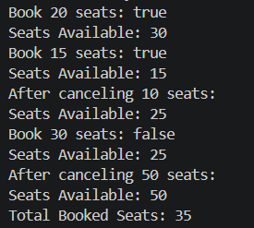

MiniBank
In Practical 1 you built the empty menu shell. Now you create the data the bank works on —
the Customer and Account classes. Using encapsulation, an account’s balance can change
only through deposit() and withdraw(), never directly. These two classes are the foundation
every later lab extends.
1. Create a class named Customer with private fields name, email and mobile (all String)
and a private final field customerId (String). Use a private static long field
customerCounter and a private static method generateCustomerId() to create ids such as
“CUST101”. Add a constructor and public getter methods.
2. Create a class named Account with private fields: a final String accountNumber, a String
ownerName, a long balance (whole rupees) and a boolean active. Generate
accountNumber with a private static counter (for example “AC0001”).
3. Add two constructors to Account: one taking ownerName and an opening balance; one
taking only ownerName that calls the first using this(ownerName, 0).
4. Add a public method deposit(long amount) that adds amount to balance. Add a public
method withdraw(long amount) that subtracts amount and returns true when the balance
is sufficient, otherwise returns false without changing the balance. Add getter methods.
Do NOT add a public setter for balance.
5. In main, create three Account objects inside an Account[] array, perform a few deposits
and withdrawals, and print each balance.

Code (minibank.java) :
import java.util.*;

public class MiniBank
{
public static void main(String args[])
{
Scanner sc = new Scanner(System.in);

BankInfo Bank = new BankInfo("SBI", "Changa");

System.out.println("-------------------------------------");
System.out.println(Bank);
System.out.println("-------------------------------------");

Account[] accounts = new Account[3];

accounts[0] = new Account("Rahul", 5000);
accounts[1] = new Account("Ayush");
accounts[2] = new Account("Preeti5", 10000);

accounts[0].deposit(2000);
accounts[0].withdraw(1000);

accounts[1].deposit(5000);
accounts[1].withdraw(2000);

accounts[2].deposit(3000);
accounts[2].withdraw(4000);

System.out.println("\n----- Account Details -----");

for (Account account : accounts)
{
System.out.println("Account Number : " + account.getAccountNumber());
System.out.println("Owner Name : " + account.getOwnerName());
System.out.println("Balance : " + account.getBalance());
System.out.println("Active : " + account.isActive());
System.out.println("-------------------------------------");
}

int choice;

do
{
System.out.println("1. Open Account");
System.out.println("2. Deposit");
System.out.println("3. Withdraw");
System.out.println("4. Transfer");
System.out.println("5. Exit");

System.out.print("Enter your choice : ");
choice = sc.nextInt();

MenuOption option = switch (choice)
{
case 1 -> MenuOption.OPEN_ACCOUNT;
case 2 -> MenuOption.DEPOSIT;
case 3 -> MenuOption.WITHDRAW;
case 4 -> MenuOption.TRANSFER;
case 5 -> MenuOption.EXIT;
default -> null;
};

if (option == null)
{
System.out.println("Invalid choice");
continue;
}

switch (option)
{
case OPEN_ACCOUNT ->
System.out.println("Open Account — to be implemented in a later lab");

case DEPOSIT ->
System.out.println("Deposit — to be implemented in a later lab");

case WITHDRAW ->
System.out.println("Withdraw — to be implemented in a later lab");

case TRANSFER ->
System.out.println("Transfer — to be implemented in a later lab");

case EXIT ->
System.out.println("Exiting MiniBank...");
}
}
while (choice != 5);

sc.close();
}
}
Code(customer.java) :
public class Customer
{
private String name;
private String email;
private String mobile;
private final String customerId;

private static long customerCounter = 100;

private static String generateCustomerId()
{
customerCounter++;
return "CUST" + customerCounter;
}

public Customer(String name, String email, String mobile)
{
this.customerId = generateCustomerId();
this.name = name;
this.email = email;
this.mobile = mobile;
}

public String getCustomerId()
{
return customerId;
}

public String getName()
{
return name;
}

public String getEmail()
{
return email;
}

public String getMobile()
{
return mobile;
}
}

Code(account.java) :
public class Account
{
private final String accountNumber;
private String ownerName;
private long balance;
private boolean active;

private static int accountCounter = 0;

private static String generateAccountNumber()
{
accountCounter++;
return String.format("AC%04d", accountCounter);
}

public Account(String ownerName, long balance)
{
this.accountNumber = generateAccountNumber();
this.ownerName = ownerName;
this.balance = balance;
this.active = true;
}

public Account(String ownerName)
{
this(ownerName, 0);
}

public void deposit(long amount)
{
balance += amount;
}

public boolean withdraw(long amount)
{
if (balance >= amount)
{
balance -= amount;
return true;
}

return false;
}

public String getAccountNumber()
{
return accountNumber;
}

public String getOwnerName()
{
return ownerName;
}

public long getBalance()
{
return balance;
}

public boolean isActive()
{
return active;
}
}

OUTPUT :


