PRACTICAL – 1

Vending machine (VendingMachine.java, main in this file)
(a) Define an enum Coin with constants ONE, TWO, FIVE, TEN.
(b) In main, set a snack price of 15 and a running total of 0; create a Scanner.
(c) Loop: read a coin name, use a switch expression to convert the Coin to its value
(ONE→1, TWO→2, FIVE→5, TEN→10), add it to the total, and print the total so
far.
(d) Stop the loop once the total reaches 15 or more.
(e) Print the change to return (total − 15).

Code :
import java.util.*;

class vendingmachine
{
enum coin {one , two , five , ten}

public static void main(String args[])
{
Scanner input = new Scanner(System.in);

int s;
int total = 0;
int snack = 15;
String coin;

while(total < snack)
{
System.out.print("\nenter coin : ");
coin = input.next();

switch(coin)
{
case "one" :
s = 1;
break;
case "two" :
s = 2;
break;
case "five" :
s = 5;
break;
case "ten" :
s = 10;
break;
default :
System.out.println("invalid coin");
continue;
}

total += s;
System.out.println("coin enter so far : " + total);
}

if(total >= snack)
{
int change = total - snack;
System.out.println("change : " + change);
}
}
}

OUTPUT :
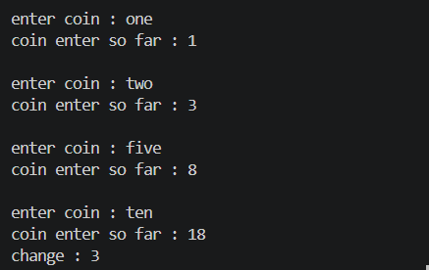

Toll booth (TollBooth.java, main in this file)
(a) Define a record Vehicle(String number, String type).
(b) In main, keep a running toll total and three counters (bike, car, truck).
(c) Loop until the user types “done” for the number: build a Vehicle, use a switch
expression on its type for the toll (bike→20, car→50, truck→150), add to the total,
and increment that type’s counter.
(d) After the loop, print the total toll and the type with the highest count.

Code :
import java.util.*;

public class tollbooth
{
record Vehicle(String number, String type) {}

public static void main(String args[])
{
Scanner sc = new Scanner(System.in);

int bike = 0, car = 0, truck = 0, total = 0;

while (true)
{
System.out.print("Enter vehicle number or (done): ");
String number = sc.next();

if (number.equalsIgnoreCase("done"))
{
break;
}

System.out.print("Enter vehicle type: ");
String type = sc.next().toLowerCase();

Vehicle vehicle = new Vehicle(number, type);

int toll = switch (vehicle.type())
{
case "bike" -> 100;
case "car" -> 200;
case "truck" -> 500;
default -> 0;
};

if (toll == 0)
{
System.out.println("Invalid vehicle type!");
continue;
}

total += toll;

switch (vehicle.type())
{
case "bike" -> bike++;
case "car" -> car++;
case "truck" -> truck++;
}
}

String most;

if (bike >= car && bike >= truck)
{
most = "Bike";
}
else if (car >= bike && car >= truck)
{
most = "Car";
}
else
{
most = "Truck";
}

System.out.println("Total Toll: " + total);
System.out.println("Vehicle Type with Highest Count: " + most);
}

}

OUTPUT :
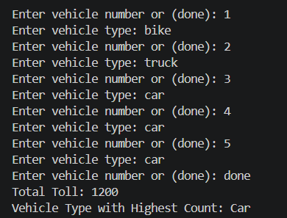

MiniBank
MiniBank is the console banking application you will build across the whole semester. In
this first lab you set up your tools and create the project and its menu shell — the screen the
user navigates. Every later lab attaches one real banking feature behind these menu options.
1. Set up your environment: open the project in GitHub Codespaces (or install JDK 17+ and
an IDE locally), and create a private GitHub repository named oop-minibank-<rollno>;
add the faculty as a collaborator.
2. Create a public class named MiniBank that contains the main method.
3. Define a record named BankInfo with two String fields, name and branch (a record is a
short, read-only class; Java auto-generates its constructor and field accessors). Print one
BankInfo object as the application header.
4. Define an enum named MenuOption with the constants OPEN_ACCOUNT, DEPOSIT,
WITHDRAW, TRANSFER and EXIT — these are the actions MiniBank will offer.
5. Display the numbered menu to the user and read the chosen number with a Scanner.
6. Use a switch expression on the choice to print a short placeholder for that option (for
example, “Deposit — to be implemented in a later lab”). Keep showing the menu in a
loop until the user selects EXIT, then print a goodbye message.

Code(minibank.java) :
import java.util.*;

public class MiniBank
{

public static void main(String args[])
{
Scanner sc = new Scanner(System.in);

BankInfo Bank = new BankInfo("SBI" , "Changa");

System.out.println("-------------------------------------");
System.out.println(Bank);
System.out.println("-------------------------------------");

int choice;

do
{
System.out.println("1. open account");
System.out.println("2. deposit");
System.out.println("3. withdraw");
System.out.println("4. transfer");
System.out.println("5. exit");

System.out.print("enter your choice : ");
choice = sc.nextInt();

MenuOption option = switch (choice) {
case 1 -> MenuOption.OPEN_ACCOUNT;
case 2 -> MenuOption.DEPOSIT;
case 3 -> MenuOption.WITHDRAW;
case 4 -> MenuOption.TRANSFER;
case 5 -> MenuOption.EXIT;
default -> null;
};

switch (option) {
case OPEN_ACCOUNT ->
System.out.println("Open Account — to be implemented in a later lab");

case DEPOSIT ->
System.out.println("Deposit — to be implemented in a later lab");

case WITHDRAW ->
System.out.println("Withdraw — to be implemented in a later lab");

case TRANSFER ->
System.out.println("Transfer — to be implemented in a later lab");

case EXIT ->
System.out.println("Exiting MiniBank...");
}
}
while(choice != 5);

}
}
Code (menuoption.java) :
enum MenuOption{OPEN_ACCOUNT , DEPOSIT , WITHDRAW , TRANSFER , EXIT}
Code (bankinfo.java) :
record BankInfo(String name , String branch){}

OUTPUT :


