CSUC201 Fundamentals of Data Structures and Algorithms 25DCS032

FACULTY OF TECHNOLOGY AND ENGINEERING
DEVANG PATEL INSTITUTE OF ADVANCE TECHNOLOGY
AND RESEARCH
DEPARTMENT OF COMPUTER ENGINEERING
A.Y 2026 – 27 Semester – 3
LAB MANUAL

CSUC201 Fundamentals of Data Structures and Algorithms

Practical 5: Doubly Linked List and Circular Linked List
Operations
Practical Aim
To implement core doubly linked list and circular linked list operations and understand how
bidirectional and circular linking change the way nodes are inserted, deleted, and traversed.
Problem 1
A music player maintains a playlist where songs can be added to the beginning, added to the end, or inserted right after a specific song that is currently playing. When a song is removed,
only the first song in the playlist is dropped. At any point the player can count how many songs are in the playlist and display them from first to last. Given a sequence of such operations,
implement all of them on a doubly linked playlist and print the result after each operation. Describe how your insertion after a given song works. What extra step does a doubly linked list
require here that a singly linked list did not? What happens if the given song is not found in the
playlist?
Code:
Git hub link:
https://github.com/25DCS032/DSA-25dcs032
Out put screenshot:

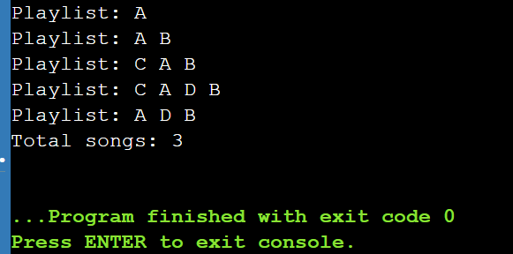
Problem 2
A group of students are sitting in a circle playing a passing game. A token starts at the first
student and is passed around the circle one student at a time. Students can join the circle at any
position and leave at any time, and the circle must remain unbroken after every join or leave.
Given a sequence of join, leave, and display operations, implement them on both a singly
circular and a doubly circular linked list and print the current circle after each operation.
Describe how your solution ensures the circle stays unbroken after a student leaves. What is
the one case where breaking the circle is most likely to happen as a bug, and how did you
handle it?Code:
Git hub link:
25dce103_DSA_PJP_3CE2_B/Practical-2 at main · nidhisavalia/25dce103_DSA_PJP_3CE2_B
Out put screenshot:

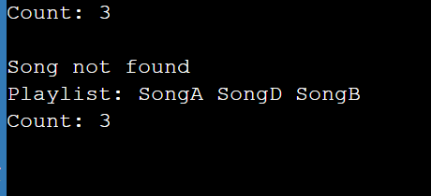

Key Questions / Analysis / Interpretation
1. How does a sorting algorithm arrange elements in ascending or descending order?
Answer: A sorting algorithm compares elements and arranges them in ascending or descending order. Ascending order means smallest to largest, while descending order means largest to smallest.
2. What is the difference between Bubble Sort, Selection Sort, and Insertion Sort?
Answer:
Bubble Sort: Compares adjacent elements and swaps them if they are in the wrong order.
Selection Sort: Finds the smallest element and places it in the correct position.
Insertion Sort: Takes one element at a time and inserts it into its correct position in the sorted part.

