CSUC201 Fundamentals of Data Structures and Algorithms 25DCS032

FACULTY OF TECHNOLOGY AND ENGINEERING
DEVANG PATEL INSTITUTE OF ADVANCE TECHNOLOGY
AND RESEARCH
DEPARTMENT OF COMPUTER ENGINEERING
A.Y 2026 – 27 Semester – 3
LAB MANUAL

CSUC201 Fundamentals of Data Structures and Algorithms


Practical 6: Stack Implementation using Array and Linked
List, with Expression Processing
Practical Aim
To implement stack using array and linked list, and apply stack-based logic to expression
conversion, evaluation, and bracket validation problems.
Problem 1
A cafeteria stacks clean trays on a fixed-size counter. New trays are always placed on top, and
customers always take from the top. The counter can hold at most n trays at a time — if it is full,
no more trays can be added, and if it is empty, no tray can be taken. Given a sequence of place
and take operations, implement this fixed-capacity tray stack and print the current top tray after
each operation. Report an error if a place or take operation cannot be performed.
Describe how your solution tracks whether the stack is full or empty. What are the exact
conditions you check before a push and before a pop, and what does your program do when
those conditions fail?
Code:
Git hub link:
https://github.com/25DCS032/DSA-25dcs032
Out put screenshot:

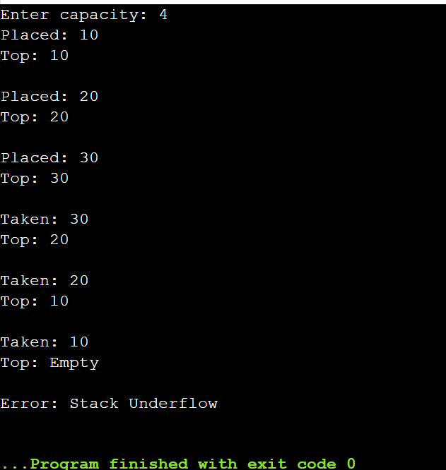

Problem 2
A web browser keeps track of pages visited so that the back button always returns to the most
recently visited page. Unlike a fixed counter, the browser has no hard limit on how many pages
it can remember — it grows as the user visits more pages and shrinks as they press back.
Given a sequence of visit and back operations, implement this unlimited page history and print
the current page after each operation.
Describe how your solution differs from Problem 1 in how it handles memory. What happens in
your solution when the user presses back on the very first page with no history left?
Code:
Git hub link:
25dce103_DSA_PJP_3CE2_B/Practical-2 at main · nidhisavalia/25dce103_DSA_PJP_3CE2_B
Out put screenshot:

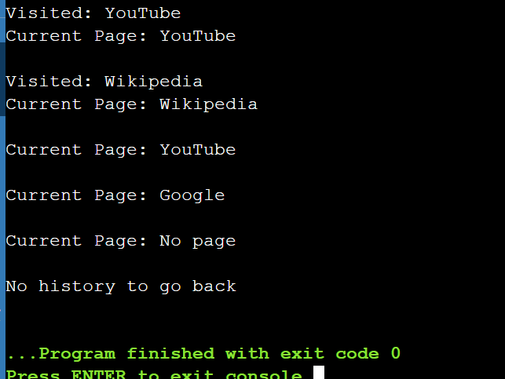
Problem 3
A calculator application receives arithmetic expressions typed by users in the usual way —
numbers and operators written in between, with brackets to control priority (e.g. 3 + 4 * 2 or (3 +
4) * 2). Internally the calculator needs to convert each expression into a form where operators
appear after their operands, so it can evaluate them without needing to re-read brackets. Given
an infix expression, convert it to the equivalent postfix form and print the result.
Page 20 DSA Lab Manual (CSUC201) CSE Department, CHARUSAT
Describe the role the stack plays in your conversion. What does your solution do when it
encounters a closing bracket, and what happens to the operators that were waiting on the stack
at that point?
Code:
Git hub link:
25dce103_DSA_PJP_3CE2_B/Practical-2 at main · nidhisavalia/25dce103_DSA_PJP_3CE2_B
Out put screenshot:

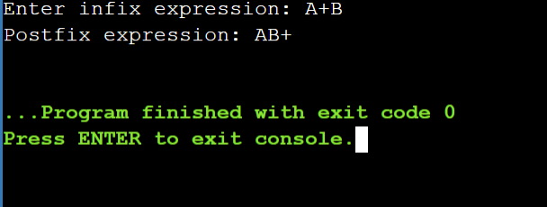

Key Questions / Analysis / Interpretation
1. Problem 1: Circular Array
Answer: In a circular array, the front and rear pointers move back to index 0 after reaching the last index using the modulo (%) operator. The array is full when (rear + 1) % size == front.
2. Problem 2: Linked List Stack
Answer: Yes, a linked list stack can run out of space when the computer's available memory is exhausted. Its actual limit depends on the available memory and system resources. This limit is invisible in the code because memory is allocated dynamically.
3. Problem 3: Operator Precedence
Answer: If all operators have equal precedence, the expression may be evaluated in the wrong order. For example, multiplication should be performed before addition. Ignoring precedence can produce an incorrect postfix expression and an incorrect result.

