FACULTY OF TECHNOLOGY AND ENGINEERING
DEVANG PATEL INSTITUTE OF ADVANCE TECHNOLOGY
AND RESEARCH
DEPARTMENT OF COMPUTER ENGINEERING
A.Y 2026 – 27 Semester – 3
LAB MANUAL

CSUC201 Fundamentals of Data Structures and Algorithms


Practical Aim
Practical 4: Singly Linked List: Dynamic Insertion, Deletion,
and Traversal

Practical Aim
To implement core singly linked list operations and develop the ability to manipulate dynamic
sequences through real-world problem scenarios.
Problem 1
A hospital manages a queue of patient tokens. New critical patients must be added to the front,
routine patients are added to the end, and occasionally a patient with a priority number must be
inserted at a specific position in the queue. Given a sequence of such operations, implement all
three insertion types and print the final queue after each operation.
Describe how your insertion at a specific position works. What does your solution do if the
position given is greater than the current length of the queue? Is that handled explicitly or does it
cause an error?

Code:
Git hub link:
https://github.com/25DCS032/DSA-25dcs032

Out put screenshot:

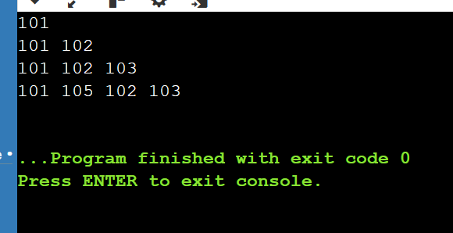

Problem 2
The hospital also needs to remove a patient token from the queue when a patient leaves, print
all remaining tokens from last to first for an end-of-day audit, and display the full queue from
front to back at any point. Implement deletion by value, reverse printing, and forward traversal
on the same queue from Problem 4.1a.
Describe how your reverse printing works. Does it use any extra storage, or does it work purely
by following the links? Can you think of another way to reverse-print without modifying the
original queue?
Code:
Git hub link:

nidhisavalia/25dce103_DSA_PJP_3CE2_B
Out put screenshot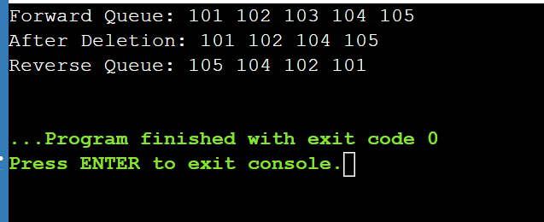:

Key Questions / Analysis / Interpretation
1. Inserting at a position beyond the current length of the list is an invalid operation. Should your solution silently insert at the end, report an error, or do something else entirely? Justify your choice and explain what assumption about the caller your choice makes.
Answer: The solution should report an error because the given position is invalid. It should not insert the node at the end automatically. This assumes that the caller provides a valid position and expects the program to identify invalid input.
2. If the node to be deleted is the only node in the list, how many pointers need to change and what must they be set to? How is this case structurally different from deleting a node in the middle?
Answer: Only the head pointer needs to change, and it must be set to NULL (or nullptr in C++). In a middle-node deletion, the previous node's next pointer must be updated to point to the next node. Deleting the only node makes the entire list empty.

