# 导入工程后的修改

## 1.提示servlet 相关类找不到

The type javax.servlet.ServletContext cannot be resolved. It is indirectly referenced from required .class files

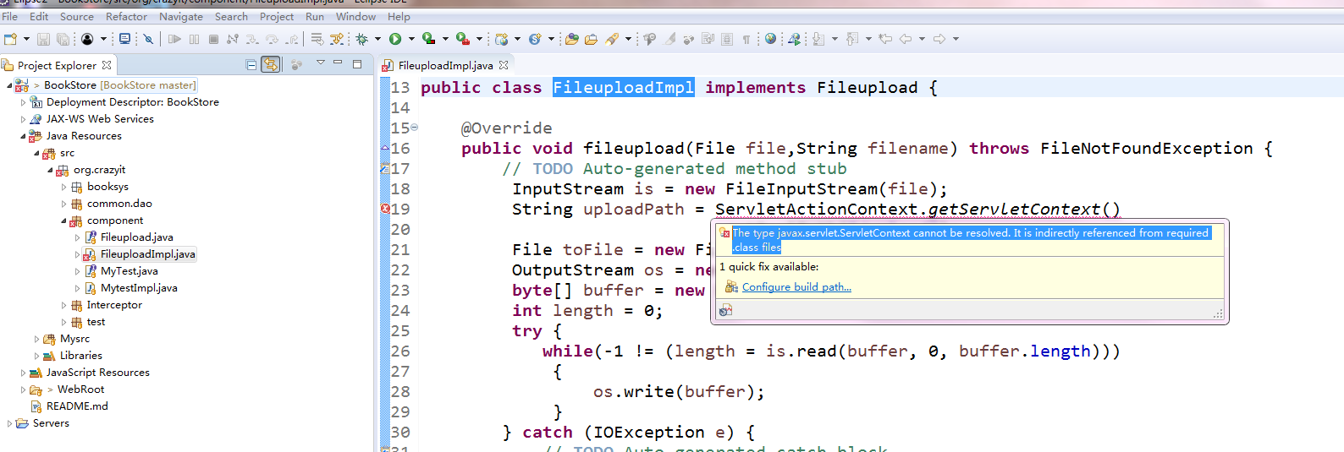

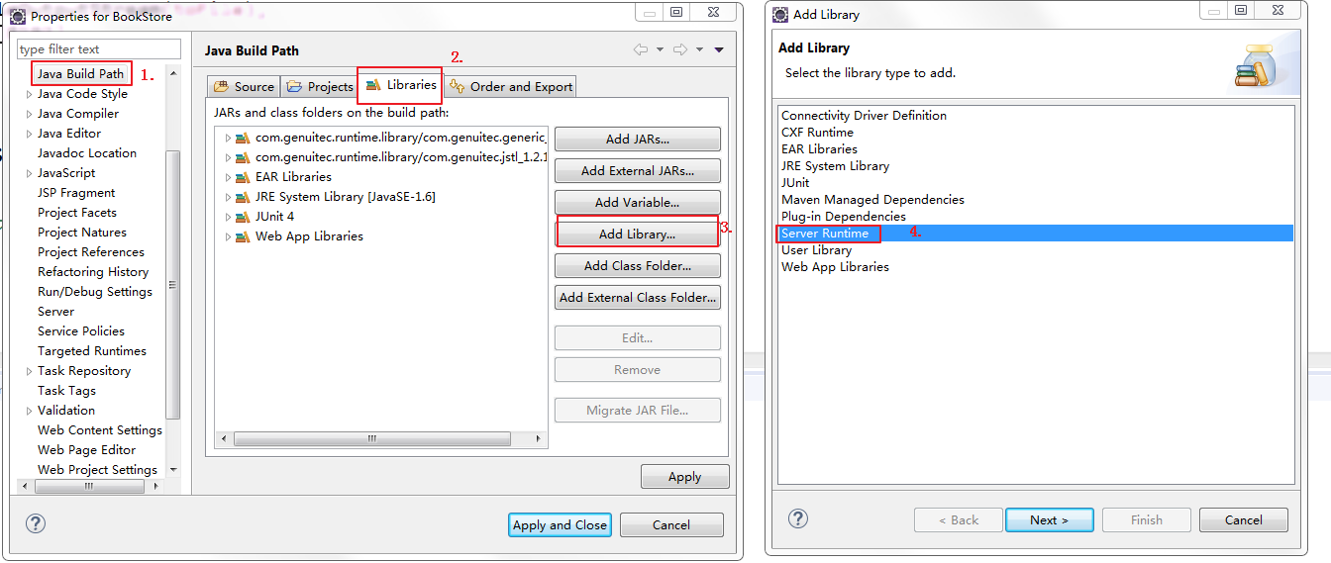

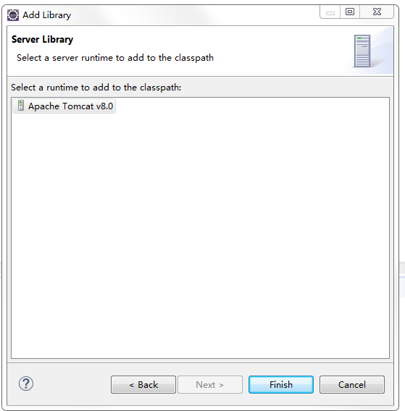

## 2.Java代码中文注释乱码

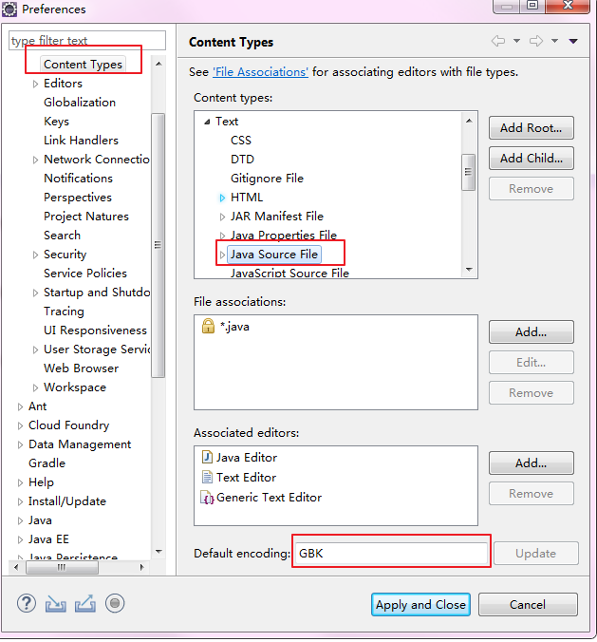

## 3.编码配置

编码统一为utf-8编码

Window-->Preferences

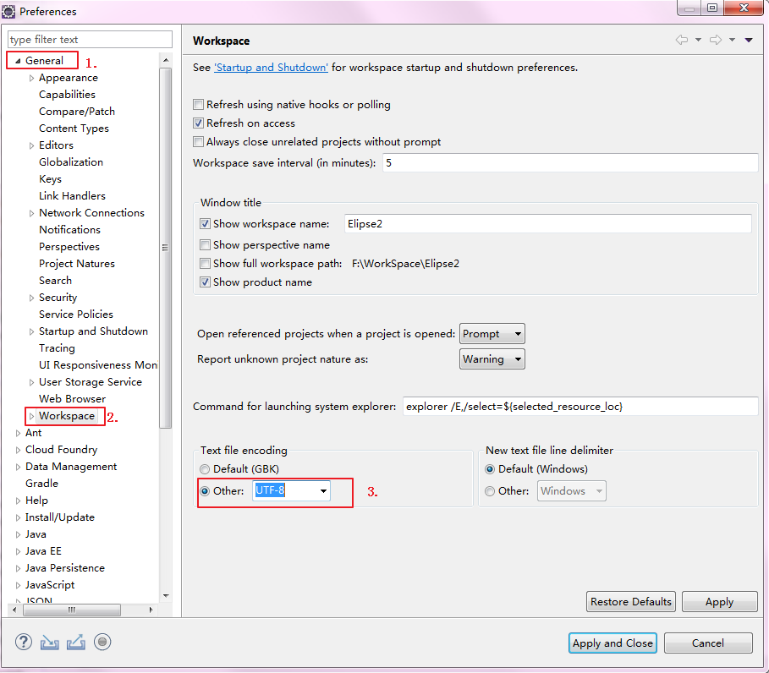

单个文件的编码更改为utf-8

文件右键，选择properties

