MACSE604 – EDGE INTELLIGENCE
Lab ex 1: Errors Encountered
Date: 11-12-252

ROHIT P
25MML0001

In all these ‘errors’ I used try-catch blocks to skip any corrupt rows, so there wasn’t a explicit error being thrown, rather the output of the cell was wrong or simply didn’t exist (since the logic got skipped)

1. 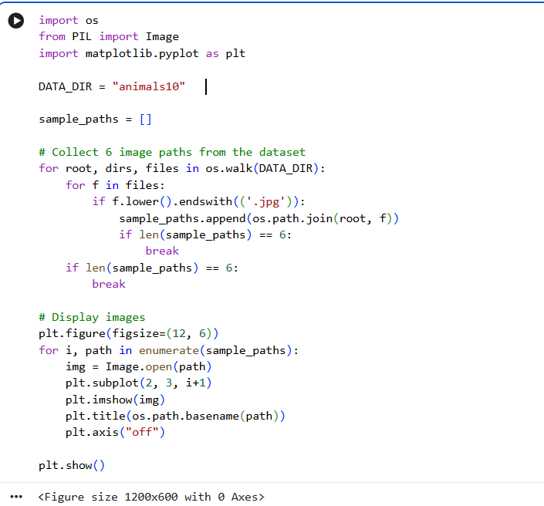

- In this code the main problem was I was trying to read ‘.jpg’ files.
- But this dataset also had ‘.jpeg’ files
- So the images were not being read and skipped
- That’s why there is ‘0’ Axes in the output page
- So I fixed it using read jpg or jpeg or png
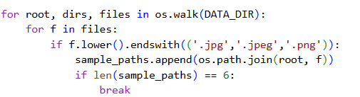

2. Problem: In the cell responsible for extracting features from images there was a break statement placed at the end of the outer loop (for root, dirs, files in os.walk(RESIZED_DIR):).
This meant that after os.walk found the very first directory (even if it contained no images itself, only subdirectories), the entire process of traversing the image folders would stop.
only a very limited number of images, or sometimes none at all, would be processed.
Solution: I modified the code in that cell to use an image_count and a MAX_IMAGES_TO_PROCESS variable.
The break statements were placed to exit the loops only after a specified number of images (e.g., 10) had been processed, ensuring that the code traversed through subdirectories and extracted features from a representative sample of images.
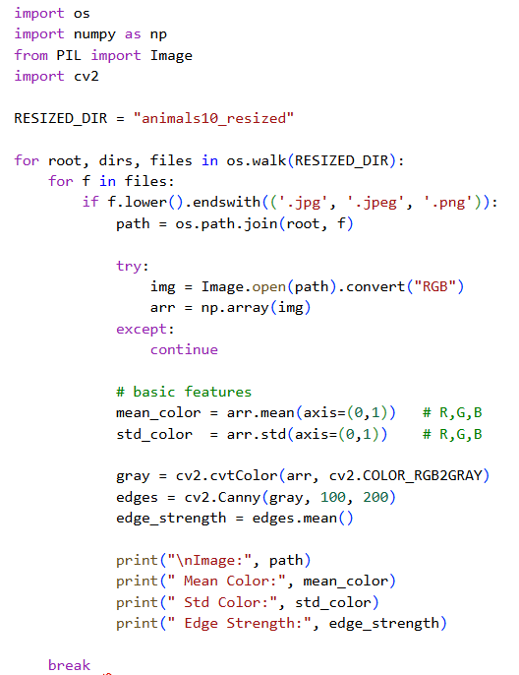
FIX:
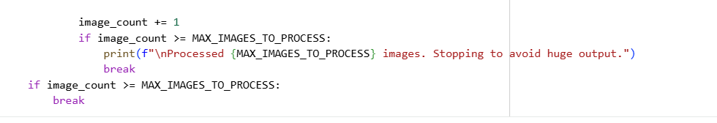

3. PROBLEM: This was a small but very noticeable error that happened because previously I worked with only square image data. That is, width and height were same, but not here.

This ran correctly until I printed the images.

The images were stretched out horizontaly

What had happened was I gave height, width but the arguments were actually expecting the order of ‘width,height’

So I fixed it by simply resizing
