Task 1 – Design Document

Introduction
This is the design document for an informational webpage with the purpose to suggest interesting places to explore, eat, or have fun in Dublin. It will serve as a great source of information for anyone on holiday in Dublin, anyone new to the city, or anyone who just wants to discover more about what Dublin has to offer.

Website Overview
The Website will consist of 5 pages. A home/landing page, an interactive to-do list page, a benefits of to-do lists page, a page suggesting landmarks, and a page suggesting places to eat.

Pages

Homepage
This will be the entry point to the website. It will tell users what the site has to offer and direct them to the content that they want to access.

Interactive To-do List Page
This page will allow the user to create and edit their own custom to-do list of things that they would like to do in Dublin.

Benefits of To-do Lists Page
This page will describe the benefits of a to-do list and how it can improve the experience of exploring Dublin by gamifying the experience a bit and keeping track of what you would like to do.

Places to See Page
This page will be informational presenting interesting and important landmarks in Dublin, giving a brief description of why they are interesting and what experiences you can have as well as showing images of them.

Places to Eat Page
This page will include top rated restaurants around Dublin. It will serve as a suggestion list for places for people to go and get something to eat. It will describe the restaurants and give links where appropriate and show pictures of the food or the restaurant itself.

Wireframes

Homepage
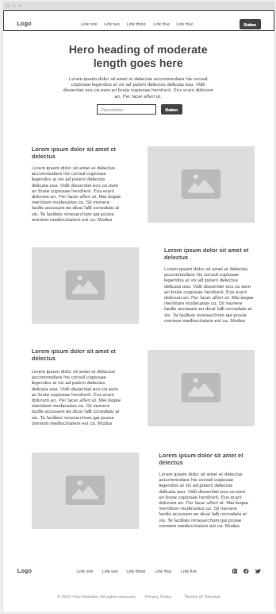
Wireframe.cc – Homepage

Interactive To-do List Page
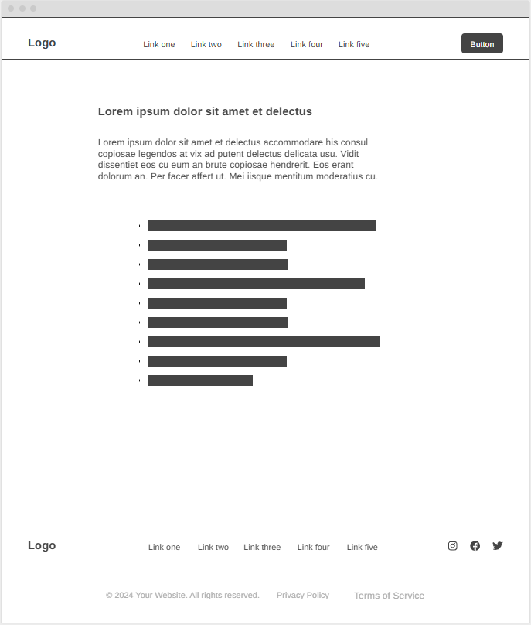
Wireframe.cc – Interactive To-do List Page

Benefits of To-do Lists
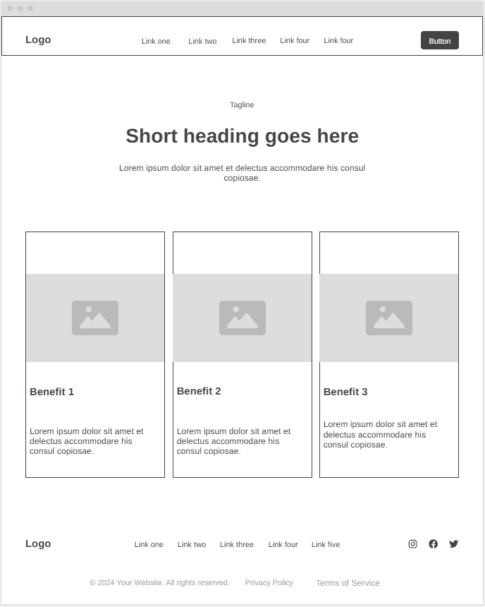
Wireframe.cc – Benefits of To-do Lists

Places to See Page
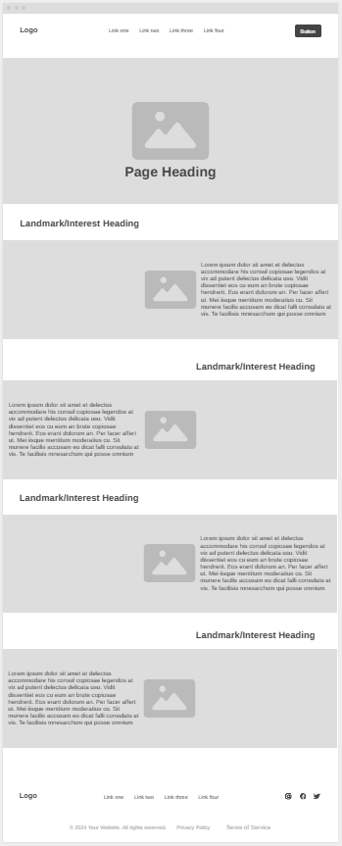
Wireframe.cc – Places to See Page

Places to Eat Page
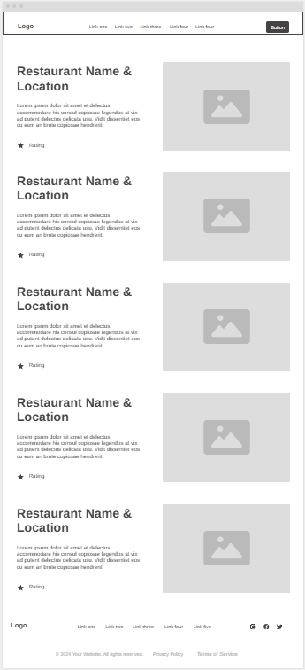
Wireframe.cc – Places to Eat Page

Final Wireframe (Places to See Page with common updated design changes to header, footer, top banner, information card design)
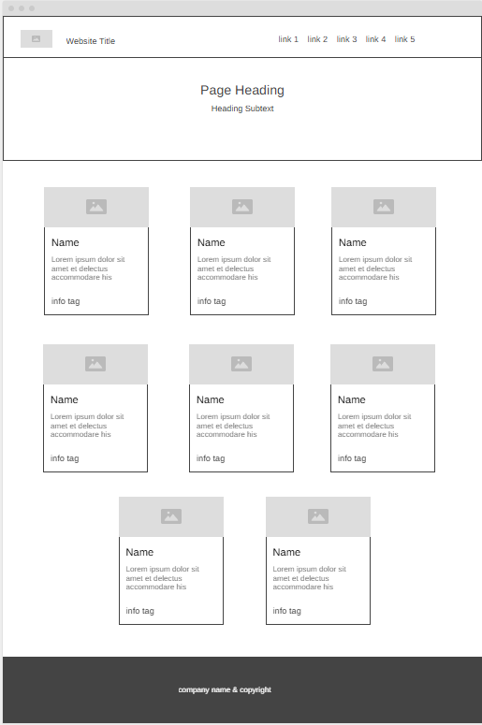
Wireframe.cc – Updated design elements
This final wireframe displays the iteration process for many elements that have changed in the final design.
In the header the design has been simplified, and this has been changed for all pages.
The footer has been greatly simplified taking out all unnecessary information.
An information banner has been added to all pages outside the homepage to help the user recognise where they are.
This flexbox grid of information cards style design has been implemented on multiple pages (places to see/places to eat/benefits pages) although the places page is the biggest divergence from the original design which is why I’m using it to show the design change.

Discussion of Layouts

Header & Footer
I have kept a consist design for my header and footer across all the pages of the site, this is to create the feeling of continuity for the user so that they know they are still on the site and also for functional purposes like keeping a consistent navigation menu. The only differences in these across the pages is that the page a user is on is highlighted in the nav menu to make it apparent what page the user is on.

Header
I kept my header and footer quite simple with my designs as the website did not require any complicated navigation or lots of extra outside information links for specialist users.
For my header I placed the logo in the top left as this is typically the place a user will look to first and displaying the website name and logo is what I want to be seen by every user, this helps the user to immediately identify the website they are on and outs our name and branding in their head, this is important as a method for growth of our user base.
Then we have a simple nav menu. This has a link for each page of the website displayed clearly so that the user can quickly navigate to where they want to go and also quickly get an idea of the scope of the website and what is on offer.
The colours of the header match the same theme as the rest of the website using a linear gradient of blues to make it look a bit more interesting and dynamic that a solid single colour. You will see this gradient echoed across the rest of the website in different sections also.

Footer
The footer I have designed is super basic whose primary purpose is to make it apparent to the user that they have reached the end of the page. I include the company name and copyright mark. I went for quite a dark navy colour for the footer so as to make clear that this is what it is. It appears like a block that you can’t scroll past making it intuitive that it’s the end of the page. Keeping a hint of blue (having it navy instead of dark grey or black) is used to keep with the overall colour scheme of the website.

Homepage
The homepage layout is designed to instantly let the user know where they are and what the website is about. It includes a header with the website logo in the top left and a navigation menu so the user can see the different pages of the site and access the content they want immediately. A hero banner below which will include a background image/video making it clear that this is a Dublin information website.
Below this when the user scrolls down, they are given larger explanations of what the website has to offer and pictures to further give them a sense of the themes of each section. These sections are presented in an alternating pattern where the images and text swap sides for each row of content, this is more appealing and interesting to look at than a more basic pattern while still being simple enough to be clearly readable and understandable.

Interactive To-do List Page
This page is kept simple as the main purpose of it is to serve the function stated, of an interactive to-do list. It briefly explains what it is about in a top banner with a heading and some text and then displays the to-do list application so the user can use it straight away. It was important here to make the to-do list display immediately without the user having to scroll or go looking for it. It will display the user's current to-do items and be customizable by checking off completed items, adding or deleting unwanted items, editing the text of a task or reordering the to-do list to the user's preferences using drag functionality. The goal is to make the user interface as simple and intuitive as possible so immediately the user is shown an input field and with placeholder text telling them to Enter a new to-do list item, once they do this it will display on their to-do list with a checkbox to mark completed tasks, an option to edit the item or delete the item outright, all button were designed to be very obvious by having contrasting colours and a recognisable button shape, also when hovered over the buttons animate to make it obvious that they are an interactive feature.
I will use a background image for this page that will display a map of Dublin City. This will be a good use of empty space as an image that is on topic and also could be useful to the user as they may spot things on the map that are of interest to them.

Benefits of To-do Lists
This page serves as an informational for the user so that they can understand how a to-do list might enhance their experience exploring Dublin and encourage them to use the feature on the website.
Once again it is a banner with a simple title and short introduction followed by the main content, which in this case is panels with icons explaining all the many reasons that creating a to-do list might be a good idea to have the best experience while in Dublin.
The reason I split them into panels is to so that the users eye can be drawn to points that interest them and to keep the text horizontally short which improves the users experience reading it and to give them a sense of completion every time they finish reading a line/panel, this helps to keep the user engaged and enjoying reading the webpage.
At the end of the page there is a call to action, I used size, colour and animation to distinguish this from the information panels along with it being outside of the regular flexbox layout of the panels. This call to action suggests the user create their own to-do list and points towards the website's inbuilt interactive to-do list page. The link to this page has animation when hovered over to show interactivity and an animated pointing finger to create a strong suggestion to the user to interact with the link.

Places to See Page
Once again, this page has a top banner with a heading and sub-text so the user immediately knows what page they are on.
It then has a flexbox with each location displayed on information cards. This design follows gestalt principles as it shows the user a consistent pattern, but each card will have a different image of the location to draw the user's eye to the differences. Then they also have a bright orange tag saying what type of experience the user might have as another way of using eye-catching visuals to bring attention to important information for the user if they don’t immediately read the full description. On top of this there will be a paragraph giving a description of the place for anything that the user takes an interest in.

Places to Eat Page
The layout of this page was heavily inspired by the design of the Places to eat page. We begin at the top with our usual heading banner letting the user know where they are.
Below this is a grid of information cards that draw the users eye using images and then give them important information on the place. Firstly, the name of it at the top as it's the most important piece of information. Then we have our own star rating showing what quality can be expected there. Below this we have a small tag to say what type of establishment it is to further let the user know what to expect. Then a description to give the details if the user takes a particular interest in this place. And lastly at the bottom we have a relative price rating which so that the user can distinguish between places where they might be spending a lot of money versus places where they might be able to find better value for money.
This page was designed to give the user as much information about these places, displayed in an easy to navigate fashion so that the user does not need to read through paragraphs to find a place they might like.

To-do List Functionality
A primary part of the task I am given was to create an interactive to-do list. This was given special attention and good functionality, I will describe that here.
The first functionality is the ability to add an item to the list by the user. This will be achieved through a basic input field and button labelled “Add Item”. This allows the user to type in a to-do item and add it to their list. Also to note here that pressing the Enter key will also work to submit the input field and add the item for user convenience
Once the user has items added to their list the list is displayed on the screen. This will show the items along with the options associated with them.
The first of these options is a checkbox which when clicked, ticks the checkbox and crosses out the text of the to-do list item, also greying out the text to make it clear that this is a completed item.
The next option is the edit button, which is also accessible by double clicking the item, which allows the user to edit the text of the to-do item in case they made a spelling error or would like to change it without creating a whole new item.
There will also be a delete button allowing the user to get rid of old or unwanted items in the to-do list. This button will be red and have the word “Delete” on it to make it obvious to the user what it is for.
Further functionality will be that the user will be able to drag items around the list to rearrange them. This will allow the user to place priority items at the top or customise the order however they like.

HTML5 Features

Semantic HTML
I used semantic HTML tags throughout the website. These are tags introduced to HTML 5 to increase readability and accessibility. I used tags like <header> <main> <footer> on every page to section off my body into meaningful parts and I made my navigation menus using the <nav> tag.

Draggable Elements
In the to-list section I used this new feature to allow users to drag elements in the to-do list so that they can customise the arrangement to their own preferences.

Multimedia Support (<video>)
I used the new <video> tag to include a background video of Dublin for hero on my homepage.

Web Storage (Local Storage)
I used this to store the user's to-do list data so that when the page is refreshed or the user returns at a different time that the to-do list is still there.

Animations
I used animations in various parts of the website to add the feeling of intractability and also to make the design feel more fluid and modern instead of static.
The first animation I used was on my homepage where I had the main content after the hero float up into the screen as the user scrolls down the webpage. This makes the website feel a bit more alive and modern for the user and pulls their attention to each section as it floats into the screen. To make this I used transform and transition properties in the css, as well as a .visible class that is added to the elements when they reach a certain height on the viewport as the user scrolls activating the animation. A revealOnScroll() function will be used in the JS to detect the moment when the animation should occur.
I used small animations to change the colour of some buttons/links and to lift them off the page slightly to improve the feeling of intractability of these elements to the user. For this I used basic pseudo classes mostly as more complicated animations were not required.
The last animation I used was on the call to action at the button of the benefits of a to-do list page this takes an icon of a finger pointing and has it moving in the direction of the button that directs the user to create their own to-do list. I created this using css keyframes and the animation property on the element. It is the only animation of this kind on the website and thus should effectively grab the user's attention and direct them to one of the websites main features.

Conclusion
To conclude, this design document describes the design process and implementation of the website I was tasked with creating. It includes a brief description of the pages included in the website, my initial wireframe designs and later adjustments, a discusion of the layouts used in the end design, a description of the interactive to-do list functionality, a description of the different HTML 5 feature used, and brief discussion of the animations that appear across the website and how and why they were implemented.

Task 3 – Report

This report does 3 things:
- Briefly describes how each of the following enables the creation of and access to internet and web services:
a:
b:
c:
d:
e:
- Outlines the difference between Web 1.0 and 2.0 and discusses how technological advancements have influenced these differences.
- Explains the importance of creating both responsive and accessible websites.

I.
a: Routers connect our local devices with the wider internet. They read the address on data packets and send them on the most efficient path to reach their destination allowing data to be sent and retrieved from different servers across the world.

b: Integrated Development Environments are used to create applications and web pages for the internet (as well as for off the internet). They come with a suite of integrated features that usually allow developers to build, test, debug, version control, and generally do much of the development process on the IDE. By creating much of the content on the internet they contribute to the creation of the internet as a whole.

c: Servers are hardware or software devices that process requests sent over a network and reply to them. They are essential in accessing the internet as they are where data is stored (including webpages) and when they receive the request for the data, they will process it and send back the resources requested (unless something goes wrong).

d: Web Browsers are used to parse code and display it as a web page. This enables users to see webpages as readable content rather than as code. This is essential for accessing content that user’s want over the internet as without them they would only see lines of code

e: HTTPS Protocol is Hypertext Transfer Protocol Secure, is the rules followed for transferring files over the internet (HTTP) with an added layer of security (S). It ensures that files being sent from browsers to a server can’t be intercepted.

II.
Introduction
The move from Web 1.0 to Web 2.0 was in a basic sense a move from a static and simple internet used for one way content distribution, to a highly interactive and interconnected internet with content being created by developers and users alike, more complicated and sophisticated designs, and a massive increase in data integration across websites and applications.

Interactivity
One of the main differences between Web 1.0 and Web 2.0 is that it went from a Read-only user experience to a read-write user experience meaning there was an ability for the user to interact with and add to the content of the page themselves rather than just read information.
Technological advances that influenced this and made it possible were the introduction and usage of JavaScript (JS), Asychronous JavaScript & XML (AJAX), and backend technologies on top of the basic HTML that would have been used in Web 1.0. These technologies allowed the user to interact with the content of webpages instead of just passively read them. A hypothetical example might be a user clicking a button and having an image slide into the screen that they can then click on different parts of to show different content. In Web 1.0 this previous example would likely have all been done with hyperlinks directing the user to different parts of the page/website whereas in Web 2.0 the content comes to the user when and feels much more interactive.

User Participation in Content Creation
A second major difference would be the user participation in content creation of a website in Web 2.0. The importance of comment sections on many media websites as well as social media as a whole being basically entirely made up of user created content shows this. In Web 1.0 this was not really a thing, web pages were more like reading an information brochure where the content was created by the editors/writers to be consumed by the user with no participation coming from the users at all.
The technologies that influenced this trend would be Content Management Systems, wikis, and social media tools, all of which empowered users to create content that would be displayed on webpages driving this this user participation trend.

Social Networking and Community building
With Web 1.0 there was not as much emphasis on creating a community or social networking, it was more about giving information. But with Web 2.0 these trends caught on quickly as users interacted with each other and social media sites became extremely popular. Web 2.0 sites promoted community creation on forums or around a person on social media and also social networking in general on sites like MySpace, Bebo, and later Facebook and all the modern ones we know today.
Influential technologies that drove these advancements were CMSs, AJAX, APIs and Web Socket technologies that allowed users to connect and interact with each other online without having to have any real technical knowledge.

Presentation and Design
The transition from Web 1.0 to Web 2.0 brought with it a massive change in the presentation and style of webpages. In Web 1.0 often things were very rigid, static, and similar as layouts and alignments were generally handled with HTML and tables which limited design flexibility. Web 2.0 brought with it much more advanced, visually appealing, and responsive designs for webpages.
This change was driven by the development and increased use of CSS, HTML5, JS, and the use of frontend frameworks like React and many others that allowed the creation of much more complex designs allowing websites to appear much more appealing and responsive to users as they have allowed the development of many more design options and streamlined the production of these complicated designs using frameworks and libraries.

Data Integration
The improvement in data integration between web applications has shaped how we use the internet. In Web 1.0 we saw much more isolated websites where mostly each one was its own ecosystem and not sharing data or being connected to other websites in meaningful ways. In Web 2.0 we saw much more interconnection between different websites and web apps that allowed users to use sites in interoperable ways. An example could be a achieving a goal or high score on one website and being able to post this achievement to their social media account or a website like google maps using satellite imagery, information about businesses, direction information, and even real time traffic information to create an the interactive map so many people use today.
The development of RESTful APIs, cloud computing, and general standards for data sharing are all advancements that made this possible. APIs allowing the controlled data transfer and interaction between different websites, apps, and databases. Cloud computing adding features to streamline this process. And a generalisation of standards making it simpler and safer for this data to be shared securely and used.

Conclusion
In conclusion, I believe I have laid out the main differences between Web 1.0 and Web 2.0 and discussed the key technological advancements that enabled these changes.

III.
Introduction
The introduction of responsive and accessible design in web development has been an important part of allowing users to access internet services regardless of the device they are using or of any disability they may have. These inclusive design philosophies have been pivotal in ensuring that the internet can be used by all and undoubtably further increased the importance of the internet in our daily lives.

Responsive Design
Responsive design is the philosophy of designing web sites that can be used on any and all devices that the user might have. So whether the user wants to access your website on mobile, tablet, or their PC they can do that. This is highly important for a few reasons. I will give some here:
- User Count: Having a website that has been designed with responsive design principals in mind will mean that users that wish to use it will not be inconvenienced by having to access it with a certain device. This means that a user that maybe only owns a phone can access it just the same as a user that prefers to access your services through their tablet or PC. This means that no customers are lost based on them not owning a particular device or it being inconvenient for them to use a particular device. This will increase the number of potential and actual users that will user your service.
- User Satisfaction: A website that a user can access on whatever device is easiest for them will make using that website a more frictionless and satisfying experience. This will mean that you will receive less complaints, people are more likely to use your service more than once if it is an easy experience for them and they are more likely to recommend you to others.
- SEO (Search Engine Optimisation): Responsive websites are prioritised by search engines in the modern day so to show up on the first page or as high up on the list as possible having a responsive design is very important
- Maintenance/Development: Having a responsive design potentially makes maintaining and further developing much easier as you will only need to maintain one version of the website instead of separate versions for each device. This means less time and resources spent on these tasks.

Accessible Design
Designing with accessibility in mind has become more and more important in recent years even to the point of it being a legal requirement in many countries. It follows an inclusive philosophy to internet access and means that regardless of any disability a person has or situation that a person might be in, that they can access and use all the features of a website. But in doing this it also means the web has becoming easier to use and navigate for everyone, so benefits reach far and wide. I’ll outline some of the benefits here:
- Access to Those of All Abilities: Accessible designs means that people with a wide range of abilities can access all the content and features of your website. That means that they can enjoy your content and services even if they have a visual, auditory, or motor impairment. This is a moral good that gives many people access that they would not otherwise have.
- Compliance with Laws: Many countries have introduced laws requiring accessible design to be to certain standards on websites. The EU has introduced these laws as a region also in the European Accessibility Act (EEA). So to stay operable in these countries it is essential to have accessibility baked into your website and follow certain standards (WCAG).
- Market Reach: Designing with accessibility in mind means that you are maximising the reach of your website. If people cannot access it because it was not designed with accessibility principles, then that is a potential user that may like your website but will never use it as they cannot access its features.
- SEO: Search engines will often prioritise websites with accessible design built in, this is partly because these websites are designed to be readable and navigable by machine readers and thus are designed to be highly readable to computers. Your website being optimised in this way will make you more easily found suing search engines and thus will drive traffic to your website.
- Brand Appeal: Designing with accessibility design principals will be a good thing for the overall feeling around your brand. You will generally be seen as doing better than a brand that does not provide accessibility features and people will find it much easier to look favourably on you.

Conclusion
In conclusion, both responsive and accessible design is extremely important in modern web development. They provide a net benefit to all users using your website and also provide specific access to users who otherwise would not be able to use your services. The web is surely a better place with the adoption of these design principals and there is no sign of going backwards on these fronts so for any new websites designing with these principals in mind is not only beneficial, but essential to being successful.

