Subject: | OOP-JAVA
Name: | Romil Gabani
ID No.: | 25AIML012

Practical-3
GIT REPOSITRY LINK :
https://github.com/romilgabani19/JAVA-Practical/tree/main/Practical-3

Part A

PROBLEM-1 : Distinct points (Point.java + Driver.java with main)
(a) Create class Point with private int x, y and a constructor.
(b) Override toString() to return “(x, y)”.
(c) Override equals(Object) to be true when both x and y match, and hashCode() to agree
(e.g. Objects.hash(x, y)).
(d) In Driver.main: build a Point[] with some repeated coordinates.
(e) Count distinct points: for each point, use equals() to check whether it already
appeared earlier; count those that did not.
(f) Print “Distinct: N”.
Expected output: 5 points with 2 repeats → “Distinct: 3”.

CODE : Point.java

import java.util.Objects;

public class Point {
private int x;
private int y;

public Point(int x, int y) {
this.x = x;
this.y = y;
}

@Override
public String toString() {
return "(" + x + ", " + y + ")";
}

@Override
public boolean equals(Object obj) {
if (this == obj)
return true;
if (!(obj instanceof Point))
return false;

Point p = (Point) obj;
return x == p.x && y == p.y;
}

@Override
public int hashCode() {
return Objects.hash(x, y);
}
}

CODE : Driver.java
public class Driver {
public static void main(String[] args) {

Point[] points = {
new Point(1, 2),
new Point(3, 4),
new Point(1, 2), // Repeat
new Point(5, 6),
new Point(3, 4) // Repeat
};

int distinct = 0;

for (int i = 0; i < points.length; i++) {
boolean found = false;

for (int j = 0; j < i; j++) {
if (points[i].equals(points[j])) {
found = true;
break;
}
}

if (!found) {
distinct++;
}
}

System.out.println("Distinct: " + distinct);
}
}

OUTPUT :

PROBLEM-2 : Duplicate card check (Card.java + Driver.java)
(a) Create class Card with private String rank, suit and a constructor.
(b) Override toString() to return rank + “ of ” + suit (e.g. “Queen of Hearts”).
(c) Override equals()/hashCode() by rank + suit.
(d) In Driver.main: add cards to a Card[] one at a time; before adding each, use equals()
to check it against the earlier cards.
(e) Print “Duplicate found: <card>” the first time a repeat appears.
Expected output: a second “Ace of Spades” → “Duplicate found: Ace of Spades”.

CODE : Card.java

import java.util.Objects;

public class Card {
private String rank;
private String suit;

public Card(String rank, String suit) {
this.rank = rank;
this.suit = suit;
}

@Override
public String toString() {
return rank + " of " + suit;
}

@Override
public boolean equals(Object obj) {
if (this == obj)
return true;
if (!(obj instanceof Card))
return false;

Card c = (Card) obj;
return rank.equals(c.rank) && suit.equals(c.suit);
}

@Override
public int hashCode() {
return Objects.hash(rank, suit);
}
}

CODE : Driver.java

import java.util.Scanner;

public class Driver {
public static void main(String[] args) {
Scanner sc = new Scanner(System.in);

System.out.print("Enter number of cards: ");
int n = sc.nextInt();
sc.nextLine();

Card[] cards = new Card[n];
boolean duplicateFound = false;

for (int i = 0; i < n; i++) {
System.out.print("Enter rank: ");
String rank = sc.nextLine();

System.out.print("Enter suit: ");
String suit = sc.nextLine();

Card newCard = new Card(rank, suit);

for (int j = 0; j < i; j++) {
if (newCard.equals(cards[j])) {
System.out.println("Duplicate found: " + newCard);
duplicateFound = true;
break;
}
}

cards[i] = newCard;

if (duplicateFound)
break;
}

if (!duplicateFound) {
System.out.println("No duplicate card found.");
}

sc.close();
}
}

OUTPUT :

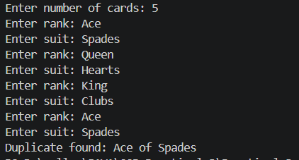

PROBLEM-3 : Fractions (Fraction.java + Driver.java)
(a) Create class Fraction with private int num, den.
(b) In the constructor, reduce to lowest terms: compute g = gcd(num, den) and divide
both by g.
(c) Override toString() to return num + “/” + den.
(d) Override equals()/hashCode() using the reduced num and den.
(e) In Driver.main: create several equivalent fractions (1/2, 2/4, 3/6) and confirm they
are all equal and print the same.
Expected output: new Fraction(2,4) prints “1/2” and equals new Fraction(1,2).

CODE : Fraction.java

import java.util.Objects;

public class Fraction {
private int num;
private int den;
public Fraction(int num, int den) {
if (den == 0) {
throw new IllegalArgumentException("Denominator cannot be zero.");
}

int g = gcd(Math.abs(num), Math.abs(den));

this.num = num / g;
this.den = den / g;

// Keep denominator positive
if (this.den < 0) {
this.num = -this.num;
this.den = -this.den;
}
}

private int gcd(int a, int b) {
while (b != 0) {
int temp = b;
b = a % b;
a = temp;
}
return a;
}
@Override
public String toString() {
return num + "/" + den;
}

@Override
public boolean equals(Object obj) {
if (this == obj)
return true;
if (!(obj instanceof Fraction))
return false;

Fraction f = (Fraction) obj;
return num == f.num && den == f.den;
}

@Override
public int hashCode() {
return Objects.hash(num, den);
}
}

CODE : Driver.java
import java.util.Scanner;
public class Driver {
public static void main(String[] args) {
Scanner sc = new Scanner(System.in);

System.out.print("Enter numerator of first fraction: ");
int n1 = sc.nextInt();
System.out.print("Enter denominator of first fraction: ");
int d1 = sc.nextInt();

System.out.print("Enter numerator of second fraction: ");
int n2 = sc.nextInt();
System.out.print("Enter denominator of second fraction: ");
int d2 = sc.nextInt();

System.out.print("Enter numerator of third fraction: ");
int n3 = sc.nextInt();
System.out.print("Enter denominator of third fraction: ");
int d3 = sc.nextInt();

Fraction f1 = new Fraction(n1, d1);
Fraction f2 = new Fraction(n2, d2);
Fraction f3 = new Fraction(n3, d3);

System.out.println("\nFractions after reduction:");
System.out.println("Fraction 1: " + f1);
System.out.println("Fraction 2: " + f2);
System.out.println("Fraction 3: " + f3);

System.out.println("\nEquality Check:");
System.out.println("f1 equals f2: " + f1.equals(f2));
System.out.println("f2 equals f3: " + f2.equals(f3));
System.out.println("f1 equals f3: " + f1.equals(f3));

sc.close();
}
}

OUTPUT :

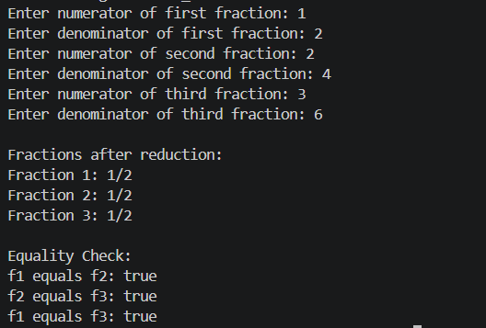

Key Questions :

1. Why must equals() and hashCode() be overridden together?
Answer:
If two objects are equal according to equals(), they must return the same hash code. Overriding both methods ensures correct behavior in hash-based collections such as HashSet and HashMap.

2. What does the default Object.toString() return, and why override it?
Answer:
The default Object.toString() returns the class name followed by the object's hash code in hexadecimal (for example, Point@1a2b3c). We override it to provide a meaningful and human-readable representation of the object's data.

3. What is the difference between a static nested class and an inner class?
Answer:
A static nested class belongs to the outer class and can be created without an object of the outer class. It can access only the static members of the outer class. An inner class is associated with an instance of the outer class, requires an outer class object to be created, and can access both instance and static members of the outer class.

