Subject: | OOP-JAVA
Name: | Romil Gabani
ID No.: | 25AIML012

Practical-1
GIT REPOSITRY LINK :
https://github.com/romilgabani19/JAVA-Practical

Part A
PROBLEM-1 : Vending machine (VendingMachine.java, main in this file)
(a) Define an enum Coin with constants ONE, TWO, FIVE, TEN.
(b) In main, set a snack price of 15 and a running total of 0; create a Scanner.
(c) Loop: read a coin name, use a switch expression to convert the Coin to its value
(ONE→1, TWO→2, FIVE→5, TEN→10), add it to the total, and print the total so
far.
(d) Stop the loop once the total reaches 15 or more.
(e) Print the change to return (total − 15).
Expected output: TEN then FIVE prints “Paid. Change: 0”; TEN then TEN prints
“Paid. Change: 5”.

CODE :

import java.util.Scanner;

public class VendingMachine {

// (a) Define enum Coin
enum Coin {
ONE, TWO, FIVE, TEN
}

public static void main(String[] args) {

// (b) Snack price and running total
final int PRICE = 15;
int total = 0;

Scanner sc = new Scanner(System.in);

// (c) Loop until enough money is inserted
while (total < PRICE) {
System.out.print("Insert coin (ONE, TWO, FIVE, TEN): ");
String input = sc.next().toUpperCase();

Coin coin = Coin.valueOf(input);

int value = switch (coin) {
case ONE -> 1;
case TWO -> 2;
case FIVE -> 5;
case TEN -> 10;
};

total += value;
System.out.println("Total so far: " + total);
}

// (e) Print change
System.out.println("Paid. Change: " + (total - PRICE));

sc.close();
}
}

OUTPUT :

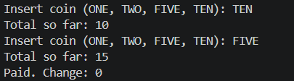

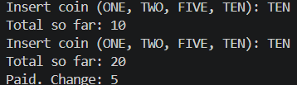

PROBLEM-2 : Toll booth (TollBooth.java, main in this file)
(a) Define a record Vehicle(String number, String type).
(b) In main, keep a running toll total and three counters (bike, car, truck).
(c) Loop until the user types “done” for the number: build a Vehicle, use a switch
expression on its type for the toll (bike→20, car→50, truck→150), add to the total,
and increment that type’s counter.
(d) After the loop, print the total toll and the type with the highest count.
Expected output: two cars + one bike → “Total toll: 120”, “Most frequent: car”.

CODE :

import java.util.Scanner;

public class TollBooth {

// (a) Define record Vehicle
record Vehicle(String number, String type) {}

public static void main(String[] args) {

Scanner sc = new Scanner(System.in);

// (b) Running total and counters
int totalToll = 0;
int bikeCount = 0;
int carCount = 0;
int truckCount = 0;

while (true) {

System.out.print("Enter vehicle number (or done to finish): ");
String number = sc.next();

if (number.equalsIgnoreCase("done")) {
break;
}

System.out.print("Enter vehicle type (bike/car/truck): ");
String type = sc.next().toLowerCase();

Vehicle vehicle = new Vehicle(number, type);

// (c) Switch expression for toll
int toll = switch (vehicle.type()) {
case "bike" -> {
bikeCount++;
yield 20;
}
case "car" -> {
carCount++;
yield 50;
}
case "truck" -> {
truckCount++;
yield 150;
}
default -> {
System.out.println("Invalid vehicle type!");
yield 0;
}
};

totalToll += toll;
}

// (d) Find most frequent type
String mostFrequent;

if (bikeCount >= carCount && bikeCount >= truckCount) {
mostFrequent = "bike";
} else if (carCount >= bikeCount && carCount >= truckCount) {
mostFrequent = "car";
} else {
mostFrequent = "truck";
}

System.out.println("\nTotal toll: " + totalToll);
System.out.println("Most frequent: " + mostFrequent);

sc.close();
}
}

OUTPUT :

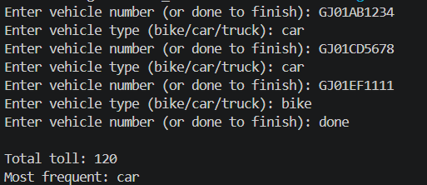

PROBLEM-3 : Rock-Paper-Scissors-Lizard-Spock (RPSLS.java)
(a) Define an enum Move with ROCK, PAPER, SCISSORS, LIZARD, SPOCK.
(b) Write winner(Move a, Move b) returning 1 if a beats b, -1 if b beats a, 0 for a tie —
use a switch expression listing what each move beats (Scissors cut Paper, Paper
covers Rock, Rock crushes Lizard, Lizard poisons Spock, Spock smashes Scissors,
and the five mirror cases).
(c) In main, play 5 rounds: pick a random computer Move, read the player’s Move, call
winner(), print the round result and keep score.
(d) After 5 rounds, print the overall winner.
Expected output: each round prints both moves and the round winner; ends with a
“You win 3–2” summary.

CODE :

import java.util.Random;
import java.util.Scanner;

public class RPSLS {

// (a) Define enum
enum Move {
ROCK, PAPER, SCISSORS, LIZARD, SPOCK
}

// (b) Method to determine winner
public static int winner(Move a, Move b) {

if (a == b) {
return 0;
}

return switch (a) {
case ROCK ->
(b == Move.SCISSORS || b == Move.LIZARD) ? 1 : -1;

case PAPER ->
(b == Move.ROCK || b == Move.SPOCK) ? 1 : -1;

case SCISSORS ->
(b == Move.PAPER || b == Move.LIZARD) ? 1 : -1;

case LIZARD ->
(b == Move.SPOCK || b == Move.PAPER) ? 1 : -1;

case SPOCK ->
(b == Move.SCISSORS || b == Move.ROCK) ? 1 : -1;
};
}

public static void main(String[] args) {

Scanner sc = new Scanner(System.in);
Random random = new Random();

int playerScore = 0;
int computerScore = 0;

Move[] moves = Move.values();

// (c) Play 5 rounds
for (int round = 1; round <= 5; round++) {

System.out.println("\nRound " + round);
System.out.print("Enter your move (ROCK, PAPER, SCISSORS, LIZARD, SPOCK): ");

Move player = Move.valueOf(sc.next().toUpperCase());
Move computer = moves[random.nextInt(moves.length)];

int result = winner(player, computer);

System.out.println("You: " + player);
System.out.println("Computer: " + computer);

if (result == 1) {
System.out.println("You win this round!");
playerScore++;
} else if (result == -1) {
System.out.println("Computer wins this round!");
computerScore++;
} else {
System.out.println("Round is a tie!");
}
}

// (d) Print overall winner
System.out.println("\nFinal Score");
System.out.println("You: " + playerScore);
System.out.println("Computer: " + computerScore);

if (playerScore > computerScore) {
System.out.println("You win " + playerScore + "–" + computerScore + "!");
} else if (computerScore > playerScore) {
System.out.println("Computer wins " + computerScore + "–" + playerScore + "!");
} else {
System.out.println("The game is a tie!");
}

sc.close();
}
}

OUTPUT :

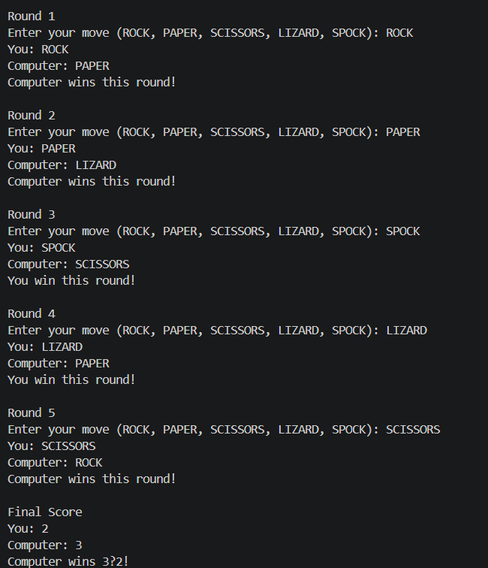

Key Questions :

1. What is the role of the JVM, and what file does the javac compiler produce?
Ans :
- JVM (Java Virtual Machine): The JVM runs Java programs by executing bytecode, making Java platform-independent (“Write Once, Run Anywhere”).
- javac compiler: It compiles a Java source file (.java) into a bytecode file (.class).

2. How does a switch expression differ from a traditional switch statement?
Ans:
- A traditional switch statement uses case: labels and usually requires break statements.
- A switch expression uses case -> syntax, does not require break, and can return a value directly.
- Switch expressions are shorter, cleaner, and less error-prone.

3. Why is an enum a good choice for a fixed set of menu options, and a record for read-only
data?
Ans :
- enum: It represents a fixed set of constants, making the code safer, more readable, and preventing invalid values.
- record: It is used for read-only (immutable) data and automatically provides a constructor, accessor methods, toString(), equals(), and hashCode(), reducing boilerplate code.

