Subject: | OOP-JAVA
Name: | Romil Gabani
ID No.: | 25AIML012

Practical-2
GIT REPOSITRY LINK :
https://github.com/romilgabani19/JAVA-Practical

Part A

PROBLEM-1 : Smart thermostat (Thermostat.java, main in this file)
(a) Create class Thermostat with private String location, private int temperature, private
static final int MIN=16 and MAX=30, and private static int activeCount=0.
(b) Constructor(location, startTemp): store location; set temperature to startTemp if it is
within MIN..MAX else 22; increment activeCount.
(c) Constructor(location): chain with this(location, 22).
(d) raise(): if temperature < MAX add 1, else print “Already at maximum (30)”.
(e) lower(): if temperature > MIN subtract 1, else print “Already at minimum (16)”.
(f) Add getTemperature() (no setter) and static getActiveCount().
(g) In main: create two thermostats, call raise() 10 times then lower() 20 times in loops
(printing the temperature each time), then print getActiveCount().
Expected output: temperature rises to 30 then “Already at maximum”, falls to 16
then “Already at minimum”, count 2.

CODE :

public class Thermostat {

// Private data members
private String location;
private int temperature;

// Constants
private static final int MIN = 16;
private static final int MAX = 30;

// Static variable
private static int activeCount = 0;

// Constructor with location and start temperature
public Thermostat(String location, int startTemp) {
this.location = location;

if (startTemp >= MIN && startTemp <= MAX) {
this.temperature = startTemp;
} else {
this.temperature = 22;
}

activeCount++;
}

// Constructor with only location
public Thermostat(String location) {
this(location, 22);
}

// Raise temperature
public void raise() {
if (temperature < MAX) {
temperature++;
} else {
System.out.println("Already at maximum (30)");
}
}

// Lower temperature
public void lower() {
if (temperature > MIN) {
temperature--;
} else {
System.out.println("Already at minimum (16)");
}
}

// Getter for temperature
public int getTemperature() {
return temperature;
}

// Static getter for active count
public static int getActiveCount() {
return activeCount;
}

// Main method
public static void main(String[] args) {

Thermostat t1 = new Thermostat("Living Room");
Thermostat t2 = new Thermostat("Bedroom", 25);

System.out.println("Raising temperature:");

for (int i = 0; i < 10; i++) {
t1.raise();
System.out.println("Temperature: " + t1.getTemperature());
}

System.out.println("\nLowering temperature:");

for (int i = 0; i < 20; i++) {
t1.lower();
System.out.println("Temperature: " + t1.getTemperature());
}

System.out.println("\nActive Thermostats: " + Thermostat.getActiveCount());
}
}

OUTPUT :
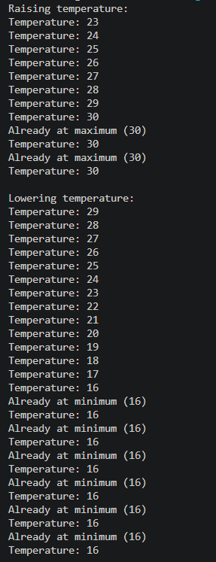
PROBLEM-2 : Cinema show (CinemaShow.java, main in this file)
(a) Create class CinemaShow with private String title, private int seatsAvailable, private
final int capacity, and private static int totalBooked=0.
(b) Constructor(title, capacity): set both and seatsAvailable = capacity.
Constructor(title): chain with this(title, 100).
(c) book(int n): if n ≤ seatsAvailable, reduce seatsAvailable by n, add n to totalBooked,
return true; else return false unchanged.
(d) cancel(int n): increase seatsAvailable by n but never above capacity.
(e) Add getSeatsAvailable() and static getTotalBooked().
(f) In main: run a sequence of book and cancel calls, printing the result and seats after
each, then print getTotalBooked().
Expected output: booking more than available prints false and leaves seats
unchanged; totalBooked equals the successful bookings.

CODE :

public class CinemaShow {

// Private data members
private String title;
private int seatsAvailable;
private final int capacity;

// Static variable
private static int totalBooked = 0;

// Constructor with title and capacity
public CinemaShow(String title, int capacity) {
this.title = title;
this.capacity = capacity;
this.seatsAvailable = capacity;
}

// Constructor with only title
public CinemaShow(String title) {
this(title, 100);
}

// Book seats
public boolean book(int n) {
if (n <= seatsAvailable) {
seatsAvailable -= n;
totalBooked += n;
return true;
}
return false;
}

// Cancel seats
public void cancel(int n) {
seatsAvailable += n;
if (seatsAvailable > capacity) {
seatsAvailable = capacity;
}
}

// Getter for available seats
public int getSeatsAvailable() {
return seatsAvailable;
}

// Static getter for total booked seats
public static int getTotalBooked() {
return totalBooked;
}

// Main method
public static void main(String[] args) {

CinemaShow show = new CinemaShow("Avengers", 50);

System.out.println("Book 20: " + show.book(20));
System.out.println("Seats Available: " + show.getSeatsAvailable());

System.out.println("Book 25: " + show.book(25));
System.out.println("Seats Available: " + show.getSeatsAvailable());

System.out.println("Book 10: " + show.book(10)); // Not enough seats
System.out.println("Seats Available: " + show.getSeatsAvailable());

show.cancel(15);
System.out.println("After Cancel 15 Seats: " + show.getSeatsAvailable());

System.out.println("Book 10: " + show.book(10));
System.out.println("Seats Available: " + show.getSeatsAvailable());

System.out.println("Total Booked Seats: " + CinemaShow.getTotalBooked());
}
}
OUTPUT :

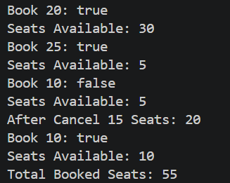

PROBLEM-3 : Parking lot (ParkingLot.java)
(a) Create class ParkingLot with private int twoWheelers and fourWheelers, private final
int twoCap and fourCap, and private static long revenue=0.
(b) park(String type): for “two”, if twoWheelers < twoCap increment and add 20 to
revenue; for “four”, if fourWheelers < fourCap increment and add 40; otherwise print
“Full” and reject.
(c) leave(String type): decrement the matching count but never below 0.
(d) In main: simulate a sequence of park/leave events, printing each outcome, then print
final occupancy and revenue.
Expected output: parking into a full section is refused; revenue = 20×(two parked)
+ 40×(four parked).
CODE :

public class ParkingLot {

// Private data members
private int twoWheelers;
private int fourWheelers;

// Final capacities
private final int twoCap;
private final int fourCap;

// Static revenue
private static long revenue = 0;

// Constructor
public ParkingLot(int twoCap, int fourCap) {
this.twoCap = twoCap;
this.fourCap = fourCap;
this.twoWheelers = 0;
this.fourWheelers = 0;
}

// Park vehicle
public void park(String type) {
if (type.equalsIgnoreCase("two")) {
if (twoWheelers < twoCap) {
twoWheelers++;
revenue += 20;
System.out.println("Two-wheeler parked.");
} else {
System.out.println("Full");
}
} else if (type.equalsIgnoreCase("four")) {
if (fourWheelers < fourCap) {
fourWheelers++;
revenue += 40;
System.out.println("Four-wheeler parked.");
} else {
System.out.println("Full");
}
} else {
System.out.println("Invalid vehicle type.");
}
}

// Vehicle leaves
public void leave(String type) {
if (type.equalsIgnoreCase("two")) {
if (twoWheelers > 0) {
twoWheelers--;
System.out.println("Two-wheeler left.");
}
} else if (type.equalsIgnoreCase("four")) {
if (fourWheelers > 0) {
fourWheelers--;
System.out.println("Four-wheeler left.");
}
}
}

// Main method
public static void main(String[] args) {

ParkingLot lot = new ParkingLot(2, 2);

lot.park("two");
lot.park("two");
lot.park("two"); // Full

lot.park("four");
lot.park("four");
lot.park("four"); // Full

lot.leave("two");
lot.leave("four");

lot.park("two");
lot.park("four");

System.out.println("\nFinal Occupancy:");
System.out.println("Two-Wheelers: " + lot.twoWheelers);
System.out.println("Four-Wheelers: " + lot.fourWheelers);

System.out.println("Total Revenue: ₹" + ParkingLot.revenue);
}
}
OUTPUT :

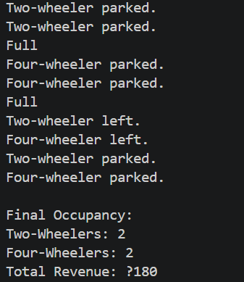

Key Questions :

1. What is encapsulation, and how do private fields with public getters enforce it?
Ans :
- Encapsulation is the OOP principle of hiding an object’s data and allowing access only through controlled methods. Private fields cannot be accessed directly from outside the class. Public getters provide read-only access and protect the data from unauthorized modification.

2. Why is accountNumber declared final?
Ans:
- accountNumber is declared final because it should never change after the object is created. The final keyword makes it immutable and ensures each account has a permanent unique account number.

3. What is the difference between a static field and an instance field when generating ids?
Ans :
- A static field is shared by all objects of a class and is used to maintain a common counter for generating unique IDs. An instance field belongs to each object separately, so using it for ID generation would produce duplicate IDs instead of unique ones.

