Subject: | OOP-JAVA
Name: | Romil Gabani
ID No.: | 25AIML012

Practical-6
GIT REPOSITRY LINK :
https://github.com/romilgabani19/JAVA-Practical

Part A
PROBLEM-1 :
Remote control: an interface Switchable with on()/off() and a default toggle(); Fan and Light implement it. Loop over a Switchable[] toggling each. Then add a functional interface that decides, given a device and an hour, whether it may switch on, and supply it once as an anonymous class and once as a lambda.

CODE :

public class RemoteControlDemo {

// Functional interface for controlling whether a device may switch on
@FunctionalInterface
interface SwitchPermission {
boolean maySwitchOn(Switchable device, int hour);
}

// Interface for switchable devices
interface Switchable {
void on();
void off();

// Default method
default void toggle() {
off();
on();
}
}

// Fan implementation
static class Fan implements Switchable {
@Override
public void on() {
System.out.println("Fan is ON");
}

@Override
public void off() {
System.out.println("Fan is OFF");
}
}

// Light implementation
static class Light implements Switchable {
@Override
public void on() {
System.out.println("Light is ON");
}

@Override
public void off() {
System.out.println("Light is OFF");
}
}

public static void main(String[] args) {

Fan fan = new Fan();
Light light = new Light();

// Array of Switchable devices
Switchable[] devices = { fan, light };

// Toggle each device
System.out.println("Toggling devices:");
for (Switchable device : devices) {
device.toggle();
}

// Functional interface using anonymous class
SwitchPermission anonymousPermission = new SwitchPermission() {
@Override
public boolean maySwitchOn(Switchable device, int hour) {
return hour >= 18 && hour <= 22;
}
};

// Functional interface using lambda
SwitchPermission lambdaPermission =
(device, hour) -> hour >= 6 && hour <= 10;

int hour = 20;

System.out.println("\nUsing anonymous class:");
System.out.println(
"Can Fan switch on at " + hour + ":00? "
+ anonymousPermission.maySwitchOn(fan, hour)
);

System.out.println("\nUsing lambda:");
System.out.println(
"Can Light switch on at " + hour + ":00? "
+ lambdaPermission.maySwitchOn(light, hour)
);
}
}

OUTPUT :

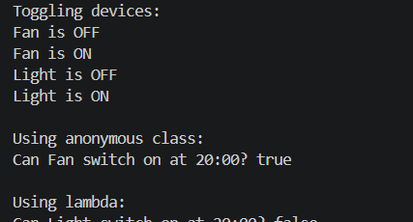

PROBLEM-2 :
Notification senders: a functional interface Notifier with send(String); make email and SMS senders as lambdas, hold them in an array, and broadcast one message through all. Add a marker interface Urgent and send twice for senders marked urgent.

CODE :

public class NotificationDemo {

// Functional interface
@FunctionalInterface
interface Notifier {
void send(String message);
}

// Marker interface
interface Urgent {
}

// Wrapper class to associate a notifier with urgency
static class NotificationSender {
Notifier notifier;
boolean urgent;

NotificationSender(Notifier notifier, boolean urgent) {
this.notifier = notifier;
this.urgent = urgent;
}
}

public static void main(String[] args) {

// Email sender as a lambda
Notifier email = message ->
System.out.println("Email: " + message);

// SMS sender as a lambda
Notifier sms = message ->
System.out.println("SMS: " + message);

/*
-> Hold the senders in an array.
-> Email is marked urgent, SMS is not.
*/
NotificationSender[] senders = {
new NotificationSender(email, true),
new NotificationSender(sms, false)
};

String message = "Server maintenance at 10 PM.";

// Broadcast the message
for (NotificationSender sender : senders) {
sender.notifier.send(message);

// Urgent senders send twice
if (sender.urgent) {
sender.notifier.send(message);
}
}
}
}

OUTPUT :

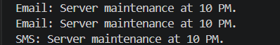

PROBLEM-3 :
Build a small discount engine where each rule is a lambda the user picks at runtime and applies to a list of prices; organise it into packages and ship it as a runnable JAR.

CODE :

package discount;

@FunctionalInterface
public interface DiscountRule {
double apply(double price);
}
package app;

import discount.DiscountRule;
import java.util.*;

public class Main {

public static void main(String[] args) {

Scanner sc = new Scanner(System.in);

List<Double> prices = Arrays.asList(
500.0,
1000.0,
1500.0,
2000.0
);

System.out.println("===== Discount Engine =====");
System.out.println("1. 10% Discount");
System.out.println("2. 20% Discount");
System.out.println("3. Flat Rs. 100 Discount");

System.out.print("Choose discount rule: ");
int choice = sc.nextInt();

DiscountRule rule;

switch (choice) {

case 1:
rule = price -> price * 0.90;
break;

case 2:
rule = price -> price * 0.80;
break;

case 3:
rule = price -> Math.max(0, price - 100);
break;

default:
System.out.println("Invalid choice");
sc.close();
return;
}

System.out.println("\nOriginal Prices:");

for (double price : prices) {
System.out.println("Rs. " + price);
}

System.out.println("\nPrices After Discount:");

for (double price : prices) {
double finalPrice = rule.apply(price);
System.out.println("Rs. " + finalPrice);
}

sc.close();
}
}

OUTPUT :

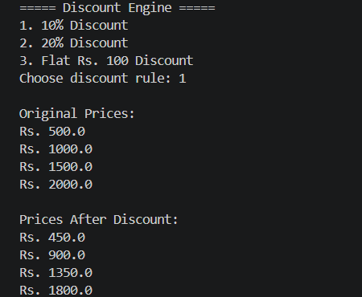

Key Questions :

- What is the difference between an abstract class and a concrete class?
Answer:
- Interface: It defines what a class should do. A class can implement multiple interfaces.
- Abstract Class: It provides common methods and properties to related classes. A class can extend only one abstract class.

- What is dynamic method dispatch (run-time polymorphism)?
Answer:
- A functional interface is an interface that has only one abstract method.
- A lambda expression provides a short implementation of that method.
- interface Add {
int sum(int a, int b);
}
Add obj = (a, b) -> a + b;

- What does the super keyword do in a subclass constructor?
Answer:
- A default method has a ready-made implementation inside an interface.
- It is useful because implementing classes can use the method directly without implementing it again.
- default void hello() {
System.out.println("Hello");
}

