Subject: | OOP-JAVA
Name: | Romil Gabani
ID No.: | 25AIML012

Practical-10
GIT REPOSITRY LINK :
https://github.com/romilgabani19/JAVA-Practical

Part A
PROBLEM-1 :
Thread-pool runner: with a fixed pool of 3 (ExecutorService), submit about 10 Runnable tasks that print their id and sleep briefly; shut down and await completion, observing the few threads being reused.

CODE :

import java.util.Scanner;
import java.util.concurrent.ExecutorService;
import java.util.concurrent.Executors;
import java.util.concurrent.TimeUnit;

public class ThreadPoolRunner {
public static void main(String[] args) throws Exception {
Scanner sc = new Scanner(System.in);

System.out.print("Enter number of tasks: ");
int tasks = sc.nextInt();

ExecutorService pool = Executors.newFixedThreadPool(3);

for (int i = 1; i <= tasks; i++) {
final int id = i;

pool.submit(() -> {
System.out.println("Task " + id + " running on "
+ Thread.currentThread().getName());

try {
Thread.sleep(500);
} catch (InterruptedException e) {
Thread.currentThread().interrupt();
}

System.out.println("Task " + id + " completed");
});
}

pool.shutdown();
pool.awaitTermination(1, TimeUnit.MINUTES);

System.out.println("All tasks completed.");
sc.close();
}
}
}

OUTPUT :
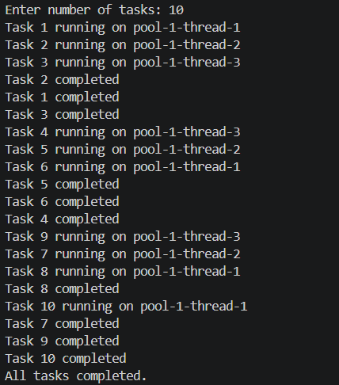

PROBLEM-2 :
Producer–consumer: one thread adds numbers to a small shared buffer and another removes them, coordinated with wait()/notify(); produce and consume a fixed number of items in order with none lost.

CODE :

import java.util.LinkedList;
import java.util.Queue;
import java.util.Scanner;

class Buffer {
private Queue<Integer> queue = new LinkedList<>();
private int capacity;

Buffer(int capacity) {
this.capacity = capacity;
}

public synchronized void produce(int value) throws InterruptedException {
while (queue.size() == capacity) {
wait();
}

queue.add(value);
System.out.println("Produced: " + value);

notify();
}

public synchronized int consume() throws InterruptedException {
while (queue.isEmpty()) {
wait();
}

int value = queue.remove();
System.out.println("Consumed: " + value);

notify();
return value;
}
}

public class ProducerConsumer {
public static void main(String[] args) throws Exception {
Scanner sc = new Scanner(System.in);

System.out.print("Enter buffer size: ");
int capacity = sc.nextInt();

System.out.print("Enter number of items: ");
int items = sc.nextInt();

Buffer buffer = new Buffer(capacity);

Thread producer = new Thread(() -> {
try {
for (int i = 1; i <= items; i++) {
buffer.produce(i);
}
} catch (InterruptedException e) {
Thread.currentThread().interrupt();
}
});

Thread consumer = new Thread(() -> {
try {
for (int i = 1; i <= items; i++) {
buffer.consume();
}
} catch (InterruptedException e) {
Thread.currentThread().interrupt();
}
});

producer.start();
consumer.start();

producer.join();
consumer.join();

System.out.println("All items produced and consumed.");
sc.close();
}
}

OUTPUT :
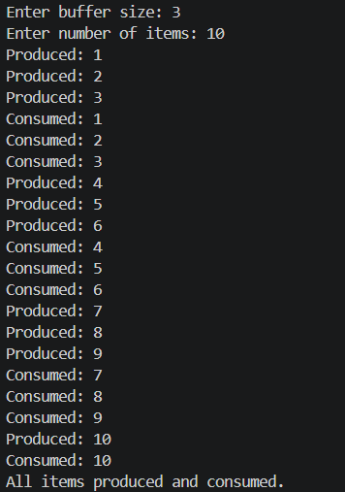

PROBLEM-3 :
Reproduce a deadlock between two threads that lock two objects in opposite order, then remove it with a consistent lock order. Choose the scenario yourself.

CODE :

import java.util.Scanner;

public class DeadlockDemo {

static final Object lock1 = new Object();
static final Object lock2 = new Object();

static void createDeadlock() {
Thread t1 = new Thread(() -> {
synchronized (lock1) {
System.out.println("Thread 1 locked Lock 1");

try {
Thread.sleep(100);
} catch (InterruptedException e) {
Thread.currentThread().interrupt();
}

synchronized (lock2) {
System.out.println("Thread 1 locked Lock 2");
}
}
});

Thread t2 = new Thread(() -> {
synchronized (lock2) {
System.out.println("Thread 2 locked Lock 2");

try {
Thread.sleep(100);
} catch (InterruptedException e) {
Thread.currentThread().interrupt();
}

synchronized (lock1) {
System.out.println("Thread 2 locked Lock 1");
}
}
});

t1.start();
t2.start();

System.out.println("Deadlock created: both threads may wait forever.");
}

static void avoidDeadlock() throws InterruptedException {
Thread t1 = new Thread(() -> {
synchronized (lock1) {
synchronized (lock2) {
System.out.println("Thread 1 completed.");
}
}
});

Thread t2 = new Thread(() -> {
synchronized (lock1) {
synchronized (lock2) {
System.out.println("Thread 2 completed.");
}
}
});

t1.start();
t2.start();

t1.join();
t2.join();

System.out.println("No deadlock. Both threads used the same lock order.");
}

public static void main(String[] args) throws Exception {
Scanner sc = new Scanner(System.in);

System.out.println("1. Create Deadlock");
System.out.println("2. Avoid Deadlock");
System.out.print("Enter choice: ");

int choice = sc.nextInt();

if (choice == 1) {
createDeadlock();
} else if (choice == 2) {
avoidDeadlock();
} else {
System.out.println("Invalid choice.");
}

sc.close();
}
}

OUTPUT :
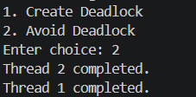
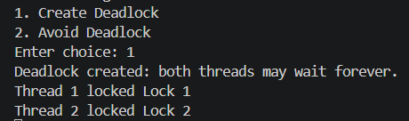

Key Questions :

- Why is a thread pool better than creating a new thread per task?
Answer:
- Thread Pool: It reuses a fixed number of threads, reducing overhead and improving performance compared to creating a new thread for every task.

- How do wait() and notify() coordinate two threads?
Answer:
- wait() and notify(): wait() makes a thread pause and release the lock, while notify() wakes a waiting thread when the resource is available.

- What causes a deadlock, and how does consistent lock ordering prevent it?
Answer:
- Deadlock: It occurs when threads wait for each other’s locks. Consistent lock ordering prevents it because all threads acquire locks in the same order.

