Subject: | OOP-JAVA
Name: | Romil Gabani
ID No.: | 25AIML012

Practical-8
GIT REPOSITRY LINK :
https://github.com/romilgabani19/JAVA-Practical

Part A
PROBLEM-1 :
Form validator: define @NotBlank and @MaxLength(int) for fields and annotate a SignupForm. Write a checker that uses reflection to read each field’s annotations and returns the list of validation errors for a given object.

CODE :

import java.lang.annotation.*;
import java.lang.reflect.Field;
import java.util.ArrayList;
import java.util.List;
import java.util.Scanner;

// @NotBlank annotation
@Retention(RetentionPolicy.RUNTIME)
@Target(ElementType.FIELD)
@interface NotBlank {
}

// @MaxLength annotation
@Retention(RetentionPolicy.RUNTIME)
@Target(ElementType.FIELD)
@interface MaxLength {
int value();
}

// SignupForm class
class SignupForm {

@NotBlank
@MaxLength(20)
String name;

@NotBlank
@MaxLength(30)
String email;

@NotBlank
@MaxLength(15)
String password;

SignupForm(String name, String email, String password) {
this.name = name;
this.email = email;
this.password = password;
}
}

// Validator class
class FormChecker {

public static List<String> validate(Object obj) {

List<String> errors = new ArrayList<>();

Class<?> clazz = obj.getClass();

for (Field field : clazz.getDeclaredFields()) {

field.setAccessible(true);

try {
Object value = field.get(obj);
String text = value == null ? "" : value.toString();

// Check @NotBlank
if (field.isAnnotationPresent(NotBlank.class)) {

if (text.trim().isEmpty()) {
errors.add(field.getName() + " must not be blank");
}
}

// Check @MaxLength
if (field.isAnnotationPresent(MaxLength.class)) {

MaxLength annotation =
field.getAnnotation(MaxLength.class);

int max = annotation.value();

if (text.length() > max) {
errors.add(field.getName()
+ " must not exceed "
+ max + " characters");
}
}

} catch (IllegalAccessException e) {
errors.add("Error reading field: " + field.getName());
}
}

return errors;
}
}

// Main class
public class FormValidator {

public static void main(String[] args) {

Scanner sc = new Scanner(System.in);

System.out.println("===== Signup Form =====");

System.out.print("Enter Name: ");
String name = sc.nextLine();

System.out.print("Enter Email: ");
String email = sc.nextLine();

System.out.print("Enter Password: ");
String password = sc.nextLine();

SignupForm form = new SignupForm(name, email, password);

List<String> errors = FormChecker.validate(form);

System.out.println("\n===== Validation Result =====");

if (errors.isEmpty()) {
System.out.println("Form is valid!");
} else {
System.out.println("Form has errors:");

for (String error : errors) {
System.out.println("- " + error);
}
}

sc.close();
}
}

OUTPUT :

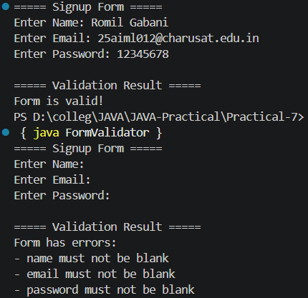

PROBLEM-2 :
Mini test runner: define a @Run annotation and mark some no-arg methods of a class with it. Use reflection to find and invoke only the @Run methods and report how many ran — the idea behind how JUnit finds @Test methods.

CODE :

import java.lang.annotation.*;
import java.lang.reflect.Method;
import java.util.Scanner;

// @Run annotation
@Retention(RetentionPolicy.RUNTIME)
@Target(ElementType.METHOD)
@interface Run {
}

// Class containing test methods
class MyTests {

@Run
public void testAddition() {
System.out.println("Test Addition: PASSED");
}

@Run
public void testSubtraction() {
System.out.println("Test Subtraction: PASSED");
}

public void normalMethod() {
System.out.println("This method should NOT run");
}

@Run
public void testMultiplication() {
System.out.println("Test Multiplication: PASSED");
}

public void anotherMethod() {
System.out.println("This method should NOT run");
}
}

// Mini test runner
public class MiniTestRunner {

public static void main(String[] args) {

Scanner sc = new Scanner(System.in);

System.out.print("Enter class name to run tests: ");
String className = sc.nextLine();

try {
// Find class using reflection
Class<?> clazz = Class.forName(className);

// Create object
Object object = clazz.getDeclaredConstructor().newInstance();

int count = 0;

System.out.println("\n===== Running Tests =====");

// Find all methods
for (Method method : clazz.getDeclaredMethods()) {

// Check @Run annotation
if (method.isAnnotationPresent(Run.class)
&& method.getParameterCount() == 0) {

System.out.println("Running: " + method.getName());

// Invoke method
method.invoke(object);

count++;
}
}

System.out.println("\n===== Test Result =====");
System.out.println("Total @Run methods executed: " + count);

} catch (Exception e) {
System.out.println("Error: " + e.getMessage());
}

sc.close();
}
}

OUTPUT :

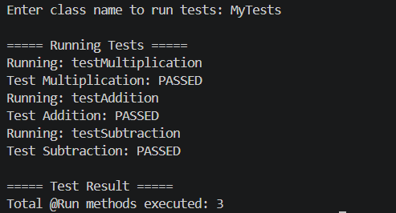

PROBLEM-3 :
Define a @Column(name) annotation and, by reflection, populate an object’s fields from a header row and a data row by matching column names; decide how to handle a missing column.

CODE :

import java.lang.annotation.*;
import java.lang.reflect.Field;
import java.util.Scanner;

// Column annotation
@Retention(RetentionPolicy.RUNTIME)
@Target(ElementType.FIELD)
@interface Column {
String name();
}

// Student class
class Student {

@Column(name = "id")
int id;

@Column(name = "name")
String name;

@Column(name = "email")
String email;

@Column(name = "age")
int age;

public void display() {
System.out.println("\n===== Student Details =====");
System.out.println("ID : " + id);
System.out.println("Name : " + name);
System.out.println("Email : " + email);
System.out.println("Age : " + age);
}
}

// Mapper class
class ColumnMapperUtil {

public static void populate(
Object object,
String[] headers,
String[] data) throws Exception {

Class<?> clazz = object.getClass();

// Check each field
for (Field field : clazz.getDeclaredFields()) {

if (!field.isAnnotationPresent(Column.class)) {
continue;
}

Column column = field.getAnnotation(Column.class);
String columnName = column.name();

// Find matching header
int index = -1;

for (int i = 0; i < headers.length; i++) {

if (headers[i].equalsIgnoreCase(columnName)) {
index = i;
break;
}
}

// Missing column handling
if (index == -1) {
System.out.println(
"Missing column: " + columnName);
continue;
}

// Make field accessible
field.setAccessible(true);

String value = data[index];

// Convert data according to field type
if (field.getType() == int.class) {
field.setInt(object, Integer.parseInt(value));
}
else if (field.getType() == String.class) {
field.set(object, value);
}
}
}
}

// Main class
public class ColumnMapper{

public static void main(String[] args) {

Scanner sc = new Scanner(System.in);

System.out.println("===== Column Mapper =====");

// Header input
System.out.print(
"Enter headers separated by comma: ");

String headerInput = sc.nextLine();

String[] headers = headerInput.split(",");

// Data input
System.out.print(
"Enter data separated by comma: ");

String dataInput = sc.nextLine();

String[] data = dataInput.split(",");

// Check same number of values
if (headers.length != data.length) {
System.out.println(
"Error: Number of headers and data values must match.");
sc.close();
return;
}

try {

Student student = new Student();

// Populate object using reflection
ColumnMapperUtil.populate(
student,
headers,
data
);

student.display();

} catch (Exception e) {

System.out.println(
"Error: " + e.getMessage());
}

sc.close();
}
}

OUTPUT :

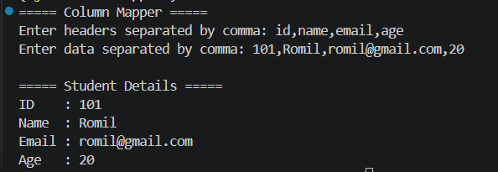

Key Questions :

- What are the meta-annotations @Retention and @Target used for?
Answer:
- @Retention specifies how long an annotation is available. @Target specifies where it can be used, such as fields or methods.

- What is reflection, and what does getDeclaredFields() return?
Answer:
- Reflection allows Java to inspect classes at runtime. getDeclaredFields() returns all fields declared in a class.

- How do annotations plus reflection let a framework validate any object?
Answer:
- Annotations define validation rules, and reflection reads those annotations and checks the object's fields automatically.

