Subject: | OOP-JAVA
Name: | Romil Gabani
ID No.: | 25AIML012

Practical-8
GIT REPOSITRY LINK :
https://github.com/romilgabani19/JAVA-Practical

Part A
PROBLEM-1 :
Guarded calculator: read two numbers and an operator; throw a custom DivideByZeroException and catch invalid-number input separately, printing a clear message each time; loop until a valid calculation succeeds and use finally to log each attempt.

CODE :

import java.util.Scanner;

class DivideByZeroException extends Exception {
public DivideByZeroException(String message) {
super(message);
}
}

public class GuardedCalculator {

static double calculate(double a, double b, char operator)
throws DivideByZeroException {

switch (operator) {
case '+':
return a + b;

case '-':
return a - b;

case '*':
return a * b;

case '/':
if (b == 0) {
throw new DivideByZeroException(
"Cannot divide by zero."
);
}
return a / b;

default:
throw new IllegalArgumentException(
"Invalid operator."
);
}
}

public static void main(String[] args) {

Scanner sc = new Scanner(System.in);
boolean success = false;

while (!success) {

try {
System.out.println("\nEnter first number:");
double num1 = Double.parseDouble(sc.nextLine());

System.out.println("Enter operator (+, -, *, /):");
char operator = sc.nextLine().charAt(0);

System.out.println("Enter second number:");
double num2 = Double.parseDouble(sc.nextLine());

double result = calculate(num1, num2, operator);

System.out.println("Result = " + result);

success = true;

} catch (NumberFormatException e) {
System.out.println(
"Invalid number input. Please enter valid numbers."
);

} catch (DivideByZeroException e) {
System.out.println("Error: " + e.getMessage());
} catch (IllegalArgumentException e) {
System.out.println("Error: " + e.getMessage());

} finally {
System.out.println("Attempt logged.");
}
}

sc.close();
System.out.println("Calculation completed successfully.");
}
}

OUTPUT :
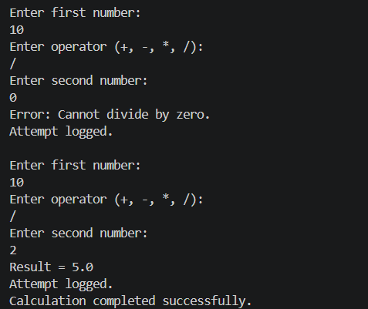
PROBLEM-2 :
Stock issue: a Warehouse where issue(item, qty) throws a custom checked OutOfStockException carrying the shortfall, and InvalidQuantityException for qty ≤ 0. Process a list of requests, catching and reporting each failure without stopping the run.

CODE :

import java.util.*;

class OutOfStockException extends Exception {

private int shortfall;

public OutOfStockException(String message, int shortfall) {
super(message);
this.shortfall = shortfall;
}

public int getShortfall() {
return shortfall;
}
}

class InvalidQuantityException extends Exception {

public InvalidQuantityException(String message) {
super(message);
}
}

class Warehouse {

private Map<String, Integer> stock = new HashMap<>();

public Warehouse() {
stock.put("Laptop", 5);
stock.put("Mouse", 10);
stock.put("Keyboard", 3);
}

public void issue(String item, int qty)
throws OutOfStockException, InvalidQuantityException {

// Check quantity
if (qty <= 0) {
throw new InvalidQuantityException(
"Quantity must be greater than zero."
);
}

if (!stock.containsKey(item)) {
throw new OutOfStockException(
"Item '" + item + "' is not available.",
qty
);
}

int available = stock.get(item);

// Check stock
if (qty > available) {

int shortfall = qty - available;

throw new OutOfStockException(
"Not enough stock for " + item +
". Available: " + available +
", Requested: " + qty,
shortfall
);
}

stock.put(item, available - qty);

System.out.println(
"Issued " + qty + " " + item +
"(s) successfully."
);
}
}

public class StockIssue {

public static void main(String[] args) {

Warehouse warehouse = new Warehouse();

// Requests: item and quantity
String[][] requests = {
{"Laptop", "2"},
{"Mouse", "15"},
{"Keyboard", "0"},
{"Keyboard", "2"},
{"Monitor", "1"},
{"Mouse", "3"}
};

for (String[] request : requests) {

String item = request[0];
int qty = Integer.parseInt(request[1]);

System.out.println(
"\nProcessing request: " +
item + " - " + qty
);

try {

warehouse.issue(item, qty);

} catch (OutOfStockException e) {

System.out.println(
"Out of stock: " + e.getMessage()
);

System.out.println(
"Shortfall: " + e.getShortfall()
);

} catch (InvalidQuantityException e) {

System.out.println(
"Invalid quantity: " + e.getMessage()
);
}
}

System.out.println("\nAll requests processed.");
}
}

OUTPUT :

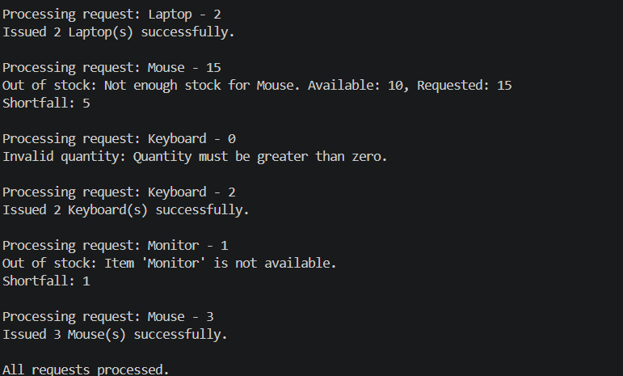

PROBLEM-3 :
Create an AutoCloseable resource and use try-withresources to prove it always closes — even when an exception is thrown inside the block — and that the original error is the one reported. Decide what to model as the resource.

CODE :

class DatabaseConnection implements AutoCloseable {

public DatabaseConnection() {
System.out.println("Database connection opened.");
}

public void execute() {
System.out.println("Executing database operation...");
throw new RuntimeException("Original database error!");
}

@Override
public void close() {
System.out.println("Database connection closed.");
}
}

public class AutoCloseableDemo {

public static void main(String[] args) {

try (DatabaseConnection db = new DatabaseConnection()) {

System.out.println("Inside try block.");

// This throws an exception
db.execute();

} catch (RuntimeException e) {

System.out.println("Caught error: " + e.getMessage());
}

System.out.println("Program continues normally.");
}
}

OUTPUT :

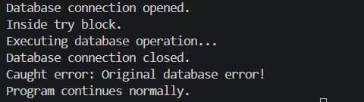

Key Questions :

- What is the difference between a checked and an unchecked exception?
Answer:
- Checked exceptions are checked at compile time and must be handled.
- Unchecked exceptions occur at runtime and do not have to be handled.
- Example: IOException (checked), NullPointerException (unchecked).

- What is the purpose of the finally block, and when does it run?
Answer:
- Used for cleanup code.
- It normally runs whether an exception occurs or not.

- How does try-with-resources guarantee a resource is closed?
Answer:
- Automatically closes resources that implement AutoCloseable.
- The resource is closed even if an exception occurs inside the try block.

