Subject: | OOP-JAVA
Name: | Romil Gabani
ID No.: | 25AIML012

Practical-9
GIT REPOSITRY LINK :
https://github.com/romilgabani19/JAVA-Practical

Part A
PROBLEM-1 :
Counter race: several threads each increment a shared counter many times. Run it without synchronization to watch the total come out too low, then make the increment synchronized and confirm it is exactly right every run.

CODE :

import java.util.Scanner;

class Counter {
int count = 0;

void increment() {
count++;
}

synchronized void synchronizedIncrement() {
count++;
}
}

public class CounterRace {
public static void main(String[] args) throws InterruptedException {
Scanner sc = new Scanner(System.in);

System.out.print("Enter number of threads: ");
int threads = sc.nextInt();

System.out.print("Enter increments per thread: ");
int increments = sc.nextInt();

Counter c1 = new Counter();

Thread[] t = new Thread[threads];

for (int i = 0; i < threads; i++) {
t[i] = new Thread(() -> {
for (int j = 0; j < increments; j++) {
c1.increment();
}
});
t[i].start();
}

for (Thread thread : t) {
thread.join();
}

int expected = threads * increments;

System.out.println("\nWithout synchronization:");
System.out.println("Expected count: " + expected);
System.out.println("Actual count: " + c1.count);

Counter c2 = new Counter();

for (int i = 0; i < threads; i++) {
t[i] = new Thread(() -> {
for (int j = 0; j < increments; j++) {
c2.synchronizedIncrement();
}
});
t[i].start();
}

for (Thread thread : t) {
thread.join();
}

System.out.println("\nWith synchronization:");
System.out.println("Expected count: " + expected);
System.out.println("Actual count: " + c2.count);

sc.close();
}
}

OUTPUT :
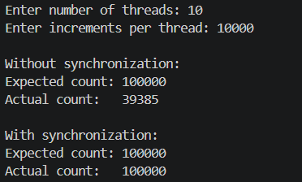
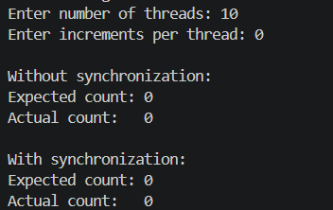
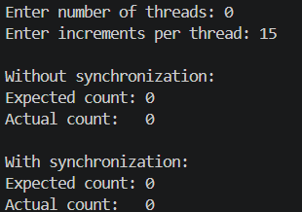

PROBLEM-2 :
Seat booking race: a shared seatsLeft of 5 with about 10 threads each trying to book one seat. Without synchronization show that more than 5 can succeed (oversell); with a synchronized book() exactly 5 do.

CODE :

import java.util.Scanner;

class Cinema {
int seatsLeft;

Cinema(int seats) {
seatsLeft = seats;
}

void book(String name) {
if (seatsLeft > 0) {
try {
Thread.sleep(10);
} catch (InterruptedException e) {
Thread.currentThread().interrupt();
}

seatsLeft--;
System.out.println(name + " booked a seat.");
} else {
System.out.println(name + " failed. No seat available.");
}
}

synchronized void synchronizedBook(String name) {
if (seatsLeft > 0) {
try {
Thread.sleep(10);
} catch (InterruptedException e) {
Thread.currentThread().interrupt();
}

seatsLeft--;
System.out.println(name + " booked a seat.");
} else {
System.out.println(name + " failed. No seat available.");
}
}
}

public class SeatBookingRace {
public static void main(String[] args) throws InterruptedException {
Scanner sc = new Scanner(System.in);

System.out.print("Enter number of seats: ");
int seats = sc.nextInt();

System.out.print("Enter number of booking threads: ");
int threads = sc.nextInt();

Cinema c1 = new Cinema(seats);
Thread[] t = new Thread[threads];

System.out.println("\n--- Without Synchronization ---");

for (int i = 0; i < threads; i++) {
final int id = i + 1;

t[i] = new Thread(() -> {
c1.book("User-" + id);
});

t[i].start();
}

for (Thread thread : t) {
thread.join();
}

System.out.println("Seats left: " + c1.seatsLeft);

Cinema c2 = new Cinema(seats);

System.out.println("\n--- With Synchronization ---");

for (int i = 0; i < threads; i++) {
final int id = i + 1;

t[i] = new Thread(() -> {
c2.synchronizedBook("User-" + id);
});

t[i].start();
}

for (Thread thread : t) {
thread.join();
}

System.out.println("Seats left: " + c2.seatsLeft);

sc.close();
}
}

OUTPUT :
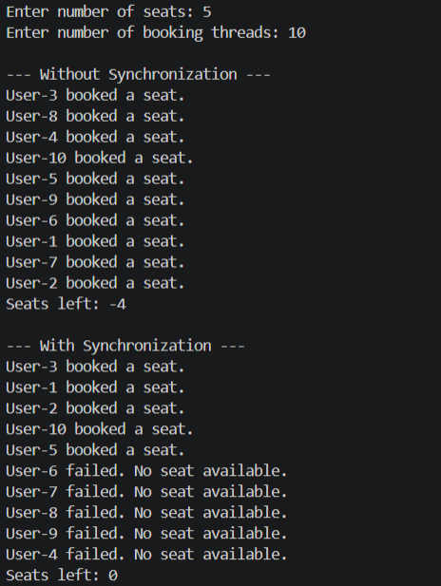

PROBLEM-3 :
Split a large array of numbers across several threads that add into one shared total, show the wrong result, then fix it two ways and compare; decide how to measure the difference.

CODE :

import java.util.Scanner;

class SharedTotal {
long total = 0;

void add(long value) {
total += value;
}

synchronized void synchronizedAdd(long value) {
total += value;
}
}

public class ArraySumRace {

public static void main(String[] args) throws InterruptedException {
Scanner sc = new Scanner(System.in);

System.out.print("Enter array size: ");
int size = sc.nextInt();

System.out.print("Enter number of threads: ");
int threads = sc.nextInt();

int[] arr = new int[size];

for (int i = 0; i < size; i++) {
arr[i] = i + 1;
}

long expected = ((long) size * (size + 1)) / 2;

System.out.println("\nExpected sum: " + expected);

// ---------------------------------
// Method 1: Without synchronization
// ---------------------------------

SharedTotal total1 = new SharedTotal();
Thread[] t = new Thread[threads];

int chunk = size / threads;

long start1 = System.nanoTime();

for (int i = 0; i < threads; i++) {
final int start = i * chunk;
final int end = (i == threads - 1) ? size : start + chunk;

t[i] = new Thread(() -> {
for (int j = start; j < end; j++) {
total1.add(arr[j]);
}
});

t[i].start();
}

for (Thread thread : t) {
thread.join();
}

long end1 = System.nanoTime();

System.out.println("\nWithout synchronization:");
System.out.println("Sum: " + total1.total);
System.out.println("Time: " + (end1 - start1) / 1_000_000.0 + " ms");

// ---------------------------------
// Method 2: synchronized
// ---------------------------------

SharedTotal total2 = new SharedTotal();

long start2 = System.nanoTime();

for (int i = 0; i < threads; i++) {
final int start = i * chunk;
final int end = (i == threads - 1) ? size : start + chunk;

t[i] = new Thread(() -> {
for (int j = start; j < end; j++) {
total2.synchronizedAdd(arr[j]);
}
});

t[i].start();
}

for (Thread thread : t) {
thread.join();
}

long end2 = System.nanoTime();

System.out.println("\nWith synchronized:");
System.out.println("Sum: " + total2.total);
System.out.println("Time: " + (end2 - start2) / 1_000_000.0 + " ms");

// ---------------------------------
// Method 3: Local partial sums
// ---------------------------------

long[] partial = new long[threads];

long start3 = System.nanoTime();

for (int i = 0; i < threads; i++) {
final int index = i;
final int start = i * chunk;
final int end = (i == threads - 1) ? size : start + chunk;

t[i] = new Thread(() -> {
long sum = 0;

for (int j = start; j < end; j++) {
sum += arr[j];
}

partial[index] = sum;
});

t[i].start();
}

for (Thread thread : t) {
thread.join();
}

long finalSum = 0;

for (long value : partial) {
finalSum += value;
}

long end3 = System.nanoTime();

System.out.println("\nUsing local partial sums:");
System.out.println("Sum: " + finalSum);
System.out.println("Time: " + (end3 - start3) / 1_000_000.0 + " ms");

sc.close();
}
}

OUTPUT :
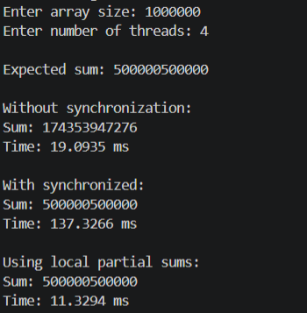

Key Questions :

- Why is a thread pool better than creating a new thread per task?
Answer:
- A thread pool reuses a fixed number of threads, reducing thread creation overhead and improving performance and resource management.

- How do wait() and notify() coordinate two threads?
Answer:
- wait() makes a thread release the lock and wait. notify() wakes a waiting thread so it can continue when the required resource is available.

- What causes a deadlock, and how does consistent lock ordering prevent it?
Answer:
- Deadlock occurs when threads wait for locks held by each other. Consistent lock ordering prevents this by ensuring all threads acquire locks in the same order.

