Subject: | OOP-JAVA
Name: | YUG GANDHI
ID No.: | 25AIML013

Practical-9
GIT REPOSITRY LINK :
https://github.com/25aiml013-sudo/JAVA-PRACTICALS.git

Part A
PROBLEM-1 :
Counter Race: Create multiple threads that repeatedly increase a common shared counter. First, run the program without synchronization and observe that the final value may be lower than expected due to a race condition. Then synchronize the increment operation and verify that the counter always reaches the correct expected value.

CODE :
import java.util.Scanner;

class SharedCounter {
int value = 0;

void addOne() {
value++;
}

synchronized void safeAddOne() {
value++;
}
}

public class CounterRace {
public static void main(String[] args) throws InterruptedException {
Scanner input = new Scanner(System.in);

System.out.print("Enter number of threads: ");
int threadCount = input.nextInt();

System.out.print("Enter increments per thread: ");
int incrementCount = input.nextInt();

SharedCounter counter1 = new SharedCounter();

Thread[] workers = new Thread[threadCount];

for (int i = 0; i < threadCount; i++) {
workers[i] = new Thread(() -> {
for (int j = 0; j < incrementCount; j++) {
counter1.addOne();
}
});
workers[i].start();
}

for (Thread worker : workers) {
worker.join();
}

int totalExpected = threadCount * incrementCount;

System.out.println("\nWithout synchronization:");
System.out.println("Expected count: " + totalExpected);
System.out.println("Actual count: " + counter1.value);

SharedCounter counter2 = new SharedCounter();

for (int i = 0; i < threadCount; i++) {
workers[i] = new Thread(() -> {
for (int j = 0; j < incrementCount; j++) {
counter2.safeAddOne();
}
});
workers[i].start();
}

for (Thread worker : workers) {
worker.join();
}

System.out.println("\nWith synchronization:");
System.out.println("Expected count: " + totalExpected);
System.out.println("Actual count: " + counter2.value);

input.close();
}
}

OUTPUT :
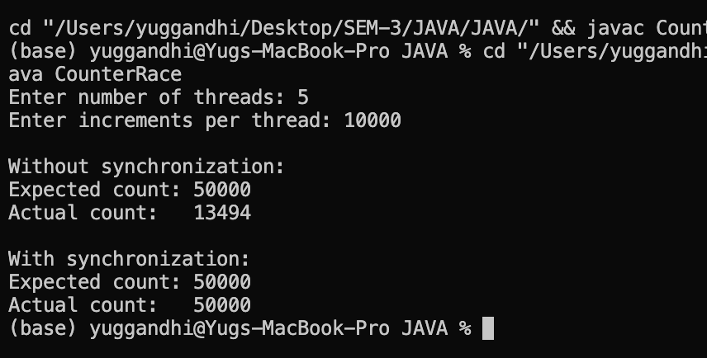
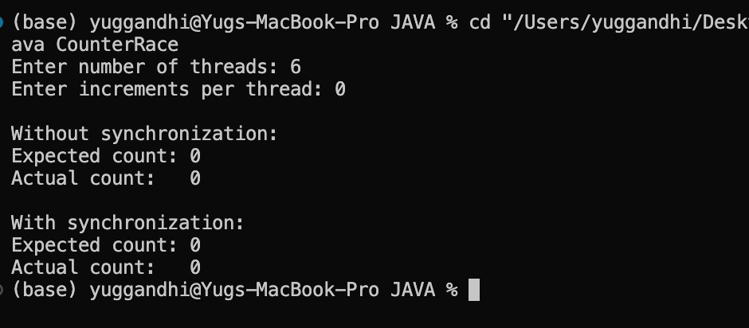

PROBLEM-2 :
Seat Booking Race: Create a shared seat counter with 5 available seats and run around 10 threads where each thread tries to book one seat. First, run the booking without synchronization and observe that more than 5 bookings may succeed due to a race condition. Then synchronize the book() method and verify that exactly 5 bookings are successful.

CODE :
import java.util.Scanner;

class Theater {
int availableSeats;

Theater(int totalSeats) {
availableSeats = totalSeats;
}

void reserve(String customer) {
if (availableSeats > 0) {
try {
Thread.sleep(10);
} catch (InterruptedException error) {
Thread.currentThread().interrupt();
}

availableSeats--;
System.out.println(customer + " booked a seat.");
} else {
System.out.println(customer + " failed. No seat available.");
}
}

synchronized void safeReserve(String customer) {
if (availableSeats > 0) {
try {
Thread.sleep(10);
} catch (InterruptedException error) {
Thread.currentThread().interrupt();
}

availableSeats--;
System.out.println(customer + " booked a seat.");
} else {
System.out.println(customer + " failed. No seat available.");
}
}
}

public class SeatRace {
public static void main(String[] args) throws InterruptedException {
Scanner input = new Scanner(System.in);

System.out.print("Enter number of seats: ");
int totalSeats = input.nextInt();

System.out.print("Enter number of booking threads: ");
int threadCount = input.nextInt();

Theater theater1 = new Theater(totalSeats);
Thread[] workers = new Thread[threadCount];

System.out.println("\n--- Without Synchronization ---");

for (int i = 0; i < threadCount; i++) {
final int userNumber = i + 1;

workers[i] = new Thread(() -> {
theater1.reserve("Customer-" + userNumber);
});

workers[i].start();
}

for (Thread worker : workers) {
worker.join();
}

System.out.println("Seats left: " + theater1.availableSeats);

Theater theater2 = new Theater(totalSeats);

System.out.println("\n--- With Synchronization ---");

for (int i = 0; i < threadCount; i++) {
final int userNumber = i + 1;

workers[i] = new Thread(() -> {
theater2.safeReserve("Customer-" + userNumber);
});

workers[i].start();
}

for (Thread worker : workers) {
worker.join();
}

System.out.println("Seats left: " + theater2.availableSeats);

input.close();
}
}

OUTPUT :
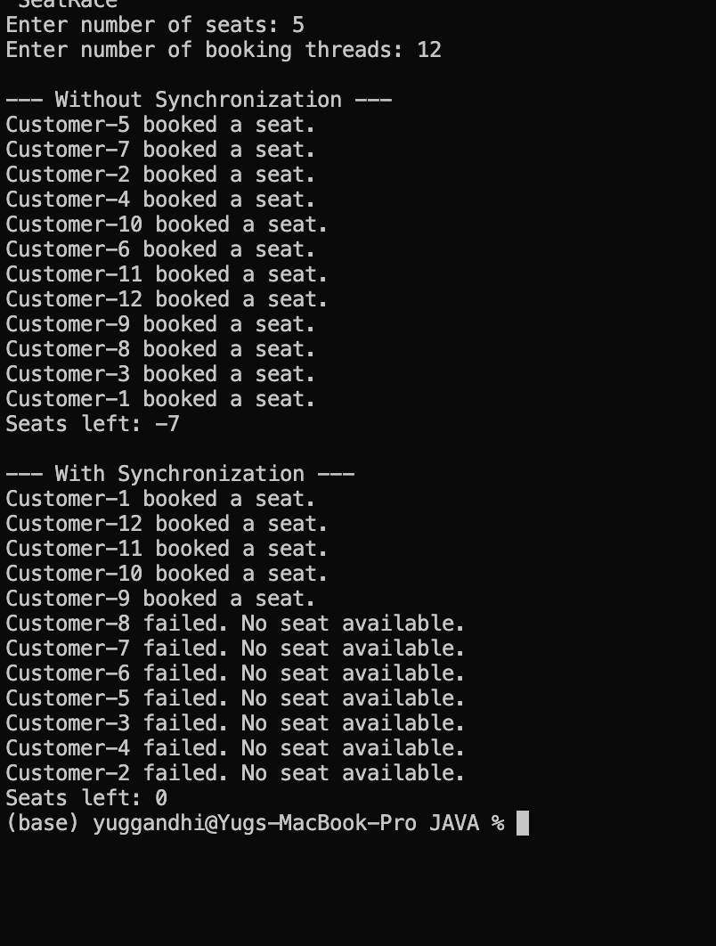

PROBLEM-3 :
Parallel Array Sum: Divide a large array of numbers among multiple threads and let them add their parts to one shared total. First, run it without synchronization and observe the incorrect result caused by a race condition. Then fix the problem using two different synchronization techniques and compare their performance. Decide how to measure the difference, such as by recording and comparing execution time.

CODE :
import java.util.Scanner;

class TotalCounter {
long sum = 0;

void addValue(long number) {
sum += number;
}

synchronized void safeAddValue(long number) {
sum += number;
}
}

public class ArraySumRace {

public static void main(String[] args) throws InterruptedException {
Scanner input = new Scanner(System.in);

System.out.print("Enter array size: ");
int arraySize = input.nextInt();

System.out.print("Enter number of threads: ");
int threadCount = input.nextInt();

int[] numbers = new int[arraySize];

for (int i = 0; i < arraySize; i++) {
numbers[i] = i + 1;
}

long correctSum = ((long) arraySize * (arraySize + 1)) / 2;

System.out.println("\nExpected sum: " + correctSum);

TotalCounter counter1 = new TotalCounter();
Thread[] workers = new Thread[threadCount];

int partSize = arraySize / threadCount;

long begin1 = System.nanoTime();

for (int i = 0; i < threadCount; i++) {
final int from = i * partSize;
final int to = (i == threadCount - 1) ? arraySize : from + partSize;

workers[i] = new Thread(() -> {
for (int j = from; j < to; j++) {
counter1.addValue(numbers[j]);
}
});

workers[i].start();
}

for (Thread worker : workers) {
worker.join();
}

long finish1 = System.nanoTime();

System.out.println("\nWithout synchronization:");
System.out.println("Sum: " + counter1.sum);
System.out.println("Time: " + (finish1 - begin1) / 1_000_000.0 + " ms");

TotalCounter counter2 = new TotalCounter();

long begin2 = System.nanoTime();

for (int i = 0; i < threadCount; i++) {
final int from = i * partSize;
final int to = (i == threadCount - 1) ? arraySize : from + partSize;

workers[i] = new Thread(() -> {
for (int j = from; j < to; j++) {
counter2.safeAddValue(numbers[j]);
}
});

workers[i].start();
}

for (Thread worker : workers) {
worker.join();
}

long finish2 = System.nanoTime();

System.out.println("\nWith synchronized:");
System.out.println("Sum: " + counter2.sum);
System.out.println("Time: " + (finish2 - begin2) / 1_000_000.0 + " ms");

long[] partialSums = new long[threadCount];

long begin3 = System.nanoTime();

for (int i = 0; i < threadCount; i++) {
final int position = i;
final int from = i * partSize;
final int to = (i == threadCount - 1) ? arraySize : from + partSize;

workers[i] = new Thread(() -> {
long localSum = 0;

for (int j = from; j < to; j++) {
localSum += numbers[j];
}

partialSums[position] = localSum;
});

workers[i].start();
}

for (Thread worker : workers) {
worker.join();
}

long totalSum = 0;

for (long value : partialSums) {
totalSum += value;
}

long finish3 = System.nanoTime();

System.out.println("\nUsing local partial sums:");
System.out.println("Sum: " + totalSum);
System.out.println("Time: " + (finish3 - begin3) / 1_000_000.0 + " ms");

input.close();
}
}

OUTPUT :
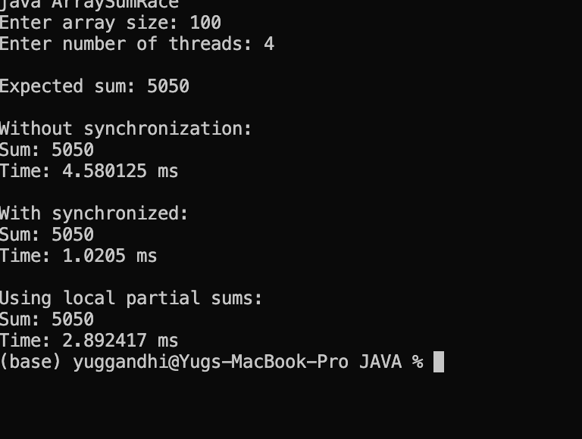

Key Questions :

1. Why is a thread pool better than creating a new thread for every task?
Answer:
A thread pool reuses a fixed number of threads instead of creating new ones for every task. This reduces thread creation overhead, improves performance, and manages system resources better.

2. How do wait() and notify() coordinate two threads?
Answer:
wait() makes a thread release the lock and wait until it is notified. notify() wakes up a waiting thread so it can continue when the required resource becomes available.

3. What causes a deadlock, and how does consistent lock ordering prevent it?
Answer:
A deadlock happens when two or more threads wait for locks held by each other. Using the same lock-acquisition order for all threads prevents them from waiting for each other indefinitely.

