PRACTICAL – 5

1
AIM :
To implement a Java interface for controlling electrical devices using on(), off(), and a default toggle() method. Create different device classes such as Fan and Light that implement the interface, and demonstrate their operation using an array and loop. Also, use a functional interface to determine whether a device can be switched on at a particular time, implementing it using both an anonymous class and a lambda expression.

CODE :
interface Switchable {

void on();

void off();

default void toggle() {
System.out.println("Toggling device...");
}
}

class Fan implements Switchable {

public void on() {
System.out.println("Fan is ON");
}

public void off() {
System.out.println("Fan is OFF");
}
}

class Light implements Switchable {

public void on() {
System.out.println("Light is ON");
}

public void off() {
System.out.println("Light is OFF");
}
}

interface SwitchPermission {
boolean maySwitchOn(Switchable item, int time);
}

public class prac_6_1 {

public static void main(String[] args) {

Switchable[] appliances = {
new Fan(),
new Light()
};

for (Switchable appliance : appliances) {
appliance.on();
appliance.off();
appliance.toggle();
}

SwitchPermission permissionCheck = new SwitchPermission() {

public boolean maySwitchOn(Switchable item, int time) {
return time >= 6 && time <= 22;
}
};

System.out.println(
"Anonymous class: " +
permissionCheck.maySwitchOn(new Fan(), 10)
);

SwitchPermission lambdaCheck =
(item, time) -> time >= 6 && time <= 22;

System.out.println(
"Lambda: " +
lambdaCheck.maySwitchOn(new Light(), 23)
);
}
}

OUTPUT SCREENSHOT :
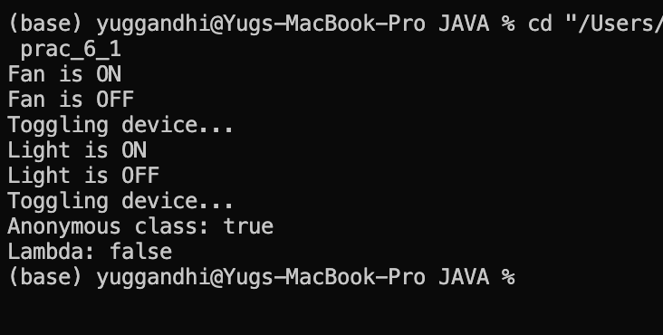
LEARNING OUTCOME :
- Learned how to achieve abstraction by defining an abstract Shape class with an area() method.
- Understood inheritance and method overriding using Circle, Rectangle, and Triangle classes.
- Implemented runtime polymorphism by keeping different shape objects inside a Shape[] array.
- Used one loop to find each shape’s area, calculate the total area, and determine the shape with the maximum area.

2

To create a functional interface Notifier with a send(String) method and implement email and SMS notifications using lambda expressions. Store the notification senders in an array and deliver the same message to all of them. Also, use a marker interface Urgent to identify priority senders and send the message twice to those senders.

CODE:
interface Notifier {
void send(String text);
}

interface Urgent {
}

class EmailSender implements Notifier, Urgent {

public void send(String text) {
System.out.println("Email: " + text);
}
}

class SMSSender implements Notifier {

public void send(String text) {
System.out.println("SMS: " + text);
}
}

public class Main {

public static void main(String[] args) {

Notifier mailService = new EmailSender();
Notifier messageService = new SMSSender();

Notifier[] notificationList = {mailService, messageService};

String alert = "Your order has been shipped.";

for (Notifier service : notificationList) {

service.send(alert);

if (service instanceof Urgent) {
service.send(alert);
}
}
}
}

OUTPUT SCREENSHOT :
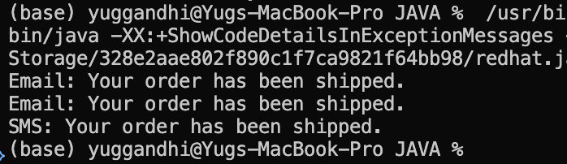

LEARNING OUTCOME :
- Learned to implement an abstract Employee class with an abstract monthlySalary() method.
- Applied inheritance and method overriding for FullTime, PartTime, and Intern.
- Learned to use super() for constructor chaining to initialize common name and ID attributes.
- Applied polymorphism using a mixed Employee[] array to calculate different salaries.
- Learned to use the instanceof operator to identify interns and display a specific note.
- Calculated individual salaries and total payroll using loops.

3.
(For Advanced Learners – home) Build a small discount engine where each rule is a
lambda the user picks at runtime and applies to a list of prices; organise it into packages
and ship it as a runnable JAR.
CODE :
import java.util.*;

@FunctionalInterface
interface DiscountRule {
double apply(double amount);
}

public class DiscountEngine {

public static void main(String[] args) {

Scanner input = new Scanner(System.in);

List<Double> productPrices = Arrays.asList(
1000.0,
2500.0,
5000.0,
8000.0
);

System.out.println("Prices:");

for (double amount : productPrices) {
System.out.println(amount);
}

System.out.println("\nChoose discount rule:");
System.out.println("1. 10% discount");
System.out.println("2. 20% discount");
System.out.println("3. Flat Rs. 500 discount");

int option = input.nextInt();

DiscountRule discount;

if (option == 1) {
discount = amount -> amount * 0.90;
}
else if (option == 2) {
discount = amount -> amount * 0.80;
}
else if (option == 3) {
discount = amount -> amount - 500;
}
else {
System.out.println("Invalid choice.");
input.close();
return;
}

System.out.println("\nPrices after discount:");

for (double amount : productPrices) {

double discountedPrice = discount.apply(amount);

if (discountedPrice < 0) {
discountedPrice = 0;
}

System.out.println(
"Original: Rs." + amount +
" -> Final: Rs." + discountedPrice
);
}

input.close();
}
}

OUTPUT SCREENSHOT :
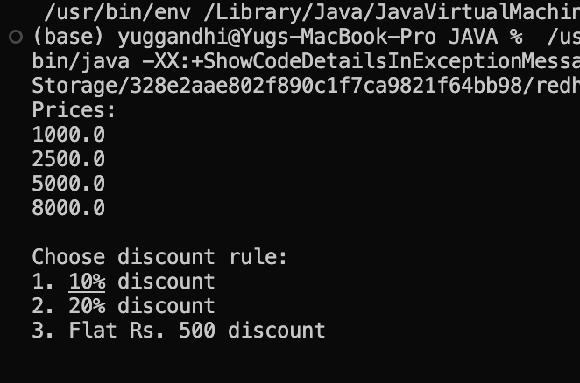

LEARNING OUTCOME :
- Learned to design an abstract media hierarchy with different media subclasses.
- Applied inheritance, abstraction, and method overriding to implement different late-fee rules.
- Used polymorphism to process different media types through a common Media[] array.
- Learned to calculate individual late fees and the total fee for a returned batch.
- Applied instanceof to identify different media types where required.

