Subject: | OOP-JAVA
Name: | YUG GANDHI
ID No.: | 25AIML013

Practical-10
GIT REPOSITRY LINK : https://github.com/25aiml013-sudo/JAVA-PRACTICALS.git

Part A
PROBLEM-1 :
Thread Pool Runner: Create a fixed thread pool with 3 threads using ExecutorService. Submit around 10 Runnable tasks that display their task ID and sleep for a short time. Then shut down the executor and wait for all tasks to finish, observing how the same few threads are reused for multiple tasks.

CODE :
import java.util.Scanner;
import java.util.concurrent.ExecutorService;
import java.util.concurrent.Executors;
import java.util.concurrent.TimeUnit;

public class PoolRunner {
public static void main(String[] args) throws Exception {
Scanner input = new Scanner(System.in);

System.out.print("Enter number of tasks: ");
int taskCount = input.nextInt();

ExecutorService executor = Executors.newFixedThreadPool(3);

for (int i = 1; i <= taskCount; i++) {
final int taskId = i;

executor.submit(() -> {
System.out.println("Task " + taskId + " running on "
+ Thread.currentThread().getName());

try {
Thread.sleep(500);
} catch (InterruptedException error) {
Thread.currentThread().interrupt();
}

System.out.println("Task " + taskId + " completed");
});
}

executor.shutdown();
executor.awaitTermination(1, TimeUnit.MINUTES);

System.out.println("All tasks completed.");

input.close();
}
}

OUTPUT :
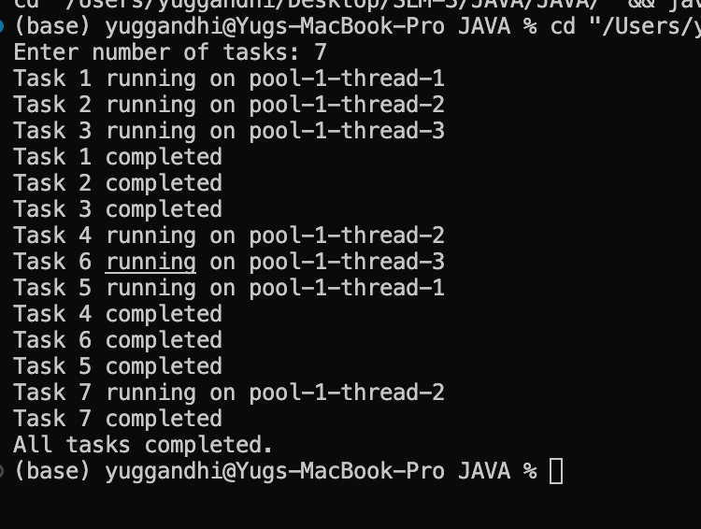

PROBLEM-2 :
Producer–Consumer: Create a small shared buffer where one thread produces numbers and another thread consumes them. Use wait() and notify() to coordinate both threads, ensuring that a fixed number of items are produced and consumed in the correct order without losing any items.

CODE :
import java.util.LinkedList;
import java.util.Queue;
import java.util.Scanner;

class SharedBuffer {
private Queue<Integer> data = new LinkedList<>();
private int limit;

SharedBuffer(int size) {
limit = size;
}

public synchronized void addItem(int number) throws InterruptedException {
while (data.size() == limit) {
wait();
}

data.add(number);
System.out.println("Produced: " + number);

notify();
}

public synchronized int removeItem() throws InterruptedException {
while (data.isEmpty()) {
wait();
}

int number = data.remove();
System.out.println("Consumed: " + number);

notify();
return number;
}
}

public class ProducerConsumerDemo {
public static void main(String[] args) throws Exception {
Scanner input = new Scanner(System.in);

System.out.print("Enter buffer size: ");
int bufferSize = input.nextInt();

System.out.print("Enter number of items: ");
int itemCount = input.nextInt();

SharedBuffer shared = new SharedBuffer(bufferSize);

Thread sender = new Thread(() -> {
try {
for (int i = 1; i <= itemCount; i++) {
shared.addItem(i);
}
} catch (InterruptedException error) {
Thread.currentThread().interrupt();
}
});

Thread receiver = new Thread(() -> {
try {
for (int i = 1; i <= itemCount; i++) {
shared.removeItem();
}
} catch (InterruptedException error) {
Thread.currentThread().interrupt();
}
});

sender.start();
receiver.start();

sender.join();
receiver.join();

System.out.println("All items produced and consumed.");

input.close();
}
}

OUTPUT :
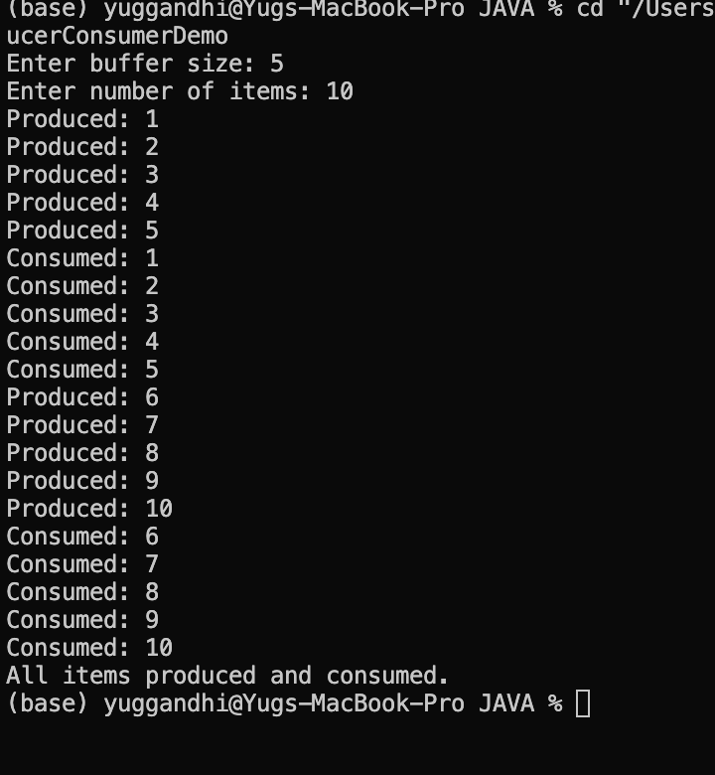

PROBLEM-3 :
Deadlock Demonstration: Create two threads that acquire two shared locks in opposite order, causing them to wait for each other and resulting in a deadlock. Then fix the problem by making both threads acquire the locks in the same consistent order, preventing the deadlock.

CODE :
import java.util.Scanner;

public class main {

static final Object resourceA = new Object();
static final Object resourceB = new Object();

static void showDeadlock() {
Thread first = new Thread(() -> {
synchronized (resourceA) {
System.out.println("Thread 1 locked Resource A");

try {
Thread.sleep(100);
} catch (InterruptedException error) {
Thread.currentThread().interrupt();
}

synchronized (resourceB) {
System.out.println("Thread 1 locked Resource B");
}
}
});

Thread second = new Thread(() -> {
synchronized (resourceB) {
System.out.println("Thread 2 locked Resource B");

try {
Thread.sleep(100);
} catch (InterruptedException error) {
Thread.currentThread().interrupt();
}

synchronized (resourceA) {
System.out.println("Thread 2 locked Resource A");
}
}
});

first.start();
second.start();

System.out.println("Deadlock created: both threads may wait forever.");
}

static void fixDeadlock() throws InterruptedException {
Thread first = new Thread(() -> {
synchronized (resourceA) {
synchronized (resourceB) {
System.out.println("Thread 1 completed.");
}
}
});

Thread second = new Thread(() -> {
synchronized (resourceA) {
synchronized (resourceB) {
System.out.println("Thread 2 completed.");
}
}
});

first.start();
second.start();

first.join();
second.join();

System.out.println("No deadlock. Both threads used the same lock order.");
}

public static void main(String[] args) throws Exception {
Scanner input = new Scanner(System.in);

System.out.println("1. Create Deadlock");
System.out.println("2. Avoid Deadlock");
System.out.print("Enter choice: ");

int option = input.nextInt();

if (option == 1) {
showDeadlock();
} else if (option == 2) {
fixDeadlock();
} else {
System.out.println("Invalid choice.");
}

input.close();
}
}

OUTPUT :
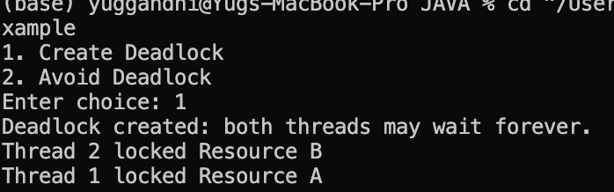
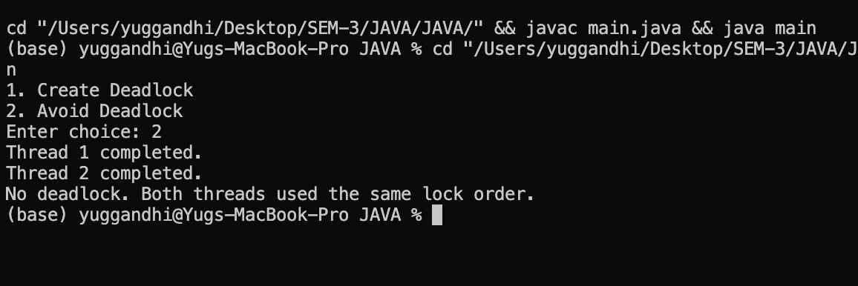

Key Questions :

1. Why is a thread pool better than creating a new thread for each task?
Answer:
A thread pool uses and reuses a fixed number of threads, which reduces the overhead of creating new threads and improves overall performance.

2. How do wait() and notify() coordinate two threads?
Answer:
wait() makes a thread pause and release its lock. notify() wakes up a waiting thread when the required resource becomes available.

3. What causes a deadlock, and how does consistent lock ordering prevent it?
Answer:
A deadlock occurs when threads are waiting for locks held by each other. Using a consistent lock order ensures that all threads acquire locks in the same sequence, preventing deadlock.

