PRACTICAL – 8
AIM:
. Guarded Calculator: Create a calculator that accepts two numbers and an operator. Use a custom DivideByZeroException to handle division by zero and separately handle invalid number input. Display a clear error message for each problem, keep asking for input until a calculation is completed successfully, and use finally to record every attempt.

CODE:
import java.util.Scanner;

public class main {

public static void main(String[] args) {

Scanner input = new Scanner(System.in);
boolean stop = false;

while (!stop) {

try {
System.out.print("Enter the first number : ");
String firstInput = input.nextLine();

System.out.print("Enter the second number : ");
String secondInput = input.nextLine();

System.out.print("Enter the operator (+,-,*,/) : ");
String operator = input.nextLine();

int firstNumber = Integer.parseInt(firstInput);
int secondNumber = Integer.parseInt(secondInput);

checkInput(firstNumber, secondNumber, operator);

int answer = performCalculation(firstNumber, secondNumber, operator);

System.out.println("Result : " + answer);

stop = true;

} catch (NumberFormatException error) {
System.out.println("Error : Enter valid integers.");

} catch (NegativeNumberException | InvalidOperatorException |
ZeroMultiplicationException | DivideByZeroException error) {
System.out.println("Error : " + error.getMessage());

} catch (ArithmeticException error) {
System.out.println("Error : Integer overflow.");

} finally {
System.out.println("Log : Attempt completed.");
}
}

input.close();
System.out.println("Calculator exited.");
}

static void checkInput(int firstNumber, int secondNumber, String operator)
throws NegativeNumberException,
InvalidOperatorException,
ZeroMultiplicationException,
DivideByZeroException {

if (firstNumber < 0 || secondNumber < 0)
throw new NegativeNumberException("Negative numbers not allowed.");

if (!operator.matches("[+\\-*/]"))
throw new InvalidOperatorException("Invalid operator.");

if (operator.equals("*") && (firstNumber == 0 || secondNumber == 0))
throw new ZeroMultiplicationException("Multiplication by zero not allowed.");

if (operator.equals("/") && secondNumber == 0)
throw new DivideByZeroException("Division by zero not allowed.");
}

static int performCalculation(int firstNumber, int secondNumber, String operator) {
return switch (operator) {
case "+" -> Math.addExact(firstNumber, secondNumber);
case "-" -> Math.subtractExact(firstNumber, secondNumber);
case "*" -> Math.multiplyExact(firstNumber, secondNumber);
case "/" -> firstNumber / secondNumber;
default -> 0;
};
}
}

class NegativeNumberException extends Exception {
NegativeNumberException(String message) {
super(message);
}
}

class InvalidOperatorException extends Exception {
InvalidOperatorException(String message) {
super(message);
}
}

class ZeroMultiplicationException extends Exception {
ZeroMultiplicationException(String message) {
super(message);
}
}

class DivideByZeroException extends Exception {
DivideByZeroException(String message) {
super(message);
}
}

OUTPUT SCREENSHOT:
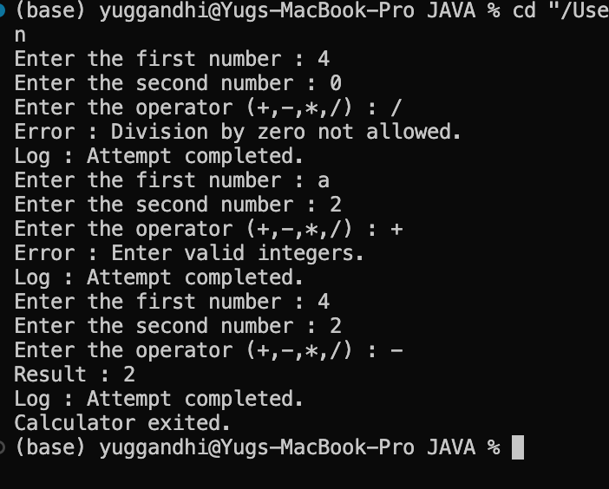

LEARNING OUTCOME:
- Understand the use of try-catch-finally blocks for handling exceptions in Java.
- Implement custom exceptions for handling specific calculator errors.
- Learn to validate user input and handle invalid numbers, operators, negative values, and division by zero.
- Use user-defined methods to improve code modularity and readability.
- Develop a user-input-based calculator with repeated execution and proper exception handling.

PRAC-2
Create a Warehouse class with an issue(item, qty) method.
- If qty <= 0, throw a custom checked InvalidQuantityException.
- If there is not enough stock, throw a custom checked OutOfStockException that stores the shortfall (how many more items are needed).
- Process multiple stock requests one by one.
- If any request fails, catch the exception, display the error, and continue processing the remaining requests.

CODE:
import java.util.Scanner;

public class main {
public static void main(String[] args) {

Scanner input = new Scanner(System.in);
Warehouse store = new Warehouse();

System.out.print("Enter number of requests: ");
int totalRequests = Integer.parseInt(input.nextLine());

for (int requestNo = 1; requestNo <= totalRequests; requestNo++) {

System.out.println("\nRequest " + requestNo);

System.out.print("Enter item: ");
String product = input.nextLine();

System.out.print("Enter quantity: ");
int amount = Integer.parseInt(input.nextLine());

try {
store.issue(product, amount);
System.out.println("Issued successfully.");

} catch (InvalidQuantityException | OutOfStockException |
ItemNotFoundException error) {

System.out.println("Issue failed: " + error.getMessage());
}
}

System.out.println("\nRemaining Stock:");
store.showStock();

input.close();
}
}

class Warehouse {

String[] productList = {"Mobile", "Laptop", "IdeaPad", "Tablet"};
int[] quantityList = {45, 25, 35, 18};

void issue(String product, int amount)
throws InvalidQuantityException, OutOfStockException,
ItemNotFoundException {

if (amount <= 0)
throw new InvalidQuantityException(
"Quantity must be greater than 0.");

int position = -1;

for (int i = 0; i < productList.length; i++) {

if (productList[i].equalsIgnoreCase(product)) {
position = i;
break;
}
}

if (position == -1)
throw new ItemNotFoundException("Item not found.");

if (amount > quantityList[position]) {

int missing = amount - quantityList[position];

throw new OutOfStockException(
"Out of stock. Shortfall = " + missing, missing);
}

quantityList[position] -= amount;

System.out.println(
amount + " " + productList[position] + " issued.");
}

void showStock() {

for (int i = 0; i < productList.length; i++) {
System.out.println(
productList[i] + " : " + quantityList[i]);
}
}
}

class OutOfStockException extends Exception {

int shortage;

OutOfStockException(String message, int shortage) {
super(message);
this.shortage = shortage;
}
}

class InvalidQuantityException extends Exception {

InvalidQuantityException(String message) {
super(message);
}
}

class ItemNotFoundException extends Exception {

ItemNotFoundException(String message) {
super(message);
}
}

OUTPUT SCREENSHOT:
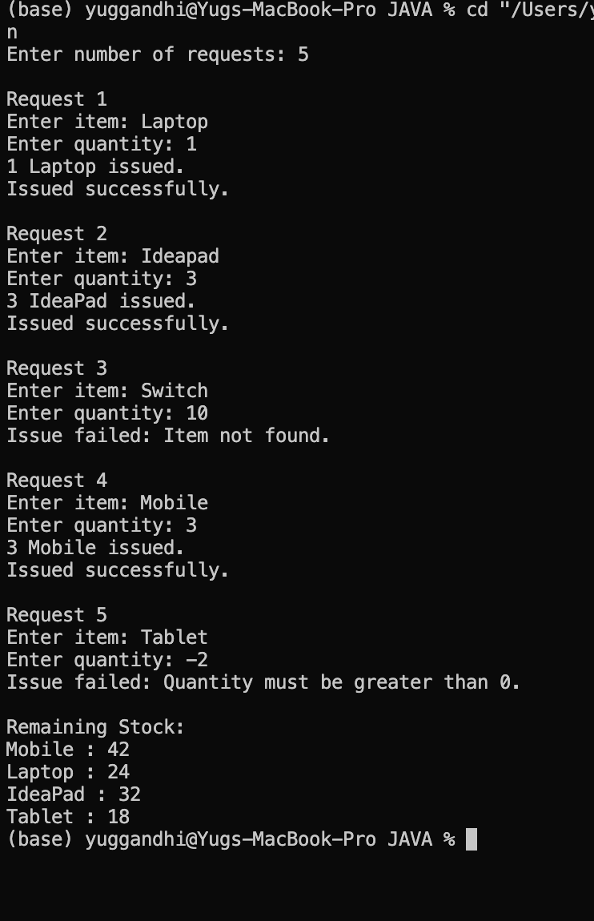

LEARNING OUTCOME:
- Understand how custom exceptions can carry additional information such as stock shortfall.
- Learn to manage and update inventory using arrays and methods.
- Apply multi-catch to handle related exceptions efficiently.
- Practice processing multiple requests independently within a loop.
- Improve error reporting by providing meaningful exception messages.

PRAC-3
Create a class that implements AutoCloseable and represents a resource, such as a file, database connection, or network connection.
Use try-with-resources to automatically close the resource after use. Inside the try block, deliberately throw an exception and verify that:
- The resource’s close() method is still called.
- The original exception from the try block is reported.
- The resource is properly closed even when an error occurs.
For this program, you can model the resource as a FileResource or DatabaseConnection.

CODE:
public class AutoCloseDemo {

public static void main(String[] args) {

try (FileResource file = new FileResource()) {

file.use();

throw new Exception("Original error occurred.");

} catch (Exception error) {

System.out.println("Caught: " + error.getMessage());

for (Throwable problem : error.getSuppressed()) {
System.out.println("Suppressed: " + problem.getMessage());
}
}
}
}

class FileResource implements AutoCloseable {

FileResource() {
System.out.println("Resource opened.");
}

void use() {
System.out.println("Resource is being used.");
}

@Override
public void close() throws Exception {
System.out.println("Resource closed.");
throw new Exception("Error while closing resource.");
}
}

OUTPUT SCREENSHOT:
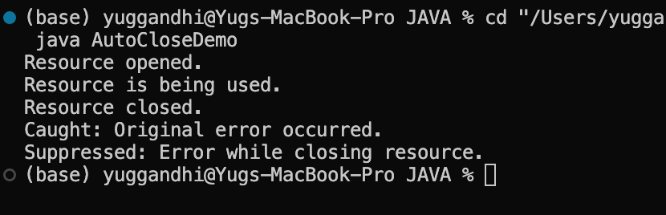
LEARNING OUTCOME:
- Understand the purpose and working of the AutoCloseable interface.
- Learn how try-with-resources automatically closes resources after use.
- Observe resource closure even when an exception occurs inside the try block.
- Understand the difference between the original and suppressed exceptions.
- Learn how automatic resource management improves reliability and reduces manual cleanup.

