SUBJECT | OOP-JAVA
NAME | YUG GANDHI
ID | 25AIML013
PRACTICAL-1
PROBLEM-1:
(For Advanced Learners – home) Rock-Paper-Scissors-Lizard-Spock
(RPSLS.java) (a) Define an enum Move with ROCK, PAPER, SCISSORS, LIZARD, SPOCK.
- Write winner(Move a, Move b) returning 1 if a beats b, -1 if b beats a, 0 for a tie —use a switch expression listing what each move beats (Scissors cut Paper, Paper covers Rock, Rock crushes Lizard, Lizard poisons Spock, Spock smashes Scissors, and the five mirror cases).
- In main, play 5 rounds: pick a random computer Move, read the player’s Move, callwinner(), print the round result and keep score.
- After 5 rounds, print the overall winner.
Expected output: each round prints both moves and the round winner; ends with a “You win 3–2” summary.
CODE:
import java.util.*;
class RPSGame
{
enum Move { ROCK, PAPER, SCISSORS, LIZARD, SPOCK }
static int result(Move user, Move computer)
{
if (user == computer)
return 0;
switch (user)
{
case ROCK:
if (computer == Move.SCISSORS || computer == Move.LIZARD) return 1; else return -1;
case PAPER:
if (computer == Move.ROCK || computer == Move.SPOCK) return 1; else return -1;
case SCISSORS:
if (computer == Move.PAPER || computer == Move.LIZARD) return 1; else return -1;
case LIZARD: if (computer == Move.PAPER ||
computer == Move.SPOCK) return 1; else return -1;
case SPOCK: if (computer == Move.ROCK || computer == Move.SCISSORS) return 1; else return -1;
}
return 0;
}
public static void main(String args[])
{
Scanner input = new Scanner(System.in); Random random = new Random(); Move arr[] = Move.values();
int userScore = 0; int computerScore = 0;
for (int round = 1; round <= 5; round++)
{
System.out.println("Round " + round);
System.out.println("Enter your move:");
Move user = Move.valueOf(input.next().toUpperCase());
Move computer = arr[random.nextInt(arr.length)];
System.out.println("Your Move: " + user); System.out.println("Computer Move: " + computer); int ans = result(user, computer);
if (ans == 1)
{
System.out.println("You Win!");
userScore++;
}
else if (ans == -1)
{
System.out.println("Computer Wins!"); computerScore++;
} else
{
System.out.println("Tie!");
}
}
System.out.println("\nFinal Score");
System.out.println("Your Score: " + userScore); System.out.println("Computer Score: " + computerScore);
if (userScore > computerScore)
System.out.println("You are the Winner!"); else if
(computerScore > userScore)
System.out.println("Computer is the Winner!"); else
System.out.println("Match Draw!");
}
}
OUTPUT:
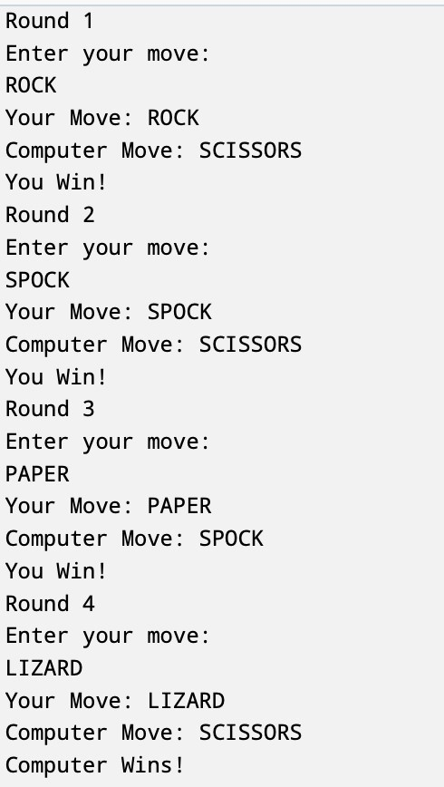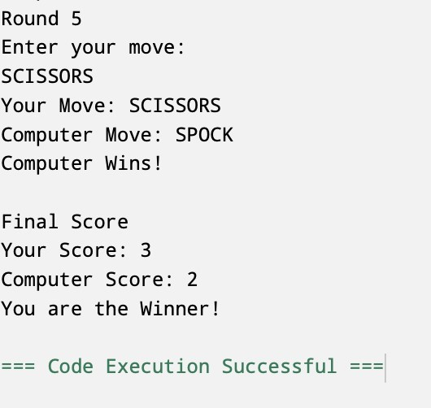
PROBLEM-2:
Toll booth (TollBooth.java, main in this file)
- Define a record Vehicle(String number, String type).
- In main, keep a running toll total and three counters (bike, car, truck). (c) Loop until the user types “done” for the number: build a Vehicle, use a switch expression on its type for the toll (bike→20, car→50, truck→150), add to the total, and increment that type’s counter.
(d) After the loop, print the total toll and the type with the highest count.
Expected output: two cars + one bike → “Total toll: 120”, “Most frequent: car”.
CODE:
import java.util.*;
class TollBoothManagement {

record VehicleDetail(String plateNumber, String vehicleType) {}
public static void main(String[] args) {
Scanner input = new Scanner(System.in);

int bikeCount = 0;
int carCount = 0; int truckCount = 0; int totalToll = 0;
while (true) {
System.out.println("Enter vehicle number (or type 'done' to finish):"); String plate = input.next();

if (plate.equalsIgnoreCase("done")) { break; }
System.out.println("Enter vehicle type:");
String type = input.next().toLowerCase();
VehicleDetail currentVehicle = new VehicleDetail(plate, type);
switch (currentVehicle.vehicleType()) { case "bike" -> { totalToll += 20;
bikeCount++;
} case "car" -> {
totalToll += 50;
carCount++;
} case "truck" -> { totalToll += 150;
truckCount++;
}
default -> System.out.println("Unknown vehicle type. No toll charged.");
}
}
System.out.println("\n--- Summary ---");
System.out.println("Total Toll Collected = " + totalToll);
if (bikeCount > carCount && bikeCount > truckCount) {
System.out.println("Most frequent vehicle = Bike");
} else if (carCount > bikeCount && carCount > truckCount) {
System.out.println("Most frequent vehicle = Car");
} else if (truckCount > carCount && truckCount > bikeCount) {
System.out.println("Most frequent vehicle = Truck");
} else {
System.out.println("No single most frequent vehicle (there is a tie or no vehicles entered).");
}

input.close();
}
}
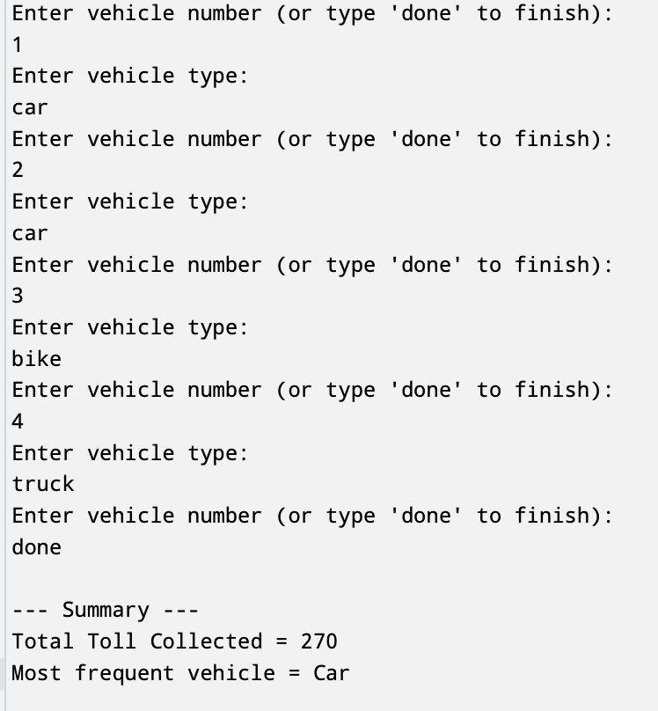
OUTPUT:
PROBLEM-3:
Vending machine (VendingMachine.java, main in this file)
- Define an enum Coin with constants ONE, TWO, FIVE, TEN.
- In main, set a snack price of 15 and a running total of 0; create a Scanner.
- Loop: read a coin name, use a switch expression to convert the Coin to its value
(ONE→1, TWO→2, FIVE→5, TEN→10), add it to the total, and print the total so far.
- Stop the loop once the total reaches 15 or more.
- Print the change to return (total − 15).
Expected output: TEN then FIVE prints “Paid. Change: 0”; TEN then TEN prints “Paid. Change: 5”.
CODE:
import java.util.*;
class SnackDispenser {

enum CoinType { ONE, TWO, FIVE, TEN }
public static void main(String[] args) {
Scanner scanner = new Scanner(System.in);

int itemPrice = 15;
int amountPaid = 0;
while (amountPaid < itemPrice) {
System.out.println("Enter the coin (ONE, TWO, FIVE, TEN):"); String userInput = scanner.next().toUpperCase();

CoinType insertedCoin = CoinType.valueOf(userInput); int coinValue = 0;
switch (insertedCoin) { case ONE: coinValue = 1;
break; case TWO: coinValue = 2;
break; case FIVE:
coinValue = 3 + 2;
break; case TEN: coinValue = 10;
break;
}
amountPaid += coinValue;
System.out.println("Current total inserted: " + amountPaid);
}
int changeDue = amountPaid - itemPrice;
System.out.println("Final Amount Paid = " + amountPaid);
System.out.println("Change Returned = " + changeDue);

scanner.close();
}
}
OUTPUT:

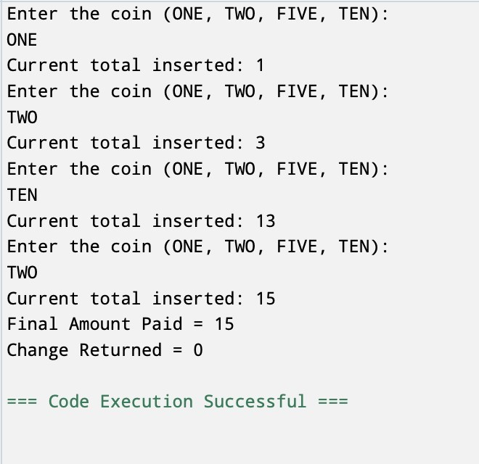

CSPIT-AIML 25AIML013
SUBJECT | OOP-JAVA
NAME | YUG GANDHI
ID | 25AIML013
PRACTICAL-2
PROBLEM-1:
1. Smart thermostat (Thermostat.java, main in this file)
(a) Create class Thermostat with private String location, private int temperature, private static final int MIN=16 and MAX=30, and private static int activeCount=0. (b) Constructor(location, startTemp): store location; set temperature to startTemp if it is within MIN..MAX else 22; increment activeCount.
(c) Constructor(location): chain with this(location, 22).
(d)raise(): if temperature < MAX add 1, else print “Already at maximum (30)”.(e) lower(): if temperature > MIN subtract 1, else print “Already at minimum (16)”.
(f) Add getTemperature() (no setter) and static getActiveCount().
(g)In main: create two thermostats, call raise() 10 times then lower() 20 times in loops
(printing the temperature each time), then print getActiveCount().
Expected output: temperature rises to 30 then “Already at maximum”, falls to 16 then “Already at minimum”, count 2.
CODE:
public class Practicle2_1 {
static class Thermostat {
private String roomName; private int currentTemperature; private static int minimumTemperature = 16; private static int maximumTemperature = 30; private static int thermostatCount = 0; Thermostat(String roomName, int initialTemperature) {
this.roomName = roomName;
if (initialTemperature >= minimumTemperature && initialTemperature <= maximumTemperature) {
this.currentTemperature = initialTemperature;
} else {
this.currentTemperature = 22;
}
thermostatCount++;
}
Thermostat(String roomName) { this.roomName = roomName; this.currentTemperature = 22;
thermostatCount++;
}
public void raise() { if (currentTemperature < maximumTemperature) { currentTemperature++;
} else {
System.out.println("Already at maximum : " + maximumTemperature);
}
}
public void lower() { if (currentTemperature > minimumTemperature) { currentTemperature--
;
} else {
System.out.println("Already at minimum : " + minimumTemperature);
}
}
public void getTemp() {
System.out.println(currentTemperature);
}
public void getCount() {
System.out.println(thermostatCount);
}
}
public static void main(String args[]) {
Thermostat thermostat1 = new Thermostat("Charusat", 26); Thermostat thermostat2 = new Thermostat("Charusat");
for (int increaseLoop = 1; increaseLoop <= 10; increaseLoop++)
{ thermostat1.raise(); thermostat1.getTemp();
}
for (int decreaseLoop = 1; decreaseLoop <= 20; decreaseLoop++)
{ thermostat1.lower(); thermostat1.getTemp();
}
thermostat1.getCount();
}
}
OUTPUT:
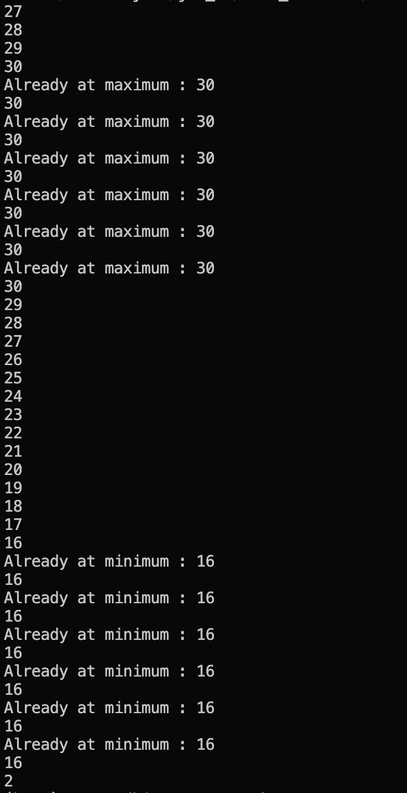
PROBLEM-2:
2. Cinema show (CinemaShow.java, main in this file)
- Create class CinemaShow with private String title, private int seatsAvailable, private final int capacity, and private static int totalBooked=0.
- Constructor(title, capacity): set both and seatsAvailable = capacity.
Constructor(title): chain with this(title, 100).
- book(int n): if n ≤ seatsAvailable, reduce seatsAvailable by n, add n to totalBooked, return true; else return false unchanged.
- cancel(int n): increase seatsAvailable by n but never above capacity.
- Add getSeatsAvailable() and static getTotalBooked().
- In main: run a sequence of book and cancel calls, printing the result and seats after each, then print getTotalBooked().
Expected output: booking more than available prints false and leaves seats unchanged; totalBooked equals the successful bookings.

CODE:
public class Practicle2_2 {
static class CinemaShow {
private String title; private int seatsAvailable; private final int capacity; private static int totalBooked = 0;
CinemaShow(String title, int capacity) {
this.title = title; this.capacity = capacity; this.seatsAvailable = capacity; } CinemaShow(String title) {
this(title, 100);
}
public boolean book(int n) { if (n <= seatsAvailable) { seatsAvailable -= n; totalBooked += n; return true;
}
return false;
}
public void cancel(int n) { seatsAvailable += n; if (seatsAvailable > capacity) { seatsAvailable = capacity;
}
}
public int getSeatsAvailable() { return seatsAvailable;
}
public static int getTotalBooked() {
return totalBooked;
}
}
public static void main(String[] args) {
CinemaShow show = new CinemaShow("Spider Man", 100);
System.out.println("Book 30 seats: " + show.book(30)); System.out.println("Seats Available: " + show.getSeatsAvailable());
show.cancel(10);
System.out.println("After Cancel 10 Seats: " + show.getSeatsAvailable());
System.out.println("Book 90 seats: " + show.book(90));
System.out.println("Seats Available: " + show.getSeatsAvailable());
System.out.println("Book 80 seats: " + show.book(80));
System.out.println("Seats Available: " + show.getSeatsAvailable());
System.out.println("Total Booked: " + CinemaShow.getTotalBooked());
}
}
OUTPUT:

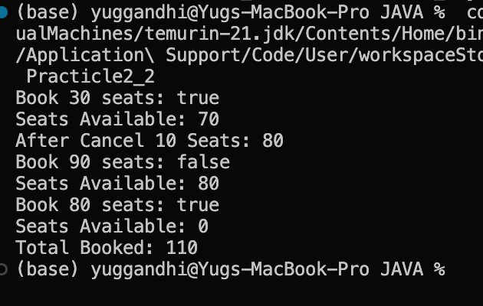
PROBLEM-3:
3. (For Advanced Learners – home) Parking lot (ParkingLot.java)
(a) Create class ParkingLot with private int twoWheelers and fourWheelers, private final int twoCap and fourCap, and private static long revenue=0.
(b)park(String type): for “two”, if twoWheelers < twoCap increment and add 20 to
revenue; for “four”, if fourWheelers < fourCap increment and add 40; otherwise print
“Full” and reject.
(c) leave(String type): decrement the matching count but never below 0.
(d)In main: simulate a sequence of park/leave events, printing each outcome, then print final occupancy and revenue.
Expected output: parking into a full section is refused; revenue = 20×(two parked) + 40×(four parked_{).}
CODE:
public class ParkingLot {
private int twoWheelers; private int fourWheelers;
private final int twoCap;
private final int fourCap;
private static long revenue = 0;
ParkingLot(int twoCap, int fourCap) {
this.twoCap = twoCap;
this.fourCap = fourCap;
this.twoWheelers = 0;
this.fourWheelers = 0;
}
public void park(String type) { if (type.equalsIgnoreCase("two")) {
if (twoWheelers < twoCap) {
twoWheelers++;
revenue += 20;
System.out.println("Two-wheeler parked.");
} else {
System.out.println("Two-wheeler section Full");
}
} else if (type.equalsIgnoreCase("four")) {
if (fourWheelers < fourCap) {
fourWheelers++;
revenue += 40;
System.out.println("Four-wheeler parked.");
} else {
System.out.println("Four-wheeler section Full");
}
} else {
System.out.println("Invalid vehicle type.");
}
}
public void leave(String type) {
if (type.equalsIgnoreCase("two")) {
if (twoWheelers > 0) {
twoWheelers--;
System.out.println("Two-wheeler left.");
} else {
System.out.println("No two-wheelers to leave.");
}
} else if (type.equalsIgnoreCase("four")) {
if (fourWheelers > 0) {
fourWheelers--;
System.out.println("Four-wheeler left.");
} else {
System.out.println("No four-wheelers to leave.");
}
} else {
System.out.println("Invalid vehicle type.");
}
}
public int getTwoWheelers() {
return twoWheelers;
}
public int getFourWheelers() {
return fourWheelers;
}
public static long getRevenue() {
return revenue;
}
public static void main(String[] args) { ParkingLot parking = new ParkingLot(2, 2); parking.park("two");
parking.park("two");
parking.park("two");
parking.park("four");
parking.park("four");
parking.park("four");
parking.leave("two");
parking.leave("four");
System.out.println("Two-Wheelers Parked: " + parking.getTwoWheelers());
System.out.println("Four-Wheelers Parked: " + parking.getFourWheelers());
System.out.println("Revenue: " + ParkingLot.getRevenue());
}
}
OUTPUT:
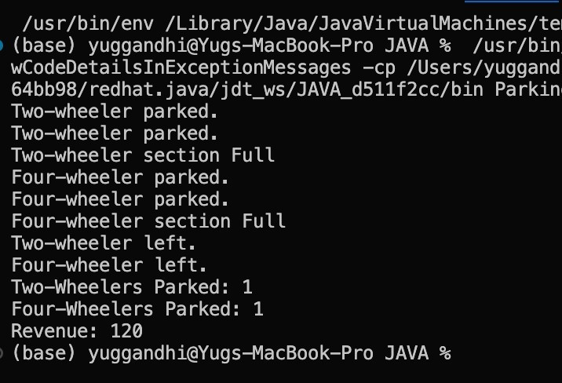

CSPIT-AIML 25AIML013
Part B — Project Work (Hour 2): MiniBank
In Practical 1 you built the empty menu shell. Now you create the data the bank works on —
the Customer and Account classes. Using encapsulation, an account’s balance can change
only through deposit() and withdraw(), never directly. These two classes are the
foundation every later lab extends.
- Create a class named Customer with private fields name, email and mobile (all String) and a private final field customerId (String). Use a private static long field
customerCounter and a private static method generateCustomerId() to create ids such as
“CUST101”. Add a constructor and public getter methods.
- Create a class named Account with private fields: a final String accountNumber, a String
ownerName, a long balance (whole rupees) and a boolean active. Generate
accountNumber with a private static counter (for example “AC0001”).
- Add two constructors to Account: one taking ownerName and an opening balance; one taking only ownerName that calls the first using this(ownerName, 0).
- Add a public method deposit(long amount) that adds amount to balance. Add a public
method withdraw(long amount) that subtracts amount and returns true when the balance is sufficient, otherwise returns false without changing the balance. Add getter methods.
Do NOT add a public setter for balance.
- In main, create three Account objects inside an Account[] array, perform a few deposits and withdrawals, and print each balance.
CODE:
public class BankSystem { static class Customer {
private String name; private String
email; private String mobile; private final String customerId; private static long customerCounter = 101; private static String generateCustomerId() { return "CUST" + customerCounter++;
}
public Customer(String name, String email, String mobile) {
this.name = name; this.email = email; this.mobile
= mobile; this.customerId = generateCustomerId();
}
public String getName() {
return name;
}
public String getEmail() {
return email;
}
public String getMobile() {
return mobile;
}
public String getCustomerId() {
return customerId;
}
} static class
Account {
private final String accountNumber; private String ownerName; private long balance; private boolean active; private static int accountCounter = 1;
private static String generateAccountNumber() { return String.format("AC%04d", accountCounter++);
}
public Account(String ownerName, long openingBalance) {
this.accountNumber = generateAccountNumber(); this.ownerName = ownerName; this.balance = openingBalance;
this.active = true;
}
public Account(String ownerName) { this(ownerName, 0);
}
public void deposit(long amount) { if (amount > 0) { balance += amount;
}
}
public boolean withdraw(long amount) {
if (amount > 0 && balance >= amount) {
balance -= amount;
return true;
}
return false;
}
public String getAccountNumber() {
return accountNumber;
}
public String getOwnerName() { return ownerName;
}
public long getBalance() { return balance;
}
public boolean isActive() { return active;
}
}
public static void main(String[] args) {
Customer customer = new Customer(
"Yug Gandhi",
"yug@gmail.com",
"9876543210"
);
System.out.println("Customer ID : " + customer.getCustomerId());
System.out.println("Customer Name : " + customer.getName()); System.out.println();
Account[] accounts = new Account[3];
accounts[0] = new Account("Yug Gandhi", 10000);
accounts[1] = new Account("Rahul Patel", 5000); accounts[2]
= new Account("Priya Shah");
accounts[0].deposit(2000);
accounts[0].withdraw(3000);
accounts[1].deposit(1000); accounts[1].withdraw(7000);
accounts[2].deposit(1500); accounts[2].withdraw(500);
for (Account account : accounts) {
System.out.println("Account Number : " + account.getAccountNumber());
System.out.println("Owner Name : " + account.getOwnerName());
System.out.println("Balance : ₹" + account.getBalance());
System.out.println("Active : " + account.isActive());
System.out.println();
}
}
}
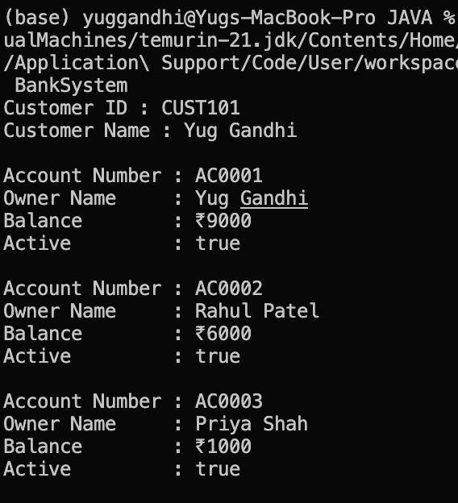
OUTPUT:
LINK: https://github.com/yuggandhi1812-code/bankproject.git
KEY QUESTIONS:
1.What is encapsulation, and how do private fields with public getters enforce it?
-Encapsulation is an OOP concept that combines data and methods into a single class while restricting direct access to the data. Private fields cannot be accessed directly from outside the class. Public getter methods provide controlled access to these fields, helping protect the object’s data and maintain data integrity.
- Why is accountNumber declared final?
-The accountNumber is declared final because it should not change after an account is created. Declaring it final ensures that each account has a permanent and unique account number throughout its lifetime.
- What is the difference between a static field and an instance field when generating ids?
-A static field is shared by all objects of a class, so a single counter can generate unique IDs for every object. An instance field belongs to each individual object, so each object would have its own separate counter, which would not generate unique IDs across all objects. Therefore, a static field is used for ID generation.
Subject: | OOP-JAVA
Name: | Yug gandhi
ID No.: | 25AIML013

Practical-3

Part A

PROBLEM-1 : Distinct points (Point.java + Driver.java with main)
- Create class Point with private int x, y and a constructor.
- Override toString() to return “(x, y)”.
- Override equals(Object) to be true when both x and y match, and hashCode() to agree
(e.g. Objects.hash(x, y)).
- In Driver.main: build a Point[] with some repeated coordinates.
- Count distinct points: for each point, use equals() to check whether it already appeared earlier; count those that did not.
- Print “Distinct: N”.
Expected output: 5 points with 2 repeats → “Distinct: 3”.

CODE : Point.java import java.util.Objects;
public class Point {
private int x; private int y;
public Point(int a, int b) {
    - = a;
    - = b;
}
@Override
public String toString() { return "(" + x + ", " + y + ")";
}
@Override public boolean equals(Object obj) {
if (obj == this)
return true;
if (obj == null || !(obj instanceof Point))
return false;
Point p = (Point) obj;
return x == p.x && y == p.y;
}
@Override
public int hashCode() {
return Objects.hash(x, y);
}
}

CODE : Driver.java public class Driver { public static void main(String[] args) {
Point[] p = { new
Point(1, 2), new Point(3,
4), new Point(1, 2), //
Repeat new Point(5, 6),
new Point(3, 4) // Repeat
};
int count = 0;
for (int a = 0; a < p.length; a++) {
boolean check = false;
for (int b = 0; b < a; b++) {
if (p[a].equals(p[b])) { check = true;
break;
} }
if (!check) {
count++;
}
}
System.out.println("Distinct: " + count);
}
}
OUTPUT :

PROBLEM-2 : Duplicate card check (Card.java + Driver.java)
- Create class Card with private String rank, suit and a constructor.
- Override toString() to return rank + “ of ” + suit (e.g. “Queen of Hearts”).
- Override equals()/hashCode() by rank + suit.
- In Driver.main: add cards to a Card[] one at a time; before adding each, use equals() to check it against the earlier cards.
- Print “Duplicate found: <card>” the first time a repeat appears.
Expected output: a second “Ace of Spades” → “Duplicate found: Ace of Spades”.

CODE : public class Driver {
static class Card {
private String cardRank; private String cardSuit;
public Card(String cardRank, String cardSuit) { this.cardRank = cardRank; this.cardSuit = cardSuit;
}
@Override public String toString() { return cardRank + " of
" + cardSuit;
}
@Override public boolean equals(Object obj) {
if (this == obj)
return true;
if (!(obj instanceof Card))
return false;
Card c = (Card) obj;
return cardRank.equals(c.cardRank) && cardSuit.equals(c.cardSuit);
}
@Override public int hashCode() { return
cardRank.hashCode() + cardSuit.hashCode();
}
}
public static void main(String[] args) { Card[] c = new Card[5];
c[0] = new Card("Ace", "Spades"); c[1] = new Card("King", "Hearts"); c[2] = new Card("Queen", "Clubs"); c[3] = new Card("Ace", "Spades"); c[4] = new Card("Jack", "Diamonds");
for (int i = 0; i < c.length; i++) {
boolean check = false;
for (int j = 0; j < i; j++) { if (c[i].equals(c[j])) { check = true;
break;
}
}
if (check) {
System.out.println("Duplicate found: " + c[i]);
break;
}
}
}
}

OUTPUT :
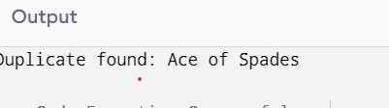

PROBLEM-3 : Fractions (Fraction.java + Driver.java) (a) Create class Fraction with private int num, den.
- In the constructor, reduce to lowest terms: compute g = gcd(num, den) and divide both by g.
- Override toString() to return num + “/” + den.
- Override equals()/hashCode() using the reduced num and den.
- In Driver.main: create several equivalent fractions (1/2, 2/4, 3/6) and confirm they are all equal and print the same.
Expected output: new Fraction(2,4) prints “1/2” and equals new Fraction(1,2).

CODE : public class Driver {
static class Fraction { private int n;
private int d;
public Fraction(int n, int d) { int g = gcd(n, d); this.n = n / g; this.d = d / g;
}
private int gcd(int a, int b) {
while (b != 0) {
int t = b;
b = a % b;
a = t;
}
return a;
}
@Override public String toString() {
return n + "/" + d;
}
@Override public boolean equals(Object obj) {
if (this == obj)
return true;
if (!(obj instanceof Fraction)) return false;
Fraction f = (Fraction) obj;
return n == f.n && d == f.d;
}
@Override public
int hashCode() {
return n + d;
}
}
public static void main(String[] args) {
Fraction f1 = new Fraction(1, 2);
Fraction f2 = new Fraction(2, 4);
Fraction f3 = new Fraction(3, 6);
System.out.println(f1);
System.out.println(f2);
System.out.println(f3);
System.out.println(f1.equals(f2)); System.out.println(f2.equals(f3));
System.out.println(f1.equals(f3));
}
}

OUTPUT :
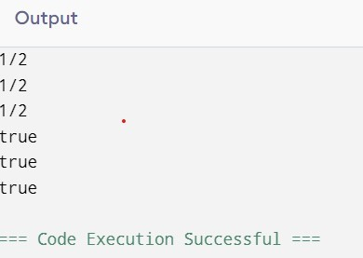

PART-B
code:
public class Driver {
static class Account { private int accNo; private String name; private double bal;
public Account(int accNo, String name, double bal) { this.accNo = accNo; this.name = name;
this.bal = bal;
}
@Override public String toString() { return "Account No: " +
accNo + ", Name: " + name + ", Balance: " + bal;
}
@Override public boolean equals(Object obj) {
if (this == obj)
return true;
if (!(obj instanceof Account))
return false;
Account a = (Account) obj;
return accNo == a.accNo;
}
@Override public int hashCode() {
return accNo;
}
}
static class Customer implements Cloneable {
private String name;
private Address address;
public Customer(String name, Address address) { this.name = name; this.address = address;
}
public Address getAddress() {
return address;
}
@Override public Customer clone() {
try {
return (Customer) super.clone();
} catch (CloneNotSupportedException e) {
return null;
}
}
public static class Address { private String line; private String city; private String pincode;
public Address(String line, String city, String pincode) {
this.line = line;
this.city = city; this.pincode = pincode;
}
public String getLine() {
return line;
}
public String getCity() {
return city;
}
public String getPincode() {
return pincode;
}
}
}
public static void main(String[] args) {
Account a1 = new Account(101, "Yug", 5000);
Account a2 = new Account(101, "Rahul", 8000);
Account a3 = new Account(102, "Amit", 7000);
System.out.println(a1);
System.out.println(a2);
System.out.println(a3);
System.out.println(a1.equals(a2));
System.out.println(a1.equals(a3));
Customer.Address ad = new Customer.Address("MG Road", "Anand", "388001");
Customer c1 = new Customer("Yug", ad);
Customer c2 = c1.clone();
System.out.println(c1.getAddress().getCity());
System.out.println(c2.getAddress().getCity());
System.out.println(a1 instanceof Account);
System.out.println(c1 instanceof Customer);
}
}

OUTPUT:
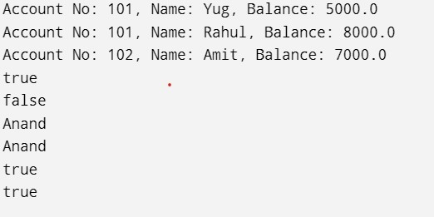
Key Questions :

- Why must equals() and hashCode() be overridden together?
Answer:
Because if two objects are equal according to equals(), they must return the same hashCode(). This ensures collections like HashSet and HashMap work correctly.
- What does the default Object.toString() return, and why override it?
Answer:
The default toString() returns the class name followed by the object's hexadecimal hash code (for example, Account@5a07e868). We override it to display meaningful, readable information about the object.

- What is the difference between a static nested class and an inner class?
Answer:
Static nested class: Declared with the static keyword and does not require an object of the outer class to be created.
Inner class: Declared without static and requires an object of the outer class to access or create it.

Subject: | OOP-JAVA
Name: | Yug Gandhi
ID No.: | 25AIML013

Practical-4

Part A
PROBLEM-1 : Password strength
- In PasswordChecker, check four rules — length ≥ 8, contains an uppercase letter,contains a digit, contains a special character — using regex (e.g. “.*[A-Z].*”) or String methods.
- Write strength(String pw) that counts how many rules pass and returns “Weak” (0–1), “Medium” (2–3) or “Strong” (4).
- In Driver.main: test several passwords; for each, print which rules passed and thefinal label.
Expected output: “abc” → Weak; “Abcd1234!” → Strong.
CODE :
import java.util.*;
public class prac_4 { public static void main(String args[]) {
Scanner sc = new Scanner(System.in);
System.out.print("Enter password: "); String s = sc.nextLine();
int count = 0;

if (s.length() >= 8)
count++;

if (s.matches(".*[A-Z].*"))
count++;
if (s.matches(".*[^a-zA-Z0-
9].*")) count++; if (s.matches(".*[0-9].*"))
count++;
System.out.println("Criteria matched: " + count + "/4");
if (count == 4)
System.out.println("Strong Password");
else
System.out.println("Weak Password");

}

OUTPUT :
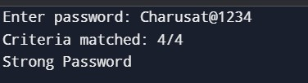
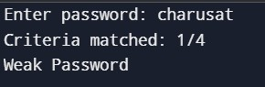
PROBLEM-2 : Chat-log filter
- In Driver.main, define a String[] of log lines like “10:05 alice Hello there” (includeone malformed line with fewer than 3 parts).
- Read a keyword from the user.
- For each line, split into time/user/message with split(“ ”, 3); skip lines that do nothave 3 parts.
- If the message contains the keyword (case-insensitive), increment a counter andappend “time user: message” to a StringBuilder.
- Print “Matches: N” and the built report.
Expected output: keyword “hello” over 3 lines (1 malformed) → “Matches: 1” and the matching line.
CODE : import java.util.*; public class prac_4_ii { public static void main(String[] args) {
Scanner sc= new Scanner(System.in);
String[] logs=
{
"10:05 alice Hello there",
"10:10 bob How are you?",
"InvalidLine"
};
System.out.print("Enter keyword: "); String keyword = sc.nextLine(); int count = 0;
StringBuilder sb = new StringBuilder();

for (String line : logs) {

String[] parts = line.split(" ", 3);

if (parts.length < 3) {
continue;
}
String time = parts[0];
String user = parts[1]; String message = parts[2]; if
(message.toLowerCase().contains(keyword.toLowerCase())) {
count++; sb.append(time) .append(" ")
.append(user)
.append(": ")
.append(message)
.append("\n");
}
}
System.out.println("\nMatches: " + count);
System.out.println(sb);

sc.close();

}
}
OUTPUT :
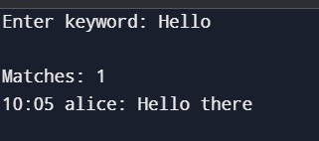
PROBLEM-3 : Template filler
- In Driver.main, define a template like “Dear {name}, order {id} ships {date}.” andtwo parallel arrays: names {“name”, “id”} and values {“Riya”, “A07”} (note {date} is not supplied).
- Compile a Pattern for \{(\w+)\} and get a Matcher on the template.
- Walk the matches with a StringBuilder: for each {placeholder}, look up its value inthe names array and replace with the value, or with “[?]” if not found.
- Print the filled template.
Expected output: the unsupplied {date} becomes [?].
CODE : import java.util.*; import java.util.regex.*;
public class Driver { public static void main(String[] args) {
String template = "Dear {name}, order {id} ships {date}.";
String[] names = {"name", "id"};
String[] values = {"Riya", "A07"};
Pattern pattern = Pattern.compile("\\{(\\w+)\\}");
Matcher matcher = pattern.matcher(template);
StringBuilder sb = new StringBuilder();
int last = 0; while (matcher.find()) {
sb.append(template.substring(last, matcher.start()));
String placeholder = matcher.group(1); String replacement = "[?]";
for (int i = 0; i < names.length; i++) { if (names[i].equals(placeholder)) {
replacement = values[i];
break;
}
}
sb.append(replacement);
last = matcher.end();
}
sb.append(template.substring(last));
System.out.println(sb);
}
}
OUTPUT :

Key Questions :
- What is the difference between String, StringBuilder and StringBuffer, and when is each preferred?
Answer:
String, StringBuilder, and StringBuffer are classes used to handle strings in Java.
  - String is immutable, which means its value cannot be changed after creation. It is preferred when the string does not need frequent modification.
  - StringBuilder is mutable, meaning its value can be changed. It is faster and preferred when frequent string modifications are required in a single-threaded program.
  - StringBuffer is also mutable but is synchronized and thread-safe. It is preferred when strings are modified by multiple threads.
- What does the regular expression [6-9][0-9]{9} match, and why use anchors?Answer:
The regular expression [6-9][0-9]{9} matches a 10-digit number where the first digit is between 6 and 9 and the remaining 9 digits can be any number from 0 to 9.
Anchors ^ and $ are used to ensure that the complete string matches the pattern. ^ indicates the start and $ indicates the end of the string.
Example: ^[6-9][0-9]{9}$ matches 9876543210.
- Why should input be validated at the boundary before it is used?
Answer:
Input should be validated at the boundary before it is used to ensure that the data is correct, safe, and in the expected format. It prevents invalid or harmful data from entering the program and causing errors or security problems.
For example, checking a user's age before using it ensures that only valid values are processed.

PRAC-5
1

AIM:
The aim of this program is to understand abstraction and polymorphism in Java.
It demonstrates how to create an abstract Shape class with an abstract area() method. Different subclasses such as Circle, Rectangle, and Triangle calculate their areas differently.A Shape[] array is used to store different types of shapes together.
The program uses a single loop to calculate and display each shape's area.
It also calculates the running total and identifies the shape with the largest area.
This program helps understand runtime polymorphism through method overriding.
Code:
abstract class Shape {
abstract double area();
}
class Circle extends Shape {
double r;
Circle(double r) {
this.r = r;
}
@Override double area() {
return Math.PI * r * r;
}
}
class Rectangle extends Shape {
double l, w;

25AIML013 Practical 5
Rectangle(double l, double w) { this.l = l; this.w = w;
}
@Override double area() { return l * w;
}
}
class Triangle extends Shape { double b, h;
Triangle(double b, double h) {
this.b = b;
this.h = h; }
@Override double area() { return 0.5 * b * h;
}
}
public class Main { public static void
main(String[] args) {
Shape[] arr = { new Circle(5), new Rectangle(4, 6), new
Triangle(8, 3), new Circle(3)
};
double sum = 0; double max = 0;
for (Shape x : arr) {
double a = x.area();
CSPIT-AIML 56
System.out.println("Area = " +
a); sum += a;
if (a > max) { max = a;
}
}
System.out.println("Total area = " + sum);
System.out.println("Largest area = " + max);
}
}
Output:
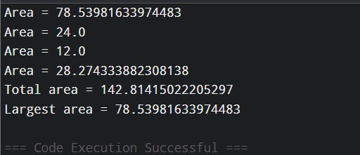
2

AIM:
to apply abstraction, inheritance, and polymorphism to media items.
It demonstrates an abstract Media class with a common title and late days.
Different media types such as books, DVDs, and magazines calculate late fees differently.
Each subclass overrides the lateFee() method according to its own fee rule.
A mixed Media[] array is used to store different types of media.
The program calculates and displays the late fee for each returned media item.
It also calculates the total late fees for the complete batch.
Code:

25AIML013 Practical 5
abstract class Employee {
String n; int i;
Employee(String n, int i) { this.n = n; this.i = i;
}
abstract double monthlySalary();
}
class FullTime extends Employee {
double s;
FullTime(String n, int i, double s) { super(n, i); this.s = s; }
@Override double monthlySalary() {
return s;
}
}
class PartTime extends Employee {
double h; double r;
PartTime(String n, int i, double h, double r) { super(n, i); this.h = h; this.r = r; }
@Override double monthlySalary() {
return h * r;
}
}
class Intern extends Employee {
double st;
Intern(String n, int i, double st) { super(n, i); this.st = st; }
CSPIT-AIML 58
@Override double monthlySalary() {
return st;
}
}
public class Main { public static void main(String[] args) {
Employee[] arr = { new
FullTime("A", 101, 50000), new PartTime("B", 102, 80, 300), new Intern("C", 103, 15000), new FullTime("D", 104, 60000)
};
double total = 0;
for (Employee x : arr) { double sal = x.monthlySalary();
System.out.println(x.n + " (ID: " + x.i + ") - Salary: INR " + sal);
if (x instanceof Intern) {
System.out.println("Note: This employee is an Intern.");
}
total += sal;
}
System.out.println("Total Salary: INR " + total);
}
}

Output:
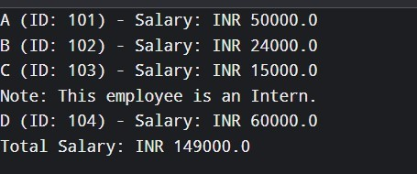
3

AIM:
To develop a Java program to fill placeholders in a given text template. The program uses a regular expression to identify placeholders in the template.
Each placeholder is matched with its corresponding name in a parallel array.
The associated value is substituted for every supplied placeholder.
If a placeholder has no corresponding value, it is replaced with [?].
A StringBuilder is used to construct the final filled template efficiently.
The completed template is then displayed as the output.
Code:
abstract class Media { String itemName; int overdueDays;
Media(String itemName, int overdueDays) { this.itemName = itemName; this.overdueDays = overdueDays;
}
abstract double calculateFee();
} class Book extends Media
{
Book(String itemName, int overdueDays) { super(itemName, overdueDays);
}
@Override double calculateFee() { return overdueDays * 2;
}
} class DVD extends Media
{
DVD(String itemName, int overdueDays) { super(itemName, overdueDays);
}
@Override double calculateFee() { return overdueDays * 5;
}
} class Magazine extends Media
{
Magazine(String itemName, int overdueDays) { super(itemName, overdueDays);
}
@Override double calculateFee() { return overdueDays *
1.5;
}
} class Newspaper extends Media
{
Newspaper(String itemName, int overdueDays) { super(itemName, overdueDays);
}
@Override double calculateFee() { return overdueDays * 1;
}
}
public class Main {
public static void main(String[] args) {
Media[] collection = { new
Book("Java Programming", 3), new
DVD("Avatar", 2), new
Magazine("Tech Today", 4), new Newspaper("Daily News", 5)
};
double grandTotal = 0;
for (Media item : collection) { double charge = item.calculateFee();
System.out.println( item.itemName + " - Late Fee: INR " + charge

25AIML013 | Practical 5
);  CSPIT-AIML | 63
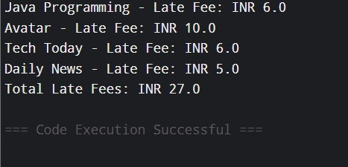
25
AIML
013
Practical 5
grandTotal += charge;
}
System.out.println("Total Late Fees: INR " + grandTotal);
}
}
Output:
10

25AIML013 Practical 5
Key Questions :
- Difference between an abstract class and a concrete class?
An abstract class is a class declared with the abstract keyword and cannot be directly instantiated. It can contain both abstract methods and fully implemented methods and is mainly used as a base class for other classes. A concrete class, on the other hand, is a normal class that provides complete implementations of its methods and can be directly instantiated to create objects. In simple words, an abstract class acts as a blueprint, while a concrete class represents the actual object.
- What is dynamic method dispatch (run-time polymorphism)?
Dynamic Method Dispatch (Run-Time Polymorphism) is a mechanism in Java where the method that gets executed is decided at run time, based on the actual object being referred to rather than the reference type. It occurs when a parent class reference refers to a child class object and the child class overrides a method of the parent class. This allows the same method call to perform different actions depending on the object.
Example: Animal a = new Dog(); and a.sound(); will call the sound() method of Dog if Dog overrides it.
- What does the super keyword do in a subclass constructor?
The super keyword in a subclass constructor is used to call the constructor of the parent class. It is mainly used to initialize the common variables inherited from the parent class. The super() call must be the first statement
CSPIT-AIML
11
in the subclass constructor. For example, super(name, id); calls the parent
constructor and initializes the shared name and id values.
Github link: https://github.com/25aiml013-sudo/JAVA-PRACTICALS.git

25AIML013  CSPIT-AIML  12 | Practical 5

CEUE203 : Object Oriented Programming 25AIML013
PRACTICAL –
6
1
AIM :
To implement a Java interface for controlling electrical devices using
on()
,
off()
, and a
default
toggle()
method. Create different device classes such as Fan and Light that
implement the interface, and demonstrate their operation using an array and loop. Also, use a
functional interface to determine whether a device can be switched on at a particular time,
implementing it using both an anonymous class and a lambda expression.
CODE
:
interface Switchable {
void on();
void off();
default void toggle() {
System.out.println("Toggling device...");
}
}
class Fan implements Switchable {
public void on() {
System.out.println("Fan is ON");
}
public void off() {
System.out.println("Fan is OFF");

CSPIT - AIML
2
CEUE203 : Object Oriented Programming 25AIML013
}
}
class Light implements Switchable {
public void on() {
System.out.println("Light is ON");
}
public void off() {
System.out.println("Light is OFF");
}
}
interface SwitchPermission { boolean maySwitchOn(Switchable item, int time);
}
public class prac_6_1 {
public static void main(String[] args) {
Switchable[] appliances =
{ new Fan(), new
Light()
};

for (Switchable appliance : appliances) { appliance.on();
CSPIT - AIML
2
CEUE203 : Object Oriented Programming 25AIML013
appliance.off();
appliance.toggle();
}
SwitchPermission permissionCheck = new SwitchPermission() {
public boolean maySwitchOn(Switchable item, int time) { return time >= 6 && time <= 22;
}
};
System.out.println( "Anonymous class: "
+ permissionCheck.maySwitchOn(new Fan(),
10)
);
SwitchPermission lambdaCheck =
(item, time) -> time >= 6 && time <= 22;
System.out.println( "Lambda: " +
lambdaCheck.maySwitchOn(new Light(), 23)
);
}
}
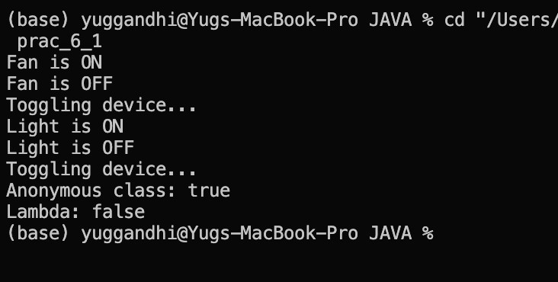
CSPIT - AIML
2
CEUE203 : Object Oriented Programming 25AIML013
OUTPUT SCREENSHOT :
LEARNING OUTCOME :
•
Learned how to achieve abstraction by defining an abstract
Shape
class with an
area()

method.
•
Understood inheritance and method overriding using
Circle
,
Rectangle
, and
Triangle

classes.
•
Implemented runtime polymorphism by keeping different shape objects inside a
Shape[]

array.
•
Used one loop to find each shape’s area, calculate the total area, and determine the
shape with the maximum area.

CSPIT - AIML
2
CEUE203 : Object Oriented Programming 25AIML013
2
To create a functional interface Notifier with a send(String) method and implement email and SMS notifications using lambda expressions. Store the notification senders in an array and deliver the same message to all of them. Also, use a marker interface Urgent to identify priority senders and send the message twice to those senders.
CODE:
interface Notifier { void send(String text);
}
interface Urgent {
}
class EmailSender implements Notifier, Urgent {

public void send(String text) {
System.out.println("Email: " + text);
}
}
class SMSSender implements Notifier {
public void send(String text) {
System.out.println("SMS: " + text);
CSPIT - AIML
2
CEUE203 : Object Oriented Programming 25AIML013
}
}
public class Main {
public static void main(String[] args) {
Notifier mailService = new EmailSender();
Notifier messageService = new SMSSender();
Notifier[] notificationList = {mailService, messageService}; String alert = "Your order has been shipped.";
for (Notifier service : notificationList) {
service.send(alert);
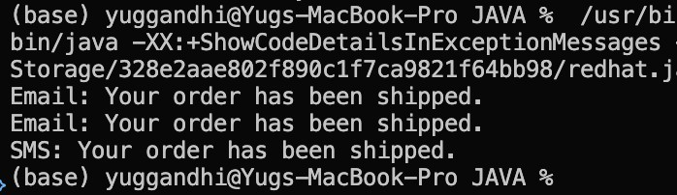
if (service instanceof Urgent) {
service.send(alert);
}
}
}
}
CSPIT - AIML
2
CEUE203 : Object Oriented Programming 25AIML013
OUTPUT SCREENSHOT :
LEARNING OUTCOME :
•
Learned to implement an abstract Employee class with an abstract monthlySalary()
method.
•
Applied inheritance and method overriding for FullTime, PartTime, and Intern.
•
Learned to use super() for constructor chaining to initialize common name and ID
attributes.
•
Applied polymorphism using a mixed Employee[] array to calculate different salaries.
•
Learned to use the instanceof operator to identify interns and display a specific note.

• Calculated individual salaries and total payroll using loops.
CSPIT - AIML
2
CEUE203 : Object Oriented Programming 25AIML013
3.
(For Advanced Learners – home) Build a small discount engine where each rule is a lambda the user picks at runtime and applies to a list of prices; organise it into packages and ship it as a runnable JAR.
CODE :
import java.util.*;
@FunctionalInterface interface DiscountRule { double apply(double amount);

}
public class DiscountEngine {
public static void main(String[] args) {
Scanner input = new Scanner(System.in);
List<Double> productPrices = Arrays.asList(
1000.0,
2500.0,
5000.0,
8000.0
);
System.out.println("Prices:");
for (double amount : productPrices) {
CSPIT - AIML
2
CEUE203 : Object Oriented Programming 25AIML013
System.out.println(amount);
}
System.out.println("\nChoose discount rule:");
System.out.println("1. 10% discount");
System.out.println("2. 20% discount");
System.out.println("3. Flat Rs. 500 discount");

int option = input.nextInt(); DiscountRule discount;
if (option == 1) { discount =
amount -> amount * 0.90;
}
else if (option == 2) { discount =
amount -> amount * 0.80;
}
else if (option == 3) { discount
= amount -> amount - 500;
}
else {
System.out.println("Invalid choice."); input.close();
return;
}
System.out.println("\nPrices after discount:");
CSPIT - AIML
2
CEUE203 : Object Oriented Programming 25AIML013
for (double amount : productPrices) {
double discountedPrice = discount.apply(amount);
if (discountedPrice < 0) {

discountedPrice = 0;
}
System.out.println(
"Original: Rs." + amount +
" -> Final: Rs." + discountedPrice
);
}
input.close();
}
}
CSPIT - AIML
2
CEUE203 : Object Oriented Programming 25AIML013
OUTPUT SCREENSHOT :
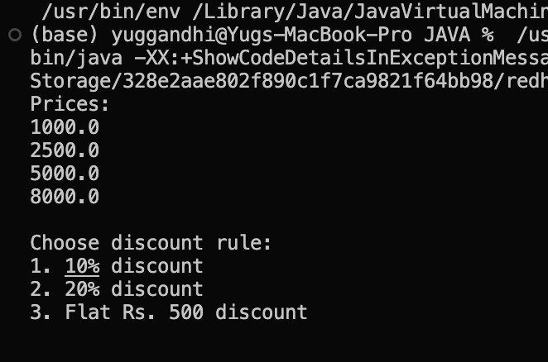
LEARNING OUTCOME :
•
Learned to design an abstract media hierarchy with different media subclasses.
•
Applied inheritance, abstraction, and method overriding to implement different latefee
rules.
•
Used polymorphism to process different media types through a common Media[] array.
•
Learned to calculate individual late fees and the total fee for a returned batch.
•
Applied instanceof to identify different media types where required.
CSPIT - AIML
2

CEUE203 : Object Oriented Programming 25AIML013
PRACTICAL – 7
AIM:
Form Validation: Create custom @NotBlank and @MaxLength(int) annotations for form fields and apply them to a SignupForm. Develop a validation checker using reflection to examine these annotations and generate a list of validation errors for a given form object.
CODE:
import java.lang.annotation.*;
import java.lang.reflect.Field; import java.util.ArrayList; import java.util.List;
@Retention(RetentionPolicy.RUNTIME)
@Target(ElementType.FIELD)
@interface NotBlank {
}
@Retention(RetentionPolicy.RUNTIME)
@Target(ElementType.FIELD)
@interface MaxLength {
int value();
} class SignupForm
{
@NotBlank
String fullName;
@NotBlank
@MaxLength(10)
String userId;
@NotBlank
@MaxLength(20)
String passcode;
SignupForm(String fullName, String userId, String passcode) { this.fullName = fullName; this.userId = userId; this.passcode = passcode;
}

ccCSPIT - AIML | 79

CEUE203 : Object Oriented Programming 25AIML013
} class FormValidator { public static List<String> checkForm(Object data) {
List<String> errorList = new ArrayList<>();
Field[] memberFields = data.getClass().getDeclaredFields(); for (Field member : memberFields) {
try {
member.setAccessible(true);
String fieldValue = (String) member.get(data);
if (member.isAnnotationPresent(NotBlank.class)) {
if (fieldValue == null || fieldValue.trim().isEmpty()) { errorList.add(member.getName() + " cannot be blank");
}
}
if (member.isAnnotationPresent(MaxLength.class)) { MaxLength limit = member.getAnnotation(MaxLength.class);
if (fieldValue != null && fieldValue.length() > limit.value()) { errorList.add(member.getName() + " cannot be more than "
+ limit.value() + " characters");
}
}
} catch (Exception ex) {
System.out.println("Error while validating field");
}
}
return errorList;
}
} public class Main { public static void

ccCSPIT - AIML | 80

CEUE203 : Object Oriented Programming 25AIML013 main(String[] args)
{
SignupForm signup = new SignupForm(
"",
"verylongusername123",
"mypassword"
);
List<String> result = FormValidator.checkForm(signup);
if (result.isEmpty()) {
System.out.println("Form is valid");
} else {
System.out.println("Validation Errors:");
for (String message : result) {
System.out.println(message);
}
}
}
}
OUTPUT SCREENSHOT:
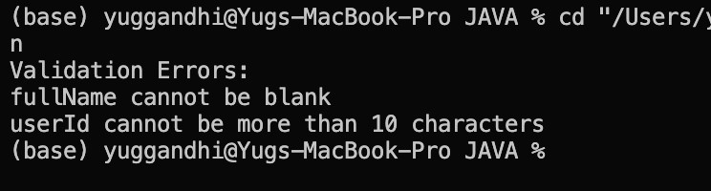
LEARNING OUTCOME:
- Understand the use of try-catch-finally blocks for handling exceptions in Java.
- Implement custom exceptions for handling specific calculator errors.
- Learn to validate user input and handle invalid numbers, operators, negative values, and division by zero.
- Use user-defined methods to improve code modularity and readability.

ccCSPIT - AIML | 81

CEUE203 : Object Oriented Programming 25AIML013
● Develop a user-input-based calculator with repeated execution and proper exception handling.
2.
Mini Test Runner: Create a custom @Run annotation and apply it to some methods that do not take any arguments. Using reflection, identify and execute only the methods marked with @Run, then display the total number of methods executed. This demonstrates the basic concept used by JUnit to detect @Test methods.
CODE:
import java.lang.annotation.*;
import java.lang.reflect.Method;
@Retention(RetentionPolicy.RUNTIME)
@Target(ElementType.METHOD)
@interface Run { } class
TestCases {
@Run
public void loginCheck() {
System.out.println("Login test passed");
}
@Run
public void signupCheck() {
System.out.println("Signup test passed");
}
public void normalCheck() {
System.out.println("This method should not run");
}
@Run
public void logoutCheck() {
System.out.println("Logout test passed");
}

ccCSPIT - AIML | 82

CEUE203 : Object Oriented Programming 25AIML013
} public class Main { public static void main(String[] args) {
TestCases testObject = new TestCases();
int total = 0;
Method[] methodList = TestCases.class.getDeclaredMethods(); for (Method currentMethod : methodList) {
if (currentMethod.isAnnotationPresent(Run.class)) {
try {
currentMethod.invoke(testObject);
total++;
} catch (Exception error) {
System.out.println("Error running test");
}
}
}
System.out.println("Total tests run: " + total); }
}

OUTPUT SCREENSHOT:
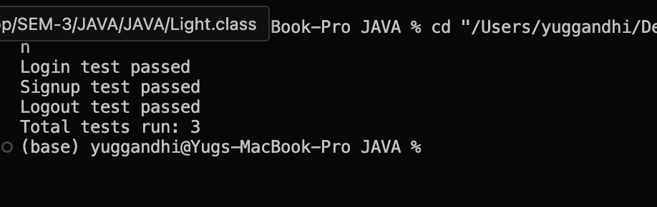

ccCSPIT - AIML | 83

CEUE203 : Object Oriented Programming 25AIML013
LEARNING OUTCOME:
- Understand how custom exceptions can carry additional information such as stock shortfall.
- Learn to manage and update inventory using arrays and methods.
- Apply multi-catch to handle related exceptions efficiently.
- Practice processing multiple requests independently within a loop.
- Improve error reporting by providing meaningful exception messages.

3.
Advanced Task: Create a @Column(name) annotation and use reflection to assign values to an object’s fields by matching the column names from a header row with the corresponding values in a data row. Also, define what should happen when a required column is missing.

CODE:
import java.lang.annotation.*; import java.lang.reflect.Field;
@Retention(RetentionPolicy.RUNTIME)
@Target(ElementType.FIELD)
@interface Column {
String name();
}
class Student {
@Column(name = "name")
String studentName;
@Column(name = "age")
String studentAge;
@Column(name = "city")
String studentCity;

ccCSPIT - AIML | 84

CEUE203 : Object Oriented Programming 25AIML013
public void display() {
System.out.println("Name: " + studentName);
System.out.println("Age: " + studentAge);
System.out.println("City: " + studentCity);
}
}
public class main {
public static void main(String[] args) {
String[] headerList = {"name", "age", "city"};
String[] dataList = {"Yug", "20", "Surat"};
Student studentObj = new Student();
Field[] fieldList = Student.class.getDeclaredFields();
for (Field currentField : fieldList) {
if (currentField.isAnnotationPresent(Column.class)) {
Column columnInfo = currentField.getAnnotation(Column.class); String fieldName = columnInfo.name();
for (int index = 0; index < headerList.length; index++) {
if (headerList[index].equals(fieldName)) {
try {
currentField.setAccessible(true); currentField.set(studentObj, dataList[index]);
} catch (Exception error) {
System.out.println("Error setting value");
}
}
}
}
}
studentObj.display();
}
}
OUTPUT SCREENSHOT:

ccCSPIT - AIML | 85

CEUE203 : Object Oriented Programming 25AIML013
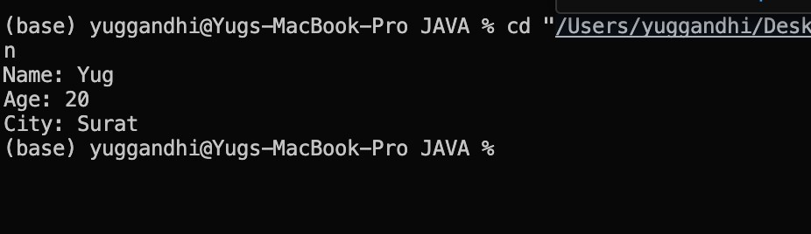

LEARNING OUTCOME:
- Understand the purpose and working of the AutoCloseable interface.
- Learn how try-with-resources automatically closes resources after use.
- Observe resource closure even when an exception occurs inside the try block.
- Understand the difference between the original and suppressed exceptions.
- Learn how automatic resource management improves reliability and reduces manual cleanup.

ccCSPIT - AIML | 86

CEUE203 : Object Oriented Programming 25AIML013
PRACTICAL – 8
AIM:
. Guarded Calculator: Create a calculator that accepts two numbers and an operator. Use a custom DivideByZeroException to handle division by zero and separately handle invalid number input. Display a clear error message for each problem, keep asking for input until a calculation is completed successfully, and use finally to record every attempt.
CODE:
import java.util.Scanner;
public class main {
public static void main(String[] args) {
Scanner input = new Scanner(System.in); boolean stop = false;
while (!stop) {
try {
System.out.print("Enter the first number : ");
String firstInput = input.nextLine();
System.out.print("Enter the second number : ");
String secondInput = input.nextLine();
System.out.print("Enter the operator (+,-,*,/) : "); String operator = input.nextLine();
int firstNumber = Integer.parseInt(firstInput); int secondNumber = Integer.parseInt(secondInput);
checkInput(firstNumber, secondNumber, operator);
int answer = performCalculation(firstNumber, secondNumber, operator); System.out.println("Result : " + answer);
stop = true;
} catch (NumberFormatException error) {
System.out.println("Error : Enter valid integers.");
} catch (NegativeNumberException | InvalidOperatorException |
ZeroMultiplicationException | DivideByZeroException error) {

System.out.println("Error : " + error.getMessage());
ccCSPIT - AIML 1
CEUE203 : Object Oriented Programming 25AIML013
} catch (ArithmeticException error) {
System.out.println("Error : Integer overflow.");
} finally {
System.out.println("Log : Attempt completed.");
}
}
input.close();
System.out.println("Calculator exited.");
}
static void checkInput(int firstNumber, int secondNumber, String operator) throws NegativeNumberException,
InvalidOperatorException,
ZeroMultiplicationException, DivideByZeroException {
if (firstNumber < 0 || secondNumber < 0) throw new NegativeNumberException("Negative numbers not allowed.");
if (!operator.matches("[+\\-*/]")) throw new InvalidOperatorException("Invalid operator.");
if (operator.equals("*") && (firstNumber == 0 || secondNumber == 0)) throw new ZeroMultiplicationException("Multiplication by zero not allowed.");
if (operator.equals("/") && secondNumber == 0) throw new DivideByZeroException("Division by zero not allowed.");
}
static int performCalculation(int firstNumber, int secondNumber, String operator) { return switch (operator) { case "+" -> Math.addExact(firstNumber, secondNumber); case "-" -> Math.subtractExact(firstNumber, secondNumber); case "*" -> Math.multiplyExact(firstNumber, secondNumber); case "/" -> firstNumber / secondNumber; default -> 0;
};
}
}

class NegativeNumberException extends Exception { NegativeNumberException(String message) { super(message);
}
}
class InvalidOperatorException extends Exception {
InvalidOperatorException(String message) {
ccCSPIT - AIML 2

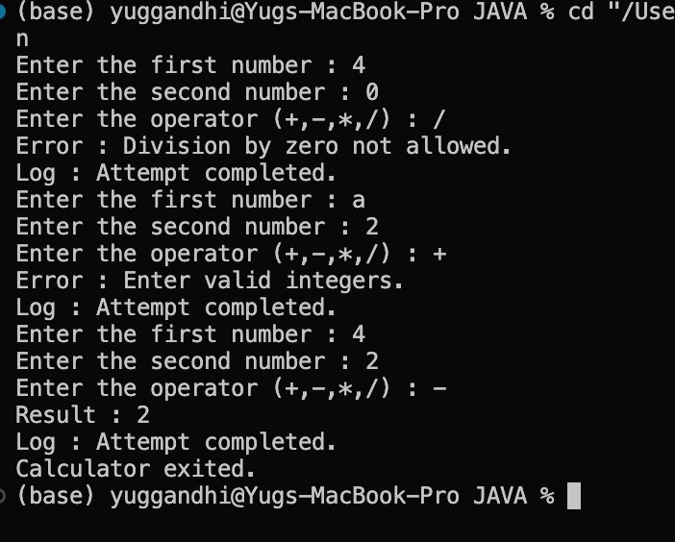
CEUE203 : Object Oriented Programming 25AIML013
CSPIT - AIML
3
cc
super
(
message
)
;
}
}
class
ZeroMultiplicationException
extends
Exception
{
ZeroMultiplicationException
(
String
message
)
{
super
(
message
)
;
}
}
class
DivideByZeroException
extends
Exception
{
DivideByZeroException
(
String
message
)
{
super
(
message
)
;
}
}
OUTPUT SCREENSHOT:
LEARNING OUTCOME:
Understand the use of try-catch-finally blocks for handling exceptions in Java.
Implement custom exceptions for handling specific calculator errors.
Learn to validate user input and handle invalid numbers, operators, negative values,
and division by zero.

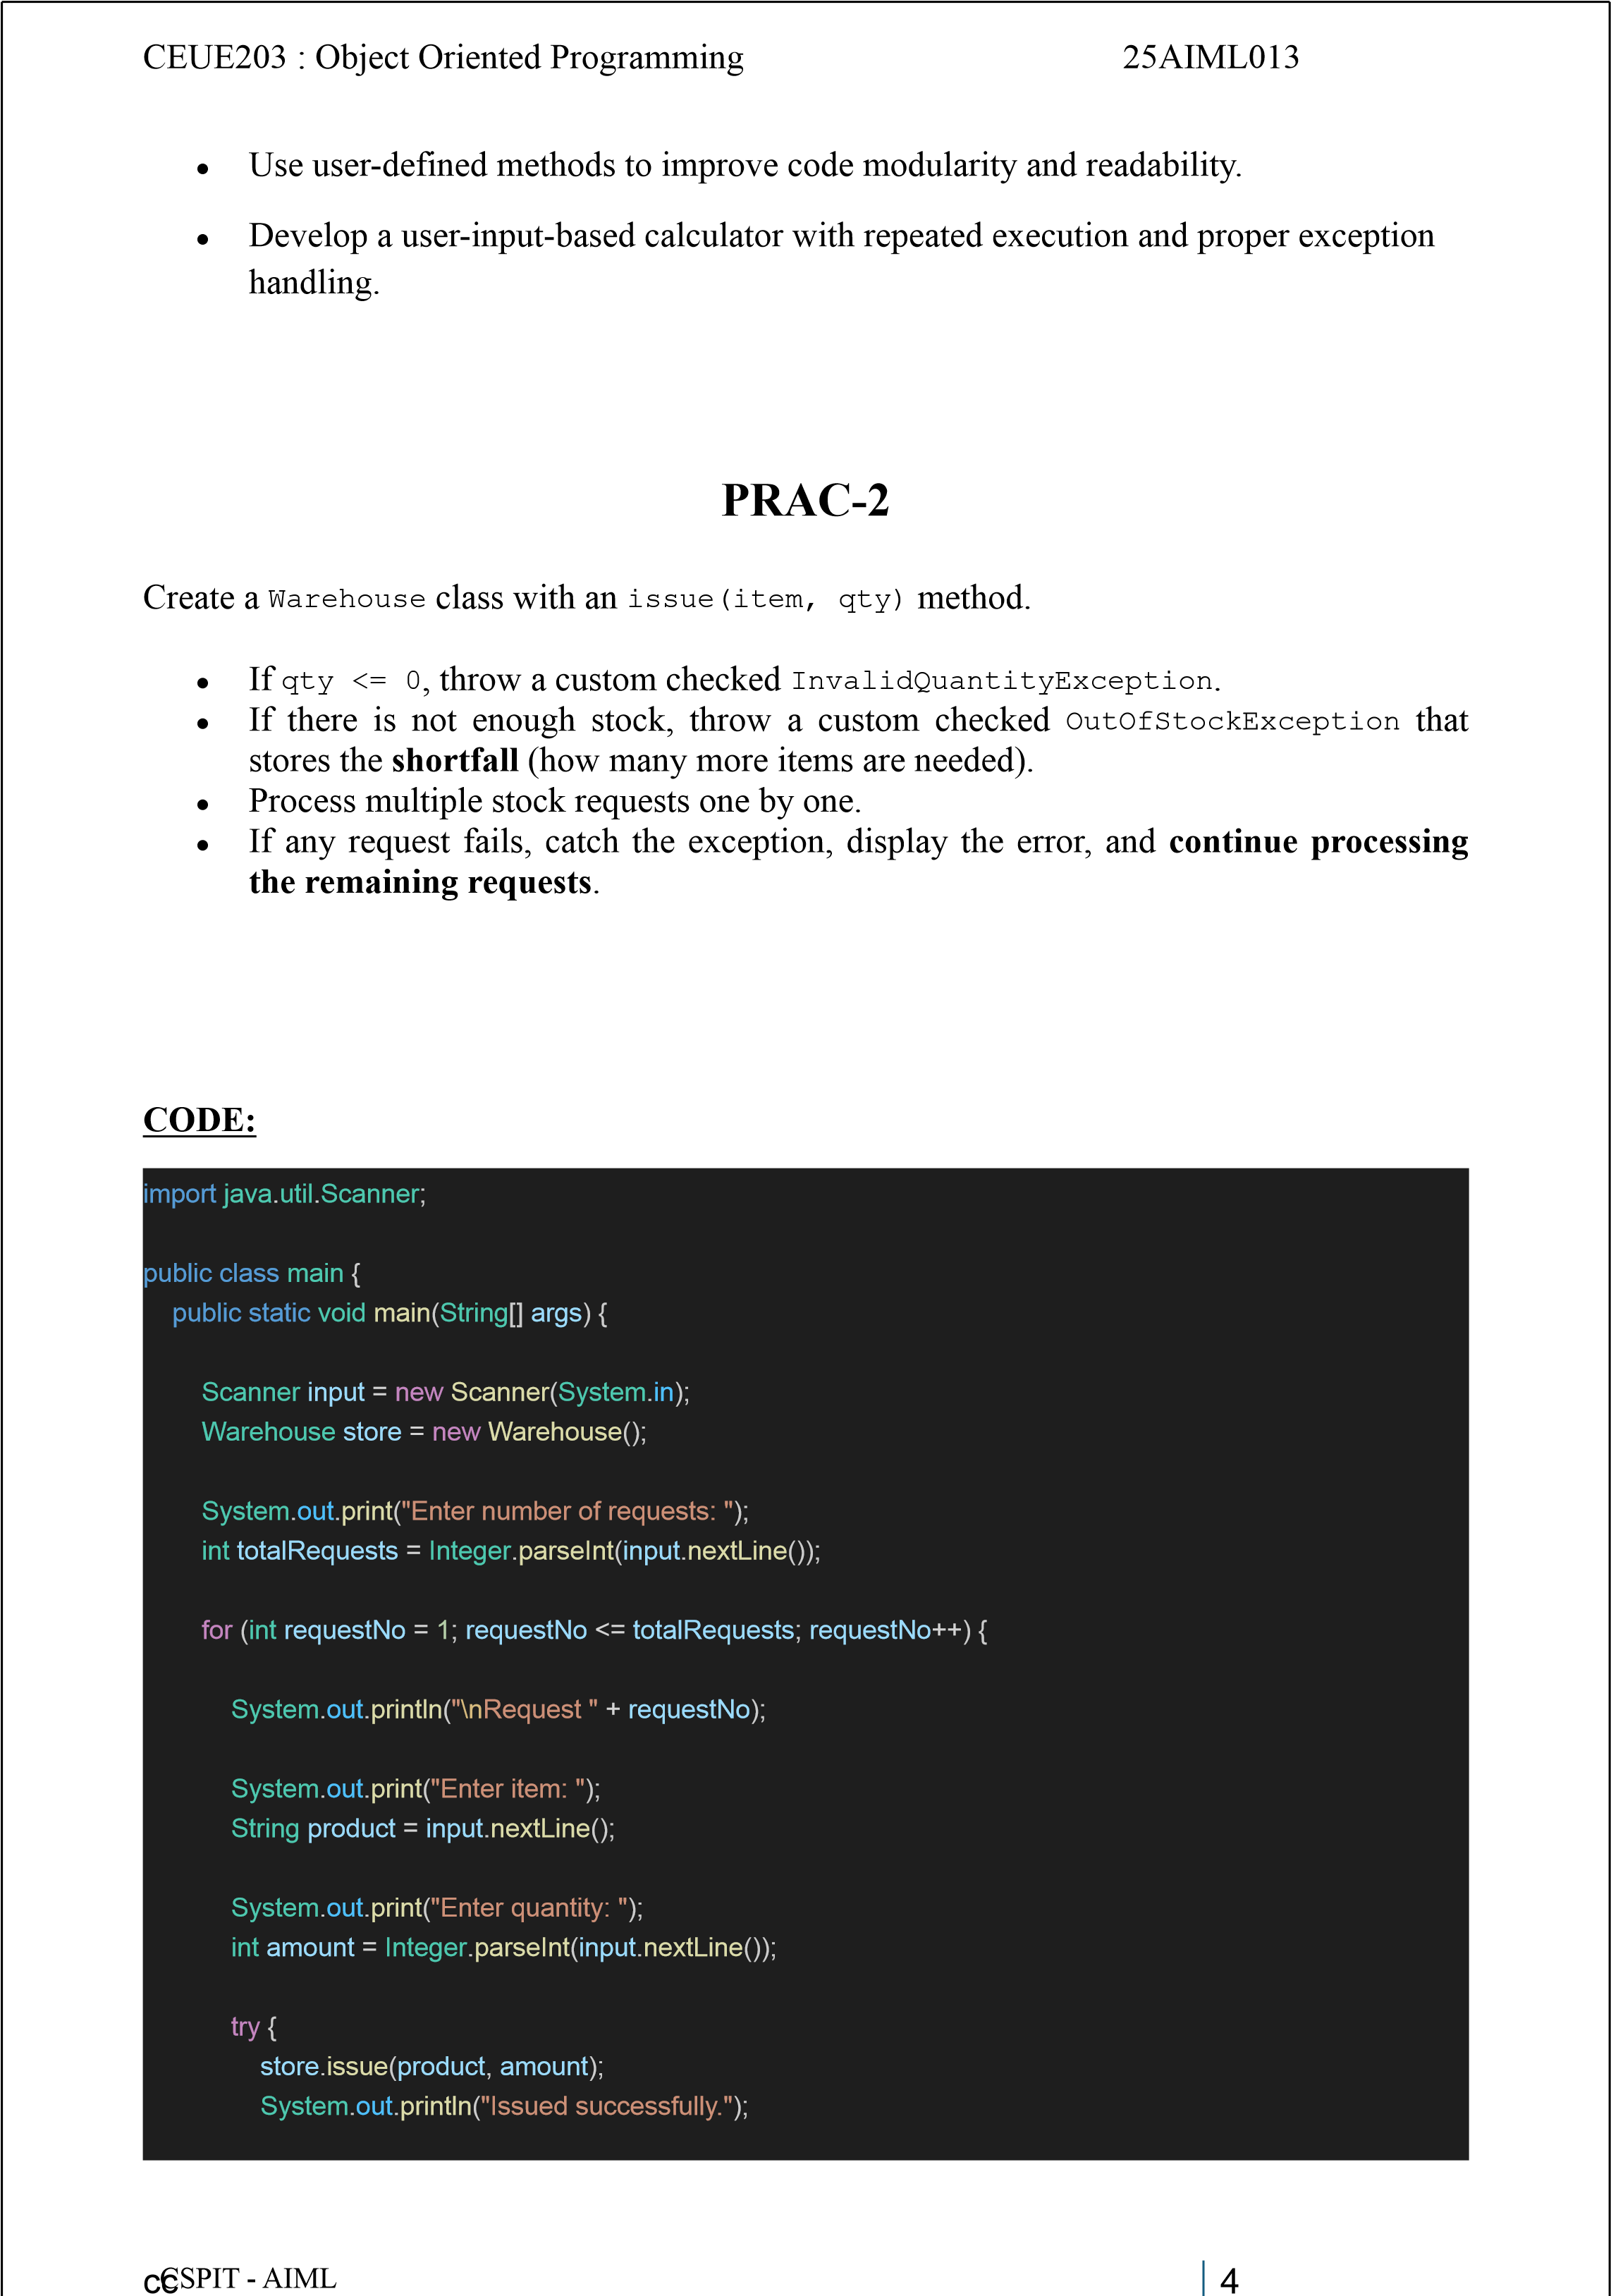

CEUE203 : Object Oriented Programming 25AIML013
} catch (InvalidQuantityException | OutOfStockException |
ItemNotFoundException error) {
System.out.println("Issue failed: " + error.getMessage());
}
}
System.out.println("\nRemaining Stock:"); store.showStock();
input.close();
}
}
class Warehouse {
String[] productList = {"Mobile", "Laptop", "IdeaPad", "Tablet"}; int[] quantityList = {45, 25, 35, 18};
void issue(String product, int amount)
throws InvalidQuantityException, OutOfStockException, ItemNotFoundException {
if (amount <= 0) throw new
InvalidQuantityException( "Quantity must be greater than 0.");
int position = -1;
for (int i = 0; i < productList.length; i++) {
if (productList[i].equalsIgnoreCase(product)) { position = i; break;
}
}
if (position == -1) throw new ItemNotFoundException("Item not found.");
if (amount > quantityList[position]) {
int missing = amount - quantityList[position];
throw new OutOfStockException(
"Out of stock. Shortfall = " + missing, missing);
}
quantityList[position] -= amount;
System.out.println(

ccCSPIT - AIML 5
CEUE203 : Object Oriented Programming 25AIML013
amount + " " + productList[position] + " issued.");
}
void showStock() {
for (int i = 0; i < productList.length; i++) {
System.out.println( productList[i] + "
: " + quantityList[i]); }
}
}
class OutOfStockException extends Exception {
int shortage;
OutOfStockException(String message, int shortage)
{ super(message); this.shortage = shortage;
}
}
class InvalidQuantityException extends Exception {
InvalidQuantityException(String message) { super(message);
}
}
class ItemNotFoundException extends Exception {
ItemNotFoundException(String message) { super(message);
} }
OUTPUT SCREENSHOT:

ccCSPIT - AIML 6

CEUE203 : Object Oriented Programming 25AIML013
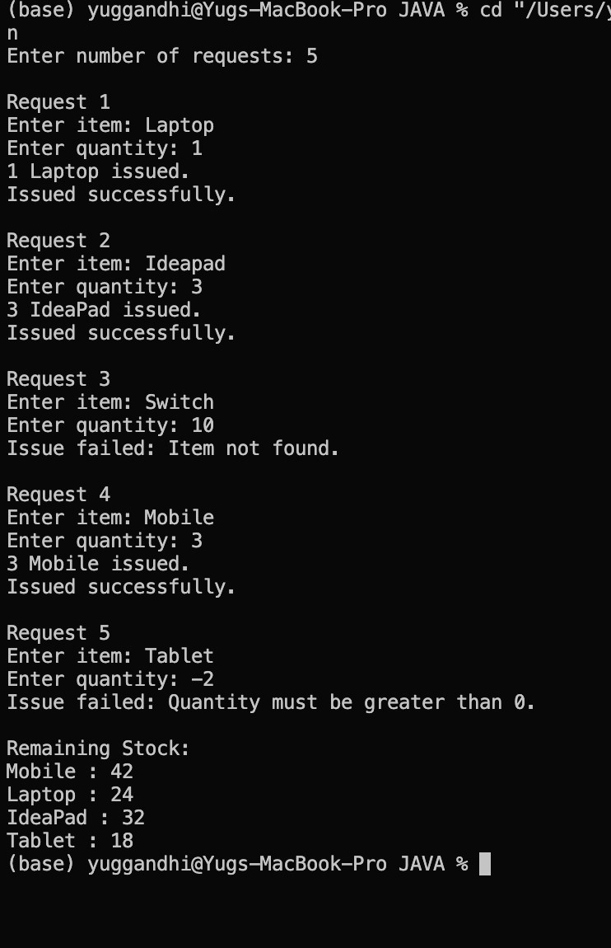
LEARNING OUTCOME:
ccCSPIT - AIML | 95

CEUE203 : Object Oriented Programming 25AIML013
- Understand how custom exceptions can carry additional information such as stock shortfall.
- Learn to manage and update inventory using arrays and methods.
- Apply multi-catch to handle related exceptions efficiently.
- Practice processing multiple requests independently within a loop.
- Improve error reporting by providing meaningful exception messages.
PRAC-3
Create a class that implements AutoCloseable and represents a resource, such as a file, database connection, or network connection.
Use try-with-resources to automatically close the resource after use. Inside the try block, deliberately throw an exception and verify that:
- The resource’s close() method is still called.
- The original exception from the try block is reported.
- The resource is properly closed even when an error occurs.
For this program, you can model the resource as a FileResource or DatabaseConnection.
CODE:
public class AutoCloseDemo {
public static void main(String[] args) {
try (FileResource file = new FileResource()) {
file.use();
throw new Exception("Original error occurred.");
} catch (Exception error) {
System.out.println("Caught: " + error.getMessage());
for (Throwable problem : error.getSuppressed()) {
System.out.println("Suppressed: " + problem.getMessage());
}
ccCSPIT - AIML | 96

CEUE203 : Object Oriented Programming 25AIML013
}
}
class FileResource implements AutoCloseable {
FileResource() {
System.out.println("Resource opened.");
}
void use() {
System.out.println("Resource is being used.");
}
}
@Override
public void close() throws Exception { System.out.println("Resource closed."); throw new Exception("Error while closing resource.");
}
}

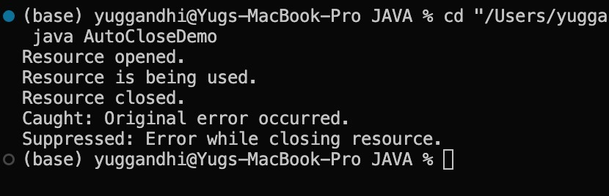
OUTPUT SCREENSHOT:
LEARNING OUTCOME:
- Understand the purpose and working of the AutoCloseable interface.
- Learn how try-with-resources automatically closes resources after use.
- Observe resource closure even when an exception occurs inside the try block.
- Understand the difference between the original and suppressed exceptions.
- Learn how automatic resource management improves reliability and reduces manual cleanup.
ccCSPIT - AIML | 97

CEUE203 : Object Oriented Programming25AIML013

Subject: | OOP-JAVA
Name: | YUG GANDHI
ID No.: | 25AIML013
Practical-9
GIT REPOSITRY LINK :
https://github.com/25aiml013-sudo/JAVA-PRACTICALS.git
Part A
PROBLEM-1 :
Counter Race: Create multiple threads that repeatedly increase a common shared counter. First, run the program without synchronization and observe that the final value may be lower than expected due to a race condition. Then synchronize the increment operation and verify that the counter always reaches the correct expected value.
CODE :
import java.util.Scanner;
class SharedCounter { int value = 0;
void addOne() { value++;
}
synchronized void safeAddOne() { value++;
}
}
public class CounterRace {
public static void main(String[] args) throws InterruptedException { Scanner input = new Scanner(System.in);
System.out.print("Enter number of threads: "); int threadCount = input.nextInt();
System.out.print("Enter increments per thread: "); int incrementCount = input.nextInt();

AIML-CSPIT 1 | P a g e
CEUE203 : Object Oriented Programming25AIML013
SharedCounter counter1 = new SharedCounter(); Thread[] workers = new Thread[threadCount];
for (int i = 0; i < threadCount; i++) { workers[i] = new Thread(() -> { for (int j = 0; j < incrementCount; j++) { counter1.addOne();
} });
workers[i].start();
}
for (Thread worker : workers) { worker.join();
}
int totalExpected = threadCount * incrementCount;
System.out.println("\nWithout synchronization:");
System.out.println("Expected count: " + totalExpected);
System.out.println("Actual count: " + counter1.value); SharedCounter counter2 = new SharedCounter();
for (int i = 0; i < threadCount; i++) { workers[i] = new Thread(() -> { for (int j = 0; j < incrementCount; j++) { counter2.safeAddOne();
} });
workers[i].start();
}
for (Thread worker : workers) { worker.join(); }
System.out.println("\nWith synchronization:");
System.out.println("Expected count: " + totalExpected); System.out.println("Actual count: " + counter2.value);
input.close();
}
}

AIML-CSPIT 2 |
P a g e
CEUE203 : Object Oriented Programming25AIML013 OUTPUT :
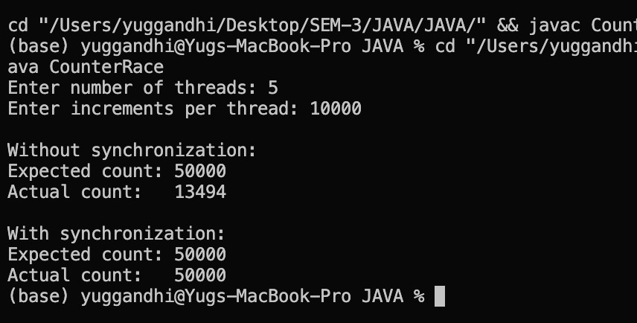
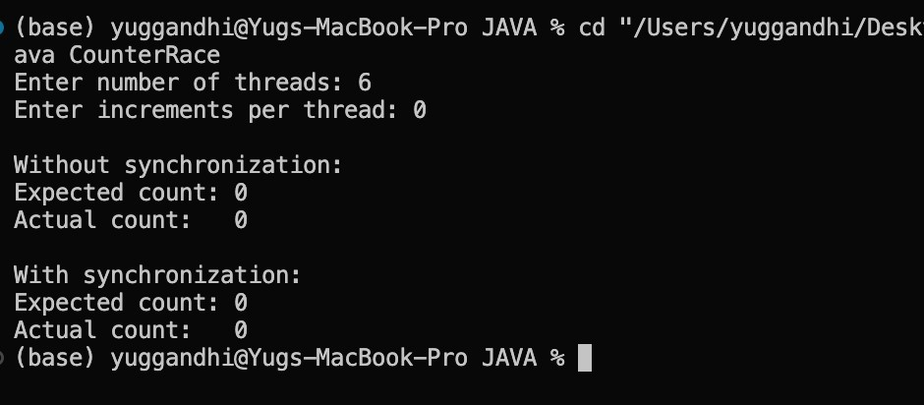

AIML-CSPIT 3 | P a g e

CEUE203 : Object Oriented Programming25AIML013
PROBLEM-2 :
Seat Booking Race: Create a shared seat counter with 5 available seats and run around 10 threads where each thread tries to book one seat. First, run the booking without synchronization and observe that more than 5 bookings may succeed due to a race condition.
Then synchronize the book() method and verify that exactly 5 bookings are successful.
CODE :
import java.util.Scanner;
class Theater { int availableSeats;
Theater(int totalSeats) { availableSeats = totalSeats;
}
void reserve(String customer) { if (availableSeats > 0) { try {
Thread.sleep(10);
} catch (InterruptedException error) {
Thread.currentThread().interrupt();
}
availableSeats--;
System.out.println(customer + " booked a seat."); } else {
System.out.println(customer + " failed. No seat available.");
}
}
synchronized void safeReserve(String customer) { if (availableSeats > 0) { try {
Thread.sleep(10);
} catch (InterruptedException error) {
Thread.currentThread().interrupt();
}
availableSeats--;
System.out.println(customer + " booked a seat."); } else {
System.out.println(customer + " failed. No seat available.");
}

}
}
AIML-CSPIT 4 | P a g e
CEUE203 : Object Oriented Programming25AIML013
public class SeatRace {
public static void main(String[] args) throws InterruptedException { Scanner input = new Scanner(System.in);
System.out.print("Enter number of seats: "); int totalSeats = input.nextInt();
System.out.print("Enter number of booking threads: "); int threadCount = input.nextInt();
Theater theater1 = new Theater(totalSeats);
Thread[] workers = new Thread[threadCount];
System.out.println("\n--- Without Synchronization ---");
for (int i = 0; i < threadCount; i++) { final int userNumber = i + 1;
workers[i] = new Thread(() -> { theater1.reserve("Customer-" + userNumber);
});
workers[i].start();
}
for (Thread worker : workers) { worker.join();
}
System.out.println("Seats left: " + theater1.availableSeats);
Theater theater2 = new Theater(totalSeats);
System.out.println("\n--- With Synchronization ---");
for (int i = 0; i < threadCount; i++) { final int userNumber = i + 1;
workers[i] = new Thread(() -> {
theater2.safeReserve("Customer-" + userNumber);

});

workers
[
i
].
start
()
;
}

for
(
Thread

worker

:

workers
)
{
worker
.
join
()
;
}

System
.
out
.
println
(
"Seats left: "

+

theater2
.
availableSeats
)
;
AIML-CSPIT 5 |
P a g e
CEUE203 : Object Oriented Programming25AIML013
input.close();
}
}
OUTPUT :
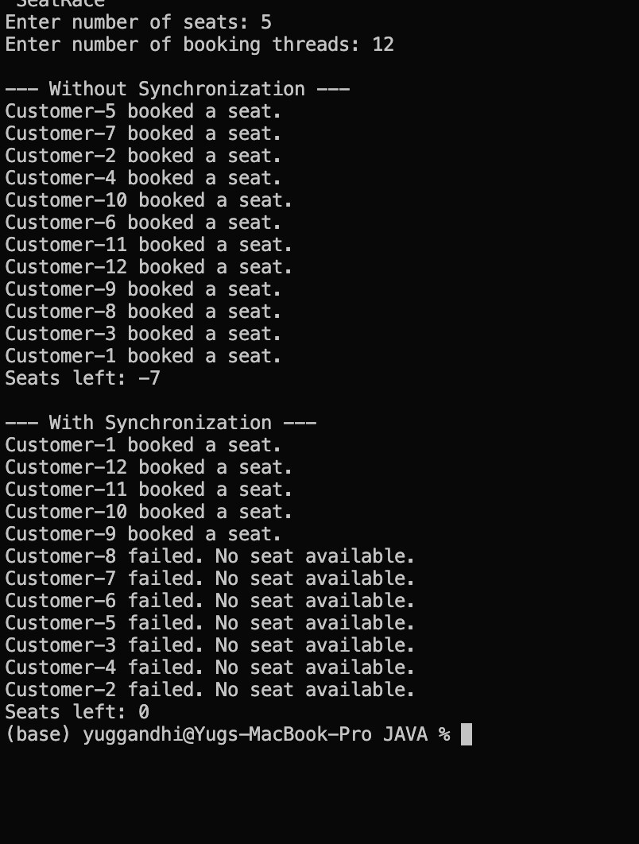

AIML-CSPIT 6 | P a g e

CEUE203 : Object Oriented Programming25AIML013
PROBLEM-3 :
Parallel Array Sum: Divide a large array of numbers among multiple threads and let them add their parts to one shared total. First, run it without synchronization and observe the incorrect result caused by a race condition. Then fix the problem using two different synchronization techniques and compare their performance. Decide how to measure the difference, such as by recording and comparing execution time.
CODE :
import java.util.Scanner;
class TotalCounter { long sum = 0;
void addValue(long number) { sum += number;
}
synchronized void safeAddValue(long number) { sum += number;
}
}
public class ArraySumRace {
public static void main(String[] args) throws InterruptedException { Scanner input = new Scanner(System.in);
System.out.print("Enter array size: "); int arraySize = input.nextInt();
System.out.print("Enter number of threads: "); int threadCount = input.nextInt();
int[] numbers = new int[arraySize];
for (int i = 0; i < arraySize; i++) { numbers[i] = i + 1;
}
long correctSum = ((long) arraySize * (arraySize + 1)) / 2;

System.out.println("\nExpected sum: " + correctSum);
TotalCounter counter1 = new TotalCounter();
Thread[] workers = new Thread[threadCount];
AIML-CSPIT 7 | P a g e
CEUE203 : Object Oriented Programming25AIML013
int partSize = arraySize / threadCount;
long begin1 = System.nanoTime();
for (int i = 0; i < threadCount; i++) { final int from = i * partSize; final int to = (i == threadCount - 1) ? arraySize : from + partSize;
workers[i] = new Thread(() -> { for (int j = from; j < to; j++) { counter1.addValue(numbers[j]);
}
});
workers[i].start();
}
for (Thread worker : workers) { worker.join();
}
long finish1 = System.nanoTime();
System.out.println("\nWithout synchronization:");
System.out.println("Sum: " + counter1.sum);
System.out.println("Time: " + (finish1 - begin1) / 1_000_000.0 + " ms"); TotalCounter counter2 = new TotalCounter();
long begin2 = System.nanoTime();
for (int i = 0; i < threadCount; i++) { final int from = i * partSize; final int to = (i == threadCount - 1) ? arraySize : from + partSize;
workers[i] = new Thread(() -> { for (int j = from; j < to; j++) { counter2.safeAddValue(numbers[j]);
}

});
workers[i].start();
}
for (Thread worker : workers) { worker.join();
}
long finish2 = System.nanoTime();
AIML-CSPIT 8 | P a g e
CEUE203 : Object Oriented Programming25AIML013
System.out.println("\nWith synchronized:");
System.out.println("Sum: " + counter2.sum);
System.out.println("Time: " + (finish2 - begin2) / 1_000_000.0 + " ms");
long[] partialSums = new long[threadCount];
long begin3 = System.nanoTime();
for (int i = 0; i < threadCount; i++) { final int position = i; final int from = i * partSize; final int to = (i == threadCount - 1)
? arraySize : from + partSize;
workers[i] = new Thread(() -> { long localSum = 0;
for (int j = from; j < to; j++) {
localSum += numbers[j];
}
partialSums[position] = localSum;
});
workers[i].start();
}
for (Thread worker : workers) { worker.join();
}
long totalSum = 0;
for (long value : partialSums) { totalSum += value;

}
long finish3 = System.nanoTime();
System.out.println("\nUsing local partial sums:");
System.out.println("Sum: " + totalSum);
System.out.println("Time: " + (finish3 - begin3) / 1_000_000.0 + " ms");
input.close();
}
}
AIML-CSPIT 9 | P a g e

OUTPUT :
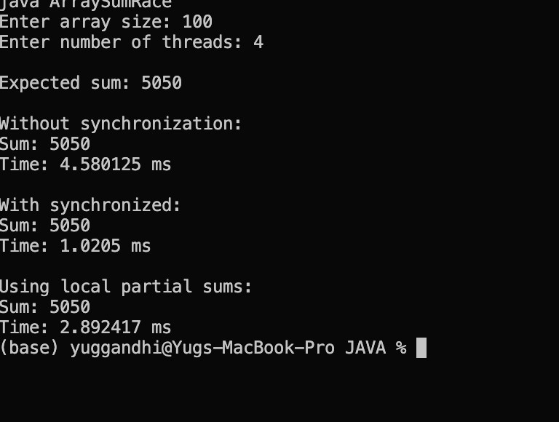

AIML-CSPIT 10
Key Questions :
1. Why is a thread pool better than creating a new thread for every task?
Answer:
A thread pool reuses a fixed number of threads instead of creating new ones for every task. This reduces thread creation overhead, improves performance, and manages system resources better.
- How do _{wait()} and _{notify()} coordinate two threads?
Answer:
wait() makes a thread release the lock and wait until it is notified. notify() wakes up a waiting thread so it can continue when the required resource becomes available.
- What causes a deadlock, and how does consistent lock ordering prevent it?
Answer:
A deadlock happens when two or more threads wait for locks held by each other. Using the same lock-acquisition order for all threads prevents them from waiting for each other indefinitely.

AIML-CSPIT 11
Subject: | OOP-JAVA
Name: | YUG GANDHI
ID No.: | 25AIML013
Practical-10
GIT REPOSITRY LINK : https://github.com/25aiml013-sudo/JAVA-PRACTICALS.git
Part A
PROBLEM-1 :
Thread Pool Runner: Create a fixed thread pool with 3 threads using ExecutorService. Submit around 10 Runnable tasks that display their task ID and sleep for a short time. Then shut down the executor and wait for all tasks to finish, observing how the same few threads are reused for multiple tasks.
CODE :
import java.util.Scanner; import java.util.concurrent.ExecutorService; import java.util.concurrent.Executors; import java.util.concurrent.TimeUnit;
public class PoolRunner {
public static void main(String[] args) throws Exception { Scanner input = new Scanner(System.in);
System.out.print("Enter number of tasks: "); int taskCount = input.nextInt();
ExecutorService executor = Executors.newFixedThreadPool(3);
for (int i = 1; i <= taskCount; i++) { final int taskId = i;
executor.submit(() -> {
System.out.println("Task " + taskId + " running on "
+ Thread.currentThread().getName());
try {
Thread.sleep(500);
AIML-CSPIT 1
} catch (InterruptedException error) {
Thread.currentThread().interrupt();
}
System.out.println("Task " + taskId + " completed");
});
}
executor.shutdown(); executor.awaitTermination(1, TimeUnit.MINUTES); System.out.println("All tasks completed.");
input.close();
}
}
OUTPUT :
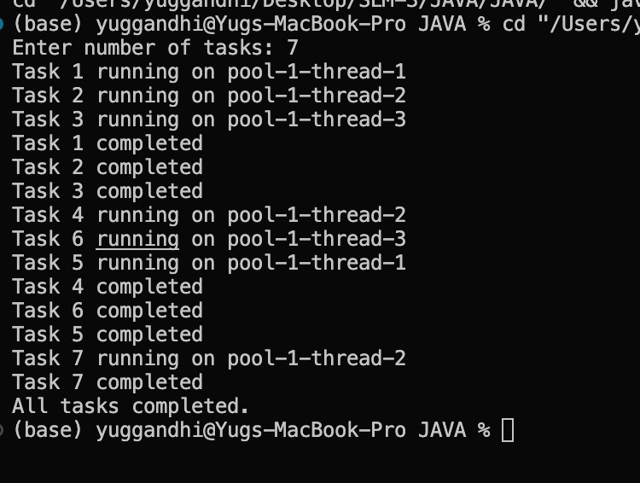

AIML-CSPIT 2

CEUE203 : Object Oriented Programming25AIML013
PROBLEM-2 :
Producer–Consumer: Create a small shared buffer where one thread produces numbers and another thread consumes them. Use wait() and notify() to coordinate both threads, ensuring that a fixed number of items are produced and consumed in the correct order without losing any items.
CODE :
import java.util.LinkedList; import java.util.Queue; import java.util.Scanner;
class SharedBuffer { private Queue<Integer> data = new LinkedList<>(); private int limit;
SharedBuffer(int size) { limit = size;
}
public synchronized void addItem(int number) throws InterruptedException { while (data.size() == limit) { wait();
}
data.add(number);
System.out.println("Produced: " + number);
notify();
}
public synchronized int removeItem() throws InterruptedException { while (data.isEmpty()) { wait();
}
int number = data.remove();
System.out.println("Consumed: " + number);
notify();
return number;
}
}
public class ProducerConsumerDemo {
public static void main(String[] args) throws Exception {
Scanner input = new Scanner(System.in);

AIML-CSPIT 3 | P a g e
CEUE203 : Object Oriented Programming25AIML013
System.out.print("Enter buffer size: "); int bufferSize = input.nextInt();
System.out.print("Enter number of items: "); int itemCount = input.nextInt();
SharedBuffer shared = new SharedBuffer(bufferSize);
Thread sender = new Thread(() -> { try { for (int i = 1; i <= itemCount; i++) { shared.addItem(i);
}
} catch (InterruptedException error) {
Thread.currentThread().interrupt();
}
});
Thread receiver = new Thread(() -> { try { for (int i = 1; i <= itemCount; i++) { shared.removeItem();
}
} catch (InterruptedException error) {
Thread.currentThread().interrupt();
}
});
sender.start(); receiver.start();
sender.join(); receiver.join();
System.out.println("All items produced and consumed.");
input.close();
}
}

AIML-CSPIT 4 |
P a g e
CEUE203 : Object Oriented Programming25AIML013 OUTPUT :
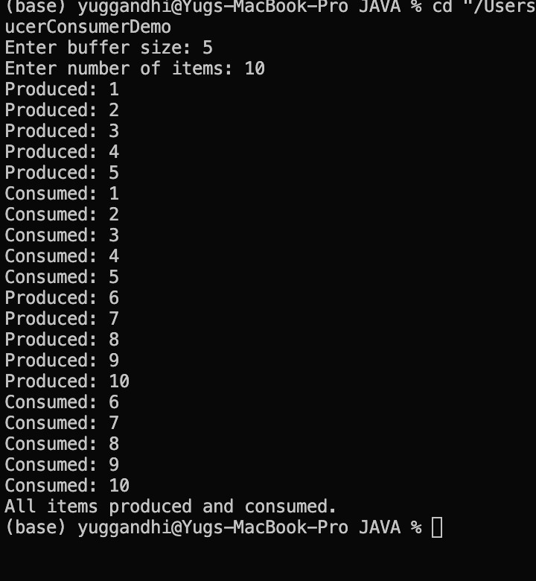

AIML-CSPIT 5 | P a g e

CEUE203 : Object Oriented Programming25AIML013
PROBLEM-3 :
Deadlock Demonstration: Create two threads that acquire two shared locks in opposite order, causing them to wait for each other and resulting in a deadlock. Then fix the problem by making both threads acquire the locks in the same consistent order, preventing the deadlock.
CODE :
import java.util.Scanner;
public class main {
static final Object resourceA = new Object(); static final Object resourceB = new Object();
static void showDeadlock() { Thread first = new Thread(() -> { synchronized (resourceA) {
System.out.println("Thread 1 locked Resource A");
try {
Thread.sleep(100);
} catch (InterruptedException error) {
Thread.currentThread().interrupt();
}
synchronized (resourceB) {
System.out.println("Thread 1 locked Resource B");
}
}
});
Thread second = new Thread(() -> { synchronized (resourceB) {
System.out.println("Thread 2 locked Resource B");
try {
Thread.sleep(100);
} catch (InterruptedException error) {
Thread.currentThread().interrupt();
}
synchronized (resourceA) {
System.out.println("Thread 2 locked Resource A");

}
}
});
AIML-CSPIT 6 | P a g e
CEUE203 : Object Oriented Programming25AIML013
first.start(); second.start();
System.out.println("Deadlock created: both threads may wait forever.");
}
static void fixDeadlock() throws InterruptedException
{ Thread first = new Thread(() -> { synchronized (resourceA) { synchronized
(resourceB) {
System.out.println("Thread 1 completed.");
}
}
});
Thread second = new Thread(() -> { synchronized (resourceA) { synchronized (resourceB) {
System.out.println("Thread 2 completed.");
}
}
});
first.start(); second.start();
first.join();
second.join();
System.out.println("No deadlock. Both threads used the same lock order.");
}
public static void main(String[] args) throws Exception { Scanner input = new Scanner(System.in);
System.out.println("1. Create Deadlock");
System.out.println("2. Avoid Deadlock"); System.out.print("Enter choice: ");
int option = input.nextInt();

if
(
option

==

1
)
{
showDeadlock
()
; }
else

if
(
option

==

2
)
{
fixDeadlock
()
;
}
else
{

System
.
out
.
println
(
"Invalid choice."
)
;
}

input
.
close
()
;
}
AIML-CSPIT 7 |
P a g e
CEUE203 : Object Oriented Programming25AIML013
}
OUTPUT :
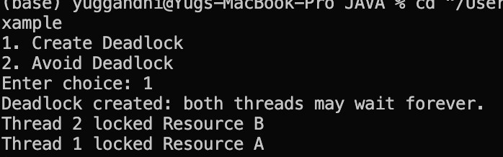
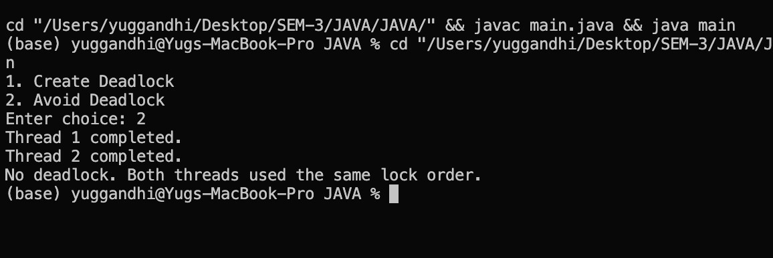
Key Questions :
1. Why is a thread pool better than creating a new thread for each task?
Answer:
A thread pool uses and reuses a fixed number of threads, which reduces the overhead of creating new threads and improves overall performance.
- How do and coordinate two threads?
wait() notify()
Answer:
wait() makes a thread pause and release its lock. notify() wakes up a waiting thread when the required resource becomes available.
- What causes a deadlock, and how does consistent lock ordering prevent it?
Answer:

AIML-CSPIT 8 | P a g e

CEUE203 : Object Oriented Programming25AIML013
A deadlock occurs when threads are waiting for locks held by each other. Using a consistent lock order ensures that all threads acquire locks in the same sequence, preventing deadlock.

AIML-CSPIT 9 | P a g e

Subject: | OOP-JAVA
Name: | Yug Gandhi
ID No.: | 25AIML013

Practical-11
GIT REPOSITRY LINK : https://github.com/25aiml013-sudo/JAVA-PRACTICALS.git

Part A
PROBLEM-1 :
Save/load: make a small class Serializable, save an array of its objects to a file with ObjectOutputStream, then read it back into fresh objects and confirm the values survived. Mark one field transient and show it is not saved.
CODE :
import java.io.*;
class Student implements Serializable { private static final long serialVersionUID = 1L;
int id;
String name; transient String password;
Student(int id, String name, String password) {
this.id = id;
this.name = name; this.password = password;
}
}
public class SerializationDemo { public static void main(String[] args) { Student[] students = { new Student(1, "Rahul", "abc123"), new Student(2, "Amit", "xyz456")
};
try {
ObjectOutputStream out = new ObjectOutputStream( new FileOutputStream("students.dat")
);
out.writeObject(students); out.close();
ObjectInputStream in = new ObjectInputStream( new FileInputStream("students.dat")
);
Student[] loaded = (Student[]) in.readObject();
in.close();
for (Student s : loaded) {
System.out.println("ID: " + s.id); System.out.println("Name: " + s.name);
System.out.println("Password: " + s.password);
System.out.println();
}
} catch (IOException | ClassNotFoundException e) {
System.out.println(e.getMessage());
}
}
}
OUTPUT :
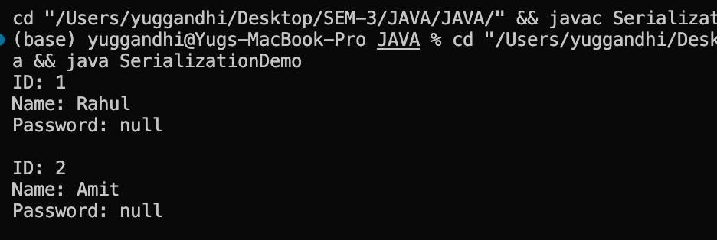
PROBLEM-2 :
Log analyzer: create a few text files, then use Path/Files to read each line by line and count the total lines and how many contain a keyword across all files; also print each file’s size from its attributes.
CODE :
import java.io.IOException; import java.nio.file.*; import java.nio.file.attribute.BasicFileAttributes; import java.util.*;
public class LogAnalyzer { public static void main(String[] args) throws IOException {
Path folder = Paths.get("logs");
Files.createDirectories(folder);
Files.write(folder.resolve("log1.txt"),
Arrays.asList("Application started", "Error found", "User logged in"));
Files.write(folder.resolve("log2.txt"),
Arrays.asList("System running", "Error occurred", "Application closed"));
int totalLines = 0; int keywordCount = 0; String keyword = "error";
try (DirectoryStream<Path> files =
Files.newDirectoryStream(folder, "*.txt")) {
for (Path file : files) { int fileLines = 0;
try (Scanner scanner = new Scanner(file)) { while (scanner.hasNextLine()) {
String line = scanner.nextLine();
totalLines++; fileLines++;
if (line.toLowerCase().contains(keyword)) { keywordCount++;
}
}
}
BasicFileAttributes attr =
Files.readAttributes(file, BasicFileAttributes.class);
System.out.println("File: " + file.getFileName());
System.out.println("Size: " + attr.size() + " bytes");
System.out.println("Lines: " + fileLines);
System.out.println();
}
}
System.out.println("Total lines: " + totalLines);
System.out.println("Lines containing '" + keyword +
"': " + keywordCount);
}
}
OUTPUT :
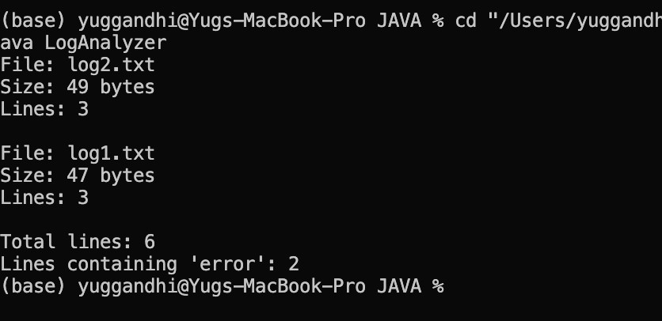
PROBLEM-3 :
Walk a folder tree with NIO and produce a report of the files it contains (name, size, modified time), writing the summary to a file; decide what to include.
CODE :
import java.io.*; import java.nio.file.*; import java.nio.file.attribute.BasicFileAttributes;
public class FolderReport { public static void main(String[] args) throws IOException {
Path folder = Paths.get("logs");
Path report = Paths.get("folder-report.txt");
try (BufferedWriter writer = Files.newBufferedWriter(report)) { writer.write("FOLDER TREE REPORT"); writer.newLine(); writer.write("=================="); writer.newLine();
Files.walkFileTree(folder, new SimpleFileVisitor<Path>() {
@Override
public FileVisitResult visitFile( Path file, BasicFileAttributes attrs) throws IOException {
writer.write("Name: " + file.getFileName()); writer.newLine();
writer.write("Size: " + attrs.size() + " bytes"); writer.newLine();
writer.write("Modified: " + attrs.lastModifiedTime()); writer.newLine();
writer.write("------------------"); writer.newLine();
return FileVisitResult.CONTINUE;
}
});
}
System.out.println("Report created: " + report.toAbsolutePath());
}
}
OUTPUT :
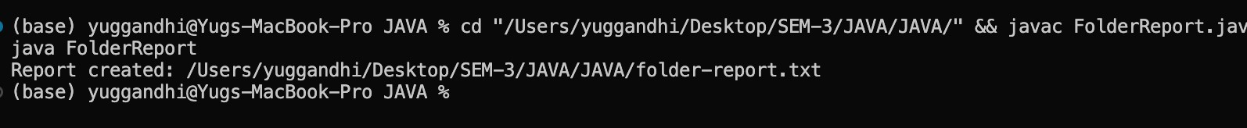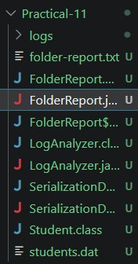
Key Questions :
- What is Serializable, and why add serialVersionUID?
Serializable allows an object to be saved as bytes. serialVersionUID identifies the class version during serialization and deserialization.
- Difference between byte stream and character stream?
- Byte stream: Handles binary data, such as images (InputStream, OutputStream).
- Character stream: Handles text data (Reader, Writer).
3. Difference between NIO Path/Files and the old File class? How is a directory stream iterated?
Path represents a file path, and Files provides advanced file operations. The old File class offers basic file handling. A DirectoryStream is iterated using a for loop to access directory entries.

Subject: | OOP-JAVA
Name: | Yug Gandhi
ID No.: | 25AIML013

Practical-12
GIT REPOSITRY LINK : https://github.com/25aiml013-sudo/JAVA-PRACTICALS.git

Part A
PROBLEM-1 :
Word frequency: split a paragraph into words, count each in a HashMap, and print the words sorted by frequency (highest first) using a Comparator.
CODE :
import java.util.*;
public class WordFrequency { public static void main(String[] args) {
String text = "java is easy java is powerful java"; Map<String, Integer> map = new HashMap<>();
for (String word : text.split(" ")) { map.put(word, map.getOrDefault(word, 0) + 1);
}
List<Map.Entry<String, Integer>> list = new ArrayList<>(map.entrySet()); list.sort((a, b) -> b.getValue().compareTo(a.getValue()));
for (Map.Entry<String, Integer> e : list) {
System.out.println(e.getKey() + " : " + e.getValue());
}
}
} OUTPUT :
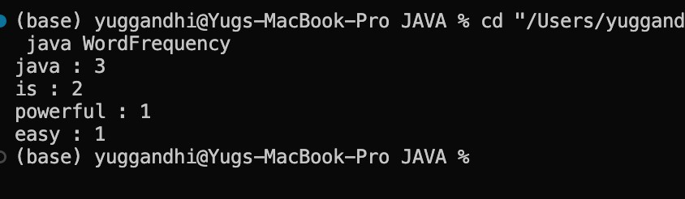
PROBLEM-2 :
Unique visitors: from a list of login names with repeats, use a HashSet to count unique users and a LinkedHashSet to keep first-seen order; print the unique count and the first three distinct names.
CODE :
import java.util.*;
public class UniqueVisitors { public static void main(String[] args) { List<String> users = Arrays.asList( "Rahul", "Amit", "Priya", "Rahul", "Neha", "Amit"
);
HashSet<String> unique = new HashSet<>(users);
LinkedHashSet<String> ordered = new LinkedHashSet<>(users); System.out.println("Unique users: " + unique.size());
int count = 0; for (String name : ordered) { if (count == 3) break; System.out.println(name); count++;
}
}
} OUTPUT :
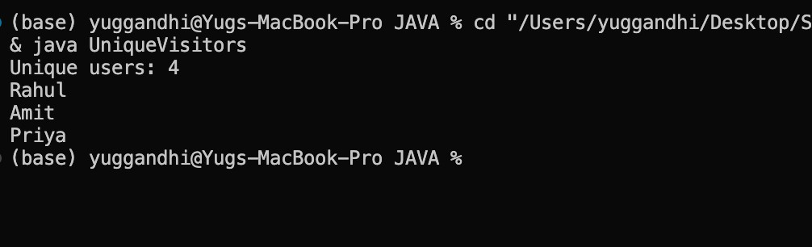
PROBLEM-3 :
Walk a folder tree with NIO and produce a report of the files it contains (name, size, modified time), writing the summary to a file; decide what to include.
CODE :
import java.util.*;
public class Leaderboard { public static void main(String[] args) { Map<String, Integer> scores = new HashMap<>();
scores.put("Rahul", 90); scores.put("Amit", 85); scores.put("Priya", 95); scores.put("Neha", 90);
List<Map.Entry<String, Integer>> list = new ArrayList<>(scores.entrySet());
list.sort((a, b) -> { int result = b.getValue().compareTo(a.getValue()); if (result == 0) return a.getKey().compareTo(b.getKey()); return result;
});
int topN = 3; for (int i = 0; i < Math.min(topN, list.size()); i++) { System.out.println( list.get(i).getKey() + " : " + list.get(i).getValue()
);
}
}
}
OUTPUT :
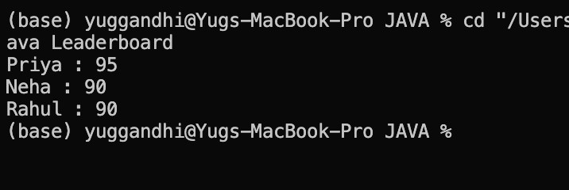
Key Questions :
- Difference between List, Set, and Map:
  - List: Stores ordered elements and allows duplicates.
  - Set: Stores unique elements without duplicates.
  - Map: Stores data as key-value pairs with unique keys.
- When do you use HashMap versus TreeMap?
  - HashMap: Use when fast data access is needed without sorted keys.
  - TreeMap: Use when keys must be stored in sorted order.
- Difference between Comparable and Comparator:
  - Comparable: Defines the natural sorting order using the compareTo() method inside the class.
  - Comparator: Defines custom sorting using the compare() method, usually in a separate class or lambda expression.

Subject: | OOP-JAVA
Name: | Yug gandhi
ID No.: | 25AIML013

Practical-13
GIT REPOSITRY LINK :
https://github.com/25aiml013-sudo/JAVA-PRACTICALS.git

Part A
PROBLEM-1 :
Generic containers: a generic Box<T> with get/set and a Pair<A,B>; use them with different types to show type safety without casts, and write a generic method that returns the first element of any array.
CODE :
class Box<T> {
private T value;
void set(T value) { this.value = value;
}
T get() { return value;
}
}
class Pair<A, B> {
- first;
- second;
Pair(A first, B second) {
this.first = first; this.second = second;
}
}
public class GenericDemo { static <T> T first(T[] array) { return array[0];
}
public static void main(String[] args) { Box<Integer> b1 = new Box<>(); b1.set(100);
System.out.println(b1.get());
Box<String> b2 = new Box<>(); b2.set("Hello");
System.out.println(b2.get());
Pair<String, Integer> p = new Pair<>("Rahul", 20);
System.out.println(p.first + " " + p.second);
String[] names = {"Amit", "Rahul", "Priya"};
System.out.println(first(names));
}
} OUTPUT :
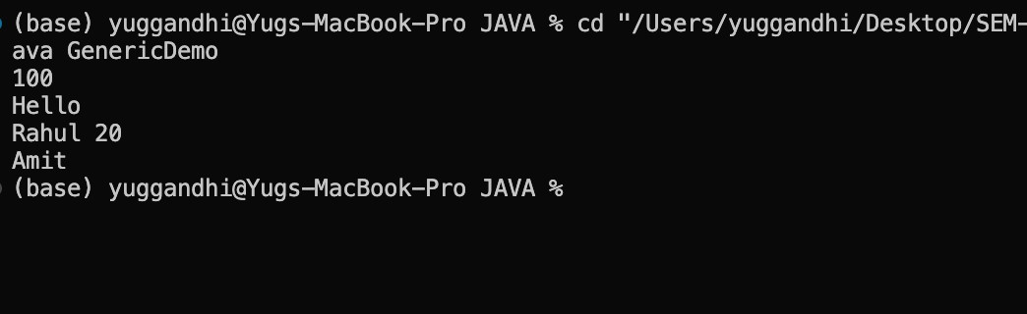
PROBLEM-2 :
Bounded stats: a generic method <N extends Number> double average(N[] values) that works for Integer[], Double[] and Long[]; note why it refuses nonNumber types.
CODE :
public class AverageDemo { static <N extends Number> double average(N[] values) { double sum = 0;
for (N n : values) { sum += n.doubleValue();
}
return sum / values.length;
}
public static void main(String[] args) {
Integer[] a = {10, 20, 30};
Double[] b = {2.5, 3.5, 4.5};
Long[] c = {100L, 200L, 300L};
System.out.println(average(a));
System.out.println(average(b));
System.out.println(average(c));
}
} OUTPUT :
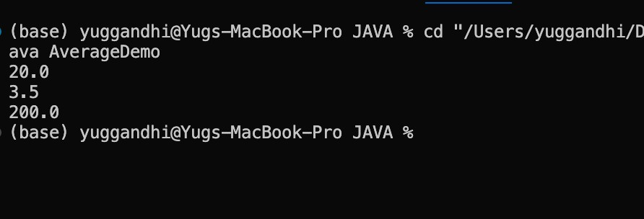
PROBLEM-3 :
Implement a small generic container of your choice (e.g. a stack) backed by an array, reuse it for two different types, and handle the empty case sensibly.
CODE :
class Stack<T> { private Object[] data; private int top = -1; Stack(int size) { data = new Object[size];
}
void push(T value) { if (top == data.length - 1) { System.out.println("Stack is full"); return;
}
data[++top] = value;
}
@SuppressWarnings("unchecked") T pop() { if (top == -1) {
System.out.println("Stack is empty"); return null;
}
T value = (T) data[top]; data[top--] = null; return value;
}
}
public class GenericStack { public static void main(String[] args) { Stack<Integer> s1 = new Stack<>(5); s1.push(10);
s1.push(20);
System.out.println(s1.pop());
Stack<String> s2 = new Stack<>(5); s2.push("Hello"); s2.push("Java");
System.out.println(s2.pop());
}
}
OUTPUT :
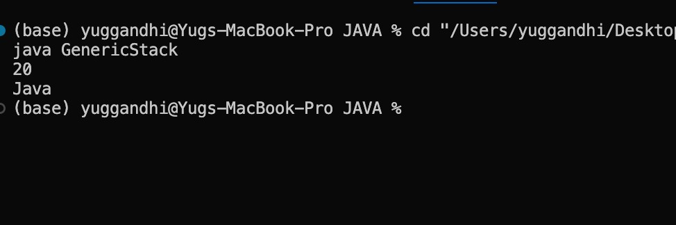
Key Questions :
- What problem do generics solve compared with using Object?
Generics provide type safety and reduce the need for type casting. They help detect type errors at compile time.
- What is a bounded type parameter, and why is <N extends Number> useful?
A bounded type parameter restricts the types that can be used. <N extends Number> allows numeric types like Integer, Double, and Long to be used in calculations.
3. What is type erasure?
Type erasure is the process in which Java removes generic type information during compilation to maintain compatibility with older Java versions.

Practical-14
GIT REPOSITRY LINK : https://github.com/25aiml013-sudo/JAVA-PRACTICALS.git

Part A
PROBLEM :
- Assemble and test: build a tiny layered app (a model, a service using an ArrayList, and a menu main), then write two or three JUnit @Test methods checking that adding increases the count and an invalid action throws — practice before testing MiniBank.
Subject: | OOP-JAVA
Name: | Yug Gandhi
ID No.: | 25AIML013
- (For Advanced Learners – home) Organise that app into packages, build a runnable JAR, and add a test that saves and reloads its data unchanged.
Command :
Output :

1
Key Questions :
- What is layered architecture (Model, Service, UI)?
  - Model: Stores application data.
  - Service: Contains business logic.
  - UI: Interacts with the user.
  - It makes code easier to maintain and test.
- How do you test exceptions in JUnit?
  - Use assertThrows() to check whether a method throws the expected exception.
  - The test passes if the expected exception occurs.
- What is a runnable JAR?
  - A JAR packages compiled Java code into a single file.
  - It can be executed using java -jar filename.jar.
2

