Subject: | OOP-JAVA
Name: | Yug gandhi
ID No.: | 25AIML013

Practical-3

Part A

PROBLEM-1 : Distinct points (Point.java + Driver.java with main)
- Create class Point with private int x, y and a constructor.
- Override toString() to return “(x, y)”.
- Override equals(Object) to be true when both x and y match, and hashCode() to agree
(e.g. Objects.hash(x, y)).
- In Driver.main: build a Point[] with some repeated coordinates.
- Count distinct points: for each point, use equals() to check whether it already appeared earlier; count those that did not.
- Print “Distinct: N”.
Expected output: 5 points with 2 repeats → “Distinct: 3”.

CODE : Point.java
import java.util.Objects;

public class Point {

private int x;
private int y;

public Point(int a, int b) {
x = a;
y = b;
}

@Override
public String toString() {
return "(" + x + ", " + y + ")";
}

@Override
public boolean equals(Object obj) {
if (obj == this)
return true;

if (obj == null || !(obj instanceof Point))
return false;

Point p = (Point) obj;
return x == p.x && y == p.y;
}

@Override
public int hashCode() {
return Objects.hash(x, y);
}
}

CODE : Driver.java
public class Driver {
public static void main(String[] args) {

Point[] p = {
new Point(1, 2),
new Point(3, 4),
new Point(1, 2), // Repeat
new Point(5, 6),
new Point(3, 4) // Repeat
};

int count = 0;

for (int a = 0; a < p.length; a++) {
boolean check = false;

for (int b = 0; b < a; b++) {
if (p[a].equals(p[b])) {
check = true;
break;
}
}

if (!check) {
count++;
}
}

System.out.println("Distinct: " + count);
}
}
OUTPUT :

PROBLEM-2 : Duplicate card check (Card.java + Driver.java)
- Create class Card with private String rank, suit and a constructor.
- Override toString() to return rank + “ of ” + suit (e.g. “Queen of Hearts”).
- Override equals()/hashCode() by rank + suit.
- In Driver.main: add cards to a Card[] one at a time; before adding each, use equals() to check it against the earlier cards.
- Print “Duplicate found: <card>” the first time a repeat appears.
Expected output: a second “Ace of Spades” → “Duplicate found: Ace of Spades”.

CODE : public class Driver {

static class Card {
private String cardRank;
private String cardSuit;

public Card(String cardRank, String cardSuit) {
this.cardRank = cardRank;
this.cardSuit = cardSuit;
}

@Override
public String toString() {
return cardRank + " of " + cardSuit;
}

@Override
public boolean equals(Object obj) {
if (this == obj)
return true;

if (!(obj instanceof Card))
return false;

Card c = (Card) obj;

return cardRank.equals(c.cardRank) && cardSuit.equals(c.cardSuit);
}

@Override
public int hashCode() {
return cardRank.hashCode() + cardSuit.hashCode();
}
}

public static void main(String[] args) {

Card[] c = new Card[5];

c[0] = new Card("Ace", "Spades");
c[1] = new Card("King", "Hearts");
c[2] = new Card("Queen", "Clubs");
c[3] = new Card("Ace", "Spades");
c[4] = new Card("Jack", "Diamonds");

for (int i = 0; i < c.length; i++) {
boolean check = false;

for (int j = 0; j < i; j++) {
if (c[i].equals(c[j])) {
check = true;
break;
}
}

if (check) {
System.out.println("Duplicate found: " + c[i]);
break;
}
}
}
}

OUTPUT :
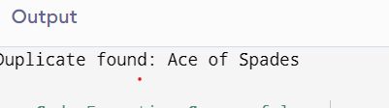

PROBLEM-3 : Fractions (Fraction.java + Driver.java)
- Create class Fraction with private int num, den.
- In the constructor, reduce to lowest terms: compute g = gcd(num, den) and divide both by g.
- Override toString() to return num + “/” + den.
- Override equals()/hashCode() using the reduced num and den.
- In Driver.main: create several equivalent fractions (1/2, 2/4, 3/6) and confirm they are all equal and print the same.
Expected output: new Fraction(2,4) prints “1/2” and equals new Fraction(1,2).

CODE : public class Driver {

static class Fraction {
private int n;
private int d;

public Fraction(int n, int d) {
int g = gcd(n, d);
this.n = n / g;
this.d = d / g;
}

private int gcd(int a, int b) {
while (b != 0) {
int t = b;
b = a % b;
a = t;
}
return a;
}

@Override
public String toString() {
return n + "/" + d;
}

@Override
public boolean equals(Object obj) {
if (this == obj)
return true;

if (!(obj instanceof Fraction))
return false;

Fraction f = (Fraction) obj;

return n == f.n && d == f.d;
}

@Override
public int hashCode() {
return n + d;
}
}

public static void main(String[] args) {

Fraction f1 = new Fraction(1, 2);
Fraction f2 = new Fraction(2, 4);
Fraction f3 = new Fraction(3, 6);

System.out.println(f1);
System.out.println(f2);
System.out.println(f3);

System.out.println(f1.equals(f2));
System.out.println(f2.equals(f3));
System.out.println(f1.equals(f3));
}
}

OUTPUT :
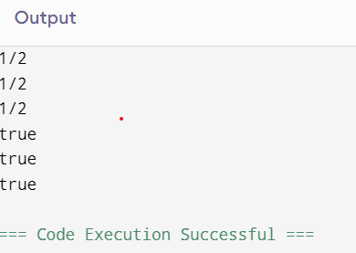

PART-B

code:
public class Driver {

static class Account {
private int accNo;
private String name;
private double bal;

public Account(int accNo, String name, double bal) {
this.accNo = accNo;
this.name = name;
this.bal = bal;
}

@Override
public String toString() {
return "Account No: " + accNo + ", Name: " + name + ", Balance: " + bal;
}

@Override
public boolean equals(Object obj) {
if (this == obj)
return true;

if (!(obj instanceof Account))
return false;

Account a = (Account) obj;
return accNo == a.accNo;
}

@Override
public int hashCode() {
return accNo;
}
}

static class Customer implements Cloneable {
private String name;
private Address address;

public Customer(String name, Address address) {
this.name = name;
this.address = address;
}

public Address getAddress() {
return address;
}

@Override
public Customer clone() {
try {
return (Customer) super.clone();
} catch (CloneNotSupportedException e) {
return null;
}
}

public static class Address {
private String line;
private String city;
private String pincode;

public Address(String line, String city, String pincode) {
this.line = line;
this.city = city;
this.pincode = pincode;
}

public String getLine() {
return line;
}

public String getCity() {
return city;
}

public String getPincode() {
return pincode;
}
}
}

public static void main(String[] args) {

Account a1 = new Account(101, "Yug", 5000);
Account a2 = new Account(101, "Rahul", 8000);
Account a3 = new Account(102, "Amit", 7000);

System.out.println(a1);
System.out.println(a2);
System.out.println(a3);

System.out.println(a1.equals(a2));
System.out.println(a1.equals(a3));

Customer.Address ad = new Customer.Address("MG Road", "Anand", "388001");
Customer c1 = new Customer("Yug", ad);
Customer c2 = c1.clone();

System.out.println(c1.getAddress().getCity());
System.out.println(c2.getAddress().getCity());

System.out.println(a1 instanceof Account);
System.out.println(c1 instanceof Customer);
}
}

OUTPUT:
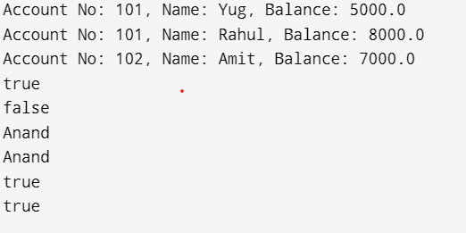

Key Questions :

- Why must equals() and hashCode() be overridden together?
Answer:
Because if two objects are equal according to equals(), they must return the same hashCode(). This ensures collections like HashSet and HashMap work correctly.
- What does the default Object.toString() return, and why override it?
Answer:
The default toString() returns the class name followed by the object's hexadecimal hash code (for example, Account@5a07e868). We override it to display meaningful, readable information about the object.

- What is the difference between a static nested class and an inner class?
Answer:
• Static nested class: Declared with the static keyword and does not require an object of the outer class to be created.
• Inner class: Declared without static and requires an object of the outer class to access or create it.

