Subject: | OOP-JAVA
Name: | Yug Gandhi
ID No.: | 25AIML013

MiniBank – Java Console Banking Application
PROJECT REPORT

GIT REPOSITORY LINK :
https://github.com/25aiml013-sudo/Mini-Bank.git

PROJECT EXPLANATION :

MiniBank is a console-based banking application written in Java. It provides a menu through which users can open accounts, deposit money, withdraw money, transfer funds between accounts, view account statements, list accounts, and generate an end-of-day report. The project demonstrates Object-Oriented Programming concepts across the semester.
The application separates its code into model, service, repository, exception, concurrency, and utility packages. It uses a generic Repository to store accounts, custom checked exceptions for banking errors, Java serialization to save account data, and file I/O to record transactions and create a report.

MAIN FEATURES :

• Open accounts using an account number, owner name, and initial balance.
• Deposit, withdraw, and transfer money with validation.
• View account statements and list stored accounts.
• Save and reload account information between runs.
• Write transaction logs and generate an end-of-day report.
• Use synchronized balance operations and transaction-processing utilities.

SCREENSHOT OF THE MAIN MODULE :

The screenshot below shows a sample execution of the MiniBank menu, including account creation, deposit, transfer, account listing, report generation, and exit. Demonstration account data is used.

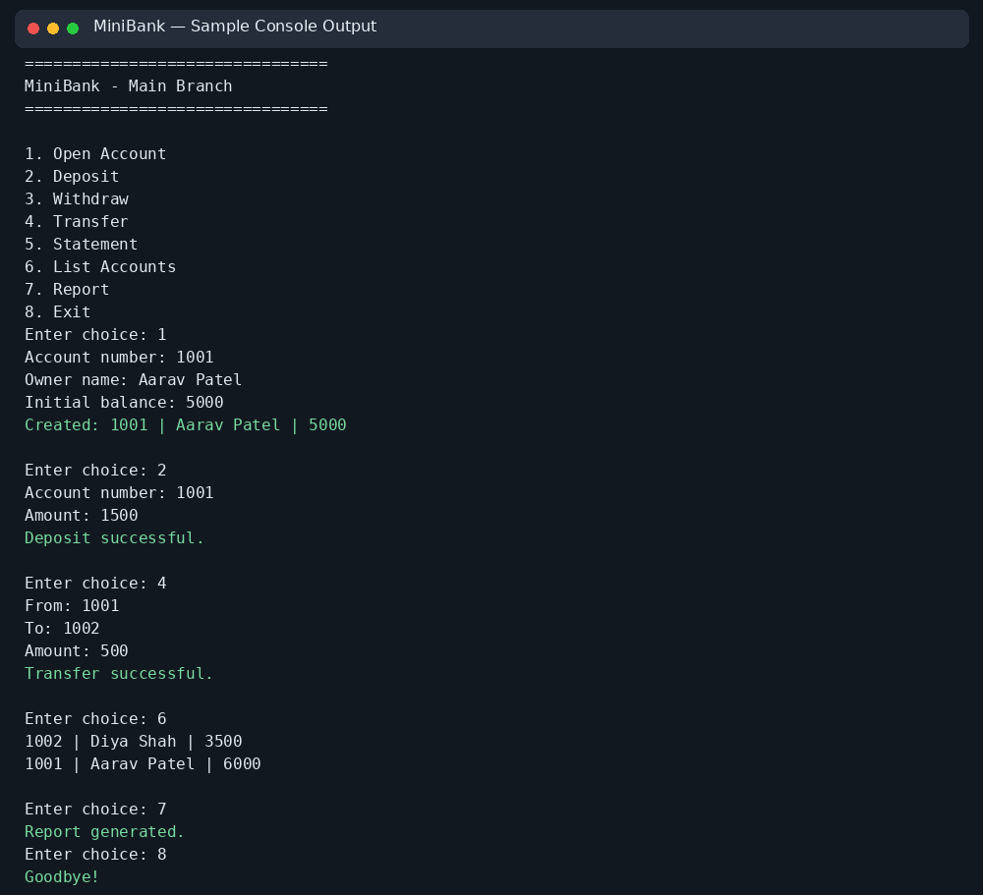
Figure 1: MiniBank console application sample output

MAIN MODULE LOGIC CODE :

The main method prints the BankInfo header, initializes the Repository and BankService, loads saved accounts, and repeatedly displays the menu. A switch statement routes each selection to the matching banking operation. Exceptions are caught and shown as messages. On exit, account data is saved.
BankInfo info = new BankInfo("MiniBank", "Main Branch");
System.out.println(info.name() + " - " + info.branch());

Repository<Account> repo = new Repository<>();
BankService bank = new BankService(repo,
Paths.get("data/accounts.dat"),
Paths.get("data/logs/transactions.log"));

try {
bank.load();
} catch (Exception e) {
System.out.println("Starting with empty data.");
}

// Menu loop handles account creation, deposit, withdrawal,
// transfer, statement, account listing, report, and exit.

LOGIC EXPLANATION :

Initialization: Creates the bank header, repository, and service with paths for account storage and transaction logs.
Menu loop: Displays the menu repeatedly until the user chooses Exit.
Transactions: Calls BankService to validate and process deposits, withdrawals, and transfers.
Persistence: Loads saved accounts at startup and saves account data when the user exits.
Reporting: Reads transaction logs and writes deposit, withdrawal, and net-change totals to the report file.

CONCLUSION :
MiniBank demonstrates how Java and Object-Oriented Programming concepts can be used to build a modular console banking application. It supports basic banking transactions, handles common errors, saves account data, records transactions, and generates a summary report. The project provides practical experience in classes, encapsulation, collections, generics, exceptions, file handling, and concurrency.

LEARNING OUTCOMES :
• Practised classes, objects, records, enums, encapsulation, and method overriding.
• Used Java collections and a generic repository for storing account objects.
• Created custom exceptions to handle invalid transactions and insufficient funds.
• Applied serialization and file operations to save data and generate reports.
• Learned the basics of synchronized methods and executor-based transaction processing.
• Compiled Java source files and ran the console application.

