PRACTICAL: 1

AIM :

Project Initiation, Requirement Analysis, Sitemap, Wireframe, and GitHub Setup
Problem Definition Initiate the semester-long StudentHub portal by identifying the problem scope,
user roles, key modules, navigation flow, and minimum 10 pages. Create a
sitemap, low-fidelity wireframe, project folder structure, README file, and
GitHub repository.

WireFrame :

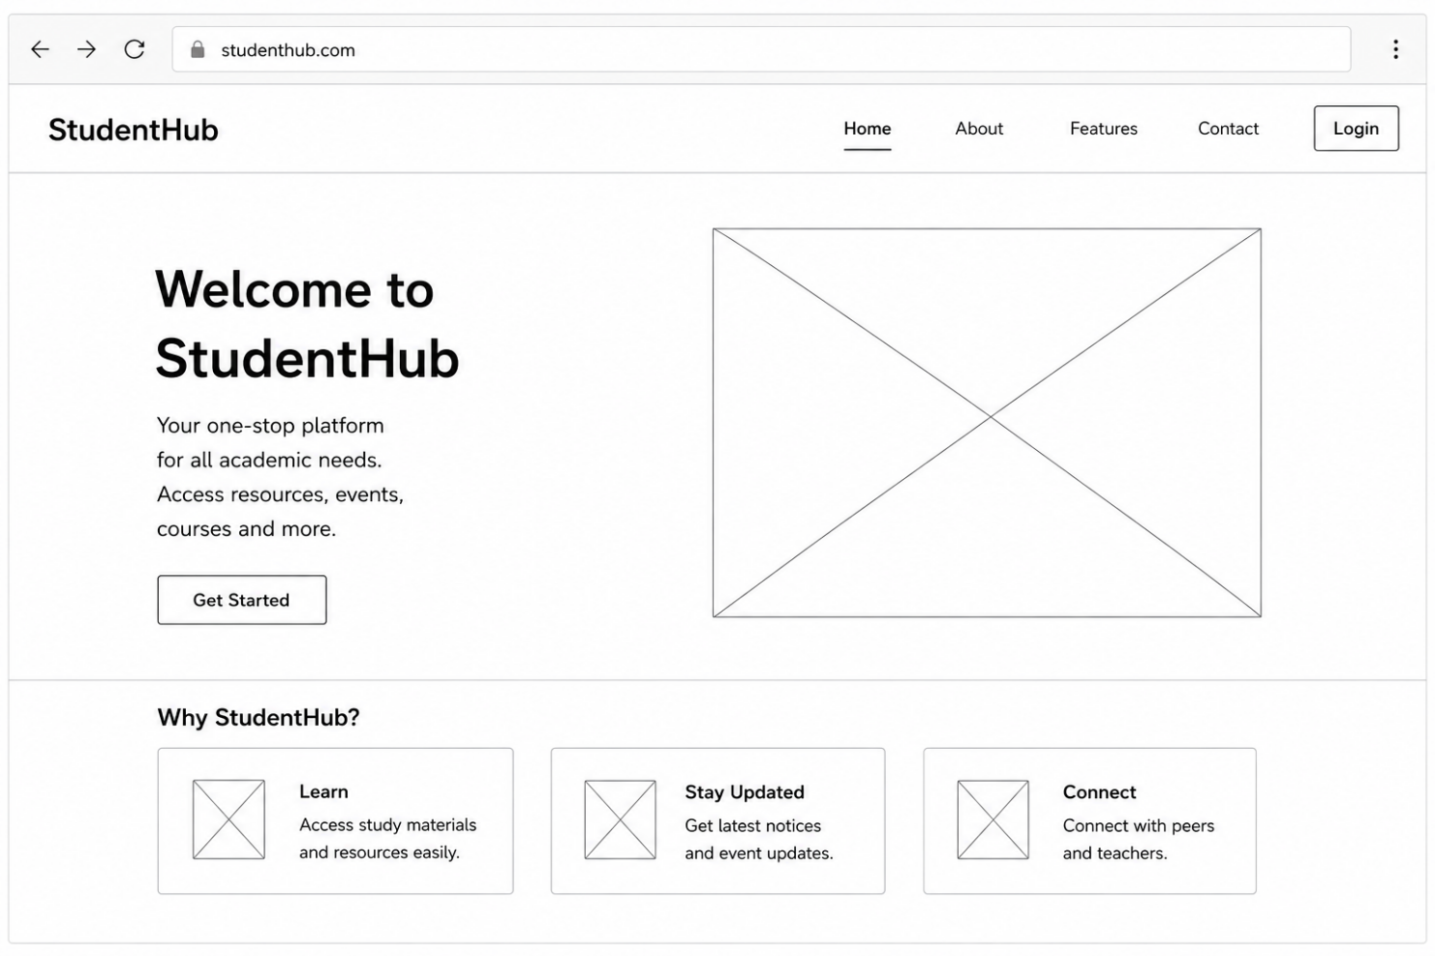

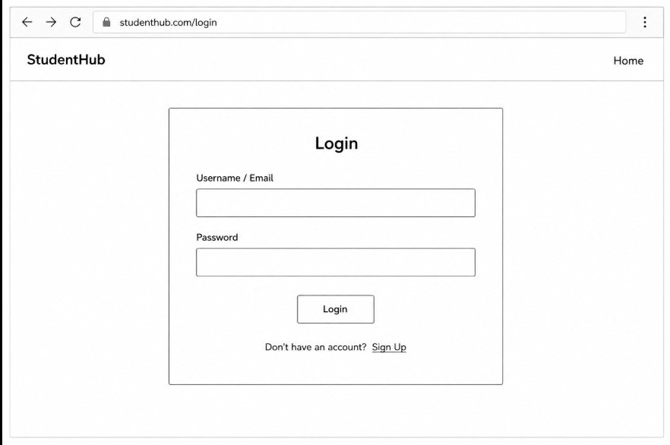

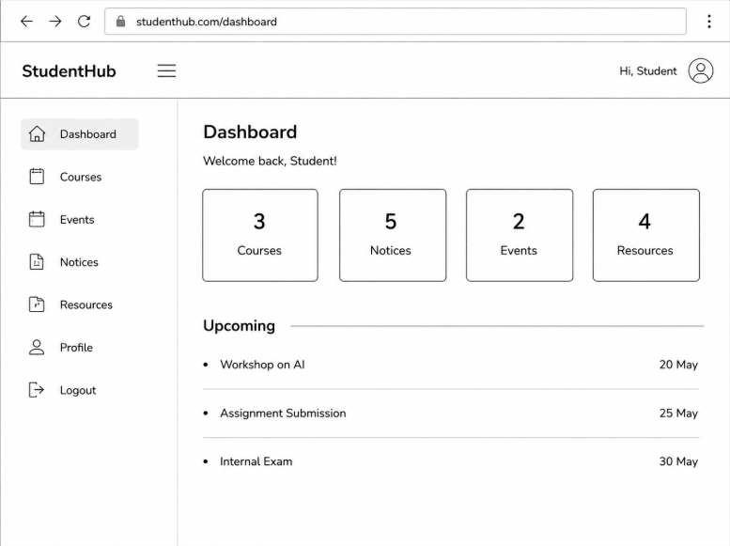

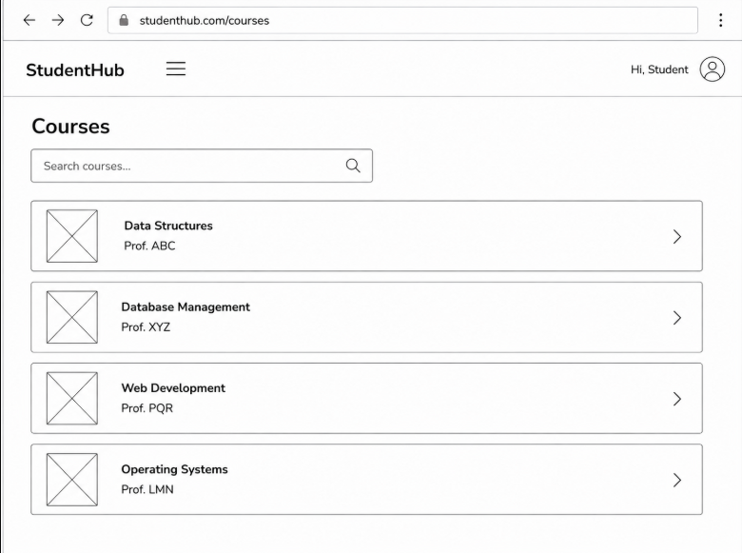
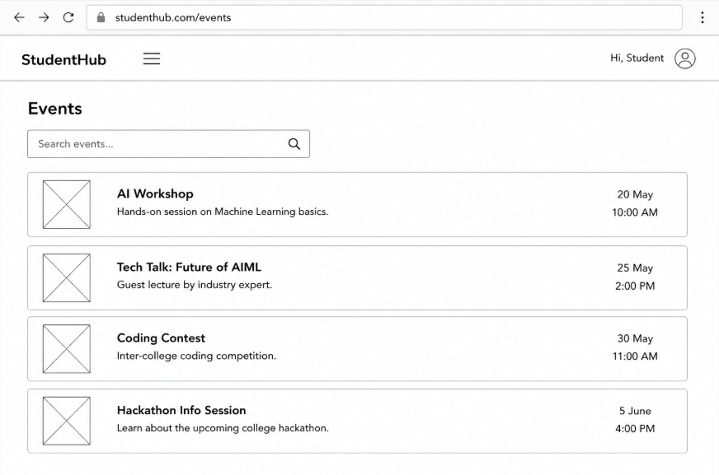

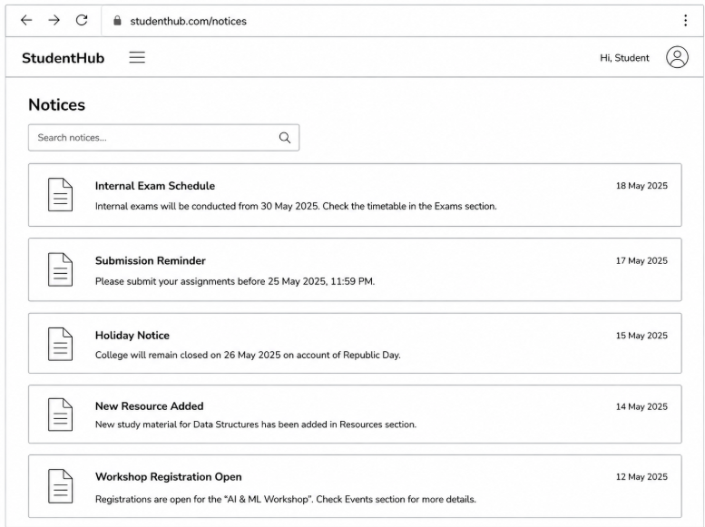

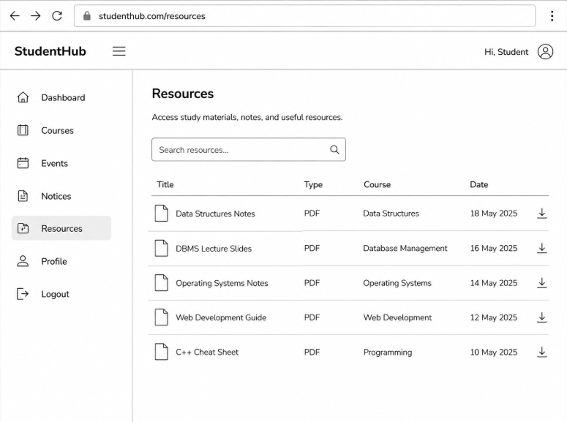
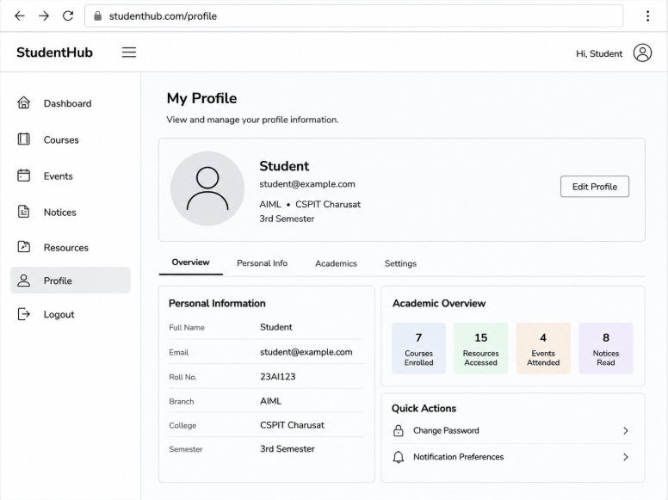
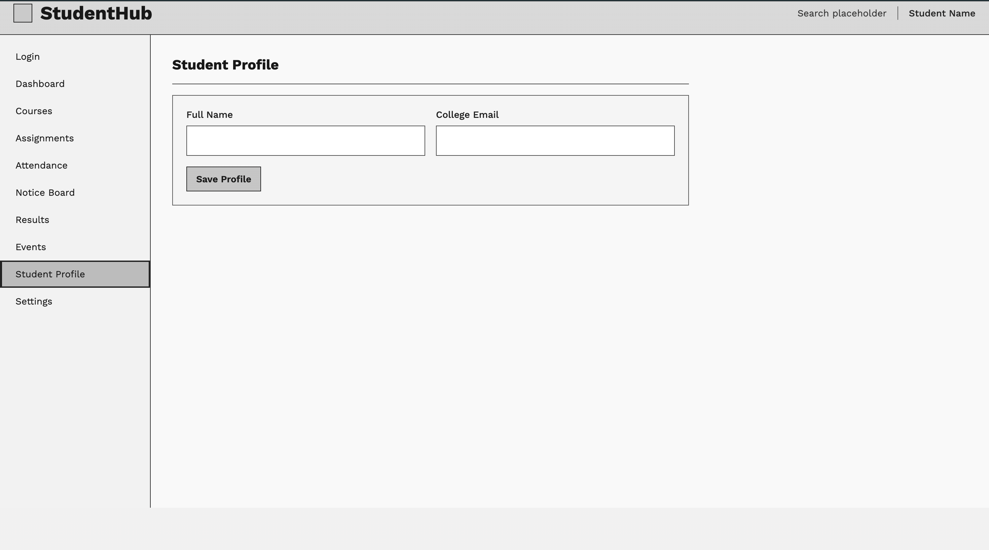

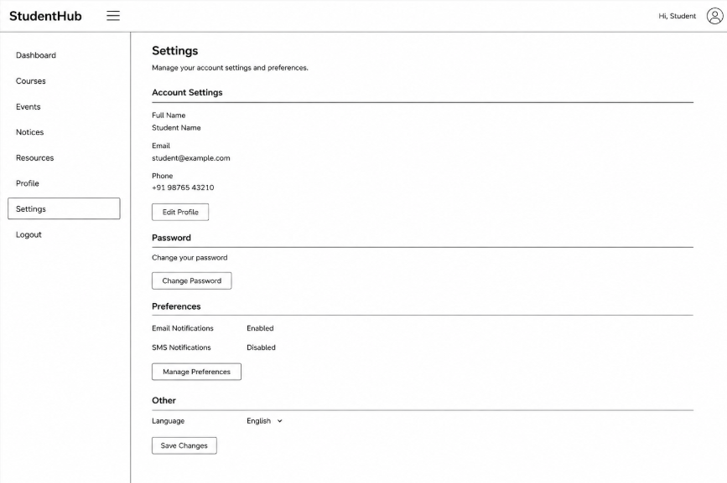

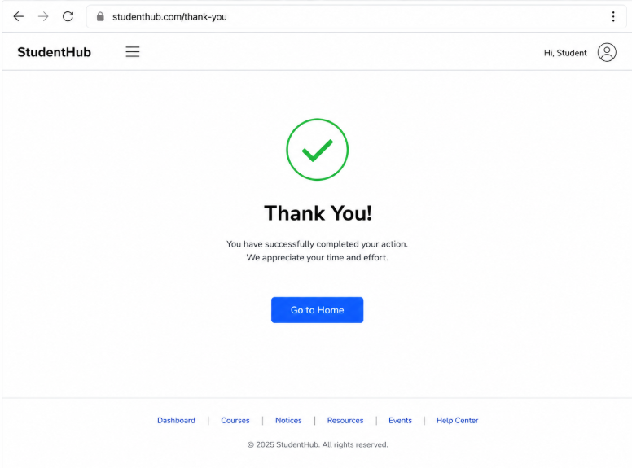

SiteMap :

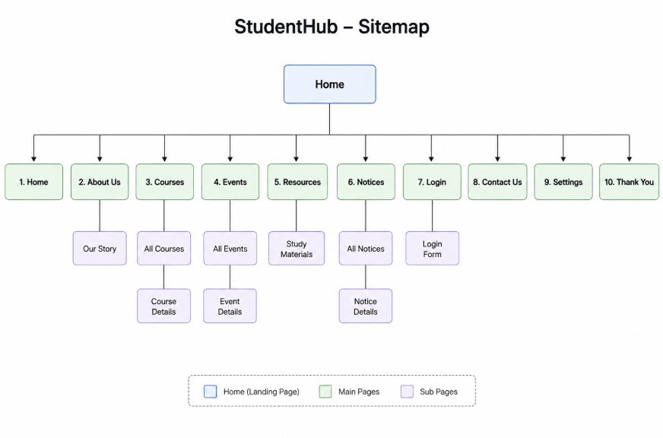

GitHub : https://github.com/25aiml013-sudo/WT_project.git

Git add .

Git commit –m “Upload File”

Git Push

