ADITYA UNIVERSITY
Surampalem
Department of Artificial Intelligence & Machine Learning
DBMS CAPSTONE PROJECT
Project Documentation Report
Project Title: University Academic Management System
Submitted by:
S.No | Student Name | Roll Number
1 | MANISH MANDAL | 25B11AI573
2 | D VAISHNAVI | 25B11AI261
3 | T MEGHANA | 25B11AIB75
Course: Database Management Systems (DBMS) Course Code: DBMS
Faculty Coordinator: THIRUVEEDULA SRINIVASULU
Academic Year: 2026–27 Date of Submission: 15 September 2026
GitHub Repository Link: https://github.com/25b11ai573/DBMS-Review-.git

TABLE OF CONTENTS
1. ABSTRACT 3
2. INTRODUCTION 3
2.1 Background 3
2.2 Purpose of the Database 3
3. PROBLEM STATEMENT 3
4. OBJECTIVES 4
5. TOOLS & TECHNOLOGIES USED 5
6. DATABASE DESIGN 6
6.1 Identified Entities 6
6.2 Entity Attributes 6
6.3 ER Diagram 8
6.4 Relationships & Cardinality 8
6.5 Relational Database Schema 9
6.6 Normalization 10
7. DATABASE IMPLEMENTATION 11
7.1 DDL — Database and Table Creation 11
7.2 Sample Data — DML 12
7.3 Constraints & Data Integrity 13
7.4 SQL Operations & Queries 13
7.5 Sample Outputs / Screenshots 15
8. MODULES & FUNCTIONALITIES 16
9. GITHUB REPOSITORY & TEAM RESPONSIBILITIES 16
10. ENHANCEMENTS & FUTURE IMPROVEMENTS 17
11. CONCLUSION 17
12. REFERENCES 18
APPENDIX 18
A. Complete SQL Script 18
B. Additional Screenshots / Outputs 18

1. ABSTRACT
The University Academic Management System is a relational database project developed to organize and manage academic information in a university environment. The system focuses on students, faculty, departments, courses, subjects, enrollments, examinations, and results. The main problem addressed is the difficulty of maintaining large academic records using separate files or manual processes, which can lead to duplication, inconsistency, slow retrieval, and errors. The proposed database centralizes academic information and connects related records using primary and foreign keys. The project includes an ER model, relationship and cardinality analysis, relational schema, normalization up to 3NF, database table creation, sample data, constraints, and representative SQL queries. The database supports common operations such as inserting, updating, deleting, retrieving, joining, grouping, and aggregating academic records. It can also be extended with reporting and a user interface in future phases. Overall, the project provides a structured foundation for efficient academic record management while improving data consistency, integrity, accessibility, and maintainability.

2. INTRODUCTION

2.1 Background
Universities manage a large volume of academic information involving students, faculty, departments, courses, subjects, examinations, enrollments, and results. Maintaining these records through separate files or spreadsheets can cause duplication, inconsistency, difficult retrieval, and time-consuming administrative work. The University Academic Management System is designed as a centralized relational database to organize this information systematically. The design follows the entity, relationship, key, and relational-schema structure established during Review-I.

2.2 Purpose of the Database
The database provides a structured way to store and retrieve academic information for students, faculty, departments, courses, subjects, enrollments, examinations, and results. It is intended to support students, faculty, and academic/administrative staff by reducing repeated data entry, improving consistency, simplifying record retrieval, and supporting useful reports through SQL queries.

3. PROBLEM STATEMENT
The existing academic management process may involve multiple files, spreadsheets, or manual records. This makes large student records difficult to maintain and can result in repeated data entry, data inconsistency, duplication, difficult tracking of enrollment and examination results, slow report generation, and limited centralized access. The proposed University Academic Management System addresses these limitations through a centralized relational database with defined entities, primary keys, foreign keys, constraints, and SQL-based operations.

4. OBJECTIVES
- 1. Maintain centralized student and faculty academic records.
- 2. Manage departments, courses, and subjects efficiently.
- 3. Maintain student enrollment and examination records.
- 4. Store and manage student marks, grades, and result status.
- 5. Reduce data redundancy and improve data consistency and integrity.

5. TOOLS & TECHNOLOGIES USED

Category | Tool / Technology Used
Database Server | MySQL 8.0 (proposed implementation)
Query / Admin Tool | MySQL Workbench / MySQL Command Line Client
Front-end (if any) | Not implemented in the current DBMS phase; can be integrated later
Operating System | Windows / Linux / macOS
Version Control | GitHub

6. DATABASE DESIGN

6.1 Identified Entities

S.No | Entity Name | Description
1 | Student | Stores information about students enrolled in the university.
2 | Faculty | Stores details of teaching staff.
3 | Department | Represents academic departments within the university.
4 | Course | Stores information about academic programs/courses.
5 | Subject | Represents subjects offered as part of courses.
6 | Enrollment | Records students registered for subjects.

6.2 Entity Attributes

Entity | Attribute | Data Type | Key (PK/FK/—) | Attribute Type
STUDENT | Student_ID | INT | PK | Simple
STUDENT | Student_Name | VARCHAR(100) | — | Simple
STUDENT | Date_of_Birth | DATE | — | Simple
STUDENT | Gender | VARCHAR(20) | — | Simple
STUDENT | Email | VARCHAR(100) | — | Simple
STUDENT | Phone | VARCHAR(15) | — | Simple
STUDENT | Address | VARCHAR(255) | — | Composite
STUDENT | Course_ID | INT | FK | Simple
FACULTY | Faculty_ID | INT | PK | Simple
FACULTY | Faculty_Name | VARCHAR(100) | — | Simple
FACULTY | Email | VARCHAR(100) | — | Simple
FACULTY | Phone | VARCHAR(15) | — | Simple
FACULTY | Designation | VARCHAR(50) | — | Simple
FACULTY | Department_ID | INT | FK | Simple
DEPARTMENT | Department_ID | INT | PK | Simple
DEPARTMENT | Department_Name | VARCHAR(100) | — | Simple
DEPARTMENT | HOD | VARCHAR(100) | — | Simple
DEPARTMENT | Office_Location | VARCHAR(100) | — | Simple
COURSE | Course_ID | INT | PK | Simple
COURSE | Course_Name | VARCHAR(100) | — | Simple
COURSE | Duration | INT | — | Simple
COURSE | Department_ID | INT | FK | Simple
SUBJECT | Subject_ID | INT | PK | Simple
SUBJECT | Subject_Name | VARCHAR(100) | — | Simple
SUBJECT | Credits | INT | — | Simple
SUBJECT | Course_ID | INT | FK | Simple
SUBJECT | Faculty_ID | INT | FK | Simple
ENROLLMENT | Enrollment_ID | INT | PK | Simple
ENROLLMENT | Student_ID | INT | FK | Simple
ENROLLMENT | Subject_ID | INT | FK | Simple
ENROLLMENT | Enrollment_Date | DATE | — | Simple
ENROLLMENT | Semester | VARCHAR(20) | — | Simple
EXAMINATION | Exam_ID | INT | PK | Simple
EXAMINATION | Subject_ID | INT | FK | Simple
EXAMINATION | Exam_Name | VARCHAR(100) | — | Simple
EXAMINATION | Exam_Date | DATE | — | Simple
EXAMINATION | Semester | VARCHAR(20) | — | Simple
RESULT | Result_ID | INT | PK | Simple
RESULT | Student_ID | INT | FK | Simple
RESULT | Exam_ID | INT | FK | Simple
RESULT | Marks | DECIMAL(5,2) | — | Simple
RESULT | Grade | VARCHAR(5) | — | Simple
RESULT | Result_Status | VARCHAR(20) | — | Simple

6.3 ER Diagram
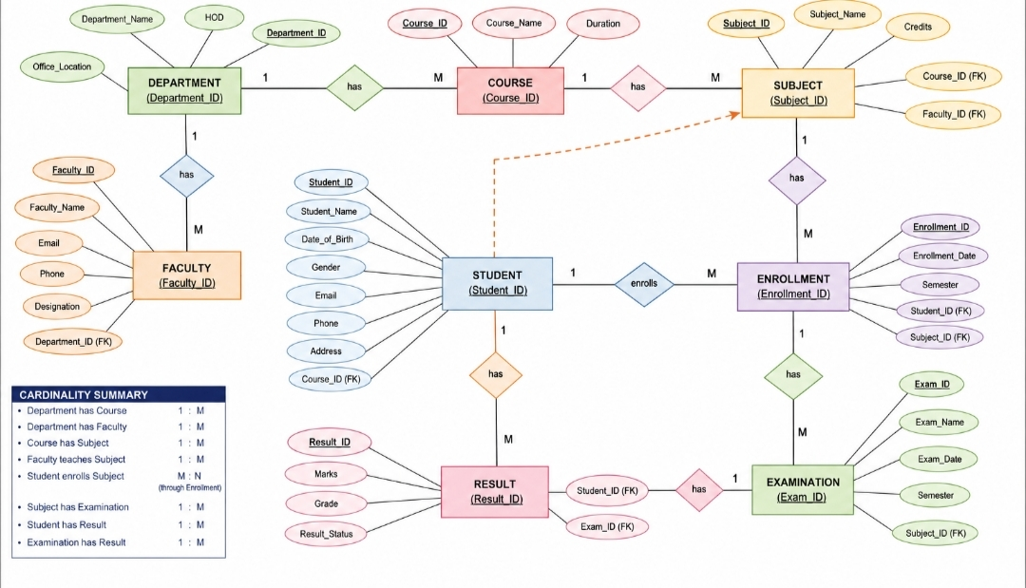

6.4 Relationships & Cardinality
Entity 1 | Relationship | Entity 2 | Cardinality (1:1 / 1:N / M:N)
Department | Offers / contains | Course | 1:N
Department | Has | Faculty | 1:N
Course | Contains | Subject | 1:N
Faculty | Teaches | Subject | 1:N
Student | Registers through | Enrollment | 1:N
Subject | Has registrations in | Enrollment | 1:N
Student | Enrolls in | Subject | M:N through Enrollment
Subject | Conducts | Examination | 1:N
Student | Receives | Result | 1:N
Examination | Produces | Result | 1:N

6.5 Relational Database Schema

Table Name | Column Name | Data Type | PK/FK/— | Constraints
Department | Department_ID | INT | PK | PRIMARY KEY
Department | Department_Name | VARCHAR(100) | — | NOT NULL, UNIQUE
Department | HOD | VARCHAR(100) | — | —
Department | Office_Location | VARCHAR(100) | — | —
Course | Course_ID | INT | PK | PRIMARY KEY
Course | Course_Name | VARCHAR(100) | — | NOT NULL
Course | Duration | INT | — | CHECK (Duration > 0)
Course | Department_ID | INT | FK | FOREIGN KEY
Faculty | Faculty_ID | INT | PK | PRIMARY KEY
Faculty | Faculty_Name | VARCHAR(100) | — | NOT NULL
Faculty | Email | VARCHAR(100) | — | UNIQUE
Faculty | Department_ID | INT | FK | FOREIGN KEY
Student | Student_ID | INT | PK | PRIMARY KEY
Student | Student_Name | VARCHAR(100) | — | NOT NULL
Student | Email | VARCHAR(100) | — | UNIQUE
Student | Course_ID | INT | FK | FOREIGN KEY
Subject | Subject_ID | INT | PK | PRIMARY KEY
Subject | Subject_Name | VARCHAR(100) | — | NOT NULL
Subject | Credits | INT | — | CHECK (Credits > 0)
Subject | Course_ID | INT | FK | FOREIGN KEY
Subject | Faculty_ID | INT | FK | FOREIGN KEY
Enrollment | Enrollment_ID | INT | PK | PRIMARY KEY
Enrollment | Student_ID | INT | FK | FOREIGN KEY
Enrollment | Subject_ID | INT | FK | FOREIGN KEY
Enrollment | Enrollment_Date | DATE | — | NOT NULL
Enrollment | Semester | VARCHAR(20) | — | NOT NULL
Examination | Exam_ID | INT | PK | PRIMARY KEY
Examination | Subject_ID | INT | FK | FOREIGN KEY
Examination | Exam_Name | VARCHAR(100) | — | NOT NULL
Examination | Exam_Date | DATE | — | NOT NULL
Result | Result_ID | INT | PK | PRIMARY KEY
Result | Student_ID | INT | FK | FOREIGN KEY
Result | Exam_ID | INT | FK | FOREIGN KEY
Result | Marks | DECIMAL(5,2) | — | CHECK (Marks BETWEEN 0 AND 100)
Result | Grade | VARCHAR(5) | — | —
Result | Result_Status | VARCHAR(20) | — | DEFAULT 'Pending'

6.6 Normalization
UNF → 1NF → 2NF → 3NF
UNF → 1NF → 2NF → 3NF
UNF: A single academic record structure could contain student, course, subject, examination, and result information together, causing repeating groups and duplication.
1NF: Repeating groups are removed and each attribute contains atomic values. Separate records are maintained for students, courses, subjects, enrollments, examinations, and results.
2NF: Partial dependencies are removed by separating attributes that depend on different keys. For example, student details remain in STUDENT, while enrollment-specific information remains in ENROLLMENT.
3NF: Transitive dependencies are removed by separating independent entities such as DEPARTMENT, COURSE, FACULTY, SUBJECT, EXAMINATION, and RESULT and connecting them with foreign keys. This reduces redundancy and helps prevent update, insertion, and deletion anomalies.

7. DATABASE IMPLEMENTATION

7.1 DDL — Database and Table Creation

CREATE DATABASE UniversityAcademicManagement;
USE UniversityAcademicManagement;
CREATE TABLE Department (
Department_ID INT PRIMARY KEY,
Department_Name VARCHAR(100) NOT NULL UNIQUE,
HOD VARCHAR(100),
Office_Location VARCHAR(100)
);
CREATE TABLE Course (
Course_ID INT PRIMARY KEY,
Course_Name VARCHAR(100) NOT NULL,
Duration INT CHECK (Duration > 0),
Department_ID INT,
FOREIGN KEY (Department_ID) REFERENCES Department(Department_ID)
);
CREATE TABLE Faculty (
Faculty_ID INT PRIMARY KEY,
Faculty_Name VARCHAR(100) NOT NULL,
Email VARCHAR(100) UNIQUE,
Phone VARCHAR(15),
Designation VARCHAR(50),
Department_ID INT,
FOREIGN KEY (Department_ID) REFERENCES Department(Department_ID)
);
CREATE TABLE Student (
Student_ID INT PRIMARY KEY,
Student_Name VARCHAR(100) NOT NULL,
Date_of_Birth DATE,
Gender VARCHAR(20),
Email VARCHAR(100) UNIQUE,
Phone VARCHAR(15),
Address VARCHAR(255),
Course_ID INT,
FOREIGN KEY (Course_ID) REFERENCES Course(Course_ID)
);
CREATE TABLE Subject (
Subject_ID INT PRIMARY KEY,
Subject_Name VARCHAR(100) NOT NULL,
Credits INT CHECK (Credits > 0),
Course_ID INT,
Faculty_ID INT,
FOREIGN KEY (Course_ID) REFERENCES Course(Course_ID),
FOREIGN KEY (Faculty_ID) REFERENCES Faculty(Faculty_ID)
);
CREATE TABLE Enrollment (
Enrollment_ID INT PRIMARY KEY,
Student_ID INT,
Subject_ID INT,
Enrollment_Date DATE NOT NULL,
Semester VARCHAR(20) NOT NULL,
FOREIGN KEY (Student_ID) REFERENCES Student(Student_ID),
FOREIGN KEY (Subject_ID) REFERENCES Subject(Subject_ID)
);
CREATE TABLE Examination (
Exam_ID INT PRIMARY KEY,
Subject_ID INT,
Exam_Name VARCHAR(100) NOT NULL,
Exam_Date DATE NOT NULL,
Semester VARCHAR(20),
FOREIGN KEY (Subject_ID) REFERENCES Subject(Subject_ID)
);
CREATE TABLE Result (
Result_ID INT PRIMARY KEY,
Student_ID INT,
Exam_ID INT,
Marks DECIMAL(5,2) CHECK (Marks BETWEEN 0 AND 100),
Grade VARCHAR(5),
Result_Status VARCHAR(20) DEFAULT 'Pending',
FOREIGN KEY (Student_ID) REFERENCES Student(Student_ID),
FOREIGN KEY (Exam_ID) REFERENCES Examination(Exam_ID)
);

7.2 Sample Data — DML

Table | No. of Records | Sample Data / Screenshot Reference
Department | 4 | Example departments such as CSE, AI&ML, ECE, and EEE.
Course | 4 | Programs linked to departments.
Faculty | 6 | Faculty records linked to departments.
Student | 10 | Student records linked to courses.
Subject | 10 | Subjects linked to courses and faculty.
Enrollment | 20 | Student-subject registration records.
Examination | 10 | Exams linked to subjects.
Result | 20 | Marks, grades, and result status.

7.3 Constraints & Data Integrity

Constraint / Validation | Applied On | Purpose | Evidence / Screenshot
PRIMARY KEY | All entity tables | Prevents duplicate/null identifiers | Table definition
FOREIGN KEY | Course, Faculty, Student, Subject, Enrollment, Examination, Result | Maintains referential integrity | Table definition
NOT NULL | Required names/dates | Prevents missing mandatory values | DDL
UNIQUE | Department_Name, selected Email fields | Prevents duplicate values | DDL
CHECK | Duration, Credits, Marks | Restricts invalid numeric values | DDL
DEFAULT | Result_Status | Provides a default status when omitted | DDL

7.4 SQL Operations & Queries

S.No | Operation / Query | Purpose | SQL Query / Screenshot Ref.
1 | DDL – CREATE TABLE | Create relational tables with keys and constraints | See Section 7.1
2 | DML – INSERT | Add student, faculty, course and academic records | INSERT INTO Student ...
3 | DML – UPDATE | Modify a student's contact information | UPDATE Student SET Phone='...' WHERE Student_ID=...;
4 | DML – DELETE | Remove a record when permitted by referential rules | DELETE FROM Student WHERE Student_ID=...;
5 | DQL – SELECT | Retrieve all students | SELECT * FROM Student;
6 | JOIN | Show students with their course names | SELECT s.Student_Name, c.Course_Name FROM Student s JOIN Course c ON s.Course_ID=c.Course_ID;
7 | JOIN | Show subjects with assigned faculty | SELECT sub.Subject_Name, f.Faculty_Name FROM Subject sub JOIN Faculty f ON sub.Faculty_ID=f.Faculty_ID;
8 | Aggregate | Count students per course | SELECT Course_ID, COUNT(*) AS Student_Count FROM Student GROUP BY Course_ID;
9 | GROUP BY / HAVING | Find courses having more than a chosen number of students | SELECT Course_ID, COUNT(*) FROM Student GROUP BY Course_ID HAVING COUNT(*) > 2;
10 | Subquery | Find students scoring above the average marks | SELECT Student_ID, Marks FROM Result WHERE Marks > (SELECT AVG(Marks) FROM Result);
11 | View | Create a reusable academic result view | CREATE VIEW Student_Result_View AS SELECT Student_ID, Exam_ID, Marks, Grade FROM Result;
12 | CRUD / Report | Retrieve a student's enrollment and result information | Use JOIN across Student, Enrollment, Subject, Examination and Result.

7.5 Sample Outputs / Screenshots
Paste important execution screenshots with a short caption. Screenshots should clearly show the query and its output.
Figure 1: Database and table creation output in the SQL client.
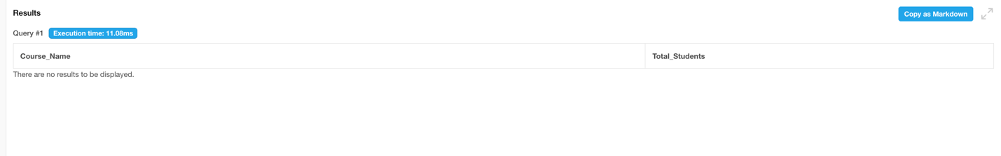
Figure 2: Sample records inserted into the Student/Faculty tables.
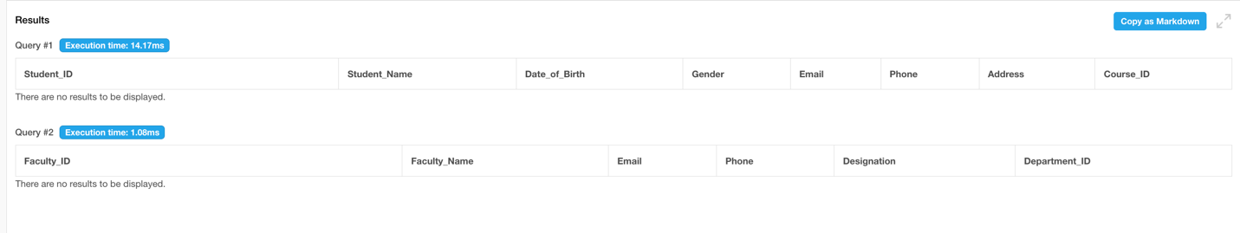
Figure 3: JOIN query showing related academic information.
[ Insert Screenshot Here ]
Figure 4: Aggregate/GROUP BY query showing summary results.
[ Insert Screenshot Here ]

8. MODULES & FUNCTIONALITIES

S.No | Module Name | Functionality
Student Management | Stores student profiles and links each student to a course. | Add, update, delete, and retrieve student records. Maintain student personal details and link each student with the respective course using Course_ID.
Faculty Management | Maintains faculty details, designation, and department mapping. | Add and manage faculty information including name, email, phone, designation, and department. Assign faculty members to subjects and maintain department mapping.
Department & Course Management | Organizes departments and their academic programs. | Create and manage departments and academic courses. Store course duration and connect each course with its department using foreign keys.
Subject Management | Stores subjects, credits, course mapping, and faculty assignment. | Add and manage subjects, credits, course mapping, and faculty assignment. Retrieve subject details and identify the faculty teaching each subject.
Enrollment Management | Records student registration for subjects by semester. | Register students for subjects and maintain enrollment date and semester details. Track the relationship between students and subjects through the Enrollment table.
Examination & Result Management | Stores exam details and student marks, grades, and result status. | Create and manage examination details such as exam name, date, subject, and semester. Record student marks, grades, and result status, and generate result reports using SQL queries.

9. GITHUB REPOSITORY & TEAM RESPONSIBILITIES

Repository Link: https://github.com/25b11ai573/DBMS-Review-.git
Student Name | Roll Number | Role / Responsibility | Contribution Status
MANISH MANDAL | 25B11AI573 | Database design, entity/attribute analysis, documentation | Completed
D VAISHNAVI | 25B11AI261 | ER model, relationships, schema support, testing | Completed
T MEGHANA | 25B11AIB75 | SQL implementation, queries, testing, documentation | Completed

10. ENHANCEMENTS & FUTURE IMPROVEMENTS

Future improvements can include a web-based or desktop front-end, role-based authentication for students/faculty/administrators, automated result and attendance reports, dashboard-based analytics, stronger input validation, indexing for faster query performance, backup and recovery procedures, audit logging, and scalability for larger student populations. The database can also be integrated with attendance, timetable, fee, and library modules in later versions.

11. CONCLUSION
The University Academic Management System provides a structured and centralized approach to managing university academic data. The Review-I design identified eight major entities, their attributes, relationships, cardinalities, primary keys, foreign keys, and relational schema. The documentation extends that design into an implementation-ready database structure with SQL DDL, sample data planning, integrity constraints, and representative DML/DQL, JOIN, aggregate, GROUP BY/HAVING, subquery, and view operations. The design reduces redundancy, improves consistency, supports reliable retrieval, and provides a foundation for future front-end and reporting features. The project also demonstrates practical DBMS concepts including ER modeling, relational mapping, normalization, keys, constraints, and SQL operations.

12. REFERENCES
- 1. Elmasri, R. and Navathe, S. B., Fundamentals of Database Systems.
- 2. Ramakrishnan, R. and Gehrke, J., Database Management Systems.
- 3. MySQL 8.0 Reference Manual – SQL statements and database concepts.
- 4. Course material and DBMS laboratory resources provided by the university.
- 5. Team Review-I presentation: University Academic Management System.

