EDUGENIE AI
AI-Powered Learning Assistant
Project Documentation

TEAM MEMBERS
1 | Jeevasri – TL
2 | Janani – J
3 | Janani – K
4 | Jeevika

A web-based educational application that uses AI to support
question answering, learning, quizzes and summaries.

1. Project Overview
EduGenie AI is designed as an AI-powered learning assistant. The project combines a Python/FastAPI backend with HTML, CSS and JavaScript for the user interface. It connects to Google's Gemini AI service for generating educational responses.
- The user can enter a learning question through the web interface.
- The backend receives the request and uses AI-related modules to process it.
- The project contains separate modules for question answering, quizzes, summaries and learning support.
- Environment variables are used to keep the Gemini API key and model configuration outside the main source code.
- Automated API tests are included to check important endpoints and input validation.

2. Project Folder Structure
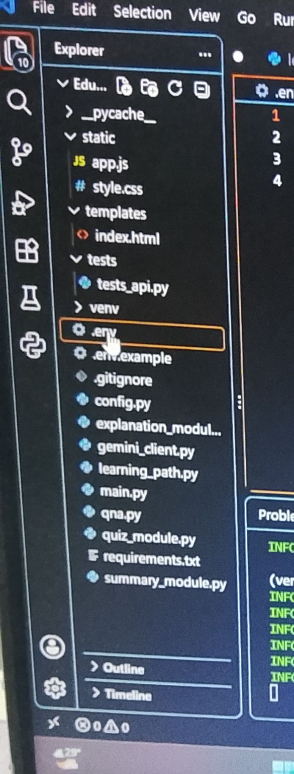
Figure 1: 2. Project Folder Structure
What the code shows: The screenshot shows the main EduGenie-AI project structure in Visual Studio Code. It separates frontend files, backend Python modules, tests, environment configuration and dependencies.
Key points:
- static contains app.js and style.css for the web interface.
- templates contains index.html, which defines the main webpage.
- tests contains tests_api.py for checking API behaviour.
- Python modules such as main.py, qna.py, quiz_module.py and summary_module.py provide application features.
- .env is used for local configuration such as the Gemini API key, while .env.example can be shared as a template.
- requirements.txt lists the Python packages required to run the project.

3. CSS Styling – style.css
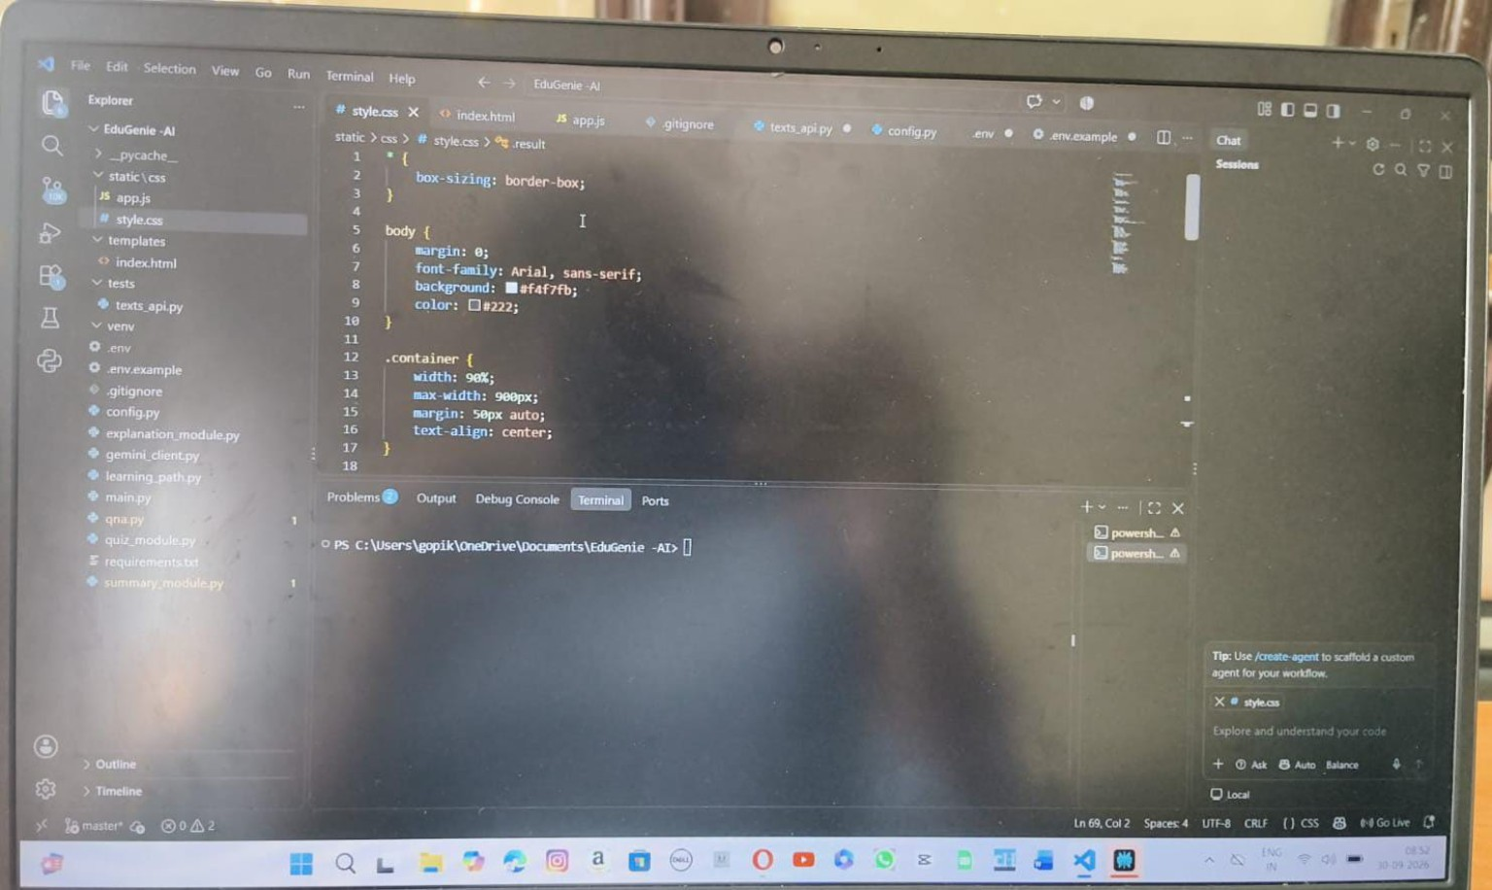
Figure 2: 3. CSS Styling – style.css
What the code shows: The CSS file controls the visual appearance of the EduGenie AI webpage. The visible section sets common sizing, page font, background, text colour and the main container layout.
Key points:
- box-sizing: border-box makes element sizing easier to manage.
- The body uses an Arial/sans-serif font and a light background.
- The .container class limits the page width and centers the content.
- The text-align property centers the content inside the main container.
- Additional CSS rules can be used to style cards, buttons, forms and results.

4. Webpage Interface – index.html
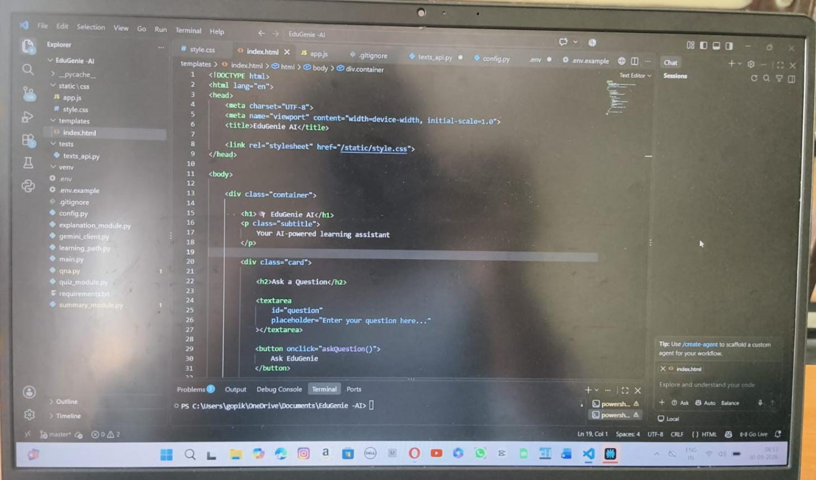
Figure 3: 4. Webpage Interface – index.html
What the code shows: The HTML file creates the main EduGenie AI user interface. It links the CSS stylesheet and displays the project title, subtitle, question input area and button used to send a question.
Key points:
- The page uses standard HTML5 structure with a head and body.
- The title identifies the application as EduGenie AI.
- The stylesheet is connected using /static/style.css.
- A textarea with the id 'question' allows the learner to enter a question.
- The 'Ask EduGenie' button calls a JavaScript function to submit the question.

5. API Testing – tests_api.py
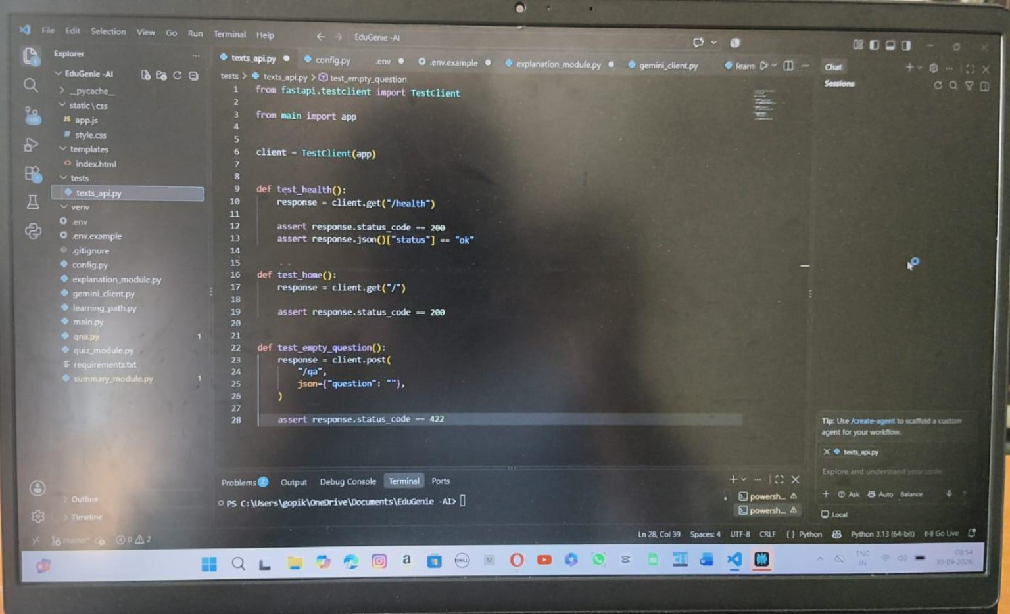
Figure 4: 5. API Testing – tests_api.py
What the code shows: This file uses FastAPI's TestClient to test the application's API endpoints without needing a browser. The visible tests check the health endpoint, the home page and validation of an empty question.
Key points:
- TestClient is created using the FastAPI app imported from main.py.
- test_health checks that /health returns HTTP 200 and a status of 'ok'.
- test_home checks that the root URL / responds successfully.
- test_empty_question sends an empty question to /qa.
- The empty-question test expects HTTP 422, confirming that invalid input is rejected.

6. Quiz Generation – quiz_module.py
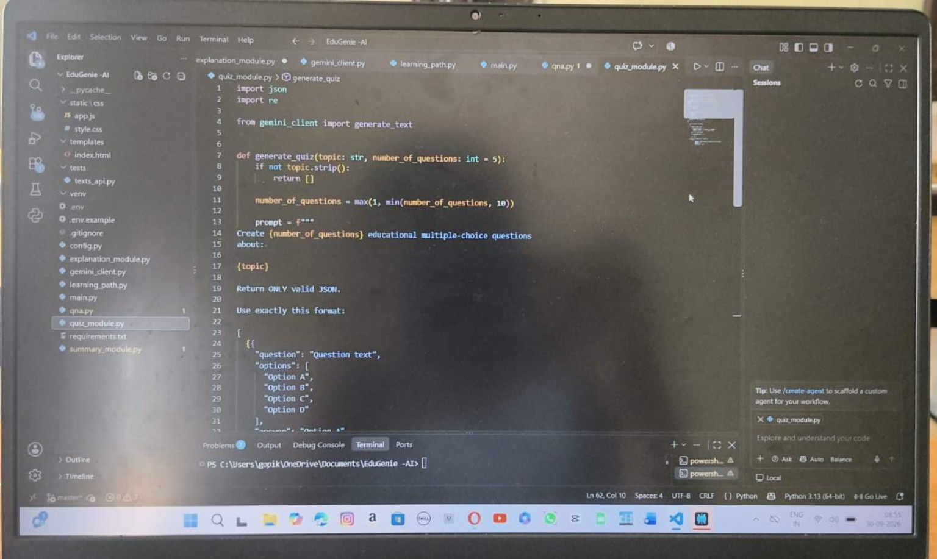
Figure 5: 6. Quiz Generation – quiz_module.py
What the code shows: The quiz module prepares a prompt for the Gemini model to create educational multiple-choice questions. It validates the topic, limits the number of questions and requests a structured JSON response.
Key points:
- generate_quiz() accepts a topic and a requested number of questions.
- An empty topic returns an empty result instead of sending an invalid request.
- The number of questions is limited to a safe range of 1 to 10.
- The prompt asks the AI to create educational multiple-choice questions.
- The requested output format contains the question, four options and an answer-related field.
- generate_text from the Gemini client is used to obtain the AI-generated content.

7. Project Dependencies – requirements.txt
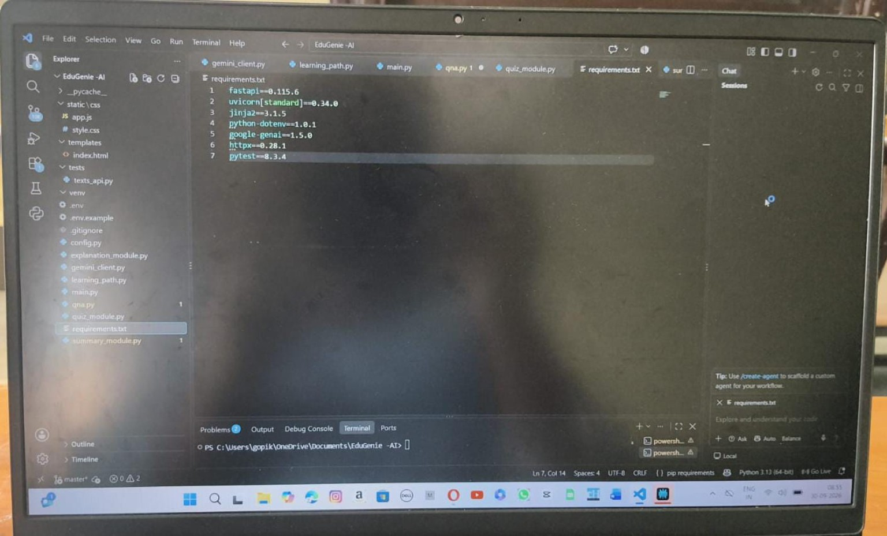
Figure 6: 7. Project Dependencies – requirements.txt
What the code shows: The requirements file records the external Python libraries needed by the project. Keeping dependencies in one file makes project setup and installation easier.
Key points:
- FastAPI provides the web API framework.
- Uvicorn runs the FastAPI application as an ASGI server.
- Jinja2 supports HTML template rendering.
- python-dotenv loads values from the .env file.
- google-genai provides access to Google's Gemini API.
- httpx supports HTTP communication and testing utilities.
- pytest is used for automated testing.

8. AI Summarization – summary_module.py
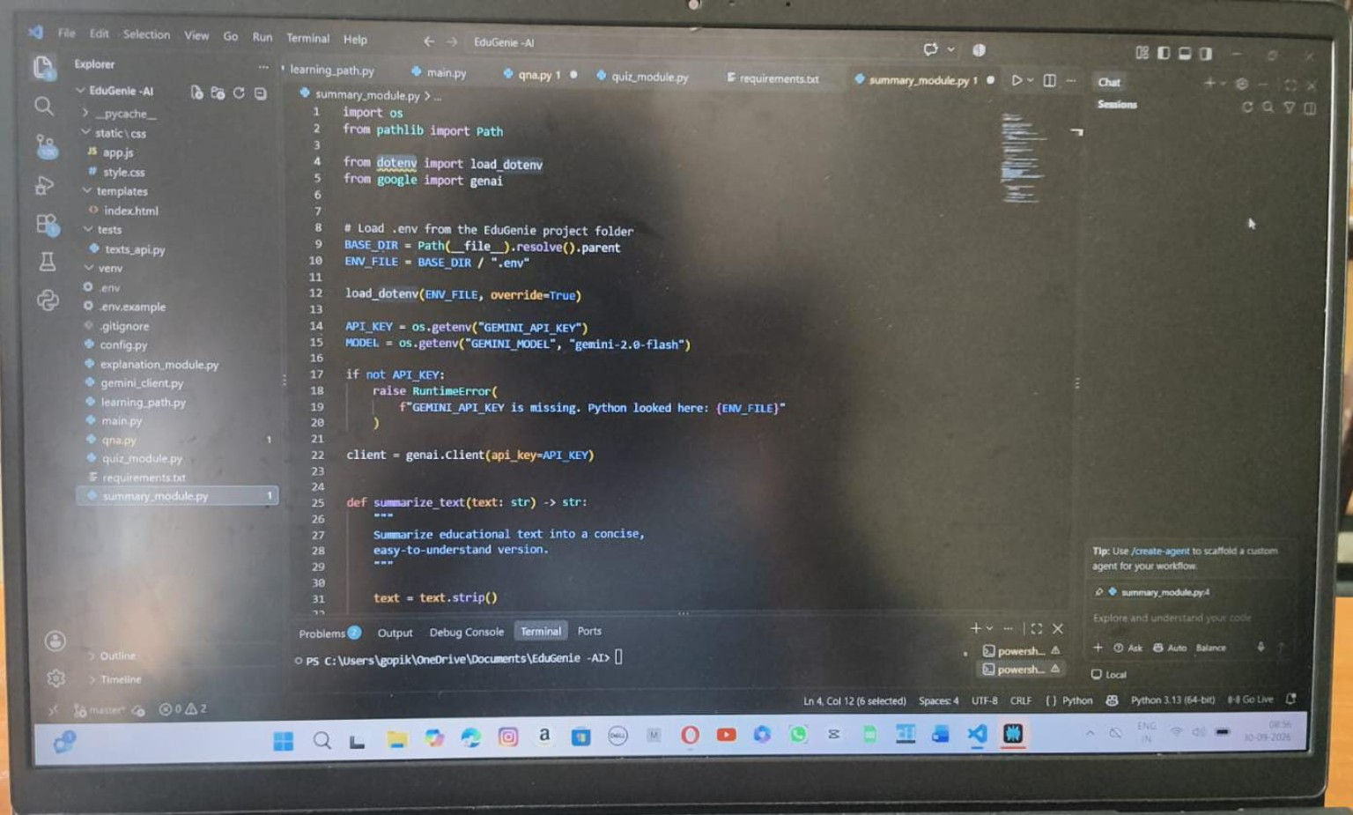
Figure 7: 8. AI Summarization – summary_module.py
What the code shows: The summary module loads the Gemini configuration from the EduGenie AI project environment and creates a Gemini client. It defines a summarize_text function intended to turn educational text into a concise, easy-to-understand version.
Key points:
- Path is used to locate the project's .env file reliably.
- load_dotenv loads environment variables from the project folder.
- GEMINI_API_KEY stores the API credential and GEMINI_MODEL selects the AI model.
- The code checks that the API key exists before creating the Gemini client.
- summarize_text() accepts text and prepares it for concise educational summarization.

9. EduGenie AI Website – How to Generate Learning Answers
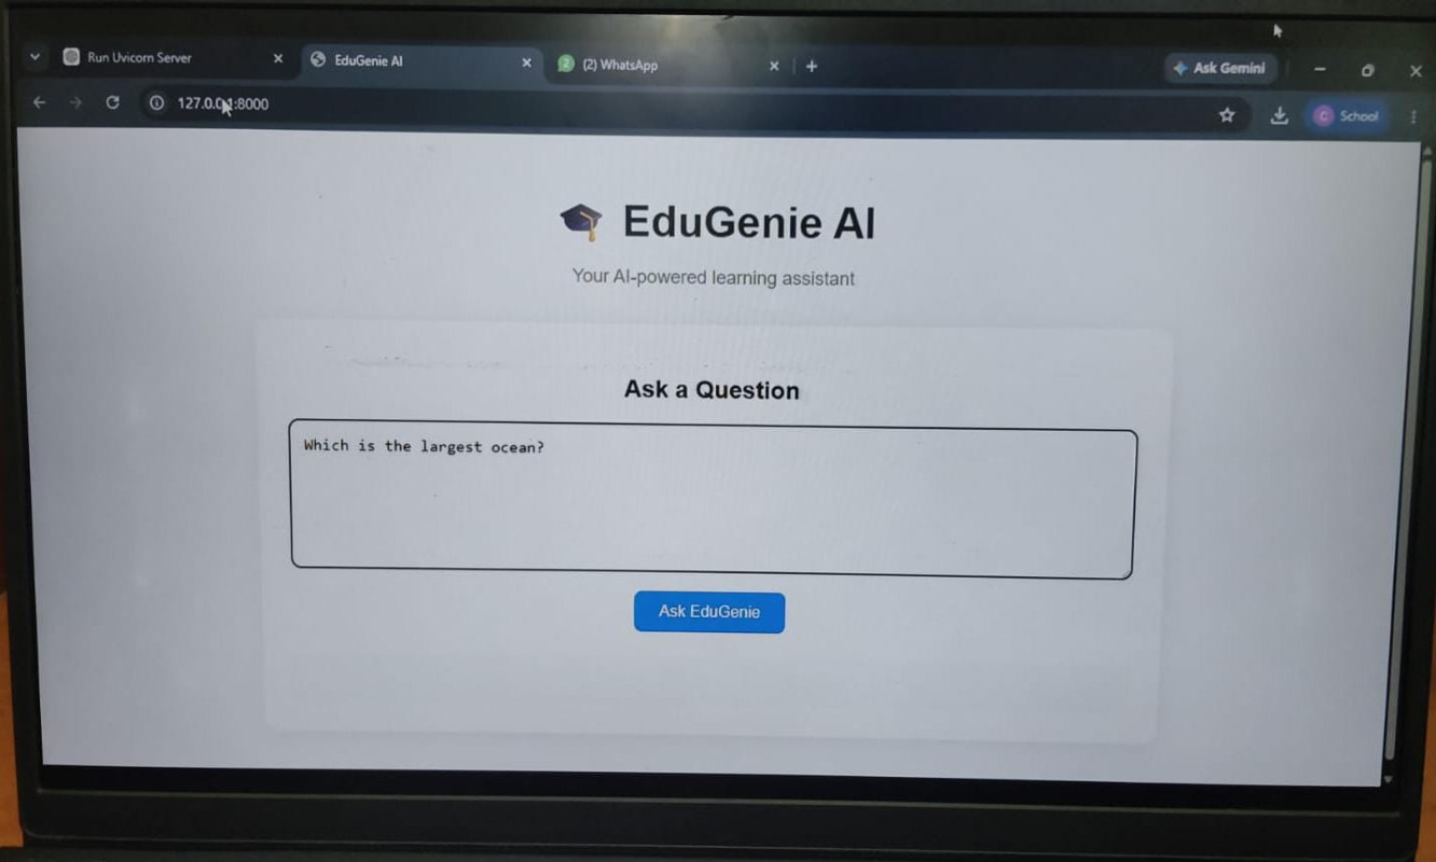
Figure 8: EduGenie AI web interface
How to use the website:
- Open the EduGenie AI website in a browser after starting the FastAPI/Uvicorn server.
- Click inside the 'Ask a Question' text box.
- Type a clear learning question, for example: 'Which is the largest ocean?'
- Click the 'Ask EduGenie' button.
- The question is sent to the backend, where the AI service processes the request.
- Read the generated answer and use it as learning support.
- For better results, ask specific questions and include the topic or subject when needed.
Example: Type “Explain photosynthesis in simple words” and click “Ask EduGenie” to request an easy-to-understand explanation.
--- End of Project Documentation ---

