Name : **Bhavana Soge**

Email : soge.bhavana@gmail.com

LinkedIn : https://www.linkedin.com/in/bhavana-soge-15a76a226/

PSYLIQ

**EMPLOYEE DATA ANALYSIS ASSESSMENT**

**1. Can you create a pivot table to summarize the total number of employees in each department?**

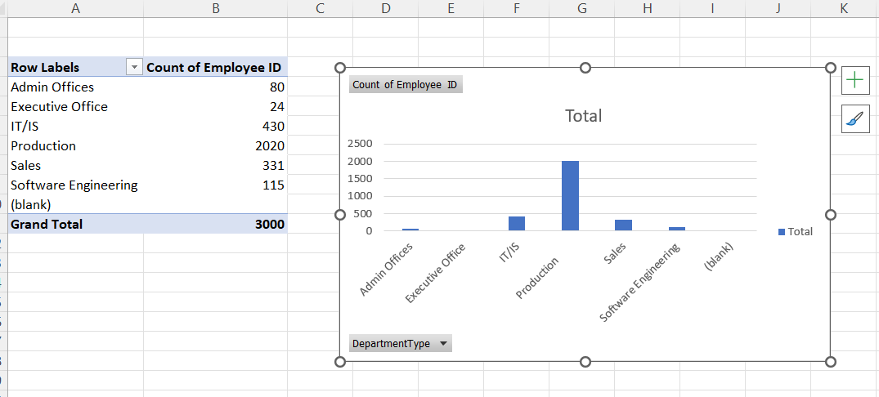

**2. Apply conditional formatting to highlight employees with a "Performance Score" below 3 in red.**

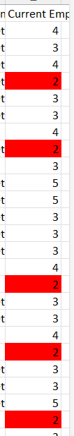

**3. Calculate the average "Satisfaction Score" for male and female employees separately using a pivot table.**

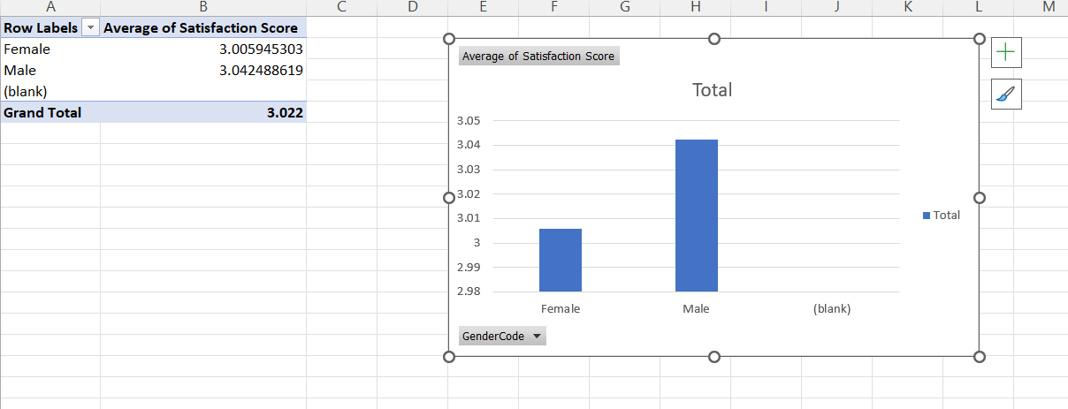

**4. Create a chart to visualize the distribution of "Work-Life Balance Score" for different job functions**.

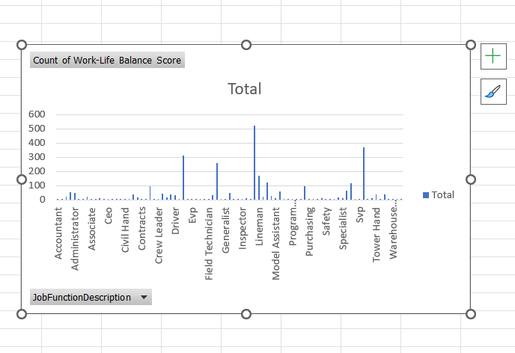

|  |  |
| --- | --- |
| **Row Labels** | **Count of Work-Life Balance Score** |
| Accountant | 2 |
| Accounting | 9 |
| Administration | 23 |
| Administrative | 56 |
| Administrator | 50 |
| Analyst | 1 |
| Apprentice | 6 |
| Assistant | 24 |
| Associate | 7 |
| Attendant | 1 |
| Billing | 13 |
| Business Development | 1 |
| Ceo | 4 |
| Cfo | 3 |
| Chief Operating Officer | 1 |
| Cio | 1 |
| Civil Hand | 1 |
| Clerical | 3 |
| Clerk | 37 |
| Construction Manager | 17 |
| Contracts | 2 |
| Controller | 7 |
| Coordinator | 96 |
| Cpo | 2 |
| Crew Leader | 1 |
| Director | 45 |
| Drafter | 19 |
| Driller | 38 |
| Driver | 36 |
| Electrician | 3 |
| Engineer | 313 |
| Estimator | 2 |
| Evp | 1 |
| Executive | 4 |
| Executive Assistant | 6 |
| Field Project Manager | 9 |
| Field Technician | 4 |
| Flagger | 34 |
| Foreman | 260 |
| General Manager | 1 |
| Generalist | 1 |
| Groundman | 51 |
| Helpdesk | 2 |
| Helper | 3 |
| Inspector | 1 |
| Intern | 12 |
| Labor | 6 |
| Laborer | 522 |
| Lineman | 169 |
| Locator | 23 |
| Manager | 124 |
| Mechanic | 29 |
| Model Assistant | 13 |
| Operator | 62 |
| Planner | 7 |
| Principal | 3 |
| Program Manager | 8 |
| Project Controls | 1 |
| Project Coordinator | 2 |
| Project Manager | 96 |
| Purchasing | 2 |
| Recruiter | 1 |
| Recruiting | 1 |
| Runner | 12 |
| Safety | 10 |
| Safety Manager | 2 |
| Services | 1 |
| Shop | 16 |
| Specialist | 15 |
| Splicer | 67 |
| Supervisor | 119 |
| Support | 1 |
| Svp | 1 |
| Technician | 368 |
| Tester | 6 |
| Top Hand | 12 |
| Tower Hand | 39 |
| Traffic | 1 |
| Vp | 37 |
| Warehouse | 2 |
| Warehouse Manager | 1 |
| Warehouse Technician | 3 |
| Welder | 5 |
| **Grand Total** | **3000** |

**5. Filter the data to display only terminated employees and find out the most common "Termination Type."**

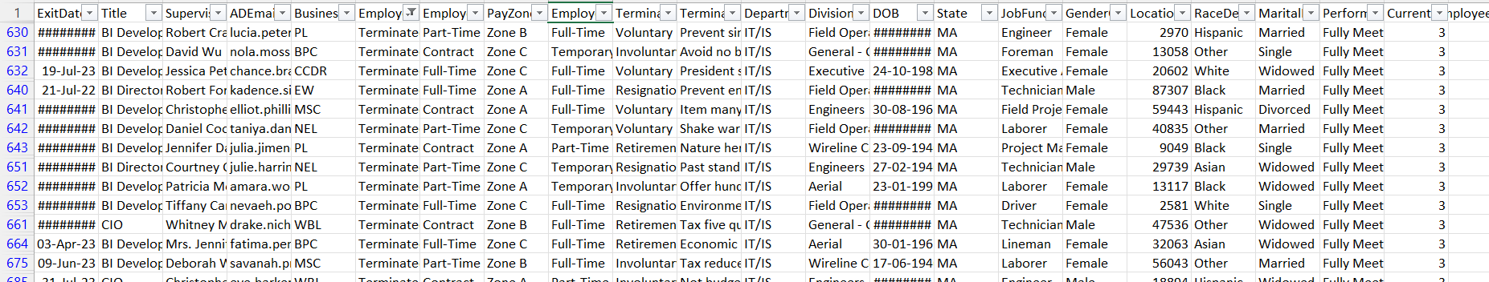

66 out of 3000 record found

**6. Calculate the average "Engagement Score" for each department using a pivot table.**

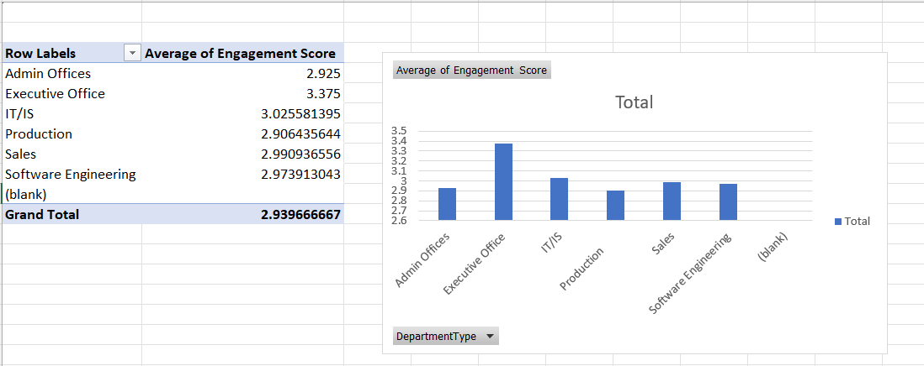

**7. Use VLOOKUP to find the supervisor's email address for a specific employee.**

For employee 1001 – susan the mail is [susan.exantus@bilearner.com](mailto:susan.exantus@bilearner.com)

And the formula is **=VLOOKUP(1001, A:I, 8, FALSE)**

8. **Can you identify the department with the highest average "Employee Rating?"**

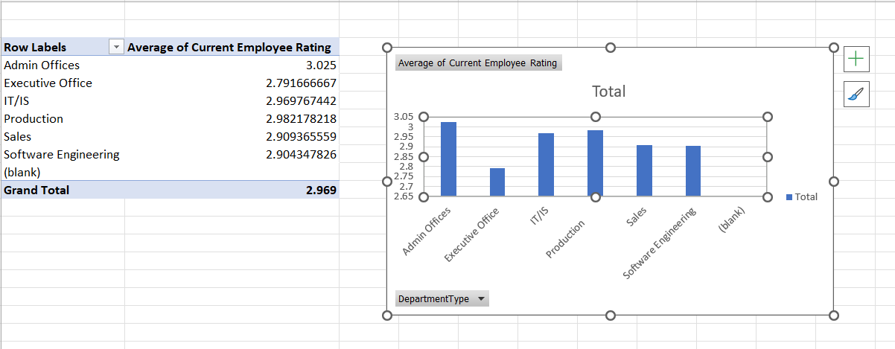

9. **Create a scatter plot to explore the relationship between "Training Duration (Days)" and "Training Cost."**

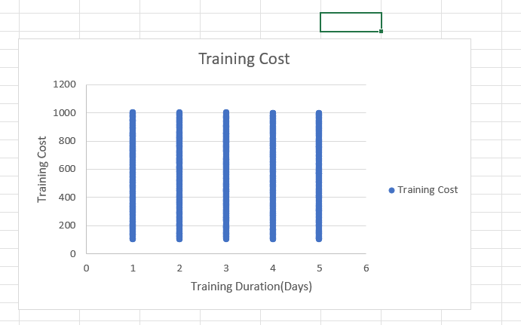

**10. Build a pivot table that shows the count of employees by "RaceDesc" and "GenderCode."**

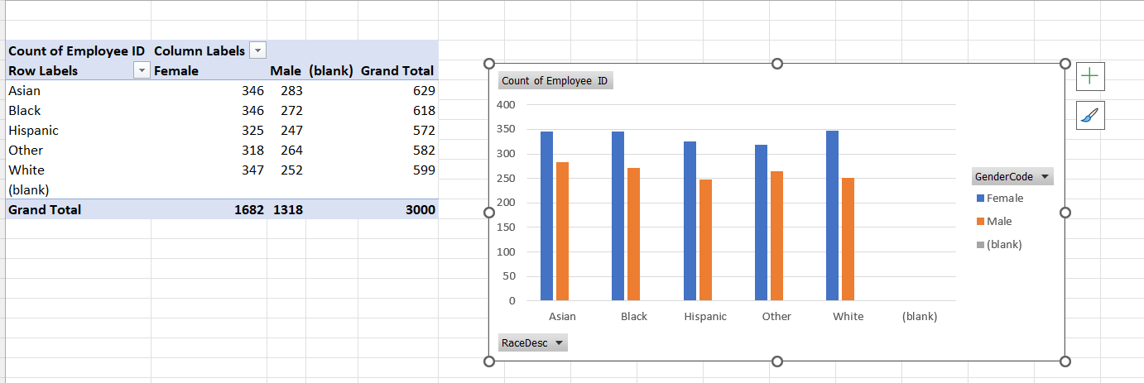

**11. Use INDEX and MATCH functions to find the "Training Program Name" for an employee with a specific ID.**

For employee 1002 – sandra the Training Program Name is Leadership development

And the formula is **=** **INDEX(C:C,MATCH(1002,A:A,0))**

**12. Create a multi-level pivot table to analyze the "Performance Score" by "BusinessUnit" and "JobFunctionDescription."**

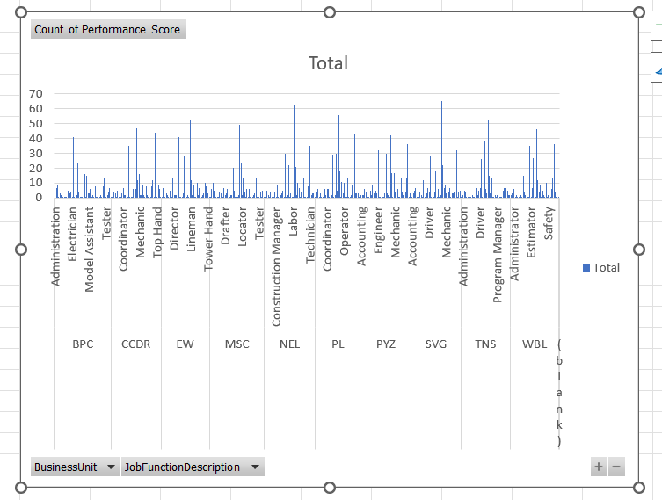

|  |  |
| --- | --- |
| **Row Labels** | **Count of Performance Score** |
| **BPC** | **303** |
| Administration | 3 |
| Administrative | 7 |
| Administrator | 9 |
| Assistant | 1 |
| Associate | 3 |
| Billing | 2 |
| Ceo | 1 |
| Cio | 1 |
| Clerk | 1 |
| Construction Manager | 1 |
| Controller | 1 |
| Coordinator | 5 |
| Director | 6 |
| Driller | 3 |
| Driver | 4 |
| Electrician | 1 |
| Engineer | 41 |
| Executive Assistant | 1 |
| Field Project Manager | 3 |
| Flagger | 2 |
| Foreman | 24 |
| Groundman | 4 |
| Helper | 1 |
| Inspector | 1 |
| Labor | 1 |
| Laborer | 49 |
| Lineman | 16 |
| Locator | 1 |
| Manager | 15 |
| Mechanic | 3 |
| Model Assistant | 3 |
| Operator | 6 |
| Planner | 1 |
| Program Manager | 2 |
| Project Controls | 1 |
| Project Manager | 8 |
| Purchasing | 1 |
| Runner | 1 |
| Safety | 1 |
| Services | 1 |
| Shop | 2 |
| Specialist | 1 |
| Splicer | 8 |
| Supervisor | 13 |
| Technician | 28 |
| Tester | 1 |
| Top Hand | 2 |
| Tower Hand | 4 |
| Vp | 7 |
| Warehouse Technician | 1 |
| **CCDR** | **300** |
| Accounting | 1 |
| Administration | 1 |
| Administrative | 4 |
| Administrator | 3 |
| Apprentice | 1 |
| Assistant | 5 |
| Associate | 1 |
| Clerk | 4 |
| Construction Manager | 1 |
| Controller | 3 |
| Coordinator | 7 |
| Director | 2 |
| Drafter | 2 |
| Driller | 3 |
| Driver | 1 |
| Engineer | 35 |
| Executive Assistant | 1 |
| Field Project Manager | 1 |
| Field Technician | 1 |
| Flagger | 6 |
| Foreman | 23 |
| Groundman | 6 |
| Laborer | 47 |
| Lineman | 12 |
| Manager | 16 |
| Mechanic | 2 |
| Model Assistant | 2 |
| Operator | 9 |
| Principal | 2 |
| Project Coordinator | 1 |
| Project Manager | 8 |
| Runner | 2 |
| Safety | 1 |
| Shop | 1 |
| Specialist | 1 |
| Splicer | 8 |
| Supervisor | 12 |
| Svp | 1 |
| Technician | 44 |
| Tester | 2 |
| Top Hand | 1 |
| Tower Hand | 9 |
| Vp | 6 |
| Warehouse | 1 |
| **EW** | **302** |
| Administration | 1 |
| Administrative | 7 |
| Administrator | 2 |
| Apprentice | 1 |
| Assistant | 3 |
| Billing | 2 |
| Clerical | 1 |
| Clerk | 5 |
| Construction Manager | 1 |
| Controller | 1 |
| Coordinator | 14 |
| Director | 2 |
| Drafter | 2 |
| Driller | 2 |
| Driver | 3 |
| Engineer | 41 |
| Evp | 1 |
| Executive Assistant | 1 |
| Field Technician | 1 |
| Flagger | 3 |
| Foreman | 28 |
| Groundman | 8 |
| Helper | 1 |
| Intern | 2 |
| Labor | 1 |
| Laborer | 52 |
| Lineman | 12 |
| Locator | 2 |
| Manager | 9 |
| Mechanic | 1 |
| Model Assistant | 1 |
| Operator | 10 |
| Planner | 2 |
| Project Manager | 7 |
| Runner | 1 |
| Safety | 1 |
| Shop | 2 |
| Specialist | 3 |
| Splicer | 10 |
| Supervisor | 8 |
| Technician | 43 |
| Tower Hand | 3 |
| Warehouse Technician | 1 |
| **MSC** | **296** |
| Accounting | 1 |
| Administration | 6 |
| Administrative | 10 |
| Administrator | 5 |
| Assistant | 3 |
| Associate | 1 |
| Cfo | 1 |
| Clerical | 1 |
| Clerk | 4 |
| Construction Manager | 3 |
| Coordinator | 12 |
| Cpo | 1 |
| Director | 7 |
| Drafter | 2 |
| Driller | 3 |
| Driver | 6 |
| Engineer | 16 |
| Executive | 1 |
| Field Project Manager | 2 |
| Flagger | 2 |
| Foreman | 20 |
| Groundman | 5 |
| Helpdesk | 1 |
| Helper | 1 |
| Intern | 1 |
| Labor | 2 |
| Laborer | 49 |
| Lineman | 24 |
| Locator | 2 |
| Manager | 14 |
| Mechanic | 4 |
| Model Assistant | 1 |
| Operator | 6 |
| Principal | 1 |
| Project Manager | 6 |
| Recruiting | 1 |
| Runner | 1 |
| Shop | 1 |
| Specialist | 2 |
| Splicer | 3 |
| Supervisor | 14 |
| Support | 1 |
| Technician | 37 |
| Tester | 1 |
| Tower Hand | 4 |
| Traffic | 1 |
| Vp | 5 |
| Warehouse Technician | 1 |
| **NEL** | **304** |
| Accounting | 1 |
| Administration | 1 |
| Administrative | 5 |
| Administrator | 2 |
| Apprentice | 1 |
| Assistant | 4 |
| Associate | 1 |
| Billing | 1 |
| Chief Operating Officer | 1 |
| Clerk | 4 |
| Construction Manager | 1 |
| Coordinator | 9 |
| Cpo | 1 |
| Director | 4 |
| Drafter | 2 |
| Driller | 3 |
| Driver | 5 |
| Electrician | 1 |
| Engineer | 30 |
| Executive Assistant | 1 |
| Flagger | 2 |
| Foreman | 22 |
| General Manager | 1 |
| Groundman | 3 |
| Intern | 1 |
| Labor | 1 |
| Laborer | 63 |
| Lineman | 21 |
| Locator | 2 |
| Manager | 10 |
| Mechanic | 7 |
| Model Assistant | 1 |
| Operator | 4 |
| Program Manager | 1 |
| Project Manager | 14 |
| Safety | 1 |
| Shop | 1 |
| Specialist | 1 |
| Splicer | 8 |
| Supervisor | 18 |
| Technician | 35 |
| Tester | 2 |
| Tower Hand | 3 |
| Vp | 3 |
| Warehouse Manager | 1 |
| **PL** | **301** |
| Administration | 1 |
| Administrative | 4 |
| Administrator | 6 |
| Analyst | 1 |
| Assistant | 3 |
| Attendant | 1 |
| Billing | 1 |
| Cfo | 2 |
| Clerk | 6 |
| Construction Manager | 2 |
| Coordinator | 6 |
| Director | 6 |
| Drafter | 1 |
| Driller | 3 |
| Driver | 2 |
| Engineer | 29 |
| Executive | 1 |
| Flagger | 2 |
| Foreman | 30 |
| Groundman | 5 |
| Laborer | 56 |
| Lineman | 18 |
| Locator | 1 |
| Manager | 11 |
| Mechanic | 3 |
| Operator | 10 |
| Program Manager | 1 |
| Project Coordinator | 1 |
| Project Manager | 13 |
| Runner | 1 |
| Shop | 1 |
| Specialist | 2 |
| Splicer | 9 |
| Supervisor | 8 |
| Technician | 43 |
| Top Hand | 3 |
| Tower Hand | 3 |
| Vp | 3 |
| Warehouse | 1 |
| Welder | 1 |
| **PYZ** | **299** |
| Accounting | 2 |
| Administration | 2 |
| Administrative | 2 |
| Administrator | 6 |
| Assistant | 4 |
| Associate | 1 |
| Billing | 1 |
| Ceo | 1 |
| Clerk | 5 |
| Construction Manager | 2 |
| Coordinator | 9 |
| Director | 3 |
| Drafter | 3 |
| Driller | 5 |
| Driver | 3 |
| Engineer | 32 |
| Estimator | 1 |
| Executive | 1 |
| Executive Assistant | 1 |
| Field Project Manager | 1 |
| Field Technician | 1 |
| Flagger | 3 |
| Foreman | 30 |
| Groundman | 3 |
| Intern | 2 |
| Labor | 1 |
| Laborer | 42 |
| Lineman | 17 |
| Locator | 1 |
| Manager | 17 |
| Mechanic | 4 |
| Model Assistant | 3 |
| Operator | 6 |
| Planner | 1 |
| Program Manager | 1 |
| Project Manager | 13 |
| Runner | 4 |
| Shop | 2 |
| Specialist | 2 |
| Splicer | 4 |
| Supervisor | 14 |
| Technician | 36 |
| Top Hand | 1 |
| Tower Hand | 3 |
| Vp | 3 |
| **SVG** | **304** |
| Accounting | 1 |
| Administration | 3 |
| Administrative | 5 |
| Administrator | 7 |
| Apprentice | 1 |
| Billing | 1 |
| Ceo | 1 |
| Clerk | 4 |
| Construction Manager | 2 |
| Contracts | 1 |
| Coordinator | 12 |
| Crew Leader | 1 |
| Director | 4 |
| Drafter | 3 |
| Driller | 7 |
| Driver | 4 |
| Engineer | 28 |
| Executive Assistant | 1 |
| Field Project Manager | 2 |
| Field Technician | 1 |
| Flagger | 4 |
| Foreman | 18 |
| Generalist | 1 |
| Groundman | 6 |
| Helpdesk | 1 |
| Intern | 2 |
| Laborer | 65 |
| Lineman | 22 |
| Locator | 7 |
| Manager | 9 |
| Mechanic | 3 |
| Model Assistant | 1 |
| Operator | 4 |
| Project Manager | 7 |
| Recruiter | 1 |
| Safety | 3 |
| Specialist | 3 |
| Splicer | 4 |
| Supervisor | 11 |
| Technician | 32 |
| Top Hand | 1 |
| Tower Hand | 4 |
| Vp | 5 |
| Welder | 1 |
| **TNS** | **297** |
| Accounting | 3 |
| Administration | 2 |
| Administrative | 5 |
| Administrator | 4 |
| Apprentice | 1 |
| Assistant | 1 |
| Billing | 3 |
| Business Development | 1 |
| Ceo | 1 |
| Construction Manager | 2 |
| Contracts | 1 |
| Controller | 1 |
| Coordinator | 7 |
| Director | 7 |
| Drafter | 2 |
| Driller | 5 |
| Driver | 7 |
| Engineer | 26 |
| Executive | 1 |
| Flagger | 3 |
| Foreman | 38 |
| Groundman | 6 |
| Intern | 3 |
| Laborer | 53 |
| Lineman | 15 |
| Locator | 3 |
| Manager | 14 |
| Mechanic | 1 |
| Model Assistant | 1 |
| Operator | 2 |
| Planner | 1 |
| Program Manager | 2 |
| Project Manager | 10 |
| Purchasing | 1 |
| Runner | 1 |
| Safety | 1 |
| Shop | 5 |
| Splicer | 7 |
| Supervisor | 7 |
| Technician | 34 |
| Tower Hand | 5 |
| Vp | 2 |
| Welder | 2 |
| **WBL** | **294** |
| Accountant | 2 |
| Administration | 3 |
| Administrative | 7 |
| Administrator | 6 |
| Apprentice | 1 |
| Billing | 2 |
| Civil Hand | 1 |
| Clerical | 1 |
| Clerk | 4 |
| Construction Manager | 2 |
| Controller | 1 |
| Coordinator | 15 |
| Director | 4 |
| Drafter | 2 |
| Driller | 4 |
| Driver | 1 |
| Electrician | 1 |
| Engineer | 35 |
| Estimator | 1 |
| Flagger | 7 |
| Foreman | 27 |
| Groundman | 5 |
| Intern | 1 |
| Laborer | 46 |
| Lineman | 12 |
| Locator | 4 |
| Manager | 9 |
| Mechanic | 1 |
| Operator | 5 |
| Planner | 2 |
| Program Manager | 1 |
| Project Manager | 10 |
| Runner | 1 |
| Safety | 2 |
| Safety Manager | 2 |
| Shop | 1 |
| Splicer | 6 |
| Supervisor | 14 |
| Technician | 36 |
| Top Hand | 4 |
| Tower Hand | 1 |
| Vp | 3 |
| Welder | 1 |
| **(blank)** |  |
| **Grand Total** | **3000** |

**13. Design a dynamic chart that allows users to select and visualize the performance of any employee over time.**

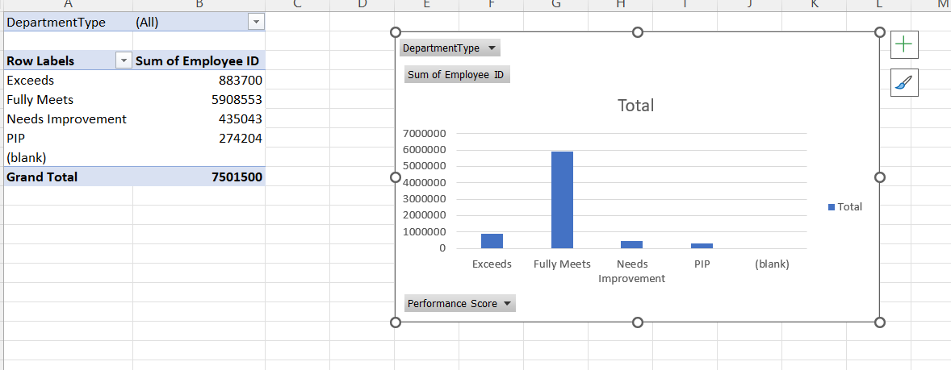

**14. Calculate the total training cost for each "Training Program Name" and display it in a bar chart.**

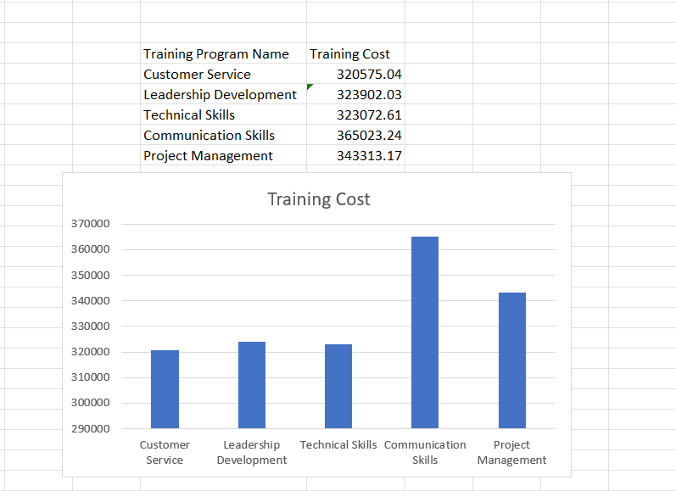

**15. Apply advanced conditional formatting to highlight the top 10% and bottom 10% of employees based on "Current Employee Rating."**

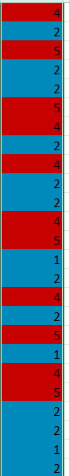

**16. Use a calculated field in a pivot table to determine the average "Engagement Score" per year**

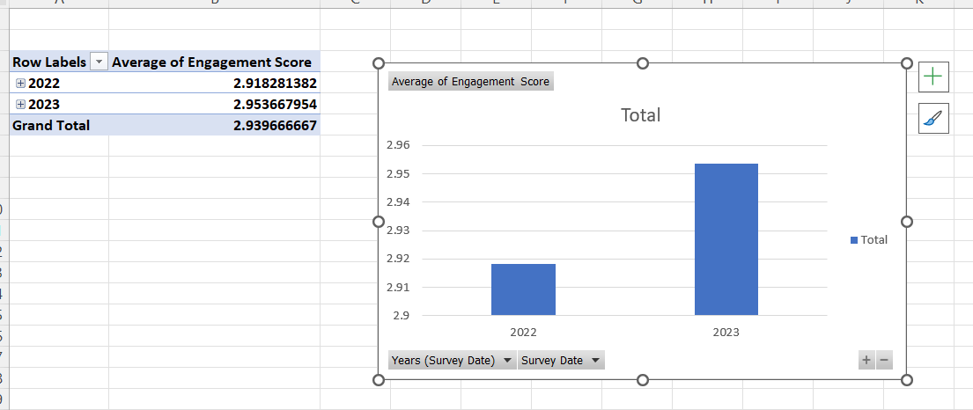

**17. Can you build a macro that automates the process of updating and refreshing all pivot tables in the workbook?**

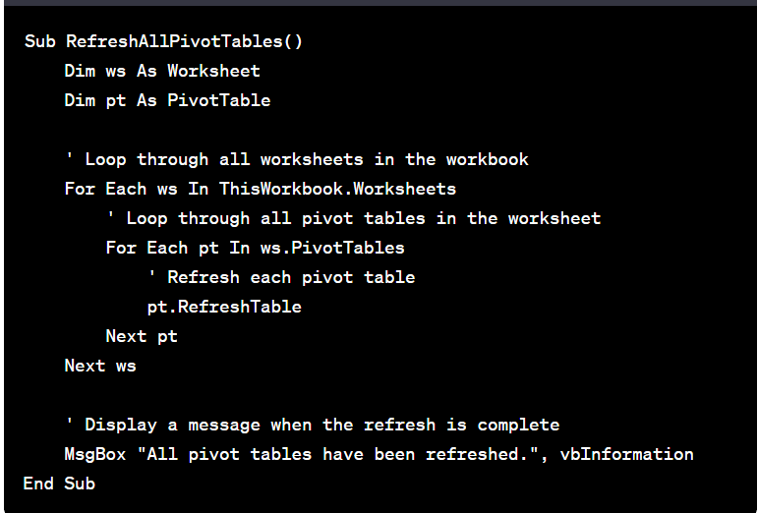

**18. Create a histogram to understand the distribution of "ExitDate" for terminated employees.**

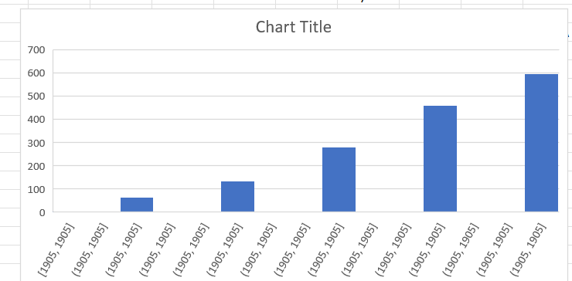

**19. Utilize the SUMPRODUCT function to calculate the total training cost for employees in a specific location.**

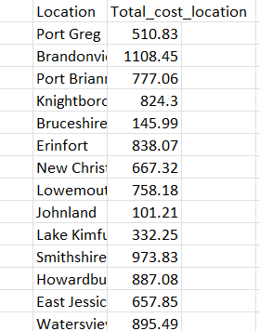

**20. Develop a dashboard that provides an overview of key HR metrics, including headcount, performance, and training costs, using charts and pivot tables**

