Name : **Bhavana Soge**

Email : soge.bhavana@gmail.com

LinkedIn : https://www.linkedin.com/in/bhavana-soge-15a76a226/

PSYLIQ



1. **Using Excel, how would you filter the dataset to only show employees aged 30 and above?**

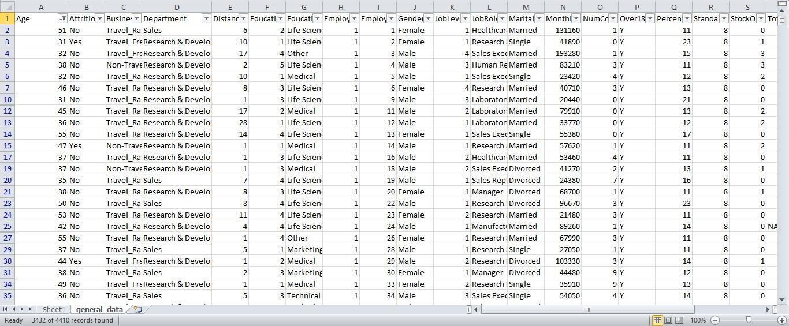

1. **Create a pivot table to summarize the average Monthly Income by Job Role.**

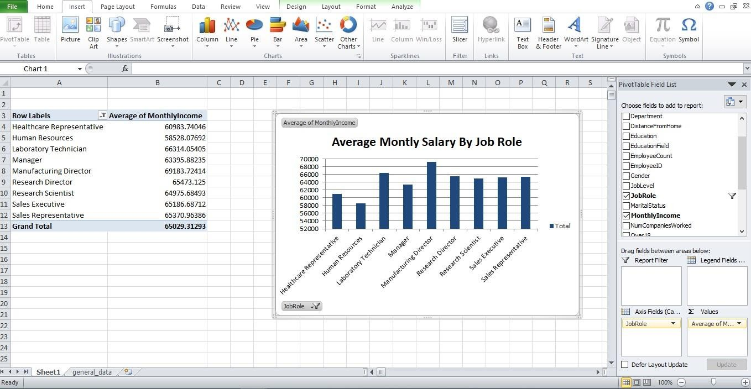

1. **Apply conditional formatting to highlight employees with Monthly Income above the company's average income.**

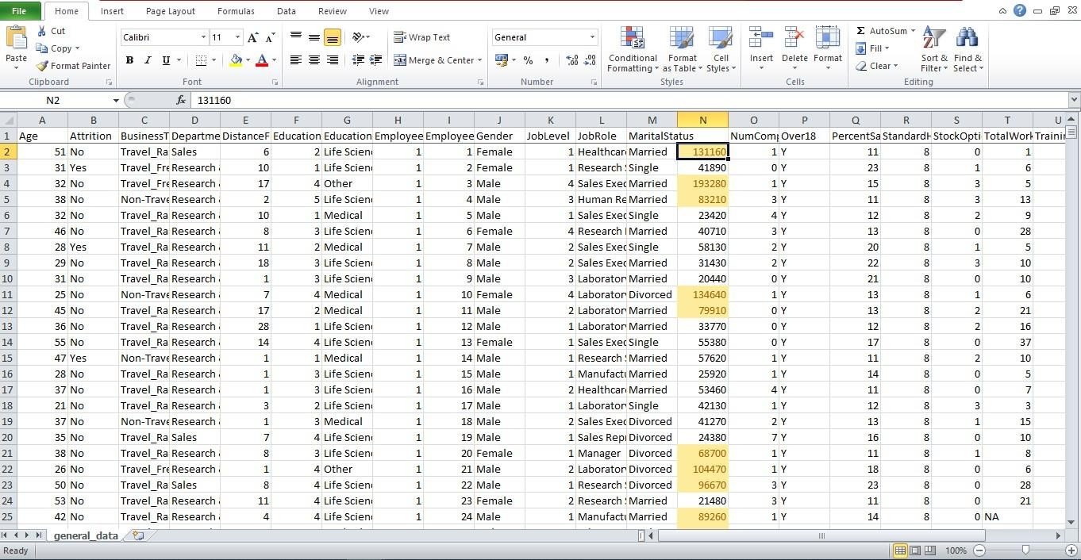

1. **Create a bar chart in Excel to visualize the distribution of employee ages.**

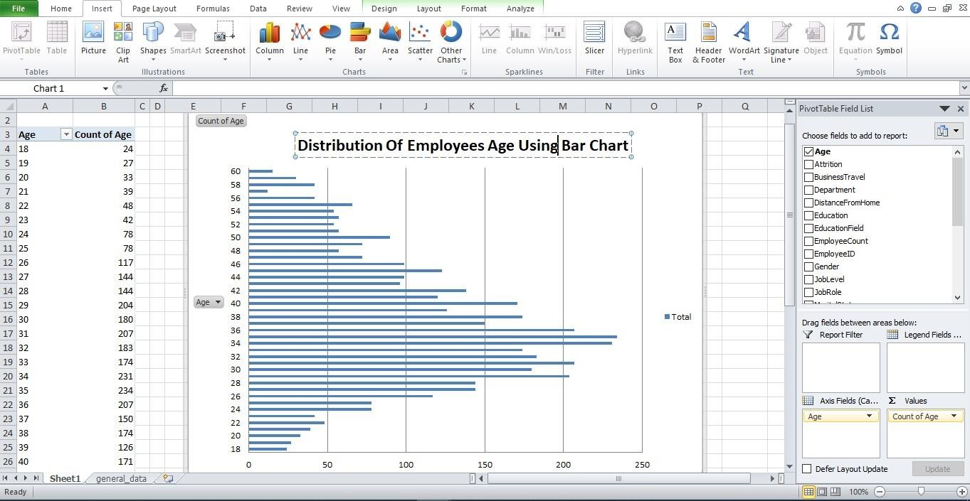

1. **Identify and clean any missing or inconsistent data in the "Department" column.**

No Missing or Inconsistent Data**.**

1. **In Power BI, establish a relationship between the "EmployeeID" in the employee data and the "EmployeeID" in the time tracking data.**

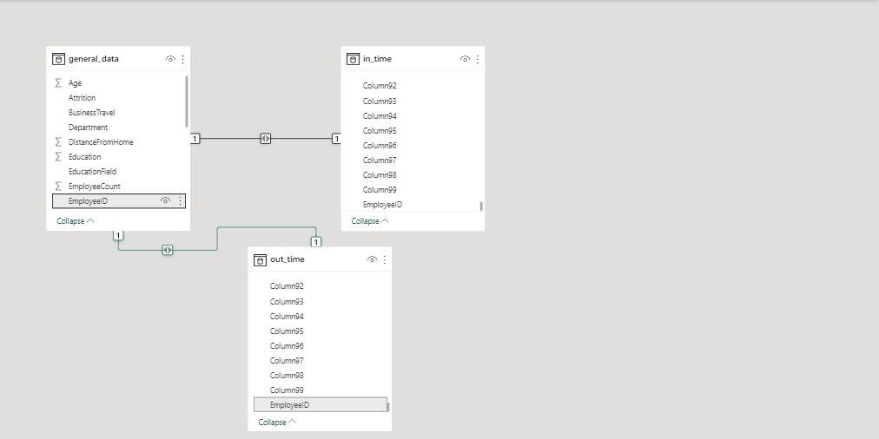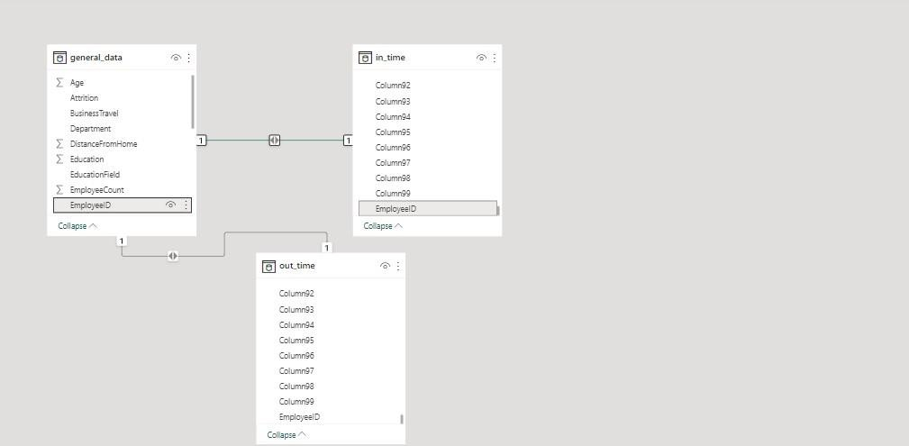

1. **Using DAX, create a calculated column that calculates the average years an employee has spent with their current manager.**

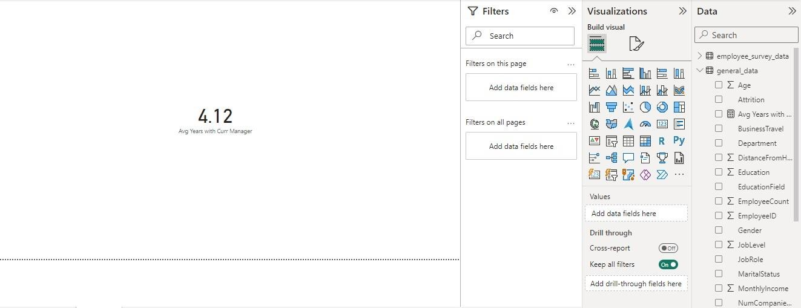

1. **Using Excel, create a pivot table that displays the count of employees in each Marital Status category, segmented by Department.**

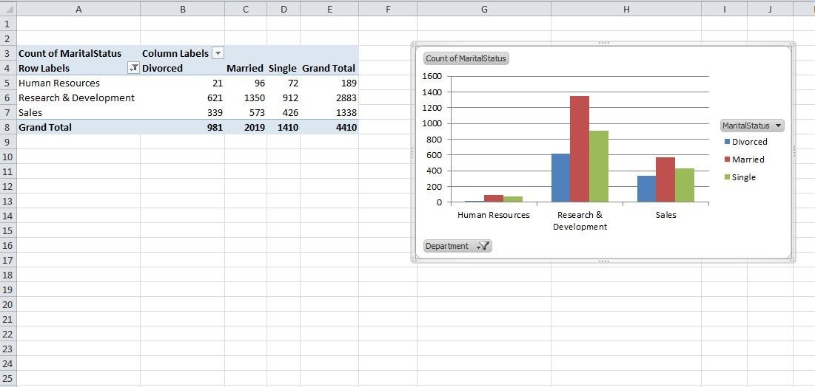

1. **Apply conditional formatting to highlight employees with both above-average Monthly Income and above-average Job Satisfaction**.

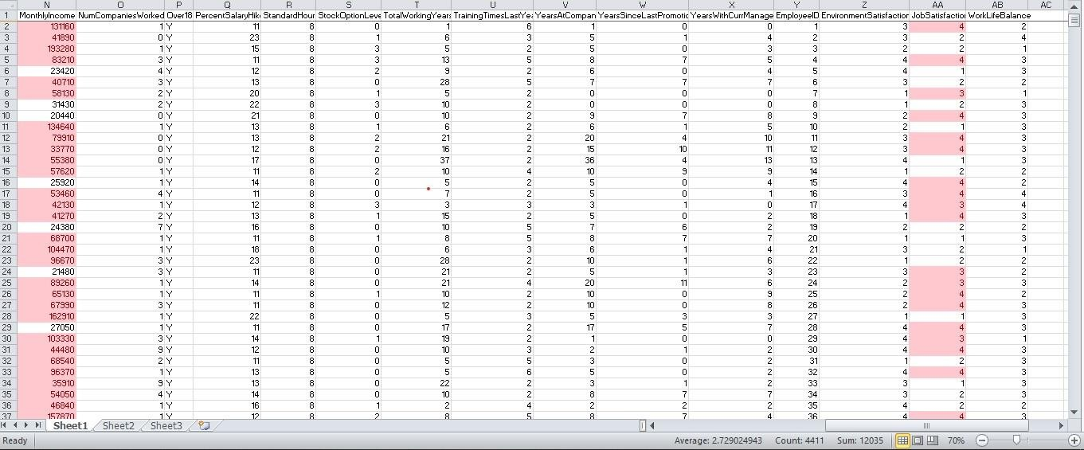

1. **In Power BI, create a line chart that visualizes the trend of Employee Attrition over the years.**

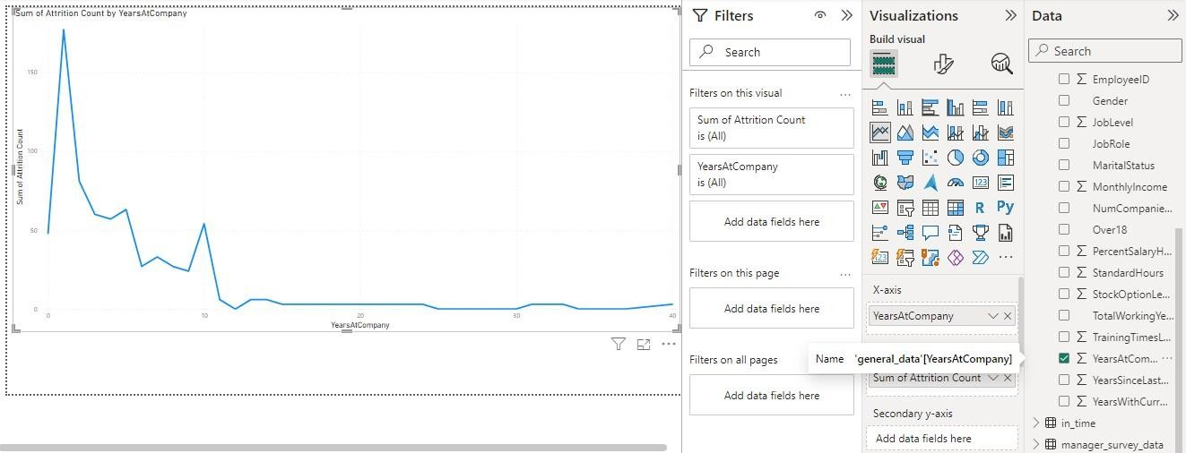

1. **Describe how you would create a star schema for this dataset, explaining the benefits of doing so?**
   * Star Schema Components:
     + **Fact Table**: This table holds the primary metrics or measures of interest.
       - **Primary Key : EmployeeID**
     + **Dimension Tables**: These tables contain descriptive information related to each dimension.
       - **Employee Details**
       - **Manager**
       - **Time Benefits of a Star Schema:**
2. **Simplicity and Query Performance**: Star schemas simplify queries by separating

measures from descriptive attributes. This structure streamlines querying and improves performance by minimizing the number of joins needed to retrieve information.

1. **Scalability**: It's easier to extend star schemas with new dimensions or measures. Adding new data doesn’t require modifying existing tables extensively, making it more scalable as the dataset grows.
2. **Improved Data Analysis** : With a star schema, it's easier to perform complex analyses.
3. **Easier to Understand and Navigate :** The star schema’s structure is intuitive and user-friendly, making it easier for analysts and users to understand relationships between different data elements.
4. **Better for Data Warehousing**: Star schemas are commonly used in data warehousing environments, facilitating efficient data retrieval and analysis in decision-making processes.

1. **Using DAX, calculate the rolling 3-month average of Monthly Income for each employee.**

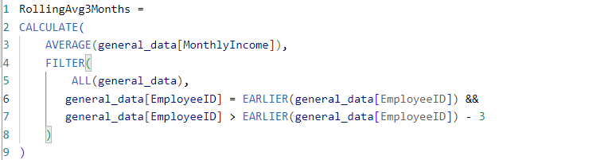

1. **Create a hierarchy in Power BI that allows users to drill down from Department to Job Role to further narrow their analysis?**

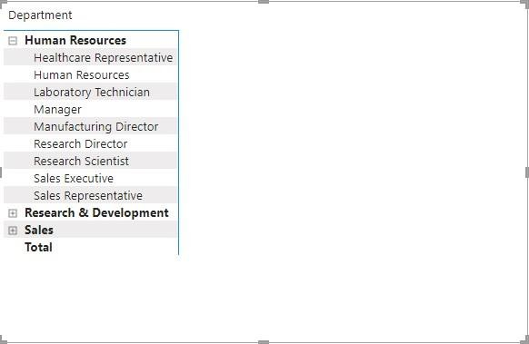

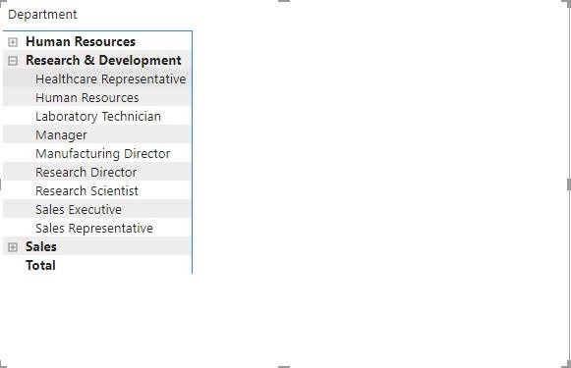

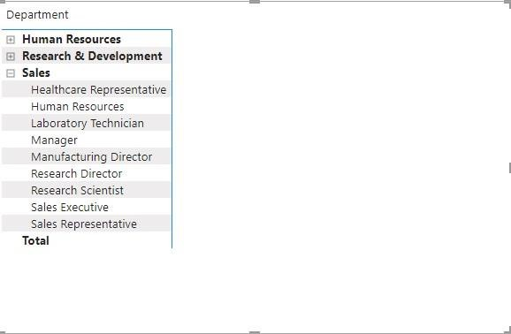

1. **How can you set up parameterized queries in Power BI to allow users to filter data based on the Distance from Home column?**
   1. Create a Parameter
   2. Use the parameters in Queries
   3. Apply filtering based on Parameters
   4. Interacting with the parameter
      1. This setup enables users to dynamically filter data based on the distance from the Home column, providing a user-friendly way to interact with the report and customize data analysis based on varying distance criteria.
2. **In Excel, calculate the total Monthly Income for each Department, considering only the employees with a Job Level greater than or equal to 3.**

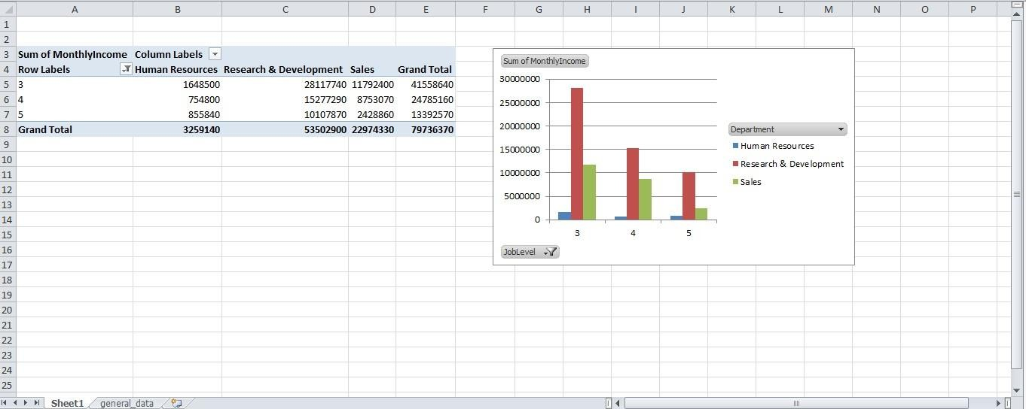

1. **Explain how to perform a What-If analysis in Excel to understand the impact of a 10% increase in Percent Salary Hike on Monthly Income.**

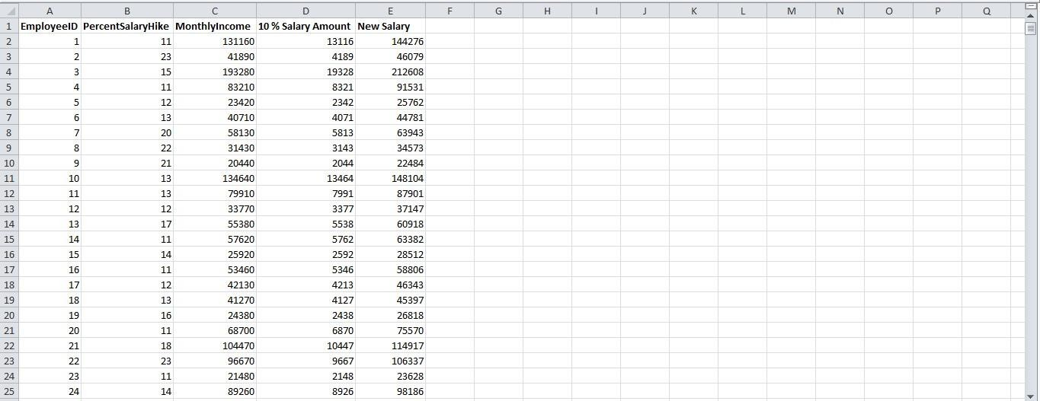

1. **Verify if the data adheres to a predefined schema. What actions would you take if you find inconsistencies?**

* **Understand the Predefined Schema:** Review the predefined schema or data model to understand the expected structure, data types, relationships, constraints, and other specifications
* **Examine the Data:**
  + Analyze the actual data against the predefined schema.
  + Check column names, data types, null values, unique constraints, relationships between tables (if applicable), and overall data consistency
* **Use Automated Checks:**
  + Employ automated tools or scripts to compare the actual data against the schema.
  + Utilize validation scripts or functions to check for data type mismatches, missing values, unexpected values, or any inconsistencies.