MiniBank Java Project
  - Practical journal 1 to 14
This journal follows the supplied MiniBank sample. It contains the aim, runnable Java source code, captured output and result for each practical. The final practical combines the topics into a working console application.

Student details
Student name ______________________________
Enrolment number __________________________
Subject Object Oriented Programming
Subject code CEUE203 | Semester 3
Academic year 2026 to 2027

How to use this project
Use JDK 17 or later. Open one practical folder and run run.bat on Windows, or bash run.sh on Linux or macOS. Each practical has its own classes and must be compiled separately. Start with Practical 1 and work through the folders in order.
The code uses clear steps and comments for a beginner. Features such as records, annotations, lambdas, generics and threads are included where required by the supplied practical topics.
Output figures are rendered images of real console output captured during execution. They are not screenshots of a desktop or IDE. The original text is included in the outputs folder. Demonstration names and account details are fictional.
Validation completed on Java 17. All 14 programs compiled and ran; all seven JUnit 5 tests passed. Account saving and restart loading were also checked.

Practical index
Practical | Topic
1 | Menu shell
2 | Customer and account encapsulation
3 | Object methods and nested class
4 | Validation and command parsing
5 | Inheritance and polymorphism
6 | Interfaces packages and runnable JAR
7 | Annotations and reflection
8 | Exception handling
9 | Threads and synchronization
10 | Thread pool and deadlock prevention
11 | File handling and serialization
12 | Collections and sorting
13 | Generic repository
14 | Complete MiniBank application

Practical 1

Menu shell

Aim
Create a menu using Scanner, an enum, a record and a switch expression. Repeat the menu until the user exits.

Source code

MiniBank.java
// Run this class to see the demonstration for this practical.
import java.util.Scanner;

record BankInfo(String name, String branch) {}

enum MenuOption {
OPEN_ACCOUNT, DEPOSIT, WITHDRAW, TRANSFER, EXIT
}

public class MiniBank {
public static void main(String[] args) {
BankInfo info = new BankInfo("MiniBank Student Bank", "Campus Branch");
System.out.println("=== " + info.name() + " (" + info.branch() + ") ===");

Scanner scanner = new Scanner(System.in);
boolean running = true;

while (running) {
System.out.println("\n1. OPEN_ACCOUNT 2. DEPOSIT 3. WITHDRAW 4. TRANSFER 5. EXIT");
System.out.print("Select option: ");
if (!scanner.hasNextInt()) break;
if (!scanner.hasNextLine()) break;
int choice;
try { choice = Integer.parseInt(scanner.nextLine().trim()); }
catch (NumberFormatException e) { System.out.println("Enter a number from 1 to 5.");
continue; }

if (choice < 1 || choice > MenuOption.values().length) {
System.out.println("Invalid option. Please try again.");
continue;
}

MenuOption option = MenuOption.values()[choice - 1];
String message = switch (option) {
case OPEN_ACCOUNT -> "Open Account — to be implemented in a later lab";
case DEPOSIT -> "Deposit — to be implemented in a later lab";
case WITHDRAW -> "Withdraw — to be implemented in a later lab";
case TRANSFER -> "Transfer — to be implemented in a later lab";
case EXIT -> {
running = false;
yield "Thank you for banking with MiniBank. Goodbye!";
}
};
System.out.println(message);
}
scanner.close();
}
}

Run the program
From Practical-01, run run.bat on Windows or bash run.sh on Linux or macOS.

Output
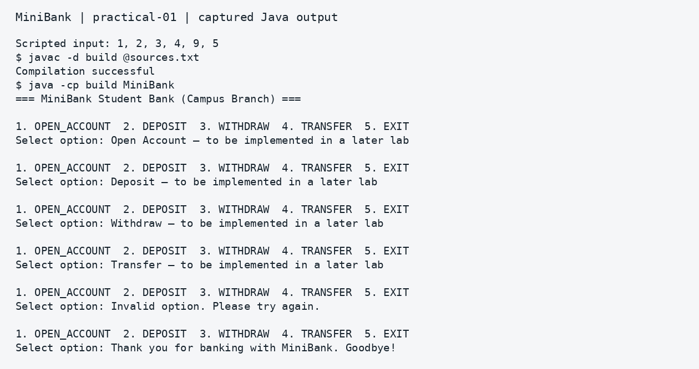
Captured output — practical 01

Result
The menu accepts valid choices, rejects an invalid option and exits when option 5 is selected.

Practical 2

Customer and account encapsulation

Aim
Store customer and account details in private fields. Use constructors, getters, deposits and withdrawals.

Source code

Account.java
// Account stores the details and balance of one bank account.
public class Account {
private static int accountCounter = 0;
private final String accountNumber;
private String ownerName;
private long balance;
private boolean active;

public Account(String ownerName, long openingBalance) {
this.accountNumber = String.format("AC%04d", ++accountCounter);
this.ownerName = ownerName;
this.balance = Math.max(0, openingBalance);
this.active = true;
}

public Account(String ownerName) {
this(ownerName, 0);
}

public void deposit(long amount) {
if (amount > 0) {
balance += amount;
}
}

public boolean withdraw(long amount) {
if (amount > 0 && balance >= amount) {
balance -= amount;
return true;
}
return false;
}

public String getAccountNumber() { return accountNumber; }
public String getOwnerName() { return ownerName; }
public long getBalance() { return balance; }
public boolean isActive() { return active; }
}

Customer.java
public class Customer {
private static long customerCounter = 100;
private final String customerId;
private String name;
private String email;
private String mobile;

private static String generateCustomerId() {
return "CUST" + (++customerCounter);
}

public Customer(String name, String email, String mobile) {
this.customerId = generateCustomerId();
this.name = name;
this.email = email;
this.mobile = mobile;
}

public String getCustomerId() { return customerId; }
public String getName() { return name; }
public String getEmail() { return email; }
public String getMobile() { return mobile; }
}

MiniBank.java
// Run this class to see the demonstration for this practical.
public class MiniBank {
public static void main(String[] args) {
Account[] accounts = {
new Account("Diya", 5000),
new Account("Arjun", 3000),
new Account("Neel")
};

accounts[0].deposit(2000);
System.out.println(accounts[0].getAccountNumber() + " after deposit(2000): " +
accounts[0].getBalance());

for (Account a : accounts) System.out.println(a.getAccountNumber() + " | " + a.getOwnerName() +
" | " + a.getBalance());
boolean ok1 = accounts[0].withdraw(3000);
System.out.println("Withdraw 3000 (" + ok1 + ") -> Balance: " + accounts[0].getBalance());

boolean ok2 = accounts[0].withdraw(10000);
System.out.println("Withdraw 10000 (" + ok2 + ") -> Balance: " + accounts[0].getBalance());
}
}

Run the program
From Practical-02, run run.bat on Windows or bash run.sh on Linux or macOS.

Output
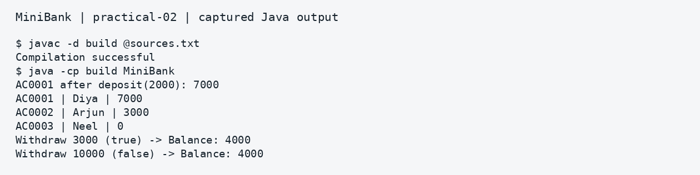
Captured output — practical 02

Result
Account balances change through deposit and withdrawal methods. A withdrawal above the available balance is rejected.

Practical 3

Object methods and nested class

Aim
Override toString, equals and hashCode. Add a static nested Address class and demonstrate cloning.

Source code

Account.java
// Account stores the details and balance of one bank account.
import java.util.Objects;

public class Account {
private final String accountNumber;
private String ownerName;
private long balance;

public Account(String accountNumber, String ownerName, long balance) {
this.accountNumber = accountNumber;
this.ownerName = ownerName;
this.balance = balance;
}

public String getAccountNumber() { return accountNumber; }
public String getOwnerName() { return ownerName; }
public long getBalance() { return balance; }

@Override
public String toString() {
return accountNumber + " | " + ownerName + " | " + balance;
}

@Override
public boolean equals(Object o) {
if (this == o) return true;
if (o == null || getClass() != o.getClass()) return false;
Account account = (Account) o;
return Objects.equals(accountNumber, account.accountNumber);
}

@Override
public int hashCode() {
return Objects.hash(accountNumber);
}
}

Customer.java
public class Customer implements Cloneable {
public static class Address {
private final String line;
private final String city;
private final String pincode;

public Address(String line, String city, String pincode) {
this.line = line;
this.city = city;
this.pincode = pincode;
}

public String getLine() { return line; }
public String getCity() { return city; }
public String getPincode() { return pincode; }

@Override
public String toString() {
return line + ", " + city + " - " + pincode;
}
}

private String name;
private Address address;

public Customer(String name, Address address) {
this.name = name;
this.address = address;
}

public String getName() { return name; }
public Address getAddress() { return address; }

@Override
public Customer clone() {
try {
return (Customer) super.clone();
} catch (CloneNotSupportedException e) {
throw new AssertionError();
}
}

@Override
public String toString() {
return name + " (" + address + ")";
}
}

MiniBank.java
// Run this class to see the demonstration for this practical.
public class MiniBank {
public static void main(String[] args) {
Account a1 = new Account("AC0001", "Diya", 4000);
Account a2 = new Account("AC0001", "Diya", 4000);

System.out.println(a1);
System.out.println("a1.equals(a2): " + a1.equals(a2));
System.out.println("a1 instanceof Account: " + (a1 instanceof Account));

Customer c1 = new Customer("Diya", new Customer.Address("MG Road", "Anand", "388001"));
Customer c2 = c1.clone();
System.out.println("Cloned Customer: " + c2);
}
}

Run the program
From Practical-03, run run.bat on Windows or bash run.sh on Linux or macOS.

Output
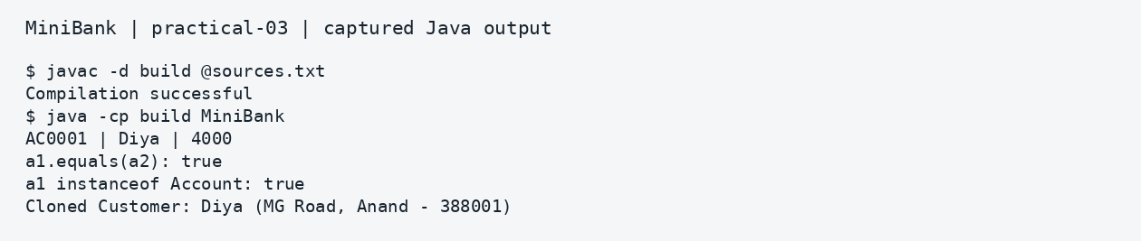
Captured output — practical 03

Result
Two accounts with the same number compare as equal. A customer can be cloned and its address displayed.

Practical 4

Validation and command parsing

Aim
Validate mobile, email, PAN and IFSC strings. Convert a command string to a record and format a statement.

Source code

Account.java
// Account stores the details and balance of one bank account.
public class Account {
private final String accountNumber;
private final String ownerName;
private final long balance;

public Account(String accountNumber, String ownerName, long balance) {
this.accountNumber = accountNumber;
this.ownerName = ownerName;
this.balance = balance;
}

public String getAccountNumber() { return accountNumber; }
public String getOwnerName() { return ownerName; }
public long getBalance() { return balance; }
}

Command.java
public record Command(TransactionType type, String accountNumber, long amount) {}

CommandParser.java
public class CommandParser {
public static Command parse(String line) {
String[] parts = line.trim().split("\\s+");
if (parts.length != 3) {
throw new IllegalArgumentException("Expected 3 tokens: TYPE ACCOUNT AMOUNT");
}
return new Command(
TransactionType.valueOf(parts[0].toUpperCase()),
parts[1],
Long.parseLong(parts[2])
);
}
}

MiniBank.java
// Run this class to see the demonstration for this practical.
public class MiniBank {
public static void main(String[] args) {
System.out.println("isValidMobile('9876543210'): " + Validator.isValidMobile("9876543210"));
System.out.println("isValidMobile('12345'): " + Validator.isValidMobile("12345"));
System.out.println("isValidPan('ABCDE1234F'): " + Validator.isValidPan("ABCDE1234F"));
System.out.println("isValidIfsc('SBIN0001234'): " + Validator.isValidIfsc("SBIN0001234"));

Command cmd = CommandParser.parse("DEPOSIT AC0001 500");
System.out.println("Parsed: " + cmd);
System.out.print(StatementFormatter.buildStatement(new Account("AC0001", "Diya", 5500)));
System.out.println("Email valid: " + Validator.isValidEmail("diya@example.com"));

Account acc = new Account("AC0001", "Diya", 4500);
System.out.print(StatementFormatter.buildStatement(acc));
}
}

StatementFormatter.java
public class StatementFormatter {
public static String buildStatement(Account account) {
StringBuilder sb = new StringBuilder();
sb.append("--- Account Statement ---\n")
.append("Account : ").append(account.getAccountNumber()).append("\n")
.append("Owner : ").append(account.getOwnerName()).append("\n")
.append("Balance : Rs. ").append(account.getBalance()).append("\n");
return sb.toString();
}
}

TransactionType.java
public enum TransactionType {
DEPOSIT, WITHDRAW, TRANSFER
}

Validator.java
import java.util.regex.Pattern;

public class Validator {
private static final Pattern MOBILE = Pattern.compile("^[6-9][0-9]{9}$");
private static final Pattern EMAIL = Pattern.compile("^[\\w._%+-]+@[\\w.-]+\\.[a-zA-Z]{2,}$");
private static final Pattern PAN = Pattern.compile("^[A-Z]{5}[0-9]{4}[A-Z]$");
private static final Pattern IFSC = Pattern.compile("^[A-Z]{4}0[A-Z0-9]{6}$");

public static boolean isValidMobile(String s) { return s != null && MOBILE.matcher(s).matches(); }
public static boolean isValidEmail(String s) { return s != null && EMAIL.matcher(s).matches(); }
public static boolean isValidPan(String s) { return s != null && PAN.matcher(s).matches(); }
public static boolean isValidIfsc(String s) { return s != null && IFSC.matcher(s).matches(); }
}

Run the program
From Practical-04, run run.bat on Windows or bash run.sh on Linux or macOS.

Output
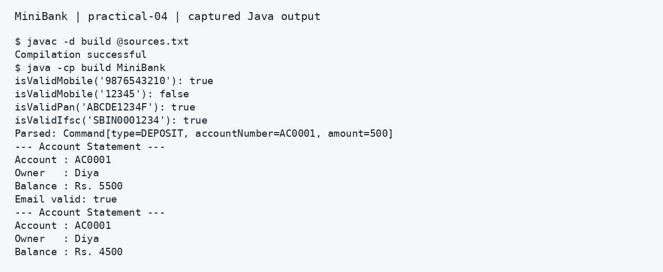
Captured output — practical 04

Result
The validators distinguish valid and invalid values. The command parser and statement formatter produce readable output.

Practical 5

Inheritance and polymorphism

Aim
Create an abstract Account class and demonstrate savings, current and fixed deposit account types.

Source code

Account.java
// Account stores the details and balance of one bank account.
public abstract class Account {
protected final String accountNumber;
protected String ownerName;
protected long balance;

public Account(String accountNumber, String ownerName, long balance) {
this.accountNumber = accountNumber;
this.ownerName = ownerName;
this.balance = balance;
}

public abstract double interestRate();
public abstract boolean canWithdraw(long amount);

public String getAccountNumber() { return accountNumber; }
public String getOwnerName() { return ownerName; }
public long getBalance() { return balance; }
}

CurrentAccount.java
public class CurrentAccount extends Account {
private final long overdraftLimit;

public CurrentAccount(String accNo, String owner, long balance, long overdraftLimit) {
super(accNo, owner, balance);
this.overdraftLimit = overdraftLimit;
}

@Override
public double interestRate() { return 0.0; }

@Override
public boolean canWithdraw(long amount) {
return amount > 0 && (balance - amount) >= -overdraftLimit;
}

public long getOverdraftLimit() { return overdraftLimit; }
}

FixedDepositAccount.java
public class FixedDepositAccount extends Account {
public FixedDepositAccount(String accNo, String owner, long balance) {
super(accNo, owner, balance);
}

@Override
public double interestRate() { return 7.0; }

@Override
public boolean canWithdraw(long amount) { return false; }
}

MiniBank.java
// Run this class to see the demonstration for this practical.
public class MiniBank {
public static void main(String[] args) {
Account[] accounts = {
new SavingsAccount("AC0001", "Diya", 5000, 1000),
new CurrentAccount("AC0002", "Arjun", 2000, 5000),
new FixedDepositAccount("AC0003", "Neel", 50000)
};

for (Account acc : accounts) {
System.out.println(acc.getAccountNumber() + " (" + acc.getClass().getSimpleName()
+ ") -> Interest Rate: " + acc.interestRate() + "%");
if (acc instanceof CurrentAccount ca) {
System.out.println(" Overdraft Limit: Rs. " + ca.getOverdraftLimit());
}
}
}
}

SavingsAccount.java
public class SavingsAccount extends Account {
private final long minBalance;

public SavingsAccount(String accNo, String owner, long balance, long minBalance) {
super(accNo, owner, balance);
this.minBalance = minBalance;
}

@Override
public double interestRate() { return 4.0; }

@Override
public boolean canWithdraw(long amount) {
return amount > 0 && (balance - amount) >= minBalance;
}
}

Run the program
From Practical-05, run run.bat on Windows or bash run.sh on Linux or macOS.

Output
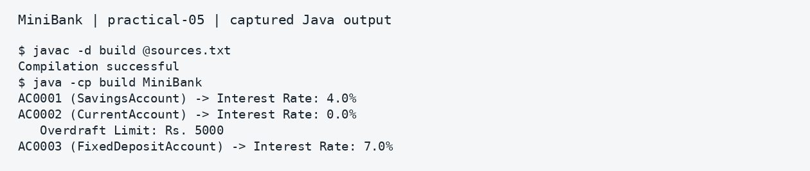
Captured output — practical 05

Result
The same base type calls the correct subclass interestRate method. The current account displays its overdraft limit.

Practical 6

Interfaces packages and runnable JAR

Aim
Use interfaces, a default method, a marker interface, a lambda and packages. Build a runnable JAR.

Source code

model/Account.java
// Account stores the details and balance of one bank account.
package model;

public abstract class Account implements Transactable, InterestBearing {
protected final String accountNumber;
protected String ownerName;
protected long balance;

public Account(String accountNumber, String ownerName, long balance) {
this.accountNumber = accountNumber;
this.ownerName = ownerName;
this.balance = balance;
}

public abstract double interestRate();
public abstract boolean canWithdraw(long amount);

@Override
public void deposit(long amount) {
if (amount > 0) balance += amount;
}

@Override
public boolean withdraw(long amount) {
if (amount > 0 && canWithdraw(amount)) {
balance -= amount;
return true;
}
return false;
}

public String getAccountNumber() { return accountNumber; }
public String getOwnerName() { return ownerName; }
@Override
public long getBalance() { return balance; }
}

model/InterestBearing.java
package model;

public interface InterestBearing {
double interestRate();
long getBalance();

default double yearlyInterest() {
return getBalance() * (interestRate() / 100.0);
}
}

model/Premium.java
package model;

public interface Premium {}

model/SavingsAccount.java
package model;

public class SavingsAccount extends Account implements Premium {
private final long minBalance;

public SavingsAccount(String accNo, String owner, long balance, long minBalance) {
super(accNo, owner, balance);
this.minBalance = minBalance;
}

@Override
public double interestRate() { return 4.0; }

@Override
public boolean canWithdraw(long amount) {
return amount > 0 && (balance - amount) >= minBalance;
}
}

model/Transactable.java
package model;

public interface Transactable {
void deposit(long amount);
boolean withdraw(long amount);
}

service/MiniBank.java
// Run this class to see the demonstration for this practical.
package service;
import model.*;
import static util.Validator.isValidMobile;

public class MiniBank {
public static void main(String[] args) {
SavingsAccount acc = new SavingsAccount("AC0001", "Diya", 10000, 1000);

WithdrawRule anonRule = new WithdrawRule() {
@Override
public boolean allow(Account a, long amt) {
return amt <= 5000 && a.canWithdraw(amt);
}
};

WithdrawRule lambdaRule = (a, amt) -> amt <= 5000 && a.canWithdraw(amt);

System.out.println("Anonymous Rule allow(3000): " + anonRule.allow(acc, 3000));
System.out.println("Lambda Rule allow(3000): " + lambdaRule.allow(acc, 3000));
System.out.println("Yearly Interest: Rs. " + acc.yearlyInterest());
System.out.println("Mobile valid check via static import: " + isValidMobile("9876543210"));
}
}

service/WithdrawRule.java
package service;
import model.Account;

@FunctionalInterface
public interface WithdrawRule {
boolean allow(Account account, long amount);
}

util/Validator.java
package util;
import java.util.regex.Pattern;

public class Validator {
private static final Pattern MOBILE = Pattern.compile("^[6-9][0-9]{9}$");
public static boolean isValidMobile(String s) {
return s != null && MOBILE.matcher(s).matches();
}
}

Run the program
From Practical-06, run run.bat on Windows or bash run.sh on Linux or macOS.
After compiling, create the runnable JAR with: jar cfm minibank.jar MANIFEST.MF -C build . Then run: java -jar minibank.jar

Output
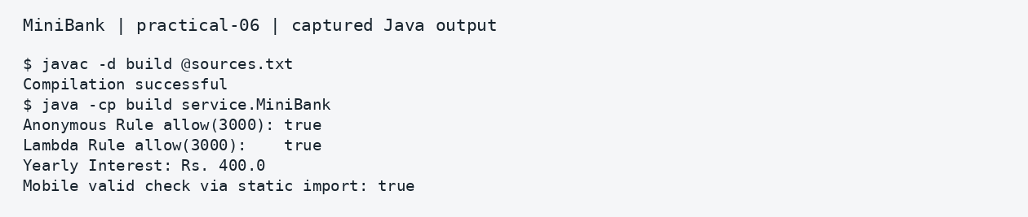
Captured output — practical 06

Result
The anonymous rule and lambda return the same result. The default interface method calculates yearly interest.

Practical 7

Annotations and reflection

Aim
Define runtime field annotations and check annotated values using reflection.

Source code

model/Account.java
// Account stores the details and balance of one bank account.
package model;
import model.annotation.*;
import java.util.Objects;

public abstract class Account {
@Id
protected final String accountNumber;

@MaxLength(20)
protected String ownerName;

@Positive
protected long balance;

public Account(String accountNumber, String ownerName, long balance) {
this.accountNumber = accountNumber;
this.ownerName = ownerName;
this.balance = balance;
}

public abstract double interestRate();
public abstract boolean canWithdraw(long amount);

@Override
public String toString() {
return accountNumber + " | " + ownerName + " | " + balance;
}

@Override
public boolean equals(Object o) {
if (this == o) return true;
if (!(o instanceof Account account)) return false;
return Objects.equals(accountNumber, account.accountNumber);
}

@Override
public int hashCode() {
return Objects.hash(accountNumber);
}
}

model/SavingsAccount.java
package model;

public class SavingsAccount extends Account {
private final long minBalance;

public SavingsAccount(String accNo, String owner, long balance, long minBalance) {
super(accNo, owner, balance);
this.minBalance = minBalance;
}

@Override
public double interestRate() { return 4.0; }

@Override
public boolean canWithdraw(long amount) {
return (balance - amount) >= minBalance;
}
}

model/annotation/Id.java
package model.annotation;
import java.lang.annotation.*;

@Target(ElementType.FIELD)
@Retention(RetentionPolicy.RUNTIME)
public @interface Id {}

model/annotation/MaxLength.java
package model.annotation;
import java.lang.annotation.*;

@Target(ElementType.FIELD)
@Retention(RetentionPolicy.RUNTIME)
public @interface MaxLength {
int value();
}

model/annotation/Positive.java
package model.annotation;
import java.lang.annotation.*;

@Target(ElementType.FIELD)
@Retention(RetentionPolicy.RUNTIME)
public @interface Positive {
String message() default "must be > 0";
}

service/MiniBank.java
// Run this class to see the demonstration for this practical.
package service;
import model.SavingsAccount;
import util.AnnotationValidator;
import java.util.Arrays;

public class MiniBank {
public static void main(String[] args) throws Exception {
SavingsAccount invalidAcc = new SavingsAccount("AC0001", "Diya", -100, 500);
SavingsAccount validAcc = new SavingsAccount("AC0002", "Arjun", 5000, 500);

System.out.println("Invalid account errors: " +
Arrays.toString(AnnotationValidator.validate(invalidAcc)));
System.out.println("Valid account errors: " +
Arrays.toString(AnnotationValidator.validate(validAcc)));
}
}

util/AnnotationValidator.java
package util;
import model.annotation.*;
import java.lang.reflect.Field;
import java.util.*;

public class AnnotationValidator {
public static String[] validate(Object obj) throws IllegalAccessException {
List<String> errors = new ArrayList<>();
Class<?> cls = obj.getClass();
while (cls != null && cls != Object.class) {
for (Field field : cls.getDeclaredFields()) {
field.setAccessible(true);
Object val = field.get(obj);
if (field.isAnnotationPresent(Positive.class) && val instanceof Number num) {
if (num.longValue() <= 0) {
errors.add(field.getAnnotation(Positive.class).message());
}
}
if (field.isAnnotationPresent(MaxLength.class) && val instanceof String s) {
int max = field.getAnnotation(MaxLength.class).value();
if (s.length() > max) {
errors.add("exceeds max length " + max);
}
}
}
cls = cls.getSuperclass();
}
return errors.toArray(new String[0]);
}
}

Run the program
From Practical-07, run run.bat on Windows or bash run.sh on Linux or macOS.

Output
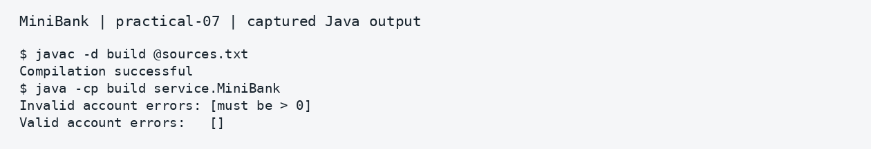
Captured output — practical 07

Result
The validator reports the intentionally negative balance through its runtime annotation.

Practical 8

Exception handling

Aim
Create custom checked exceptions. Demonstrate catch, finally and try with resources.

Source code

exception/AccountNotFoundException.java
package exception;

public class AccountNotFoundException extends BankException {
public AccountNotFoundException(String accNo) {
super("Account not found: " + accNo);
}
}

exception/BankException.java
package exception;

public class BankException extends Exception {
public BankException(String message) { super(message); }
}

exception/InsufficientFundsException.java
package exception;

public class InsufficientFundsException extends BankException {
private final long shortfall;
public InsufficientFundsException(long shortfall) {
super("Withdrawal failed: short by " + shortfall);
this.shortfall = shortfall;
}
public long getShortfall() { return shortfall; }
}

exception/InvalidAmountException.java
package exception;

public class InvalidAmountException extends BankException {
public InvalidAmountException(long amount) {
super("Invalid transaction amount: " + amount);
}
}

model/Account.java
// Account stores the details and balance of one bank account.
package model;
import exception.*;

public abstract class Account {
protected final String accountNumber;
protected String ownerName;
protected long balance;

public Account(String accountNumber, String ownerName, long balance) {
this.accountNumber = accountNumber;
this.ownerName = ownerName;
this.balance = balance;
}

public abstract double interestRate();
public abstract boolean canWithdraw(long amount);

public void deposit(long amount) throws InvalidAmountException {
if (amount <= 0) throw new InvalidAmountException(amount);
balance += amount;
}

public void withdraw(long amount) throws InsufficientFundsException, InvalidAmountException {
if (amount <= 0) throw new InvalidAmountException(amount);
if (amount > balance) throw new InsufficientFundsException(amount - balance);
balance -= amount;
}

public void transfer(Account to, long amount) throws BankException {
try {
this.withdraw(amount);
to.deposit(amount);
} catch (BankException e) {
throw e;
} finally {
System.out.println("Transfer attempt logged for " + accountNumber);
}
}

public String getAccountNumber() { return accountNumber; }
public long getBalance() { return balance; }
}

model/SavingsAccount.java
package model;

public class SavingsAccount extends Account {
private final long minBalance;

public SavingsAccount(String accNo, String owner, long balance, long minBalance) {
super(accNo, owner, balance);
this.minBalance = minBalance;
}

@Override
public double interestRate() { return 4.0; }

@Override
public boolean canWithdraw(long amount) {
return (balance - amount) >= minBalance;
}
}

service/MiniBank.java
// Run this class to see the demonstration for this practical.
package service;
import exception.*;
import model.SavingsAccount;

class AuditResource implements AutoCloseable {
public AuditResource() { System.out.println("[AuditResource] Opened"); }
@Override
public void close() { System.out.println("[AuditResource] Closed"); }
}

public class MiniBank {
public static void main(String[] args) {
SavingsAccount a1 = new SavingsAccount("AC0001", "Diya", 1000, 0);
try (AuditResource res = new AuditResource()) {
a1.withdraw(5000);
} catch (InsufficientFundsException e) {
System.out.println(e.getMessage() + " | Balance remains: " + a1.getBalance());
} catch (BankException e) {
System.out.println("Bank error: " + e.getMessage());
} finally {
System.out.println("Finally block executed.");
}
}
}

Run the program
From Practical-08, run run.bat on Windows or bash run.sh on Linux or macOS.

Output
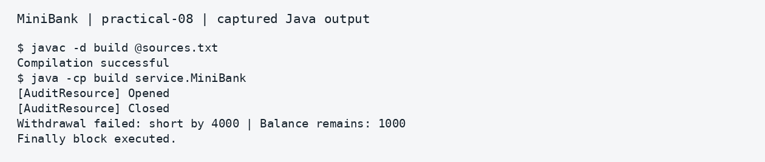
Captured output — practical 08

Result
Invalid operations produce readable exceptions, and cleanup messages show finally and resource closing.

Practical 9

Threads and synchronization

Aim
Start ten worker threads and join them. Use synchronized methods to prevent lost deposits.

Source code

model/Account.java
// Account stores the details and balance of one bank account.
package model;

public class Account {
private final String accountNumber;
private final String ownerName;
private long balance;

public Account(String accountNumber, String ownerName, long balance) {
this.accountNumber = accountNumber;
this.ownerName = ownerName;
this.balance = balance;
}

public synchronized void deposit(long amount) {
balance += amount;
}

public synchronized boolean withdraw(long amount) {
if (balance >= amount) {
balance -= amount;
return true;
}
return false;
}

public synchronized long getBalance() { return balance; }
}

service/AccountWorker.java
package service;
import model.Account;

public class AccountWorker implements Runnable {
private final Account account;
private final int times;
private final long amount;

public AccountWorker(Account account, int times, long amount) {
this.account = account;
this.times = times;
this.amount = amount;
}

@Override
public void run() {
for (int i = 0; i < times; i++) {
account.deposit(amount);
}
}
}

service/MiniBank.java
// Run this class to see the demonstration for this practical.
package service;
import model.Account;

public class MiniBank {
public static void main(String[] args) throws InterruptedException {
Account acc = new Account("AC0001", "Diya", 0);
Thread[] workers = new Thread[10];

for (int i = 0; i < 10; i++) {
workers[i] = new Thread(new AccountWorker(acc, 1000, 1), "Worker-" + (i + 1));
workers[i].start();
}
System.out.println("Started threads: " + workers[0].getName() + " .. " + workers[9].getName());

for (Thread t : workers) {
t.join();
}
System.out.println("Final synchronized balance: " + acc.getBalance());
}
}

Run the program
From Practical-09, run run.bat on Windows or bash run.sh on Linux or macOS.

Output
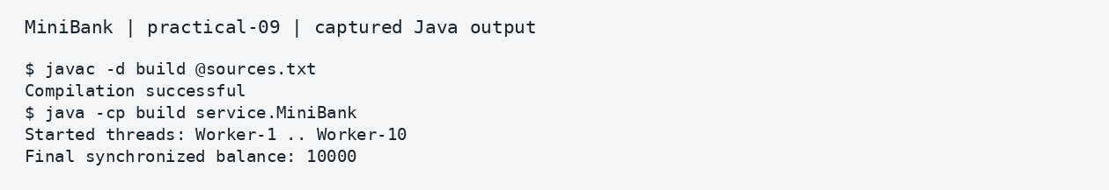
Captured output — practical 09

Result
Ten threads each add 1000 units. The final synchronized balance is exactly 10000.

Practical 10

Thread pool and deadlock prevention

Aim
Use a fixed thread pool, a wait and notify buffer, and ordered locks for transfers.

Source code

model/Account.java
// Account stores the details and balance of one bank account.
package model;

public class Account {
private final String accountNumber;
private final String ownerName;
private long balance;

public Account(String accountNumber, String ownerName, long balance) {
this.accountNumber = accountNumber;
this.ownerName = ownerName;
this.balance = balance;
}

public synchronized void deposit(long amount) {
balance += amount;
}

public synchronized boolean withdraw(long amount) {
if (balance >= amount) {
balance -= amount;
return true;
}
return false;
}

public String getAccountNumber() { return accountNumber; }
public synchronized long getBalance() { return balance; }
}

service/MiniBank.java
// Run this class to see the demonstration for this practical.
package service;
import model.Account;

public class MiniBank {
public static void main(String[] args) throws InterruptedException {
Account a = new Account("AC0001", "Diya", 5000);
Account b = new Account("AC0002", "Arjun", 5000);

TransactionProcessor processor = new TransactionProcessor();
for (int i = 0; i < 5; i++) {
processor.submit(() -> TransactionProcessor.transferOrdered(a, b, 200));
processor.submit(() -> TransactionProcessor.transferOrdered(b, a, 100));
}
processor.stop();
TransactionBuffer buffer = new TransactionBuffer();
Thread consumer = new Thread(() -> {
try { System.out.println("Consumed: " + buffer.take()); }
catch (InterruptedException e) { Thread.currentThread().interrupt(); }
});
consumer.start();
buffer.put("DEPOSIT AC0001 100");
consumer.join();

System.out.println("Ordered transfers finished without deadlock.");
System.out.println("Account AC0001 Balance: " + a.getBalance());
System.out.println("Account AC0002 Balance: " + b.getBalance());
}
}

service/TransactionBuffer.java
package service;

public class TransactionBuffer {
private final String[] buffer = new String[4];
private int count = 0;

public synchronized void put(String tx) throws InterruptedException {
while (count == buffer.length) wait();
buffer[count++] = tx;
notifyAll();
}

public synchronized String take() throws InterruptedException {
while (count == 0) wait();
String tx = buffer[--count];
notifyAll();
return tx;
}
}

service/TransactionProcessor.java
package service;
import model.Account;
import java.util.concurrent.*;

public class TransactionProcessor {
private final ExecutorService pool = Executors.newFixedThreadPool(4);

public void submit(Runnable task) {
pool.execute(task);
}

public void stop() throws InterruptedException {
pool.shutdown();
pool.awaitTermination(5, TimeUnit.SECONDS);
}

public static void transferOrdered(Account from, Account to, long amount) {
Account first = from.getAccountNumber().compareTo(to.getAccountNumber()) < 0 ? from : to;
Account second = (first == from) ? to : from;

synchronized (first) {
synchronized (second) {
if (from.withdraw(amount)) {
to.deposit(amount);
}
}
}
}
}

Run the program
From Practical-10, run run.bat on Windows or bash run.sh on Linux or macOS.

Output
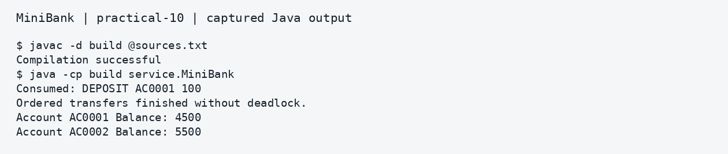
Captured output — practical 10

Result
The worker pool completes opposing transfers without deadlock. The consumer receives a buffer entry.

Practical 11

File handling and serialization

Aim
Save and reload account objects. Append transaction logs and create a summary report.

Source code

model/Account.java
// Account stores the details and balance of one bank account.
package model;
import java.io.Serializable;

public class Account implements Serializable {
private static final long serialVersionUID = 1L;
private final String accountNumber;
private final String ownerName;
private long balance;

public Account(String accountNumber, String ownerName, long balance) {
this.accountNumber = accountNumber;
this.ownerName = ownerName;
this.balance = balance;
}

public String getAccountNumber() { return accountNumber; }
public String getOwnerName() { return ownerName; }
public long getBalance() { return balance; }

@Override
public String toString() {
return accountNumber + " | " + ownerName + " | " + balance;
}
}

model/Customer.java
package model;
import java.io.Serializable;

public class Customer implements Serializable {
private static final long serialVersionUID = 1L;
private final String customerId;
private final String name;

public Customer(String customerId, String name) {
this.customerId = customerId;
this.name = name;
}

public String getCustomerId() { return customerId; }
public String getName() { return name; }
}

service/MiniBank.java
// Run this class to see the demonstration for this practical.
package service;
import model.Account;
import util.*;
import java.nio.file.*;
import java.util.Arrays;

public class MiniBank {
public static void main(String[] args) throws Exception {
Path dataDir = Path.of("data");
Files.createDirectories(dataDir);
Path accFile = dataDir.resolve("accounts.dat");
Path logFile = dataDir.resolve("tx_2026_10_21.log");
Files.deleteIfExists(logFile);

Account[] accounts = {
new Account("AC0001", "Diya", 5500),
new Account("AC0002", "Arjun", 2800)
};
StatePersister.save(accounts, accFile);
Account[] reloaded = StatePersister.load(accFile);
System.out.println("Reloaded: " + Arrays.toString(reloaded));

TransactionLog.append(logFile, "DEPOSIT AC0001 500");
TransactionLog.append(logFile, "WITHDRAW AC0002 200");
System.out.print(ReportGenerator.generate(dataDir, dataDir.resolve("report.txt")));
}
}

util/ReportGenerator.java
package util;
import java.io.*;
import java.nio.file.*;
import java.nio.file.attribute.BasicFileAttributes;

public class ReportGenerator {
public static String generate(Path logsDir, Path reportFile) throws IOException {
long totalDeposits = 0;
long totalWithdrawals = 0;
StringBuilder sb = new StringBuilder("=== End-of-Day Summary Report ===\n");

try (DirectoryStream<Path> stream = Files.newDirectoryStream(logsDir, "*.log")) {
for (Path logPath : stream) {
BasicFileAttributes attr = Files.readAttributes(logPath, BasicFileAttributes.class);
sb.append("File: ").append(logPath.getFileName())
.append(" (").append(attr.size()).append(" bytes)\n");
try (BufferedReader reader = Files.newBufferedReader(logPath)) {
String line;
while ((line = reader.readLine()) != null) {
String[] parts = line.trim().split("\\s+");
if (parts.length == 3) {
long amt = Long.parseLong(parts[2]);
if ("DEPOSIT".equalsIgnoreCase(parts[0])) totalDeposits += amt;
else if ("WITHDRAW".equalsIgnoreCase(parts[0])) totalWithdrawals += amt;
}
}
}
}
}
sb.append("Total Deposits : Rs. ").append(totalDeposits).append("\n")
.append("Total Withdrawals : Rs. ").append(totalWithdrawals).append("\n")
.append("Net Change : Rs. ").append(totalDeposits - totalWithdrawals).append("\n");
Files.writeString(reportFile, sb.toString());
return sb.toString();
}
}

util/StatePersister.java
package util;
import model.Account;
import java.io.*;
import java.nio.file.*;

public class StatePersister {
public static void save(Account[] accounts, Path file) throws IOException {
try (ObjectOutputStream out = new ObjectOutputStream(Files.newOutputStream(file))) {
out.writeObject(accounts);
}
}

public static Account[] load(Path file) throws IOException, ClassNotFoundException {
try (ObjectInputStream in = new ObjectInputStream(Files.newInputStream(file))) {
return (Account[]) in.readObject();
}
}
}

util/TransactionLog.java
package util;
import java.io.IOException;
import java.nio.file.*;

public class TransactionLog {
public static void append(Path file, String line) throws IOException {
Files.writeString(file, line + System.lineSeparator(),
StandardOpenOption.CREATE, StandardOpenOption.APPEND);
}
}

Run the program
From Practical-11, run run.bat on Windows or bash run.sh on Linux or macOS.

Output
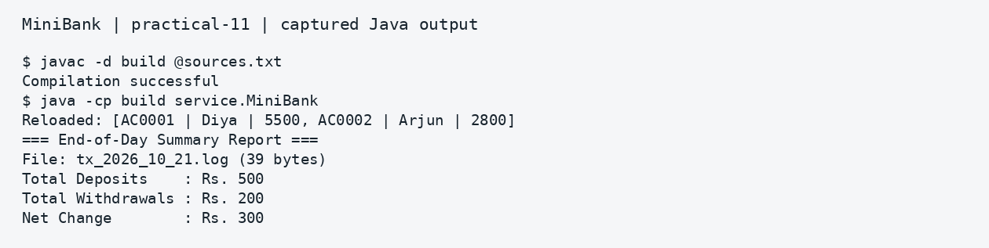
Captured output — practical 11

Result
The reloaded account data matches the saved data. The report shows deposits of 500 and withdrawals of 200.

Practical 12

Collections and sorting

Aim
Store accounts in maps, record history and sort accounts by balance using a comparator.

Source code

model/Account.java
// Account stores the details and balance of one bank account.
package model;

public class Account implements Comparable<Account> {
private final String accountNumber;
private final String ownerName;
private long balance;

public Account(String accountNumber, String ownerName, long balance) {
this.accountNumber = accountNumber;
this.ownerName = ownerName;
this.balance = balance;
}

public String getAccountNumber() { return accountNumber; }
public String getOwnerName() { return ownerName; }
public long getBalance() { return balance; }

@Override
public int compareTo(Account other) {
return this.accountNumber.compareTo(other.accountNumber);
}

@Override
public String toString() {
return accountNumber + " | " + ownerName + " | " + balance;
}
}

service/AccountStore.java
package service;
import model.Account;
import java.util.*;
import java.util.concurrent.ConcurrentHashMap;

public class AccountStore {
private final Map<String, Account> map = new HashMap<>();
private final ConcurrentHashMap<String, Account> concurrentMap = new ConcurrentHashMap<>();
private final ArrayList<String> history = new ArrayList<>();

public void add(Account account) {
map.put(account.getAccountNumber(), account);
concurrentMap.put(account.getAccountNumber(), account);
history.add("OPEN " + account.getAccountNumber());
}

public Account get(String accountNumber) {
return map.get(accountNumber);
}

public Collection<Account> getAll() {
return map.values();
}

public ArrayList<Account> sortedByBalance() {
ArrayList<Account> list = new ArrayList<>(map.values());
list.sort(Comparator.comparingLong(Account::getBalance).reversed());
return list;
}
}

service/MiniBank.java
// Run this class to see the demonstration for this practical.
package service;
import model.Account;

public class MiniBank {
public static void main(String[] args) {
AccountStore store = new AccountStore();
store.add(new Account("AC0001", "Diya", 5000));
store.add(new Account("AC0002", "Arjun", 2000));
store.add(new Account("AC0003", "Neel", 9000));

System.out.println("Lookup AC0002: " + store.get("AC0002"));
System.out.println("Accounts sorted by balance (descending):");
for (Account a : store.sortedByBalance()) {
System.out.println(" " + a);
}
}
}

Run the program
From Practical-12, run run.bat on Windows or bash run.sh on Linux or macOS.

Output
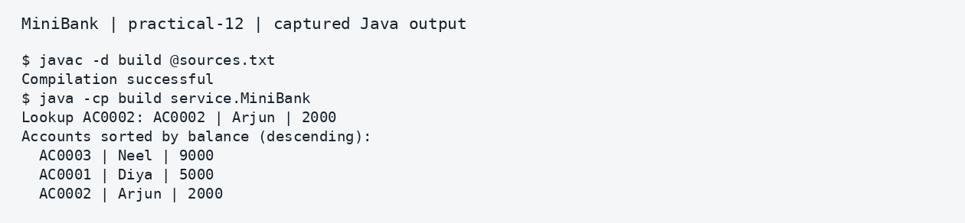
Captured output — practical 12

Result
The store finds an account by number and prints accounts in descending balance order.

Practical 13

Generic repository

Aim
Create one generic repository for both accounts and customers, using an Id annotation and reflection.

Source code

model/Account.java
// Account stores the details and balance of one bank account.
package model;
import model.annotation.Id;

public class Account {
@Id
private final String accountNumber;
private final String ownerName;
private long balance;

public Account(String accountNumber, String ownerName, long balance) {
this.accountNumber = accountNumber;
this.ownerName = ownerName;
this.balance = balance;
}

public String getAccountNumber() { return accountNumber; }
public String getOwnerName() { return ownerName; }
public long getBalance() { return balance; }

@Override
public String toString() {
return accountNumber + " | " + ownerName + " | " + balance;
}
}

model/Customer.java
package model;
import model.annotation.Id;

public class Customer {
@Id
private final String customerId;
private final String name;

public Customer(String customerId, String name) {
this.customerId = customerId;
this.name = name;
}

@Override
public String toString() {
return customerId + " (" + name + ")";
}
}

model/annotation/Id.java
package model.annotation;
import java.lang.annotation.*;

@Target(ElementType.FIELD)
@Retention(RetentionPolicy.RUNTIME)
public @interface Id {}

service/MiniBank.java
// Run this class to see the demonstration for this practical.
package service;
import model.*;

public class MiniBank {
public static void main(String[] args) {
Repository<Account> accRepo = new Repository<>();
accRepo.saveAll(
new Account("AC0001", "Diya", 5000),
new Account("AC0002", "Arjun", 8000),
new Account("AC0003", "Neel", 11000)
);

System.out.println("findById('AC0002'): " + accRepo.findById("AC0002"));
System.out.println("All Accounts: " + accRepo.findAll());
Repository<model.Customer> customers = new Repository<>();
customers.save(new model.Customer("CUST101", "Diya"));
System.out.println("Customer repository: " + customers.findById("CUST101"));
System.out.println("Deleted AC0003: " + accRepo.delete("AC0003"));
Long[] balances = {5000L, 8000L, 11000L};
System.out.println("Average Balance: Rs. " + Repository.average(balances));

Repository<Customer> custRepo = new Repository<>();
custRepo.save(new Customer("CUST101", "Diya"));
System.out.println("Customer findById('CUST101'): " + custRepo.findById("CUST101"));
}
}

service/Repository.java
package service;
import model.annotation.Id;
import java.lang.reflect.Field;
import java.util.*;

public class Repository<T> {
private final Map<String, T> store = new HashMap<>();

private String extractId(T entity) {
Class<?> cls = entity.getClass();
while (cls != null && cls != Object.class) {
for (Field f : cls.getDeclaredFields()) {
if (f.isAnnotationPresent(Id.class)) {
f.setAccessible(true);
try {
return String.valueOf(f.get(entity));
} catch (IllegalAccessException e) {
throw new RuntimeException(e);
}
}
}
cls = cls.getSuperclass();
}
throw new IllegalArgumentException("No @Id field found on " + entity.getClass().getName());
}

public T save(T entity) {
store.put(extractId(entity), entity);
return entity;
}

@SafeVarargs
public final void saveAll(T... items) {
for (T item : items) save(item);
}

public T findById(String id) { return store.get(id); }
public ArrayList<T> findAll() { return new ArrayList<>(store.values()); }
public boolean delete(String id) { return store.remove(id) != null; }

public static <N extends Number> double average(N[] values) {
double sum = 0;
for (N v : values) sum += v.doubleValue();
return values.length == 0 ? 0.0 : sum / values.length;
}
}

Run the program
From Practical-13, run run.bat on Windows or bash run.sh on Linux or macOS.

Output
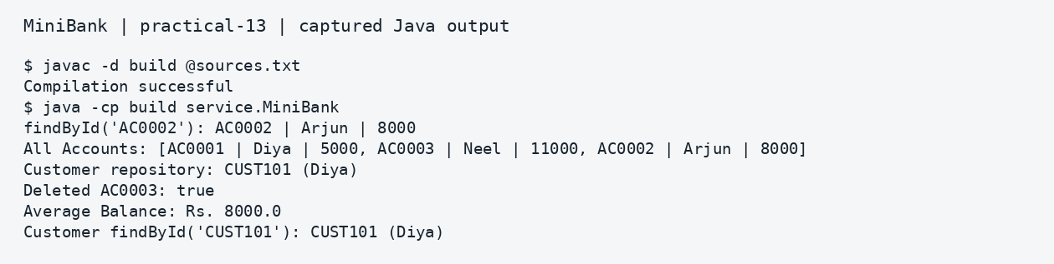
Captured output — practical 13

Result
The same repository class works with Account and Customer. The demonstration also deletes an account and calculates an average.

Practical 14

Complete MiniBank application

Aim
Connect a simple console menu to account opening, deposits, withdrawals, transfers and statements. Save accounts on exit and reload them at startup. Verify behavior with JUnit 5.

Source code

exception/AccountNotFoundException.java
package exception;

public class AccountNotFoundException extends BankException {
public AccountNotFoundException(String accNo) {
super("Account not found: " + accNo);
}
}

exception/BankException.java
package exception;

public class BankException extends Exception {
public BankException(String message) { super(message); }
}

exception/InsufficientFundsException.java
package exception;

public class InsufficientFundsException extends BankException {
private final long shortfall;
public InsufficientFundsException(long shortfall) {
super("Withdrawal failed: short by " + shortfall);
this.shortfall = shortfall;
}
public long getShortfall() { return shortfall; }
}

exception/InvalidAmountException.java
package exception;

public class InvalidAmountException extends BankException {
public InvalidAmountException(long amount) {
super("Invalid transaction amount: " + amount);
}
}

model/Account.java
// Account stores the details and balance of one bank account.
package model;
import exception.*;
import model.annotation.Id;
import java.io.Serializable;

public class Account implements Serializable, Comparable<Account> {
private static final long serialVersionUID = 1L;

@Id
private final String accountNumber;
private final String ownerName;
private long balance;

public Account(String accountNumber, String ownerName, long balance) {
this.accountNumber = accountNumber;
this.ownerName = ownerName;
this.balance = balance;
}

public synchronized void deposit(long amount) throws InvalidAmountException {
if (amount <= 0) throw new InvalidAmountException(amount);
balance += amount;
}

public synchronized void depositSync(long amount) {
if (amount > 0) balance += amount;
}

public synchronized void withdraw(long amount) throws InsufficientFundsException,
InvalidAmountException {
if (amount <= 0) throw new InvalidAmountException(amount);
if (amount > balance) throw new InsufficientFundsException(amount - balance);
balance -= amount;
}

public String getAccountNumber() { return accountNumber; }
public String getOwnerName() { return ownerName; }
public synchronized long getBalance() { return balance; }

@Override
public int compareTo(Account other) {
return this.accountNumber.compareTo(other.accountNumber);
}

@Override
public String toString() {
return accountNumber + " | " + ownerName + " | " + balance;
}
}

model/annotation/Audit.java
package model.annotation;
import java.lang.annotation.*;

@Target(ElementType.METHOD)
@Retention(RetentionPolicy.RUNTIME)
public @interface Audit {
String action() default "";
}

model/annotation/Id.java
package model.annotation;
import java.lang.annotation.*;

@Target(ElementType.FIELD)
@Retention(RetentionPolicy.RUNTIME)
public @interface Id {}

service/BankService.java
package service;
import exception.*;
import model.Account;
import model.annotation.Audit;
import util.*;
import java.lang.reflect.Method;
import java.nio.file.*;
import java.io.*;
import java.util.List;

public class BankService {
// The repository stores accounts using their account numbers.
private final Repository<Account> repo = new Repository<>();
private void logAudit(String name) {
for (Method m : getClass().getDeclaredMethods()) {
if (m.getName().equals(name) && m.isAnnotationPresent(Audit.class))
System.out.println("[Audit] " + m.getAnnotation(Audit.class).action());
}
}
@Audit(action = "OPEN_ACCOUNT")
public synchronized Account openAccount(String id, String owner,
String mobile, long balance) throws BankException {
if (id == null || !id.matches("AC[0-9]{4,}"))
throw new BankException("Use account ID AC followed by at least four digits.");
if (repo.findById(id) != null) throw new BankException("Account already exists.");
if (owner == null || owner.isBlank()) throw new BankException("Owner is required.");
if (!Validator.isValidMobile(mobile)) throw new BankException("Invalid mobile number.");
if (balance < 0) throw new InvalidAmountException(balance);
Account a = new Account(id, owner.trim(), balance);
repo.save(a); logAudit("openAccount"); return a;
}
@Audit(action = "DEPOSIT")
public synchronized void deposit(String id, long amount) throws BankException {
Account a = getRequired(id);
if (amount <= 0 || a.getBalance() > Long.MAX_VALUE - amount)
throw new InvalidAmountException(amount);
a.deposit(amount); logAudit("deposit");
}
@Audit(action = "WITHDRAW")
public synchronized void withdraw(String id, long amount) throws BankException {
getRequired(id).withdraw(amount); logAudit("withdraw");
}
// synchronized lets only one service operation run at a time.
// Check both accounts before changing either balance.
@Audit(action = "TRANSFER")
public synchronized void transfer(String fromId, String toId, long amount)
throws BankException {
if (fromId.equals(toId)) throw new BankException("Choose two different accounts.");
Account from = getRequired(fromId), to = getRequired(toId);
if (amount <= 0 || to.getBalance() > Long.MAX_VALUE - amount)
throw new InvalidAmountException(amount);
from.withdraw(amount); to.deposit(amount); logAudit("transfer");
}
public synchronized Account getRequired(String id) throws AccountNotFoundException {
Account a = repo.findById(id);
if (a == null) throw new AccountNotFoundException(id);
return a;
}
public synchronized String statement(String id) throws BankException {
return StatementFormatter.buildStatement(getRequired(id));
}
public synchronized List<Account> listAccounts() {
List<Account> list = repo.findAll(); list.sort(null); return list;
}
// Save to a temporary file first so a failed write keeps the old file.
public synchronized void save(Path file) throws IOException {
Path target = file.toAbsolutePath();
Files.createDirectories(target.getParent());
Path temp = Files.createTempFile(target.getParent(), "accounts-", ".tmp");
try {
try (ObjectOutputStream out = new ObjectOutputStream(Files.newOutputStream(temp))) {
out.writeObject(listAccounts().toArray(new Account[0]));
}
Files.move(temp, target, StandardCopyOption.REPLACE_EXISTING);
} finally { Files.deleteIfExists(temp); }
}
public synchronized void load(Path file) throws IOException, ClassNotFoundException {
if (!Files.exists(file)) return;
try (ObjectInputStream in = new ObjectInputStream(Files.newInputStream(file))) {
Account[] accounts = (Account[]) in.readObject();
for (Account a : accounts) repo.save(a);
}
}
}

service/MiniBank.java
// Run this class to see the demonstration for this practical.
package service;
import exception.BankException;
import java.nio.file.Path;
import java.util.Scanner;

public class MiniBank {
private static String ask(Scanner s, String label) {
System.out.print(label + ": ");
if (!s.hasNextLine()) throw new java.util.NoSuchElementException();
return s.nextLine().trim();
}
private static long amount(Scanner s, String label) {
return Long.parseLong(ask(s, label));
}
public static void main(String[] args) {
// BankService performs all banking operations.
BankService bank = new BankService();
Path file = Path.of("data", "accounts.dat");
try { bank.load(file); }
catch (Exception e) {
System.out.println("Cannot load saved accounts. No data overwritten: " + e);
return;
}
System.out.println("=== MiniBank Student Bank ===");
System.out.println("Loaded accounts: " + bank.listAccounts().size());
try (Scanner sc = new Scanner(System.in)) {
boolean running = true;
while (running) {
System.out.println("1 Open 2 Deposit 3 Withdraw 4 Transfer");
System.out.println("5 Statement 6 List accounts 0 Save and exit");
try {
switch (ask(sc, "Choice")) {
case "1": {
bank.openAccount(ask(sc,"Account ID"), ask(sc,"Owner"),
ask(sc,"Mobile"), amount(sc,"Opening balance"));
System.out.println("Account opened.");
break;
}
case "2": { bank.deposit(ask(sc,"Account ID"), amount(sc,"Amount"));
System.out.println("Deposit successful."); break; }
case "3": { bank.withdraw(ask(sc,"Account ID"), amount(sc,"Amount"));
System.out.println("Withdrawal successful."); break; }
case "4": { bank.transfer(ask(sc,"From account"), ask(sc,"To account"),
amount(sc,"Amount")); System.out.println("Transfer successful."); break; }
case "5":
System.out.print(bank.statement(ask(sc,"Account ID")));
break;
case "6":
for (model.Account account : bank.listAccounts()) {
System.out.println(account);
}
break;
case "0": running = false; break;
default: System.out.println("Invalid menu option.");
}
} catch (BankException | IllegalArgumentException e) {
System.out.println("Error: " + e.getMessage());
} catch (java.util.NoSuchElementException e) { running = false; }
}
}
try { bank.save(file); System.out.println("Accounts saved. Goodbye!"); }
catch (Exception e) { System.out.println("Save failed: " + e.getMessage()); }
}
}

service/Repository.java
package service;
import model.annotation.Id;
import java.lang.reflect.Field;
import java.util.*;

public class Repository<T> {
private final Map<String, T> store = new HashMap<>();

private String extractId(T entity) {
Class<?> cls = entity.getClass();
while (cls != null && cls != Object.class) {
for (Field f : cls.getDeclaredFields()) {
if (f.isAnnotationPresent(Id.class)) {
f.setAccessible(true);
try {
return String.valueOf(f.get(entity));
} catch (IllegalAccessException e) {
throw new RuntimeException(e);
}
}
}
cls = cls.getSuperclass();
}
throw new IllegalArgumentException("No @Id field found on " + entity.getClass().getName());
}

public T save(T entity) {
store.put(extractId(entity), entity);
return entity;
}

public T findById(String id) { return store.get(id); }
public ArrayList<T> findAll() { return new ArrayList<>(store.values()); }
public boolean delete(String id) { return store.remove(id) != null; }
}

tests/BankServiceTest.java
package tests;
import service.BankService;
import exception.*;
import org.junit.jupiter.api.Test;
import org.junit.jupiter.api.io.TempDir;
import java.nio.file.Path;
import java.util.concurrent.*;
import static org.junit.jupiter.api.Assertions.*;

public class BankServiceTest {
BankService bank() throws Exception {
BankService b = new BankService();
b.openAccount("AC0001", "Diya", "9876543210", 5000);
b.openAccount("AC0002", "Arjun", "9876543211", 2000);
return b;
}
@Test void depositIncreasesBalance() throws Exception {
BankService b = bank(); b.deposit("AC0001",1500);
assertEquals(6500,b.getRequired("AC0001").getBalance());
}
@Test void overLimitWithdrawalIsRejected() throws Exception {
BankService b = bank();
assertThrows(InsufficientFundsException.class, () -> b.withdraw("AC0001",6000));
assertEquals(5000,b.getRequired("AC0001").getBalance());
}
@Test void transferPreservesTotal() throws Exception {
BankService b = bank(); b.transfer("AC0001","AC0002",1000);
assertEquals(4000,b.getRequired("AC0001").getBalance());
assertEquals(3000,b.getRequired("AC0002").getBalance());
}
@Test void failedTransferDoesNotDebit() throws Exception {
BankService b = bank();
assertThrows(AccountNotFoundException.class, () -> b.transfer("AC0001","AC9999",500));
assertEquals(5000,b.getRequired("AC0001").getBalance());
}
@Test void invalidInputsAreRejected() throws Exception {
BankService b = bank();
assertThrows(InvalidAmountException.class, () -> b.deposit("AC0001",0));
assertThrows(InvalidAmountException.class, () -> b.withdraw("AC0001",-1));
assertThrows(BankException.class, () -> b.openAccount("AC0001","Diya","9876543210",0));
assertThrows(BankException.class, () -> b.openAccount("AC0003","Diya","123",0));
}
@Test void concurrentDepositsKeepExactBalance() throws Exception {
BankService b = bank();
ExecutorService pool = Executors.newFixedThreadPool(10);
java.util.List<Future<?>> jobs = new java.util.ArrayList<>();
try {
for (int i=0;i<10;i++) jobs.add(pool.submit(() -> {
for (int j=0;j<100;j++) {
try { b.deposit("AC0001",10); }
catch (BankException e) { throw new RuntimeException(e); }
}
}));
for (Future<?> job : jobs) job.get();
} finally { pool.shutdownNow(); }
assertEquals(15000,b.getRequired("AC0001").getBalance());
}
@Test void persistenceRoundTrip(@TempDir Path dir) throws Exception {
BankService b = bank(); b.deposit("AC0001",500);
Path file=dir.resolve("accounts.dat"); b.save(file);
BankService restored=new BankService(); restored.load(file);
assertEquals(5500,restored.getRequired("AC0001").getBalance());
assertEquals(2,restored.listAccounts().size());
}
}

util/StatementFormatter.java
package util;
import model.Account;

public class StatementFormatter {
public static String buildStatement(Account account) {
StringBuilder sb = new StringBuilder();
sb.append("--- Account Statement ---\n")
.append("Account : ").append(account.getAccountNumber()).append("\n")
.append("Owner : ").append(account.getOwnerName()).append("\n")
.append("Balance : Rs. ").append(account.getBalance()).append("\n");
return sb.toString();
}
}

util/Validator.java
package util;
import java.util.regex.Pattern;

public class Validator {
private static final Pattern MOBILE = Pattern.compile("^[6-9][0-9]{9}$");
public static boolean isValidMobile(String s) {
return s != null && MOBILE.matcher(s).matches();
}
}

Run the program
From Practical-14, run run.bat on Windows or bash run.sh on Linux or macOS.
After compiling, create the runnable JAR with: jar cfm minibank.jar MANIFEST.MF -C build . Then run: java -jar minibank.jar

Output
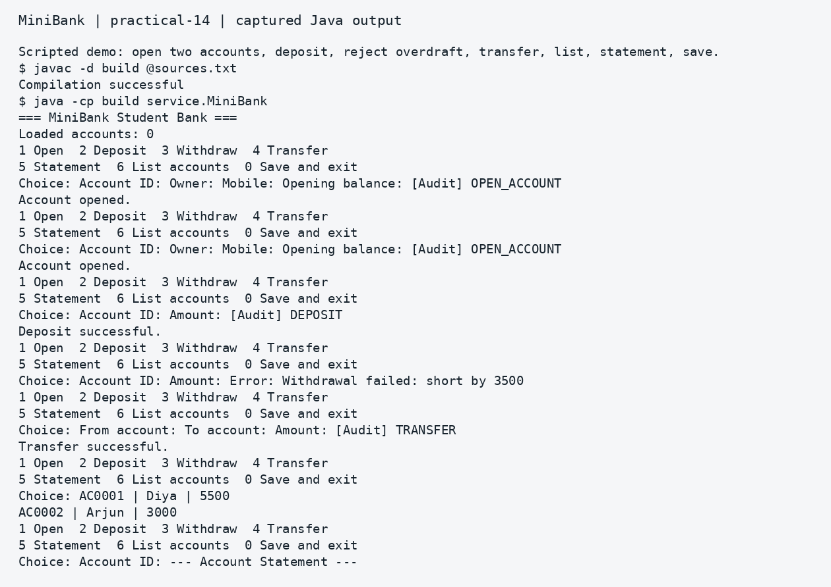
Captured output — practical 14 1
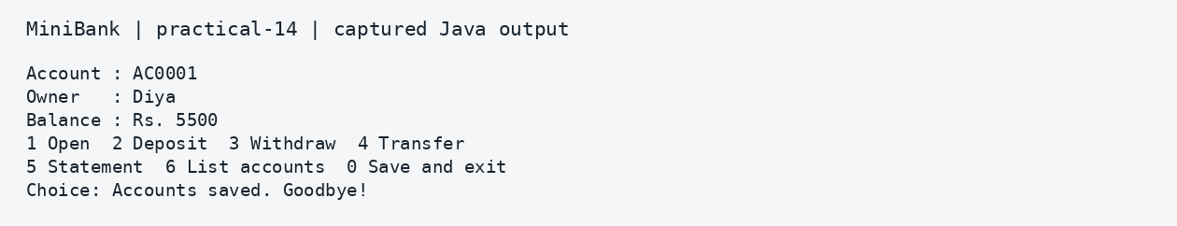
Captured output — practical 14 2
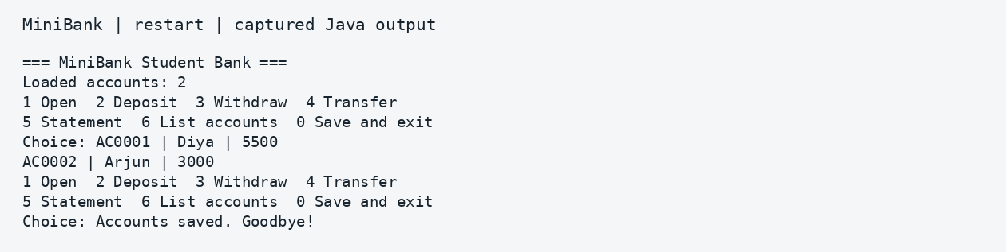
Captured output — restart
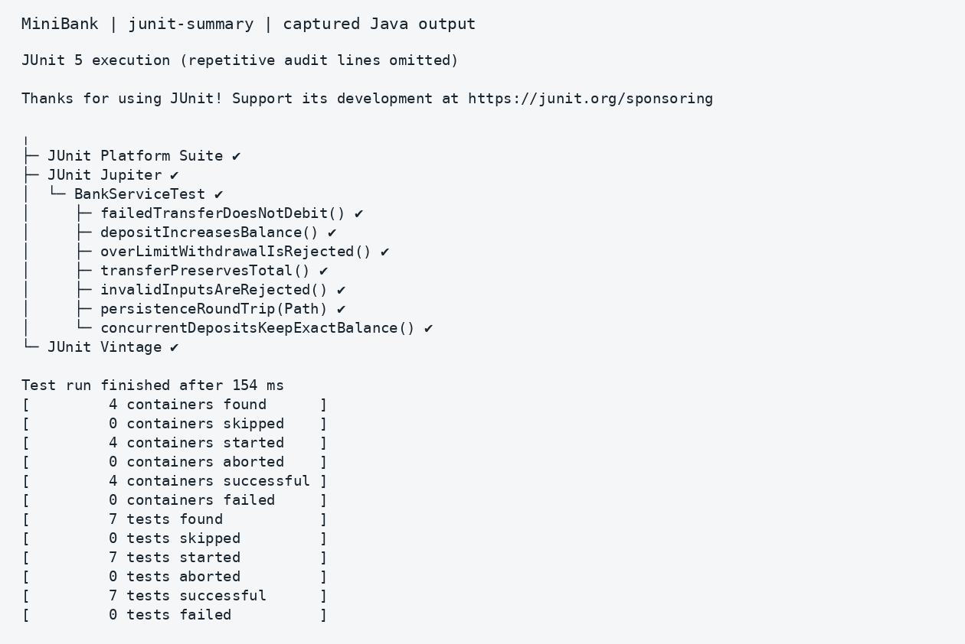
Captured output — junit summary

Result
The demonstration finishes with balances of 5500 and 3000. Restarting reloads both accounts. All seven JUnit tests pass.

GitHub submission
The source folders, output images, README and this Word journal belong to the MiniBank project repository below.
GitHub repository: https://github.com/25ce138/JAVA-MINI-PROJECT
The commands below show the initial upload procedure for this repository. For later changes, use git add, git commit and git push from your existing checkout.
git init
git branch -M main
git add .
git commit -m "Add MiniBank practicals with report"
git remote add origin https://github.com/25ce138/JAVA-MINI-PROJECT.git
git push -u origin main
If your repository already contains files, clone it first and add this project in a new folder. Do not force-push. The .gitignore file excludes compiled classes, build folders and local account data. Read GITHUB_GUIDE.md for the full procedure.

Project conclusion
The project demonstrates object oriented Java concepts through a small banking example. Practical 14 provides working account operations, readable error messages, saved account data and automated tests. Earlier practicals keep each concept small enough to study separately.

