
Assignment-04

CL5P252
Numerical Modelling and Observations Lab

Student: Afiya
Assistant: Ritwik Manna, Nihas A K
Date of laboratory: 02/01/2026
Date of submission: 08/01/2026

1. Introduction:
the rainfall data of the year 2022 is taken to study how rainfall is distributed over different regions and how it changes with time. The first step is to plot the average rainfall map by taking the mean over time, which gives a general idea of rainfall distribution over the area.
Next, seasonal mean rainfall maps are created to see how the rainfall pattern differs from season to season. After that, the focus is shifted to Central India during the JJAS months, where the rainfall is averaged over space to obtain a time series. To understand the variation more clearly, the rainfall anomaly is calculated by subtracting the mean rainfall from the time series, and both are plotted together to compare their behavior.

2. Results:
2.1Mean rainfall map (2022)
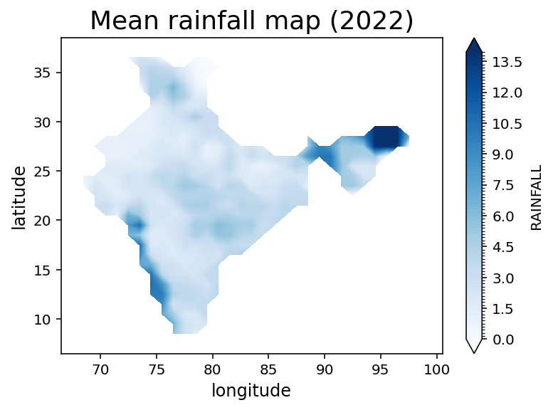

interpretation:

The map shows the average rainfall distribution over India for the year 2022 after taking the mean over time. It can be seen that rainfall is not uniformly distributed across the country. Some regions clearly receive more rainfall while others remain comparatively dry.

Higher mean rainfall values are visible along the Western Ghats and in the North-Eastern part of India, indicating these areas receive consistently higher rainfall during the year. In contrast, central and north-western regions show lighter shades, which represent lower average rainfall. This uneven pattern highlights how rainfall varies spatially across different parts of the country even when averaged over the entire year.

2.2seasonal mean rainfall(2022)

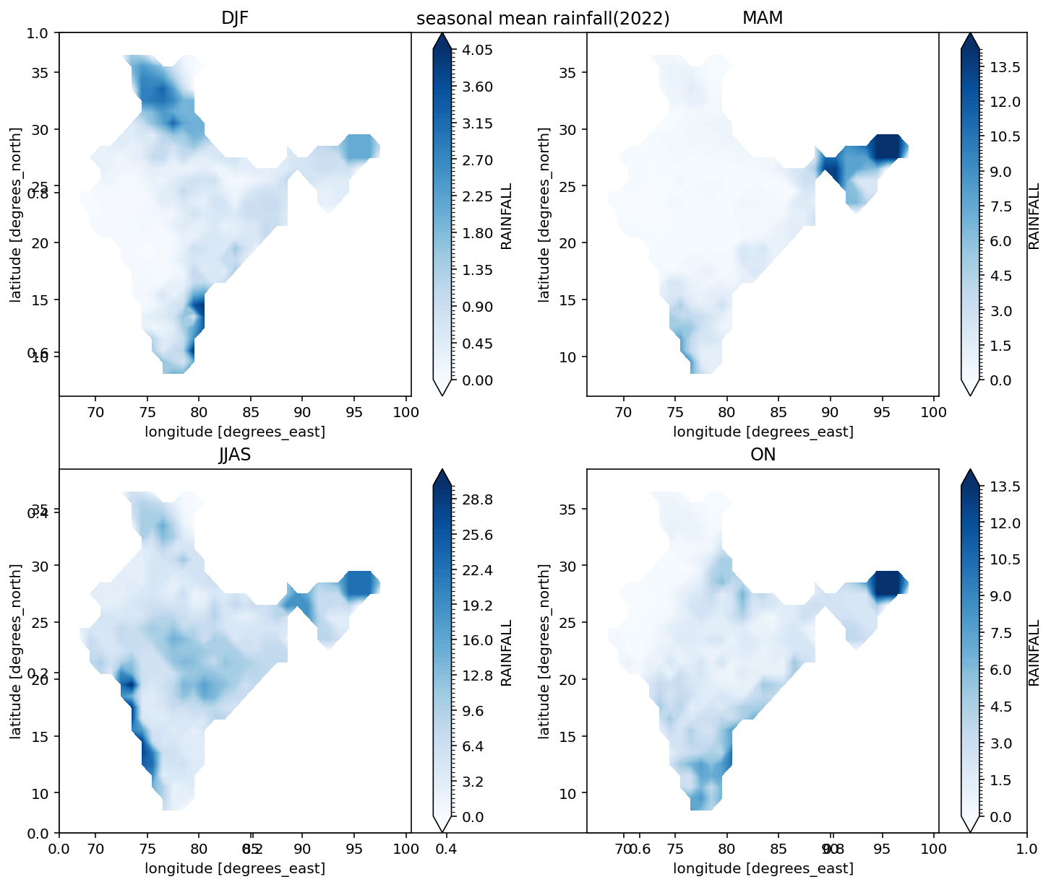

interpretation

The seasonal maps show clear changes in rainfall pattern throughout the year. In DJF, most regions receive very little rainfall, with slightly higher values in the south and north-east. During MAM, rainfall increases a bit in these areas but remains low over central and north-western parts.
A major increase is seen in JJAS, where rainfall spreads over almost the whole country, especially along the western coast, central India, and the north-east due to the monsoon. In ON, rainfall decreases again over most regions, while the southern peninsula still receives noticeable rainfall.

2.3jjas rainfall time series over central india (2022)

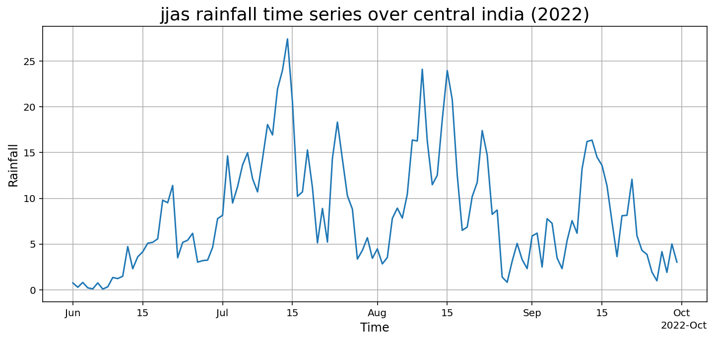

interpretation

The time series shows how rainfall over Central India changes day by day during the JJAS months. Rainfall is not uniform and fluctuates throughout the season, with several peaks and low values in between. Higher peaks are mostly seen during July and August, indicating stronger monsoon activity during this period.
In June, rainfall starts gradually, then increases in July. After August, the rainfall begins to decrease slowly towards September. This pattern clearly reflects the active and weak phases of the monsoon over Central India during the JJAS season.

2.4jjas rainfall and rainfall anomaly over central india (2022)

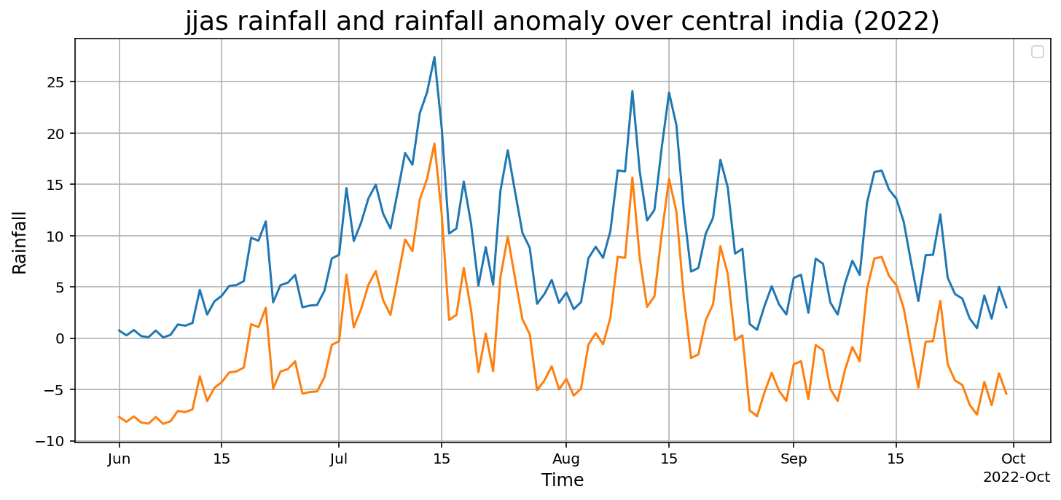

interpretation

The plot shows both the actual rainfall and its anomaly during the JJAS season over Central India. The anomaly line clearly follows the ups and downs of the rainfall curve. Whenever rainfall increases sharply, the anomaly becomes positive, and when rainfall decreases, the anomaly turns negative.
Higher positive anomalies are mostly seen during July and August, which indicates stronger monsoon activity during this period. In contrast, during late August and September, more negative anomalies are visible, showing weaker rainfall compared to the mean. This comparison helps in clearly identifying the active and weak phases of the monsoon over Central India.

3. Conclusion:

From the 2022 data, it is clear that rainfall over India varies a lot across regions and seasons. JJAS shows the highest and most widespread rainfall due to the monsoon, while other seasons receive comparatively less rainfall.
The JJAS time series over Central India shows fluctuating rainfall with active and weak phases. The anomaly plot helps to clearly identify these variations. Overall, the analysis gives a simple understanding of rainfall pattern over India and Central India during 2022.

