

ASSIGNMENT 4
COURSE CL5P252
NAME OF THE COURSE – NUMERICAL MODELLING AND DIAGNOSTICS LAB

NAME – AAROKSH CHAUHAN
ASSISTANT NAME – RITWIK MANNA , NIHAS A.K.
DATE OF LABORATORY – 2 FEB 2026
DATE OF SUBMISSION – 8 FEB 2026
- INTRODUCTION

In this assignment , we are dealing with the rainfall data over the Indian subcontinent , encompassing a wide range of temporal resolution(many years of data is provided) . But here , we have taken the rainfall data for the year 2011.

The data we have took into consideration has an temporal resolution of 365 days , with latitude ranging from 6.5 to 38.5 ( in 33 steps) , and longitude from 66.5 to 100.5 (with 35 steps) . And the variable being the rainfall values [in mm] throughout these three dimensional data .

The aim of this report is to interpret and visualize the pattern of rainfall throughout the year . It is varying from a daily to monthly scale, thus it increases the importance of us studying and interpreting these plots .

- RESULTS

Q1.Open any of the shared rainfall dataset and plot the spatial map by taking the mean along the time dimension.

Solution – Opening the data file using xarray is necessary because the format of the file is .Netcdf . And taking the mean along time in order to cut the ‘TIME’ dimension from the data , facilitates the plotting of spatial plot because only latitude and longitude data is left afterwards . So , the desired plot is coming out to be like :-
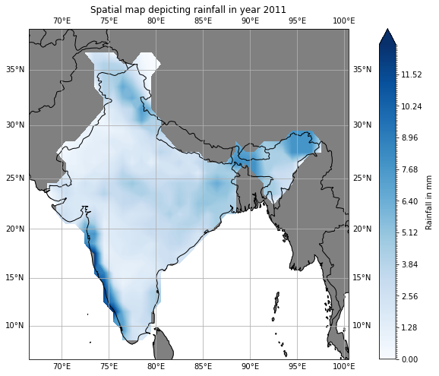
Fig 1 – Spatial map of India , representing rainfall in year 2011

As we can observe from the Figure , we can say that throughout the year , there is very minimal rainfall in North-Western India , but comparatively high in North-Eastern India due to the reason that monsoon winds blow from South-western direction .
This explains the heavy intensity of rainfall over Western Ghats , because strong convective motions can be observed due to orographic uplifting . This also creates a region of low or almost rainfall beside Western Ghats , because most of the moist air got convected there , thus creating a shadow zone like area of rainfall there.
In the regions of Himalayas also , convective movements are supported by orographic lifting but due to its distance from oceans , rainfall intensity is not very high as compared to that in Western Ghats .

Q2.Plot the spatial plots of seasonal mean rainfall.

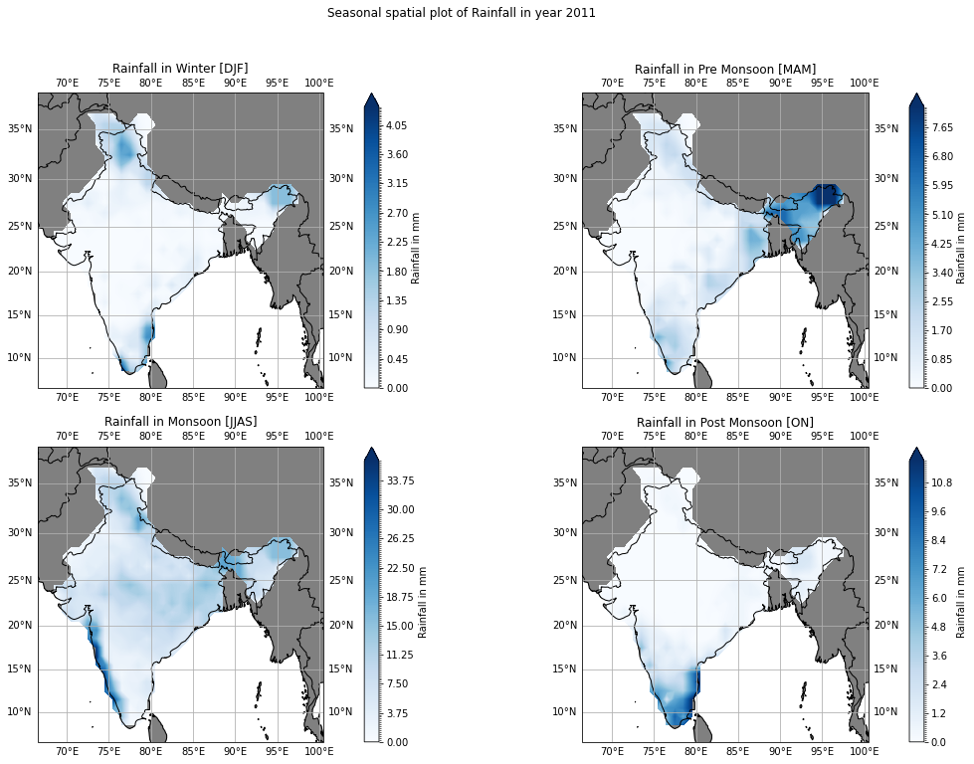
Solution – Since we need to create spatial plots of seasonal mean rainfall , we will group the data into the seasons (As defined by IMD) ,to check and compare the change in rainfall throughout the year in different seasons [in year 2011] .
Fig 2 – Spatial plot depicting mean rainfall in different seasons for year 2011

As we can see from the figure , which depicts spatial plots for 4 different seasons, we can interpret different trends and values of rainfall in these seasons
In DJF months [Winter] , The rainfall values are at lowest throughout the Indian Subcontinent . Very random values of rainfall can be observed.
In MAM months [Pre monsoon/Summer] , We can still lower rainfall throughout the India except North eastern region , showing abnormally very high rainfall values before the actual onset of the Monsoon . This can be explained by the Heating up of Bay of Bengal in Summer Season and when that air started moving towards land , Due to the presence of Himalayas there , strong convective movements can initiate leading to the strong rainfall intensity there before the actual onset of Monsoon .
This is not characterised as the onset of monsoon because it does not embark the Monsoon throughout the India , but got constrained in North-Eastern India .
In JJAS months [Monsoon] , Higher rainfall is observed throughout the India , with the highest amount of Precipitation present in the Western Ghats Regions .This can be explained by the southwestern winds blown during the Monsoon season , carrying moisture with them and orographic lifting , triggering the heavy rains in that area . Also , decent amount of rainfall can be observed in Nothern regions as well as the monsoon trough shifts northwards during the monsoon season
But , In ON months [Post-Monsoon] , heavy rains are observable in southern India . This is because the monsoon trough shifts towards Southern India during the retreating phase .

Q3. Use the same data to select central India region during JJAS season and take spatial average to plot the time series.

Solution – Central India lies between the latitude range of 18°N to 26°N , and longitude range between 70°E to 90°E . This region is of important consideration as the movement of monsoon trough with respect to Central India will decide the intensity and location of heavy rainfall .

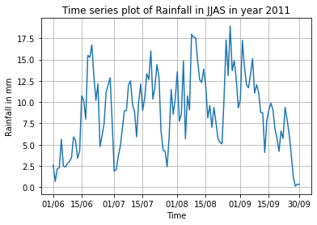
Fig 3 – Time series plot of rainfall over Central India , in Monsoon months

As we look into the time series plot , we can see that there are almost two peaks , both lying at the different ends of the plot . These two peaks can be explained by the presence of monsoon trough over Central India , and consecutively after these peaks we can see decrease in amount of rainfall over that region .
Basically ,Over Central India this trough passes through it two times. One during the onset of Monsoon when the monsoon is approaching Northern parts of India , and second during the retreating phase of monsoon when the trough starts moving southwards from the Northern India (Monsoon trough is the low pressure system where the intensity of rainfall is high)

