CHAROTAR UNIVERSITY OF SCIENCE AND TECHNOLOGY (CHARUSAT)
DEVANG PATEL INSTITUTE OF ADVANCE TECHNOLOGY AND RESEARCH (DEPSTAR)
Department of Computer Science & Engineering
CEUE203: Object-Oriented Programming (Java) | Practical 11
Object Serialization, I/O Streams & NIO File Processing

Student Name: Krupal Parmar Student ID: 25CS057
Branch/Semester: B.Tech CSE / Semester 3 Academic Year: 2026–2027
GitHub Branch: https://github.com/25cs057/25cs057_java_practicals/tree/lab11

Practical Objectives & Theoretical Concepts
1. Java Object Serialization & Deserialization: Implementing java.io.Serializable, establishing version compatibility via serialVersionUID, writing object arrays with ObjectOutputStream, and reconstructing object graphs with ObjectInputStream.
2. Transient Field Mechanics: Applying the transient keyword to prevent ephemeral or sensitive in-memory state (such as security tokens) from being written to byte streams, verifying its default initialization upon deserialization.
3. Modern Java NIO File I/O & Attributes: Leveraging Path and Files utilities (java.nio.file) to create log directories, stream files line-by-line via BufferedReader, match keywords, and query metadata attributes using BasicFileAttributes.

Exercise 1: Object Serialization & Transient Fields
Problem Statement 1 (Unabridged Syllabus Requirement):
Save/load: make a small class Serializable, save an array of its objects to a file with ObjectOutputStream, then read it back into fresh objects and confirm the values survived. Mark one field transient and show it is not saved.

Source File 1: StudentRecord.java (Serializable Model with Persistent Fields and Transient sessionToken)
package exercise1;

import java.io.Serializable;

/**
* Serializable student entity demonstrating persistent state and transient exclusion.
*
* @author Krupal Parmar (25CS057)
*/
public class StudentRecord implements Serializable {
private static final long serialVersionUID = 1L;

private final String studentId;
private final String name;
private final double gpa;

// Transient field: explicitly excluded from Java serialization stream
private transient String sessionToken;

public StudentRecord(String studentId, String name, double gpa, String sessionToken) {
this.studentId = studentId;
this.name = name;
this.gpa = gpa;
this.sessionToken = sessionToken;
}

public String getStudentId() {
return studentId;
}

public String getName() {
return name;
}

public double getGpa() {
return gpa;
}

public String getSessionToken() {
return sessionToken;
}

public void setSessionToken(String sessionToken) {
this.sessionToken = sessionToken;
}

@Override
public String toString() {
return String.format("StudentRecord [ID=%s, Name=%-14s, GPA=%.2f, sessionToken=%s]",
studentId, name, gpa, (sessionToken != null ? "'" + sessionToken + "'" : "null (transient reset)"));
}
}

Source File 2: Driver.java (Object Array Serialization/Deserialization Driver & Integrity Validator)
package exercise1;

import java.io.File;
import java.io.FileInputStream;
import java.io.FileOutputStream;
import java.io.IOException;
import java.io.ObjectInputStream;
import java.io.ObjectOutputStream;

/**
* Driver demonstrating serialization of object arrays and transient field behavior.
*
* @author Krupal Parmar (25CS057)
*/
public class Driver {
private static final String DATA_FILE = "student_records.ser";

public static void main(String[] args) {
System.out.println("======================================================================");
System.out.println(" Practical 11 - Exercise 1: Object Serialization & Transient Fields");
System.out.println(" Student: Krupal Parmar | ID: 25CS057 | University: CHARUSAT (DEPSTAR)");
System.out.println("======================================================================\n");

// 1. Create original array of objects
StudentRecord[] originalStudents = new StudentRecord[] {
new StudentRecord("25CS057", "Krupal Parmar", 3.92, "SESSION-TOKEN-90812-LIVE"),
new StudentRecord("25CS058", "Aarav Patel", 3.78, "SESSION-TOKEN-44129-LIVE"),
new StudentRecord("25CS059", "Diya Sharma", 3.85, "SESSION-TOKEN-81273-LIVE")
};

System.out.println("--- 1. Original Records Before Serialization ---");
for (StudentRecord s : originalStudents) {
System.out.println(" " + s);
}
System.out.println(" Notice: All records have active sessionToken values populated.\n");

// 2. Save array to file using ObjectOutputStream
System.out.printf("--- 2. Serializing Object Array to File: '%s' ---%n", DATA_FILE);
try (ObjectOutputStream oos = new ObjectOutputStream(new FileOutputStream(DATA_FILE))) {
oos.writeObject(originalStudents);
System.out.println(" Successfully written " + originalStudents.length + " StudentRecord objects via ObjectOutputStream.");
} catch (IOException e) {
System.err.println(" Serialization failed: " + e.getMessage());
return;
}

File fileOnDisk = new File(DATA_FILE);
System.out.printf(" Serialized File Size on Disk: %d bytes%n%n", fileOnDisk.length());

// 3. Read back array from file using ObjectInputStream into fresh objects
System.out.printf("--- 3. Deserializing Object Array from File: '%s' ---%n", DATA_FILE);
StudentRecord[] deserializedStudents = null;
try (ObjectInputStream ois = new ObjectInputStream(new FileInputStream(DATA_FILE))) {
deserializedStudents = (StudentRecord[]) ois.readObject();
System.out.println(" Successfully deserialized object array from file stream.\n");
} catch (IOException | ClassNotFoundException e) {
System.err.println(" Deserialization failed: " + e.getMessage());
return;
}

// 4. Verification and Confirmation
System.out.println("--- 4. Verification of Deserialized State ---");
boolean allPersistentSurvived = true;
boolean allTransientNull = true;

for (int i = 0; i < deserializedStudents.length; i++) {
StudentRecord loaded = deserializedStudents[i];
StudentRecord orig = originalStudents[i];

System.out.println(" " + loaded);

boolean idMatches = loaded.getStudentId().equals(orig.getStudentId());
boolean nameMatches = loaded.getName().equals(orig.getName());
boolean gpaMatches = Double.compare(loaded.getGpa(), orig.getGpa()) == 0;

if (!idMatches || !nameMatches || !gpaMatches) {
allPersistentSurvived = false;
}
if (loaded.getSessionToken() != null) {
allTransientNull = false;
}
}

System.out.println("\n----------------------------------------------------------------------");
System.out.println(" Serialization Integrity & Transient Behavior Summary");
System.out.println("----------------------------------------------------------------------");
System.out.printf(" Persistent Fields Survived (ID, Name, GPA) : %s%n",
allPersistentSurvived ? "CONFIRMED (100% Data Integrity Preserved)" : "FAILED");
System.out.printf(" Transient Field Omitted (sessionToken) : %s%n",
allTransientNull ? "CONFIRMED (Excluded from stream, loaded as null)" : "FAILED");
System.out.println("----------------------------------------------------------------------");
System.out.printf(" Final Status : %s%n",
(allPersistentSurvived && allTransientNull)
? "SUCCESS (Serializable & Transient mechanics fully verified)"
: "FAIL");
System.out.println("======================================================================");

// Cleanup temporary serialization artifact
if (fileOnDisk.exists()) {
fileOnDisk.delete();
}
}
}

Execution Screenshot — Exercise 1 (PowerShell Live Terminal)
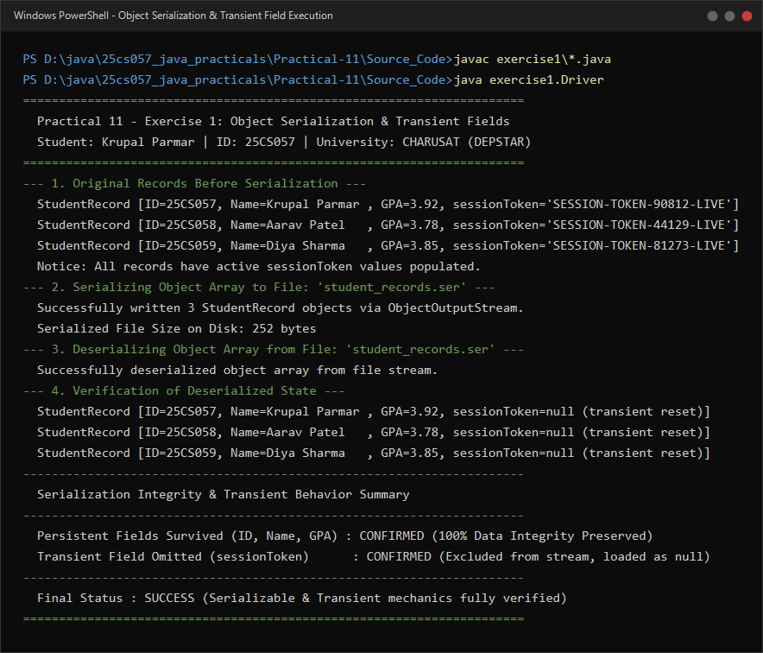

Exercise 2: NIO File Attributes & Log Analyzer
Problem Statement 2 (Unabridged Syllabus Requirement):
Log analyzer: create a few text files, then use Path/Files to read each line by line and count the total lines and how many contain a keyword across all files; also print each file's size from its attributes.

Source File 1: LogReport.java (Immutable Data Carrier for NIO File Statistics & Match Counts)
package exercise2;

import java.nio.file.Path;

/**
* Encapsulates NIO file inspection metrics and keyword frequency data.
*
* @author Krupal Parmar (25CS057)
*/
public class LogReport {
private final Path filePath;
private final long fileSizeBytes;
private final int totalLines;
private final int matchingLines;

public LogReport(Path filePath, long fileSizeBytes, int totalLines, int matchingLines) {
this.filePath = filePath;
this.fileSizeBytes = fileSizeBytes;
this.totalLines = totalLines;
this.matchingLines = matchingLines;
}

public Path getFilePath() {
return filePath;
}

public String getFileName() {
return filePath.getFileName().toString();
}

public long getFileSizeBytes() {
return fileSizeBytes;
}

public int getTotalLines() {
return totalLines;
}

public int getMatchingLines() {
return matchingLines;
}
}

Source File 2: LogAnalyzer.java (Sample Log Generator & NIO File Attribute / Line-by-Line Parser)
package exercise2;

import java.io.BufferedReader;
import java.io.IOException;
import java.nio.file.Files;
import java.nio.file.Path;
import java.nio.file.attribute.BasicFileAttributes;
import java.util.List;

/**
* NIO-based log analyzer inspecting files line-by-line and reading filesystem attributes.
*
* @author Krupal Parmar (25CS057)
*/
public class LogAnalyzer {

/**
* Generates realistic sample log files for demonstration.
*/
public static void createSampleLogFiles(Path logDir) throws IOException {
if (!Files.exists(logDir)) {
Files.createDirectories(logDir);
}

Path authLog = logDir.resolve("auth.log");
Path transLog = logDir.resolve("transaction.log");
Path sysLog = logDir.resolve("system.log");

Files.write(authLog, List.of(
"[2026-11-03 10:00:15] INFO User 'kparmar' login successful from 192.168.1.10",
"[2026-11-03 10:02:44] WARN Invalid password attempt for user 'guest'",
"[2026-11-03 10:05:12] ERROR Authentication service connection timeout on port 8443",
"[2026-11-03 10:07:01] INFO User 'admin' initiated privilege elevation",
"[2026-11-03 10:08:33] ERROR Brute force pattern detected; blocking IP 203.0.113.42"
));

Files.write(transLog, List.of(
"[2026-11-03 10:01:00] INFO TXN-1001 Deposit INR 25,000 processed to AC001",
"[2026-11-03 10:03:15] INFO TXN-1002 Transfer INR 5,000 AC001 -> AC002 success",
"[2026-11-03 10:04:50] ERROR TXN-1003 Database lock conflict during account ledger update",
"[2026-11-03 10:06:18] INFO TXN-1004 Withdrawal INR 2,000 processed from AC003",
"[2026-11-03 10:09:20] WARN TXN-1005 High value transaction triggered compliance review",
"[2026-11-03 10:11:05] ERROR TXN-1006 Payment gateway returned HTTP 503 Service Unavailable",
"[2026-11-03 10:12:40] INFO TXN-1007 Reversal completed for TXN-1006"
));

Files.write(sysLog, List.of(
"[2026-11-03 09:55:00] INFO System kernel initialized on node cluster-depstar-01",
"[2026-11-03 10:00:00] INFO Scheduled background health check completed successfully",
"[2026-11-03 10:10:00] WARN Memory utilization reached 84% threshold",
"[2026-11-03 10:15:22] ERROR Disk I/O subsystem reported degraded write performance on /dev/sda2",
"[2026-11-03 10:20:00] INFO Garbage collection freed 420 MB heap memory"
));
}

/**
* Inspects a single log file using java.nio.file APIs.
* Reads line-by-line using BufferedReader and queries BasicFileAttributes for size.
*/
public static LogReport analyzeFile(Path filePath, String keyword) throws IOException {
// Read file size attributes using NIO
BasicFileAttributes attrs = Files.readAttributes(filePath, BasicFileAttributes.class);
long sizeBytes = attrs.size();

int totalLines = 0;
int matchingLines = 0;
String lowerKeyword = keyword.toLowerCase();

// Read line by line with BufferedReader
try (BufferedReader reader = Files.newBufferedReader(filePath)) {
String line;
while ((line = reader.readLine()) != null) {
totalLines++;
if (line.toLowerCase().contains(lowerKeyword)) {
matchingLines++;
}
}
}

return new LogReport(filePath, sizeBytes, totalLines, matchingLines);
}
}

Source File 3: Driver.java (NIO DirectoryStream Traversal, Tabular Reporting & Aggregation)
package exercise2;

import java.io.IOException;
import java.nio.file.DirectoryStream;
import java.nio.file.Files;
import java.nio.file.Path;
import java.nio.file.Paths;
import java.util.ArrayList;
import java.util.Comparator;
import java.util.List;

/**
* Driver executing NIO-based batch log file analysis and filesystem attribute reporting.
*
* @author Krupal Parmar (25CS057)
*/
public class Driver {
private static final String LOG_DIRECTORY = "sample_logs";
private static final String SEARCH_KEYWORD = "ERROR";

public static void main(String[] args) {
System.out.println("======================================================================");
System.out.println(" Practical 11 - Exercise 2: NIO File Attributes & Log Analyzer");
System.out.println(" Student: Krupal Parmar | ID: 25CS057 | University: CHARUSAT (DEPSTAR)");
System.out.println("======================================================================\n");

Path logDirPath = Paths.get(LOG_DIRECTORY);

try {
// 1. Create sample log files using Files and Path
System.out.printf("Creating sample log files in '%s/' using java.nio.file.Files...%n", LOG_DIRECTORY);
LogAnalyzer.createSampleLogFiles(logDirPath);
System.out.println("Sample log files created successfully.\n");

// 2. Discover all .log files in directory using DirectoryStream
List<Path> logFiles = new ArrayList<>();
try (DirectoryStream<Path> stream = Files.newDirectoryStream(logDirPath, "*.log")) {
for (Path entry : stream) {
logFiles.add(entry);
}
}
logFiles.sort(Comparator.comparing(Path::getFileName));

System.out.printf("--- Analyzing %d Log Files for Target Keyword: '%s' ---%n",
logFiles.size(), SEARCH_KEYWORD);
System.out.printf("%-18s | %-12s | %-12s | %-14s%n",
"File Name", "Total Lines", "Matches (" + SEARCH_KEYWORD + ")", "Size on Disk");
System.out.println("----------------------------------------------------------------------");

long grandTotalLines = 0;
long grandTotalMatches = 0;
long grandTotalBytes = 0;

for (Path logFile : logFiles) {
LogReport report = LogAnalyzer.analyzeFile(logFile, SEARCH_KEYWORD);
grandTotalLines += report.getTotalLines();
grandTotalMatches += report.getMatchingLines();
grandTotalBytes += report.getFileSizeBytes();

System.out.printf("%-18s | %10d | %12d | %10d B%n",
report.getFileName(),
report.getTotalLines(),
report.getMatchingLines(),
report.getFileSizeBytes());
}

System.out.println("----------------------------------------------------------------------");
System.out.printf("%-18s | %10d | %12d | %10d B%n%n",
"TOTAL SUMMARY", grandTotalLines, grandTotalMatches, grandTotalBytes);

System.out.println("----------------------------------------------------------------------");
System.out.println(" NIO Analysis Verification Summary");
System.out.println("----------------------------------------------------------------------");
System.out.printf(" Total Files Inspected : %d files%n", logFiles.size());
System.out.printf(" Total Lines Processed : %d lines%n", grandTotalLines);
System.out.printf(" Keyword Occurrences ('%s') : %d lines matched%n", SEARCH_KEYWORD, grandTotalMatches);
System.out.printf(" Total Storage Footprint : %d bytes (retrieved via BasicFileAttributes)%n", grandTotalBytes);
System.out.println("----------------------------------------------------------------------");
System.out.println(" Status: SUCCESS (NIO line-by-line reading & attribute inspection verified)");
System.out.println("======================================================================");

// Cleanup sample files and directory
for (Path logFile : logFiles) {
Files.deleteIfExists(logFile);
}
Files.deleteIfExists(logDirPath);

} catch (IOException e) {
System.err.println("NIO Log Analysis failed with I/O error: " + e.getMessage());
}
}
}

Execution Screenshot — Exercise 2 (PowerShell Live Terminal)


