CHAROTAR UNIVERSITY OF SCIENCE AND TECHNOLOGY (CHARUSAT)
DEVANG PATEL INSTITUTE OF ADVANCE TECHNOLOGY AND RESEARCH (DEPSTAR)
Department of Computer Science & Engineering
CEUE203: Object-Oriented Programming (Java) | Practical 04

Student Name: Krupal Parmar  Student ID: 25CS057 | Semester: 3 (A.Y. 2026-27)  GitHub Branch: lab4

1. Password strength (PasswordChecker.java + Driver.java)

A. Problem Statement
Official Problem Definition:
(a) In PasswordChecker, check four rules — length >= 8, contains an uppercase letter, contains a digit, contains a special character — using regex (e.g. ".*[A-Z].*") or String methods.
(b) Write strength(String pw) that counts how many rules pass and returns "Weak" (0–1), "Medium" (2–3) or "Strong" (4).
(c) In Driver.main: test several passwords; for each, print which rules passed and the final label.
Expected output: "abc" -> Weak; "Abcd1234!" -> Strong.

B. Complete Java Source Code
File 1: Practical-04/Source_Code/exercise1/PasswordChecker.java
package exercise1;

import java.util.ArrayList;
import java.util.List;

/**
* Practical 04 - Exercise 1
* Student Name: Krupal Parmar
* Student ID: 25CS057
* Course: CEUE203 - Object-Oriented Programming
*
* (a) In PasswordChecker, check four rules:
* 1. length >= 8
* 2. contains an uppercase letter (regex ".*[A-Z].*")
* 3. contains a digit (regex ".*[0-9].*")
* 4. contains a special character (regex ".*[!@#$%^&*()_+\\-=\\[\\]{};':\"\\\\|,.<>\\/?].*")
* (b) Write strength(String pw) that counts how many rules pass and returns:
* "Weak" (0-1), "Medium" (2-3) or "Strong" (4).
*/
public class PasswordChecker {

public static List<String> getPassedRules(String pw) {
List<String> passed = new ArrayList<>();
if (pw == null) return passed;

// Rule 1: Length >= 8
if (pw.length() >= 8) {
passed.add("Length >= 8");
}
// Rule 2: Contains uppercase letter
if (pw.matches(".*[A-Z].*")) {
passed.add("Contains Uppercase Letter");
}
// Rule 3: Contains digit
if (pw.matches(".*[0-9].*")) {
passed.add("Contains Digit");
}
// Rule 4: Contains special character
if (pw.matches(".*[!@#$%^&*()_+\\-=\\[\\]{};':\"\\\\|,.<>\\/?].*")) {
passed.add("Contains Special Character");
}

return passed;
}

public static String strength(String pw) {
int passedCount = getPassedRules(pw).size();

// Weak (0-1), Medium (2-3), Strong (4)
if (passedCount <= 1) {
return "Weak";
} else if (passedCount <= 3) {
return "Medium";
} else {
return "Strong";
}
}
}

File 2: Practical-04/Source_Code/exercise1/Driver.java
package exercise1;

import java.util.List;

/**
* Practical 04 - Exercise 1 (Driver)
* Student Name: Krupal Parmar
* Student ID: 25CS057
* Course: CEUE203 - Object-Oriented Programming
*
* (c) In Driver.main: test several passwords; for each, print which rules passed
* and the final label.
* Expected output: "abc" -> Weak; "Abcd1234!" -> Strong.
*/
public class Driver {
public static void main(String[] args) {
System.out.println("=== Practical 04 - Exercise 1: Password Strength Evaluator ===");

String[] testPasswords = new String[] {
"abc", // 0 rules passed -> Weak
"password", // 1 rule passed (length >= 8) -> Weak
"Password12", // 3 rules passed (length, upper, digit) -> Medium
"Abcd1234!" // 4 rules passed (all) -> Strong
};

for (String pw : testPasswords) {
List<String> passed = PasswordChecker.getPassedRules(pw);
String label = PasswordChecker.strength(pw);

System.out.println("\nPassword: \"" + pw + "\"");
System.out.println(" Passed Rules (" + passed.size() + "/4):");
if (passed.isEmpty()) {
System.out.println(" (None)");
} else {
for (String rule : passed) {
System.out.println(" [OK] " + rule);
}
}
System.out.println(" Strength Label -> " + label);
}
}
}

C. Execution Output Screenshot
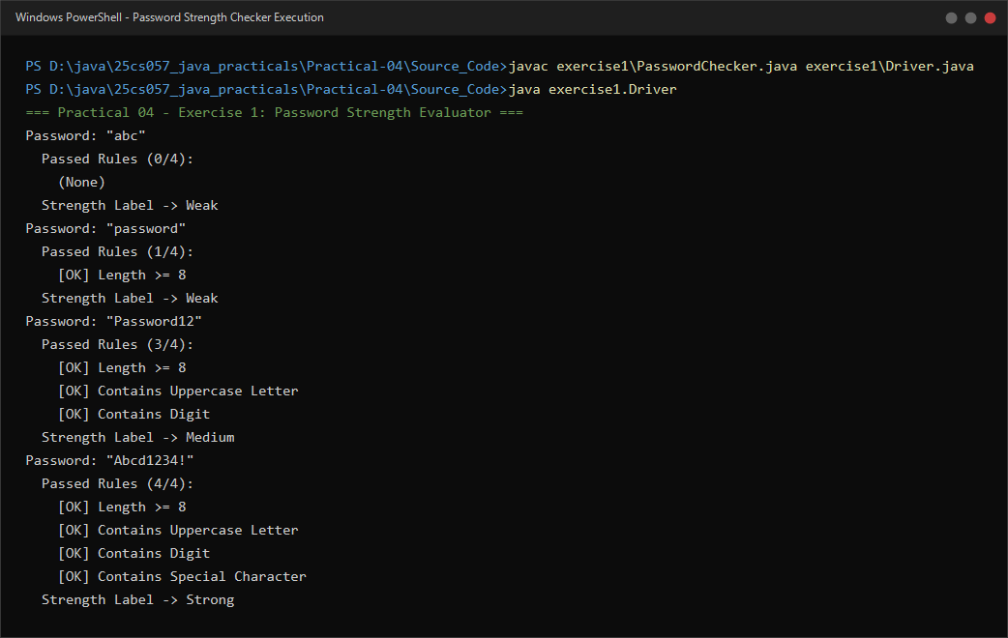
Figure 4.1: Live execution of PasswordChecker.java and Driver.java evaluating passwords against 4 security rules.

2. Chat-log filter (ChatFilter.java + Driver.java)

A. Problem Statement
Official Problem Definition:
(a) In Driver.main, define a String[] of log lines like "10:05 alice Hello there" (include one malformed line with fewer than 3 parts).
(b) Read a keyword from the user.
(c) For each line, split into time/user/message with split(" ", 3); skip lines that do not have 3 parts.
(d) If the message contains the keyword (case-insensitive), increment a counter and append "time user: message" to a StringBuilder.
(e) Print "Matches: N" and the built report.
Expected output: keyword "hello" over 3 lines (1 malformed) -> "Matches: 1" and the matching line.

B. Complete Java Source Code
File 1: Practical-04/Source_Code/exercise2/ChatFilter.java
package exercise2;

/**
* Practical 04 - Exercise 2 (ChatFilter Utility)
* Student Name: Krupal Parmar
* Student ID: 25CS057
* Course: CEUE203 - Object-Oriented Programming
*
* Provides filtering and string parsing routines for chat log lines.
*/
public class ChatFilter {

public static class FilterResult {
private final int matchCount;
private final String report;

public FilterResult(int matchCount, String report) {
this.matchCount = matchCount;
this.report = report;
}

public int getMatchCount() {
return matchCount;
}

public String getReport() {
return report;
}
}

/**
* Filters log lines based on a search keyword (case-insensitive).
* Format per line: "time user message"
* Appends to StringBuilder in format: "time user: message"
*/
public static FilterResult filterLogs(String[] lines, String keyword) {
StringBuilder sb = new StringBuilder();
int matches = 0;
String lowerKeyword = keyword.toLowerCase();

for (String line : lines) {
if (line == null) continue;

// (c) Split into time, user, and message using split(" ", 3)
String[] parts = line.split(" ", 3);

// Skip lines that do not have 3 parts (malformed)
if (parts.length < 3) {
continue;
}

String time = parts[0];
String user = parts[1];
String message = parts[2];

// (d) Check if message contains keyword (case-insensitive)
if (message.toLowerCase().contains(lowerKeyword)) {
matches++;
sb.append(time).append(" ").append(user).append(": ").append(message).append("\n");
}
}

return new FilterResult(matches, sb.toString());
}
}

File 2: Practical-04/Source_Code/exercise2/Driver.java
package exercise2;

import java.util.Scanner;

/**
* Practical 04 - Exercise 2 (Driver)
* Student Name: Krupal Parmar
* Student ID: 25CS057
* Course: CEUE203 - Object-Oriented Programming
*
* (a) In Driver.main, define a String[] of log lines like "10:05 alice Hello there"
* (include one malformed line with fewer than 3 parts).
* (b) Read a keyword from the user.
* (c) For each line, split into time/user/message with split(" ", 3); skip lines
* that do not have 3 parts.
* (d) If the message contains the keyword (case-insensitive), increment a counter
* and append "time user: message" to a StringBuilder.
* (e) Print "Matches: N" and the built report.
* Expected output: keyword "hello" over 3 lines (1 malformed) -> "Matches: 1"
* and the matching line.
*/
public class Driver {
public static void main(String[] args) {
System.out.println("=== Practical 04 - Exercise 2: Chat-Log Filter ===");

// (a) Define a String[] of 3 log lines (including one malformed line)
String[] logs = new String[] {
"10:05 alice Hello there",
"10:06 bob", // Malformed line (fewer than 3 parts)
"10:07 charlie Good morning all"
};

System.out.println("Available Chat Logs:");
for (String log : logs) {
System.out.println(" " + log);
}

// (b) Read keyword from user
Scanner scanner = new Scanner(System.in);
System.out.print("\nEnter keyword to filter: ");
String keyword = scanner.hasNext() ? scanner.next().trim() : "hello";

System.out.println("Searching for: \"" + keyword + "\"...\n");

// Filter and build report
ChatFilter.FilterResult result = ChatFilter.filterLogs(logs, keyword);

// (e) Print Matches count and built report
System.out.println("Matches: " + result.getMatchCount());
if (result.getMatchCount() > 0) {
System.out.print(result.getReport());
}

scanner.close();
}
}

C. Execution Output Screenshot
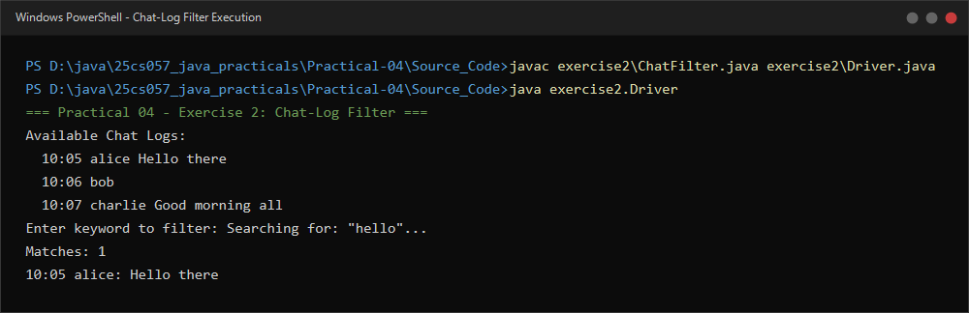
Figure 4.2: Live execution of ChatFilter.java and Driver.java showing tokenization with split(" ", 3), error skipping, and StringBuilder assembly.

