CHAROTAR UNIVERSITY OF SCIENCE AND TECHNOLOGY (CHARUSAT)
DEVANG PATEL INSTITUTE OF ADVANCE TECHNOLOGY AND RESEARCH (DEPSTAR)
Department of Computer Science & Engineering
CEUE203: Object-Oriented Programming (Java) | Practical 05

Student Name: Krupal Parmar  Student ID: 25CS057 | Semester: 3 (A.Y. 2026-27)  GitHub Branch: lab5

1. Shape areas: an abstract Shape with abstract area(); subclasses Circle, Rectangle, Triangle

A. Problem Statement
Official Problem Definition:
Shape areas: an abstract Shape with abstract area(); subclasses Circle, Rectangle, Triangle. Put a mix in a Shape[] and loop once to print each area and the running total, tracking the largest — one loop handling every shape through polymorphism.

B. Complete Java Source Code
File 1: Practical-05/Source_Code/exercise1/Shape.java
package exercise1;

/**
* Practical 05 - Exercise 1 (Abstract Shape)
* Student Name: Krupal Parmar
* Student ID: 25CS057
* Course: CEUE203 - Object-Oriented Programming
*
* An abstract Shape base class with abstract area() method.
*/
public abstract class Shape {
private final String name;

public Shape(String name) {
this.name = name;
}

public String getName() {
return name;
}

// Abstract method to be implemented by all concrete shapes
public abstract double area();

@Override
public String toString() {
return String.format("%s (Area: %.2f)", name, area());
}
}

File 2: Practical-05/Source_Code/exercise1/Circle.java
package exercise1;

public class Circle extends Shape {
private final double radius;

public Circle(double radius) {
super("Circle");
this.radius = radius;
}

public double getRadius() {
return radius;
}

@Override
public double area() {
return Math.PI * radius * radius;
}
}

File 3: Practical-05/Source_Code/exercise1/Rectangle.java
package exercise1;

public class Rectangle extends Shape {
private final double width;
private final double height;

public Rectangle(double width, double height) {
super("Rectangle");
this.width = width;
this.height = height;
}

public double getWidth() {
return width;
}

public double getHeight() {
return height;
}

@Override
public double area() {
return width * height;
}
}

File 4: Practical-05/Source_Code/exercise1/Triangle.java
package exercise1;

public class Triangle extends Shape {
private final double base;
private final double height;

public Triangle(double base, double height) {
super("Triangle");
this.base = base;
this.height = height;
}

public double getBase() {
return base;
}

public double getHeight() {
return height;
}

@Override
public double area() {
return 0.5 * base * height;
}
}

File 5: Practical-05/Source_Code/exercise1/Driver.java
package exercise1;

/**
* Practical 05 - Exercise 1 (Driver)
* Student Name: Krupal Parmar
* Student ID: 25CS057
* Course: CEUE203 - Object-Oriented Programming
*
* Problem Statement:
* Shape areas: an abstract Shape with abstract area(); subclasses Circle, Rectangle,
* Triangle. Put a mix in a Shape[] and loop once to print each area and the running
* total, tracking the largest - one loop handling every shape through polymorphism.
*/
public class Driver {
public static void main(String[] args) {
System.out.println("=== Practical 05 - Exercise 1: Polymorphic Shape Areas ===");

// Put a mix of shapes into a polymorphic Shape[] array
Shape[] shapes = new Shape[] {
new Circle(4.0), // Area: PI * 16 ≈ 50.27
new Rectangle(5.0, 8.0), // Area: 40.00
new Triangle(6.0, 7.0), // Area: 21.00
new Circle(2.5), // Area: PI * 6.25 ≈ 19.63
new Rectangle(7.0, 9.0) // Area: 63.00 (Largest)
};

double runningTotal = 0.0;
Shape largestShape = null;
double maxArea = -1.0;

System.out.println("Processing Shapes Array (One polymorphic loop):");
for (int i = 0; i < shapes.length; i++) {
Shape s = shapes[i];
double a = s.area(); // Dynamic method dispatch (polymorphism)
runningTotal += a;

if (a > maxArea) {
maxArea = a;
largestShape = s;
}

System.out.printf(" [%d] %-10s | Calculated Area: %8.2f | Running Total: %8.2f%n",
(i + 1), s.getName(), a, runningTotal);
}

System.out.println("\n--- Summary ---");
System.out.printf("Total Area of all shapes : %.2f%n", runningTotal);
if (largestShape != null) {
System.out.printf("Largest Shape : %s with area %.2f%n",
largestShape.getName(), largestShape.area());
}
}
}

C. Execution Output Screenshot
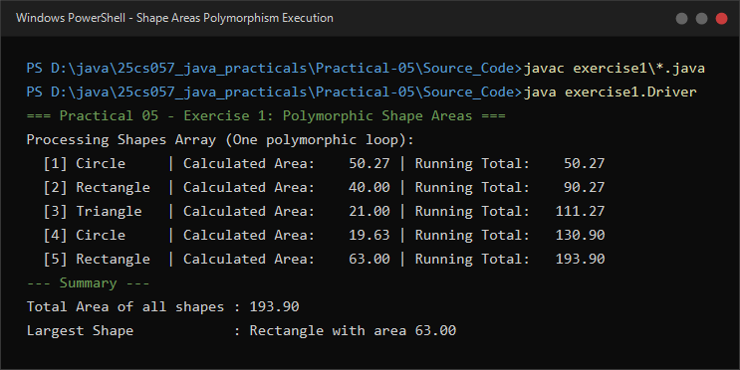
Figure 5.1: Live execution of Shape areas polymorphism demonstrating dynamic method dispatch across Circle, Rectangle, and Triangle.

2. Payroll: an abstract Employee with abstract monthlySalary(); FullTime, PartTime, Intern

A. Problem Statement
Official Problem Definition:
Payroll: an abstract Employee with abstract monthlySalary(); FullTime (fixed), PartTime (hours × rate) and Intern (stipend), each calling super for the shared name/id. Loop a mixed array to print each salary and the total; use instanceof to add a note only for interns.

B. Complete Java Source Code
File 1: Practical-05/Source_Code/exercise2/Employee.java
package exercise2;

/**
* Practical 05 - Exercise 2 (Abstract Employee)
* Student Name: Krupal Parmar
* Student ID: 25CS057
* Course: CEUE203 - Object-Oriented Programming
*
* Abstract base class representing an employee in the payroll system.
*/
public abstract class Employee {
private final String id;
private final String name;

public Employee(String id, String name) {
this.id = id;
this.name = name;
}

public String getId() {
return id;
}

public String getName() {
return name;
}

// Abstract method to be overridden by each employee subtype
public abstract double monthlySalary();

public abstract String getEmployeeType();
}

File 2: Practical-05/Source_Code/exercise2/FullTimeEmployee.java
package exercise2;

public class FullTimeEmployee extends Employee {
private final double fixedMonthlySalary;

public FullTimeEmployee(String id, String name, double fixedMonthlySalary) {
super(id, name);
this.fixedMonthlySalary = fixedMonthlySalary;
}

@Override
public double monthlySalary() {
return fixedMonthlySalary;
}

@Override
public String getEmployeeType() {
return "Full-Time";
}
}

File 3: Practical-05/Source_Code/exercise2/PartTimeEmployee.java
package exercise2;

public class PartTimeEmployee extends Employee {
private final double hoursWorked;
private final double hourlyRate;

public PartTimeEmployee(String id, String name, double hoursWorked, double hourlyRate) {
super(id, name);
this.hoursWorked = hoursWorked;
this.hourlyRate = hourlyRate;
}

public double getHoursWorked() {
return hoursWorked;
}

public double getHourlyRate() {
return hourlyRate;
}

@Override
public double monthlySalary() {
return hoursWorked * hourlyRate;
}

@Override
public String getEmployeeType() {
return "Part-Time";
}
}

File 4: Practical-05/Source_Code/exercise2/InternEmployee.java
package exercise2;

public class InternEmployee extends Employee {
private final double stipend;

public InternEmployee(String id, String name, double stipend) {
super(id, name);
this.stipend = stipend;
}

public double getStipend() {
return stipend;
}

@Override
public double monthlySalary() {
return stipend;
}

@Override
public String getEmployeeType() {
return "Intern";
}
}

File 5: Practical-05/Source_Code/exercise2/Driver.java
package exercise2;

/**
* Practical 05 - Exercise 2 (Driver)
* Student Name: Krupal Parmar
* Student ID: 25CS057
* Course: CEUE203 - Object-Oriented Programming
*
* Problem Statement:
* Payroll: an abstract Employee with abstract monthlySalary(); FullTime (fixed),
* PartTime (hours * rate) and Intern (stipend), each calling super for the shared
* name/id. Loop a mixed array to print each salary and the total; use instanceof
* to add a note only for interns.
*/
public class Driver {
public static void main(String[] args) {
System.out.println("=== Practical 05 - Exercise 2: Polymorphic Payroll System ===");

// Mixed polymorphic array of Employee references
Employee[] employees = new Employee[] {
new FullTimeEmployee("EMP001", "Aarav Sharma", 75000.0),
new PartTimeEmployee("EMP002", "Diya Patel", 80.0, 450.0), // 80 hrs * 450 = 36000
new InternEmployee("EMP003", "Karan Dave", 18000.0),
new FullTimeEmployee("EMP004", "Sneha Joshi", 62000.0),
new InternEmployee("EMP005", "Pooja Mehta", 18000.0)
};

double totalPayroll = 0.0;

System.out.println("Monthly Payroll Disbursement:");
for (int i = 0; i < employees.length; i++) {
Employee emp = employees[i];
double salary = emp.monthlySalary(); // Dynamic method dispatch
totalPayroll += salary;

System.out.printf(" [%d] ID: %s | Name: %-14s | Type: %-9s | Salary: ₹%,9.2f",
(i + 1), emp.getId(), emp.getName(), emp.getEmployeeType(), salary);

// Use instanceof to add a note only for interns
if (emp instanceof InternEmployee) {
System.out.print(" <-- [NOTE: Eligible for full-time conversion evaluation]");
}
System.out.println();
}

System.out.println("\n--- Payroll Summary ---");
System.out.printf("Total Organization Monthly Payroll: ₹%,.2f%n", totalPayroll);
}
}

C. Execution Output Screenshot
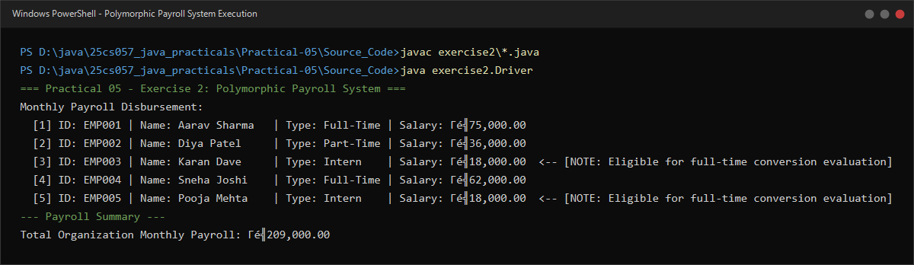
Figure 5.2: Live execution of Payroll system demonstrating salary calculations, super constructors, and instanceof identification.

