CHAROTAR UNIVERSITY OF SCIENCE AND TECHNOLOGY (CHARUSAT)
DEVANG PATEL INSTITUTE OF ADVANCE TECHNOLOGY AND RESEARCH (DEPSTAR)
Department of Computer Science & Engineering
CEUE203: Object-Oriented Programming (Java) | Practical 13
Generic Classes, Bounded Type Parameters & Type Safety

Student Name: Krupal Parmar Student ID: 25CS057
Branch/Semester: B.Tech CSE / Semester 3 Academic Year: 2026–2027
GitHub Branch: https://github.com/25cs057/25cs057_java_practicals/tree/lab13

Practical Objectives & Theoretical Concepts
1. Generic Type Parameterization: Declaring generic classes Box<T> and Pair<A, B> to eliminate error-prone explicit runtime downcasts and guarantee compile-time type safety.
2. Generic Methods & Type Inference: Implementing generic utility methods (<E> E getFirstElement(E[])) that dynamically infer argument types and execute uniformly across heterogeneous array inputs.
3. Bounded Type Parameters (<N extends Number>): Applying upper bounds to generic type parameters to safely invoke superclass operations (doubleValue()) while strictly rejecting non-numerical types at compile time.

Exercise 1: Generic Containers (Box<T>, Pair<A, B> & Array Utils)
Problem Statement 1 (Unabridged Syllabus Requirement):
Generic containers: a generic Box<T> with get/set and a Pair<A,B>; use them with different types to show type safety without casts, and write a generic method that returns the first element of any array.

Source File 1: Box.java (Generic Single-Value Container with Type-Safe Accessors)
package exercise1;

/**
* Generic single-item container providing strong compile-time type safety without casting.
*
* @param <T> the type of value stored in this box
* @author Krupal Parmar (25CS057)
*/
public class Box<T> {
private T value;

public Box() {
this.value = null;
}

public Box(T value) {
this.value = value;
}

public T get() {
return value;
}

public void set(T value) {
this.value = value;
}

public boolean isEmpty() {
return value == null;
}

@Override
public String toString() {
return String.format("Box<%s> [value=%s]",
(value != null ? value.getClass().getSimpleName() : "Empty"), value);
}
}

Source File 2: Pair.java (Heterogeneous Two-Element Tuple Container)
package exercise1;

/**
* Generic two-element heterogeneous tuple container.
*
* @param <A> the type of the first element
* @param <B> the type of the second element
* @author Krupal Parmar (25CS057)
*/
public class Pair<A, B> {
private final A first;
private final B second;

public Pair(A first, B second) {
this.first = first;
this.second = second;
}

public A getFirst() {
return first;
}

public B getSecond() {
return second;
}

@Override
public String toString() {
return String.format("Pair<%s, %s> (%s, %s)",
(first != null ? first.getClass().getSimpleName() : "null"),
(second != null ? second.getClass().getSimpleName() : "null"),
first, second);
}
}

Source File 3: ArrayUtils.java (Generic Method Returning First Element of Any Array)
package exercise1;

/**
* Utility class providing generic array operations with compile-time type inference.
*
* @author Krupal Parmar (25CS057)
*/
public class ArrayUtils {

/**
* Generic method returning the first element of any non-empty array of type E.
*
* @param <E> the component type of the array
* @param array the input array
* @return the first element, or null if the array is null or empty
*/
public static <E> E getFirstElement(E[] array) {
if (array == null || array.length == 0) {
return null;
}
return array[0];
}
}

Source File 4: Driver.java (Type Safety Verification Driver Without Casting)
package exercise1;

/**
* Driver demonstrating generic containers (Box, Pair) and generic array methods without type casts.
*
* @author Krupal Parmar (25CS057)
*/
public class Driver {
public static void main(String[] args) {
System.out.println("======================================================================");
System.out.println(" Practical 13 - Exercise 1: Generic Containers (Box<T>, Pair<A, B>)");
System.out.println(" Student: Krupal Parmar | ID: 25CS057 | University: CHARUSAT (DEPSTAR)");
System.out.println("======================================================================\n");

// 1. Box<T> demonstrations with distinct types
System.out.println("--- 1. Generic Box<T> Type Safety (No Downcasting Required) ---");

Box<String> stringBox = new Box<>("DEPSTAR CHARUSAT");
String strVal = stringBox.get(); // Directly returns String without (String) cast
System.out.printf(" String Box : %s | Extracted value length: %d chars%n",
stringBox, strVal.length());

Box<Integer> integerBox = new Box<>(25057);
Integer intVal = integerBox.get(); // Directly returns Integer without (Integer) cast
System.out.printf(" Integer Box: %s | Extracted value squared: %d%n",
integerBox, (intVal * intVal));

Box<Double> doubleBox = new Box<>(3.92);
Double dblVal = doubleBox.get();
System.out.printf(" Double Box : %s | Extracted value percentage: %.2f%%%n",
doubleBox, (dblVal * 25.0));

// 2. Pair<A, B> demonstrations with heterogeneous types
System.out.println("\n--- 2. Generic Heterogeneous Pair<A, B> ---");

Pair<String, Integer> studentAge = new Pair<>("Krupal Parmar", 19);
System.out.printf(" Student Pair: %s | First: '%s', Second: %d%n",
studentAge, studentAge.getFirst(), studentAge.getSecond());

Pair<Integer, Double> scorePercent = new Pair<>(98, 98.5);
System.out.printf(" Score Pair : %s | First: %d, Second: %.1f%n",
scorePercent, scorePercent.getFirst(), scorePercent.getSecond());

Pair<String, String> credPair = new Pair<>("25CS057", "Computer Science");
System.out.printf(" ID/Branch : %s | ID: %s, Dept: %s%n",
credPair, credPair.getFirst(), credPair.getSecond());

// 3. Generic method getFirstElement(E[] array)
System.out.println("\n--- 3. Generic Method: <E> E getFirstElement(E[] array) ---");

String[] fruits = {"Apple", "Banana", "Cherry", "Date"};
String firstFruit = ArrayUtils.getFirstElement(fruits);
System.out.printf(" String Array Input : [Apple, Banana, Cherry, Date]%n");
System.out.printf(" First Element (E=String) : '%s' (Type: %s)%n",
firstFruit, firstFruit.getClass().getSimpleName());

Integer[] primes = {2, 3, 5, 7, 11, 13};
Integer firstPrime = ArrayUtils.getFirstElement(primes);
System.out.printf(" Integer Array Input: [2, 3, 5, 7, 11, 13]%n");
System.out.printf(" First Element (E=Integer) : %d (Type: %s)%n",
firstPrime, firstPrime.getClass().getSimpleName());

Double[] metrics = {3.14159, 2.71828, 1.61803};
Double firstMetric = ArrayUtils.getFirstElement(metrics);
System.out.printf(" Double Array Input : [3.14159, 2.71828, 1.61803]%n");
System.out.printf(" First Element (E=Double) : %.5f (Type: %s)%n",
firstMetric, firstMetric.getClass().getSimpleName());

System.out.println("\n----------------------------------------------------------------------");
System.out.println(" Generics Type-Safety Verification Summary");
System.out.println("----------------------------------------------------------------------");
System.out.println(" 1. Strong Type Checking : CONFIRMED (Zero explicit runtime type casts used)");
System.out.println(" 2. Heterogeneous Pairs : CONFIRMED (Type parameters decoupled successfully)");
System.out.println(" 3. Generic Method Reuse : CONFIRMED (Method operates uniformly on any array type)");
System.out.println("----------------------------------------------------------------------");
System.out.println(" Final Status : SUCCESS (Generic Containers & Type Safety Verified)");
System.out.println("======================================================================");
}
}

Execution Screenshot — Exercise 1 (PowerShell Live Terminal)
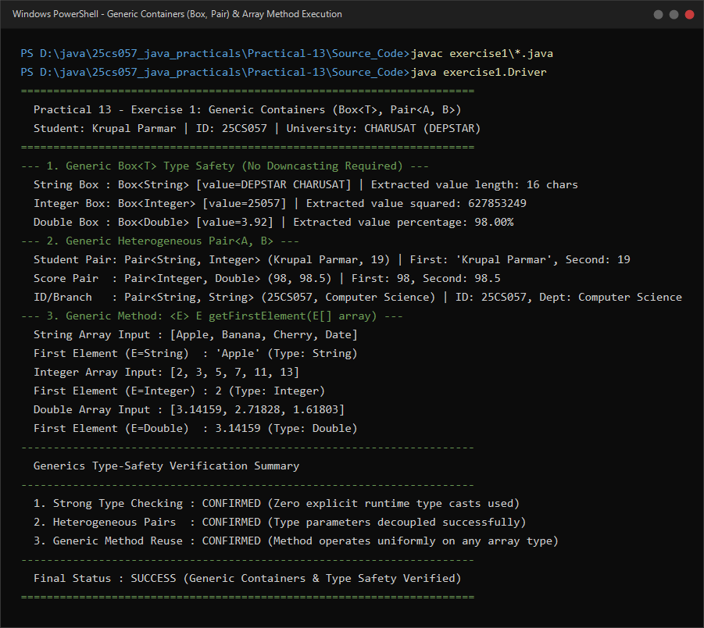

Exercise 2: Bounded Stats (<N extends Number>)
Problem Statement 2 (Unabridged Syllabus Requirement):
Bounded stats: a generic method <N extends Number> double average(N[] values) that works for Integer[], Double[] and Long[]; note why it refuses non-Number types.

Source File 1: BoundedStats.java (Bounded Type Parameter Method average(N[] values))
package exercise2;

/**
* Utility class providing bounded type generic methods for numerical computations.
*
* @author Krupal Parmar (25CS057)
*/
public class BoundedStats {

/**
* Calculates the arithmetic mean across any array of numerical types.
* The bounded type parameter <N extends Number> guarantees that every element
* has access to the doubleValue() method defined in java.lang.Number.
*
* @param <N> a type that is a subclass of java.lang.Number
* @param values input array of numerical values
* @return the arithmetic average as a double
* @throws IllegalArgumentException if values is null or empty
*/
public static <N extends Number> double average(N[] values) {
if (values == null || values.length == 0) {
throw new IllegalArgumentException("Array must not be null or empty for average computation!");
}

double sum = 0.0;
for (N val : values) {
if (val != null) {
sum += val.doubleValue();
}
}
return sum / values.length;
}
}

Source File 2: Driver.java (Numerical Execution Driver & Non-Number Rejection Analysis)
package exercise2;

import java.util.Arrays;

/**
* Driver demonstrating bounded type generics (<N extends Number>) across multiple numeric types.
*
* @author Krupal Parmar (25CS057)
*/
public class Driver {
public static void main(String[] args) {
System.out.println("======================================================================");
System.out.println(" Practical 13 - Exercise 2: Bounded Type Parameter Generics");
System.out.println(" Student: Krupal Parmar | ID: 25CS057 | University: CHARUSAT (DEPSTAR)");
System.out.println("======================================================================\n");

// 1. Integer[] average computation
Integer[] integerScores = {85, 92, 78, 96, 89};
double intAvg = BoundedStats.average(integerScores);
System.out.println("--- 1. Testing with Integer[] ---");
System.out.println(" Input Array : " + Arrays.toString(integerScores));
System.out.printf(" Calculated Average: %.2f%n%n", intAvg);

// 2. Double[] average computation
Double[] doubleWeights = {12.75, 18.50, 24.25, 30.00};
double dblAvg = BoundedStats.average(doubleWeights);
System.out.println("--- 2. Testing with Double[] ---");
System.out.println(" Input Array : " + Arrays.toString(doubleWeights));
System.out.printf(" Calculated Average: %.4f%n%n", dblAvg);

// 3. Long[] average computation
Long[] longTimestamps = {1_000_000L, 2_500_000L, 4_000_000L, 5_500_000L};
double longAvg = BoundedStats.average(longTimestamps);
System.out.println("--- 3. Testing with Long[] ---");
System.out.println(" Input Array : " + Arrays.toString(longTimestamps));
System.out.printf(" Calculated Average: %,.2f%n%n", longAvg);

// 4. Float[] average computation
Float[] floatTemperatures = {36.6f, 37.2f, 38.0f, 36.8f};
double floatAvg = BoundedStats.average(floatTemperatures);
System.out.println("--- 4. Testing with Float[] ---");
System.out.println(" Input Array : " + Arrays.toString(floatTemperatures));
System.out.printf(" Calculated Average: %.2f%n%n", floatAvg);

// 5. Analytical note on why non-Number types are strictly refused
System.out.println("----------------------------------------------------------------------");
System.out.println(" Architectural Analysis: Why Non-Number Types Are Compile-Time Refused");
System.out.println("----------------------------------------------------------------------");
System.out.println(" Problem Query : Why does BoundedStats.average(...) reject String[] or Object[]?");
System.out.println(" Compiler Rule : The type parameter signature '<N extends Number>' establishes");
System.out.println(" an upper bound constraint on type parameter N.");
System.out.println(" Mechanism : 1. java.lang.Number defines the contract for .doubleValue().");
System.out.println(" 2. Non-numeric classes (e.g., String, Date, Person) do NOT");
System.out.println(" subclass Number and lack arithmetic conversion methods.");
System.out.println(" 3. Invoking BoundedStats.average(new String[]{\"A\", \"B\"}) triggers");
System.out.println(" compile-time error: 'type argument java.lang.String is not");
System.out.println(" within bounds of type-variable N'.");
System.out.println(" 4. This provides total static type safety, eliminating any risk");
System.out.println(" of runtime ClassCastException during computation.");
System.out.println("----------------------------------------------------------------------");
System.out.println(" Final Status : SUCCESS (Bounded Type Method Validated Across All Numbers)");
System.out.println("======================================================================");
}
}

Execution Screenshot — Exercise 2 (PowerShell Live Terminal)


