CHAROTAR UNIVERSITY OF SCIENCE AND TECHNOLOGY (CHARUSAT)
DEVANG PATEL INSTITUTE OF ADVANCE TECHNOLOGY AND RESEARCH (DEPSTAR)
Department of Computer Science & Engineering
CEUE203: Object-Oriented Programming (Java) | Practical 03

Student Name: Krupal Parmar  Student ID: 25CS057 | Semester: 3 (A.Y. 2026-27)  GitHub Branch: lab3

1. Distinct points (Point.java + Driver.java with main)

A. Problem Statement
Official Problem Definition:
(a) Create class Point with private int x, y and a constructor.
(b) Override toString() to return "(x, y)".
(c) Override equals(Object) to be true when both x and y match, and hashCode() to agree (e.g. Objects.hash(x, y)).
(d) In Driver.main: build a Point[] with some repeated coordinates.
(e) Count distinct points: for each point, use equals() to check whether it already appeared earlier; count those that did not.
(f) Print "Distinct: N".
Expected output: 5 points with 2 repeats -> "Distinct: 3".

B. Complete Java Source Code
File 1: Practical-03/Source_Code/exercise1/Point.java
package exercise1;

import java.util.Objects;

/**
* Practical 03 - Exercise 1
* Student Name: Krupal Parmar
* Student ID: 25CS057
* Course: CEUE203 - Object-Oriented Programming
*
* (a) Create class Point with private int x, y and a constructor.
* (b) Override toString() to return "(x, y)".
* (c) Override equals(Object) to be true when both x and y match, and hashCode() to agree.
*/
public class Point {
// (a) Private coordinates
private final int x;
private final int y;

// Constructor
public Point(int x, int y) {
this.x = x;
this.y = y;
}

public int getX() {
return x;
}

public int getY() {
return y;
}

// (b) Override toString() to return "(x, y)"
@Override
public String toString() {
return "(" + x + ", " + y + ")";
}

// (c) Override equals(Object) to be true when both x and y match
@Override
public boolean equals(Object obj) {
if (this == obj) return true;
if (obj == null || getClass() != obj.getClass()) return false;
Point other = (Point) obj;
return this.x == other.x && this.y == other.y;
}

// hashCode() agreeing with equals()
@Override
public int hashCode() {
return Objects.hash(x, y);
}
}

File 2: Practical-03/Source_Code/exercise1/Driver.java
package exercise1;

/**
* Practical 03 - Exercise 1 (Driver)
* Student Name: Krupal Parmar
* Student ID: 25CS057
* Course: CEUE203 - Object-Oriented Programming
*
* (d) In Driver.main: build a Point[] with some repeated coordinates.
* (e) Count distinct points: for each point, use equals() to check whether it already
* appeared earlier; count those that did not.
* (f) Print "Distinct: N".
* Expected output: 5 points with 2 repeats -> "Distinct: 3".
*/
public class Driver {
public static void main(String[] args) {
System.out.println("=== Practical 03 - Exercise 1: Distinct Points ===");

// (d) Build a Point[] with 5 points and 2 repeats
Point[] points = new Point[] {
new Point(2, 3),
new Point(5, 7),
new Point(2, 3), // Repeat of index 0
new Point(8, 1),
new Point(5, 7) // Repeat of index 1
};

System.out.println("Input Points Array (Size: " + points.length + "):");
for (int i = 0; i < points.length; i++) {
System.out.println(" Index " + i + ": " + points[i]);
}

// (e) Count distinct points using equals() against all previous elements
int distinctCount = 0;
System.out.println("\nChecking uniqueness:");
for (int i = 0; i < points.length; i++) {
boolean isDuplicate = false;
for (int j = 0; j < i; j++) {
if (points[i].equals(points[j])) {
isDuplicate = true;
break;
}
}
if (!isDuplicate) {
distinctCount++;
System.out.println(" " + points[i] + " -> Unique distinct point (#" + distinctCount + ")");
} else {
System.out.println(" " + points[i] + " -> Duplicate skipped");
}
}

// (f) Print distinct count
System.out.println("\nSummary:");
System.out.println("Distinct: " + distinctCount);
}
}

C. Execution Output Screenshot
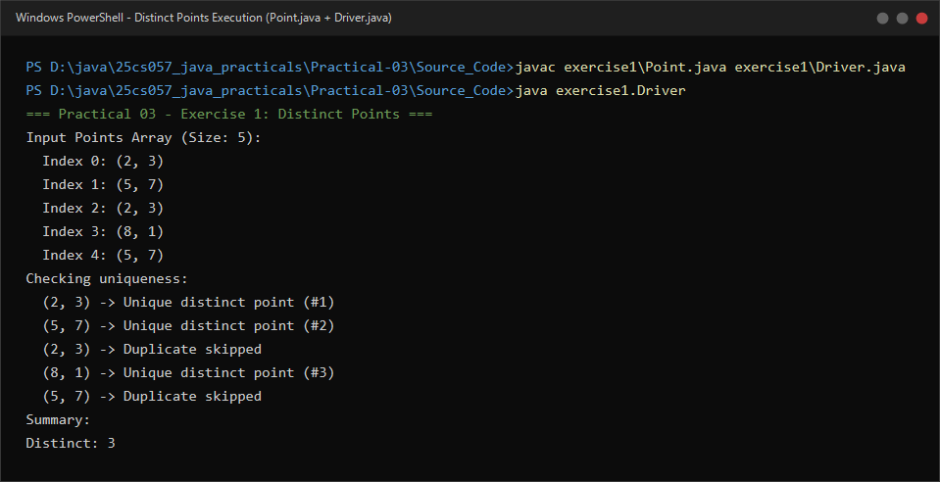
Figure 3.1: Live execution of Point.java and Driver.java showing equals() based duplicate detection and distinct point tallying.

2. Duplicate card check (Card.java + Driver.java)

A. Problem Statement
Official Problem Definition:
(a) Create class Card with private String rank, suit and a constructor.
(b) Override toString() to return rank + " of " + suit (e.g. "Queen of Hearts").
(c) Override equals()/hashCode() by rank + suit.
(d) In Driver.main: add cards to a Card[] one at a time; before adding each, use equals() to check it against the earlier cards.
(e) Print "Duplicate found: <card>" the first time a repeat appears.
Expected output: a second "Ace of Spades" -> "Duplicate found: Ace of Spades".

B. Complete Java Source Code
File 1: Practical-03/Source_Code/exercise2/Card.java
package exercise2;

import java.util.Objects;

/**
* Practical 03 - Exercise 2
* Student Name: Krupal Parmar
* Student ID: 25CS057
* Course: CEUE203 - Object-Oriented Programming
*
* (a) Create class Card with private String rank, suit and a constructor.
* (b) Override toString() to return rank + " of " + suit (e.g. "Queen of Hearts").
* (c) Override equals()/hashCode() by rank + suit.
*/
public class Card {
// (a) Private fields
private final String rank;
private final String suit;

// Constructor
public Card(String rank, String suit) {
this.rank = rank;
this.suit = suit;
}

public String getRank() {
return rank;
}

public String getSuit() {
return suit;
}

// (b) Override toString() to return rank + " of " + suit
@Override
public String toString() {
return rank + " of " + suit;
}

// (c) Override equals() by rank and suit (case-insensitive for robust comparison)
@Override
public boolean equals(Object obj) {
if (this == obj) return true;
if (obj == null || getClass() != obj.getClass()) return false;
Card other = (Card) obj;
return Objects.equals(this.rank, other.rank) &&
Objects.equals(this.suit, other.suit);
}

// Override hashCode() based on rank and suit
@Override
public int hashCode() {
return Objects.hash(rank, suit);
}
}

File 2: Practical-03/Source_Code/exercise2/Driver.java
package exercise2;

/**
* Practical 03 - Exercise 2 (Driver)
* Student Name: Krupal Parmar
* Student ID: 25CS057
* Course: CEUE203 - Object-Oriented Programming
*
* (d) In Driver.main: add cards to a Card[] one at a time; before adding each,
* use equals() to check it against the earlier cards.
* (e) Print "Duplicate found: <card>" the first time a repeat appears.
* Expected output: a second "Ace of Spades" -> "Duplicate found: Ace of Spades".
*/
public class Driver {
public static void main(String[] args) {
System.out.println("=== Practical 03 - Exercise 2: Duplicate Card Check ===");

// Stream of cards to insert one by one
Card[] incomingCards = new Card[] {
new Card("King", "Diamonds"),
new Card("Ace", "Spades"),
new Card("10", "Hearts"),
new Card("Ace", "Spades"), // Duplicate of earlier card
new Card("Jack", "Clubs")
};

// Storage array for accepted unique cards
Card[] cardDeck = new Card[incomingCards.length];
int count = 0;
boolean duplicateAlerted = false;

System.out.println("Inserting cards into deck one by one:");
for (Card nextCard : incomingCards) {
boolean duplicate = false;

// (d) Before adding, check against earlier cards using equals()
for (int i = 0; i < count; i++) {
if (nextCard.equals(cardDeck[i])) {
duplicate = true;
break;
}
}

if (duplicate) {
// (e) Print duplicate message on first repeat
System.out.println("Duplicate found: " + nextCard);
duplicateAlerted = true;
} else {
cardDeck[count++] = nextCard;
System.out.println("Added: " + nextCard + " (Deck size: " + count + ")");
}
}

System.out.println("\n--- Final Deck Status ---");
System.out.println("Total unique cards stored: " + count);
for (int i = 0; i < count; i++) {
System.out.println(" " + (i + 1) + ". " + cardDeck[i]);
}
}
}

C. Execution Output Screenshot
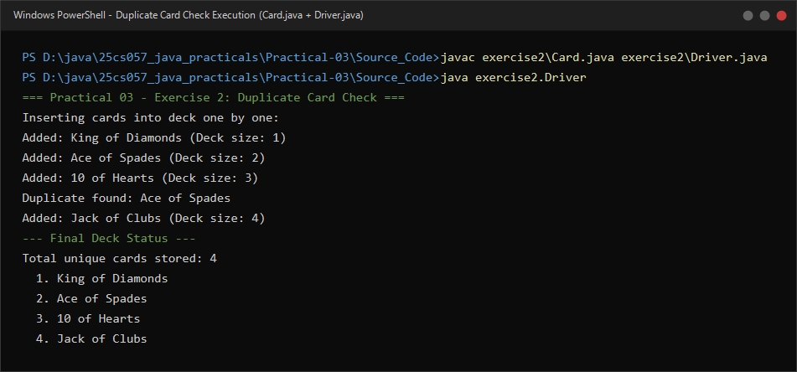
Figure 3.2: Live execution of Card.java and Driver.java showing sequential array insertion and duplicate alert upon repeat card.

