CHAROTAR UNIVERSITY OF SCIENCE AND TECHNOLOGY (CHARUSAT)
DEVANG PATEL INSTITUTE OF ADVANCE TECHNOLOGY AND RESEARCH (DEPSTAR)
Department of Computer Science & Engineering
CEUE203: Object-Oriented Programming (Java) | Practical 12
Java Collections Framework (List, Set, Map & Comparator)

Student Name: Krupal Parmar Student ID: 25CS057
Branch/Semester: B.Tech CSE / Semester 3 Academic Year: 2026–2027
GitHub Branch: https://github.com/25cs057/25cs057_java_practicals/tree/lab12

Practical Objectives & Theoretical Concepts
1. Map Storage & Frequency Aggregation: Utilizing java.util.HashMap for O(1) average lookup performance, tokenizing input strings, and aggregating word frequency distributions via map entries.
2. Custom Ordering with Comparator: Constructing custom Comparator implementations over Map.Entry pairs to sort elements by frequency descending, with secondary lexicographical tie-breaking.
3. Set Implementations (HashSet vs LinkedHashSet): Contrasting HashSet (bucket-based hashing with non-deterministic iteration order) with LinkedHashSet (doubly-linked hash table preserving exact first-seen insertion order) for visitor deduplication.

Exercise 1: Word Frequency Counter (HashMap & Comparator)
Problem Statement 1 (Unabridged Syllabus Requirement):
Word frequency: split a paragraph into words, count each in a HashMap, and print the words sorted by frequency (highest first) using a Comparator.

Source File 1: WordFrequencyCounter.java (Text Normalization, HashMap Frequency Counter & Comparator Sorter)
package exercise1;

import java.util.ArrayList;
import java.util.Comparator;
import java.util.HashMap;
import java.util.List;
import java.util.Map;

/**
* Word frequency analyzer using HashMap and custom Comparator sorting.
*
* @author Krupal Parmar (25CS057)
*/
public class WordFrequencyCounter {

/**
* Splits a text paragraph into words and accumulates counts in a HashMap.
*/
public static Map<String, Integer> countFrequencies(String paragraph) {
Map<String, Integer> frequencyMap = new HashMap<>();
if (paragraph == null || paragraph.trim().isEmpty()) {
return frequencyMap;
}

// Clean punctuation and tokenize words
String cleaned = paragraph.replaceAll("[^a-zA-Z0-9\\s]", " ").toLowerCase();
String[] tokens = cleaned.split("\\s+");

for (String token : tokens) {
String word = token.trim();
if (!word.isEmpty()) {
frequencyMap.put(word, frequencyMap.getOrDefault(word, 0) + 1);
}
}
return frequencyMap;
}

/**
* Sorts Map entries by frequency descending (highest count first);
* ties are broken alphabetically by word in ascending order.
*/
public static List<Map.Entry<String, Integer>> sortByFrequency(Map<String, Integer> frequencyMap) {
List<Map.Entry<String, Integer>> entryList = new ArrayList<>(frequencyMap.entrySet());

Comparator<Map.Entry<String, Integer>> frequencyComparator = (e1, e2) -> {
int countComparison = e2.getValue().compareTo(e1.getValue()); // Descending
if (countComparison != 0) {
return countComparison;
}
return e1.getKey().compareTo(e2.getKey()); // Ascending alphabetical tie-break
};

entryList.sort(frequencyComparator);
return entryList;
}
}

Source File 2: Driver.java (Demonstration Driver, Formatted Ranking Output & Order Validation)
package exercise1;

import java.util.List;
import java.util.Map;

/**
* Driver demonstrating HashMap frequency counting and Comparator-based sorting.
*
* @author Krupal Parmar (25CS057)
*/
public class Driver {
private static final String SAMPLE_PARAGRAPH =
"Java collections provide powerful data structures. The Java Collections Framework " +
"includes list, set, and map implementations. A map stores key-value pairs while " +
"a set stores unique elements. Java developers frequently use a hashmap because " +
"a hashmap offers fast constant-time performance for key lookup operations. Java is robust!";

public static void main(String[] args) {
System.out.println("======================================================================");
System.out.println(" Practical 12 - Exercise 1: Word Frequency Counter (HashMap & Comparator)");
System.out.println(" Student: Krupal Parmar | ID: 25CS057 | University: CHARUSAT (DEPSTAR)");
System.out.println("======================================================================\n");

System.out.println("--- Input Paragraph ---");
System.out.println("\"" + SAMPLE_PARAGRAPH + "\"\n");

// 1. Count frequencies using HashMap
Map<String, Integer> freqMap = WordFrequencyCounter.countFrequencies(SAMPLE_PARAGRAPH);
System.out.printf("Total Distinct Words Extracted: %d%n%n", freqMap.size());

// 2. Sort entries using Comparator
List<Map.Entry<String, Integer>> sortedEntries = WordFrequencyCounter.sortByFrequency(freqMap);

System.out.println("--- Word Frequencies Sorted by Occurrence (Highest First) ---");
System.out.printf("%-6s | %-16s | %-12s%n", "Rank", "Word", "Occurrences");
System.out.println("----------------------------------------------------------------------");

int rank = 1;
for (Map.Entry<String, Integer> entry : sortedEntries) {
System.out.printf("#%-5d | %-16s | %4d times%n", rank++, entry.getKey(), entry.getValue());
}

System.out.println("----------------------------------------------------------------------");
System.out.println(" Verification Summary");
System.out.println("----------------------------------------------------------------------");
System.out.printf(" Highest Frequency Word : '%s' (%d occurrences)%n",
sortedEntries.get(0).getKey(), sortedEntries.get(0).getValue());
System.out.printf(" Total Distinct Terms : %d%n", sortedEntries.size());

// Verify descending order
boolean isSorted = true;
for (int i = 0; i < sortedEntries.size() - 1; i++) {
if (sortedEntries.get(i).getValue() < sortedEntries.get(i + 1).getValue()) {
isSorted = false;
break;
}
}
System.out.printf(" Comparator Order Check : %s%n",
isSorted ? "SUCCESS (Strictly sorted highest to lowest frequency)" : "FAIL");
System.out.println("======================================================================");
}
}

Execution Screenshot — Exercise 1 (PowerShell Live Terminal)
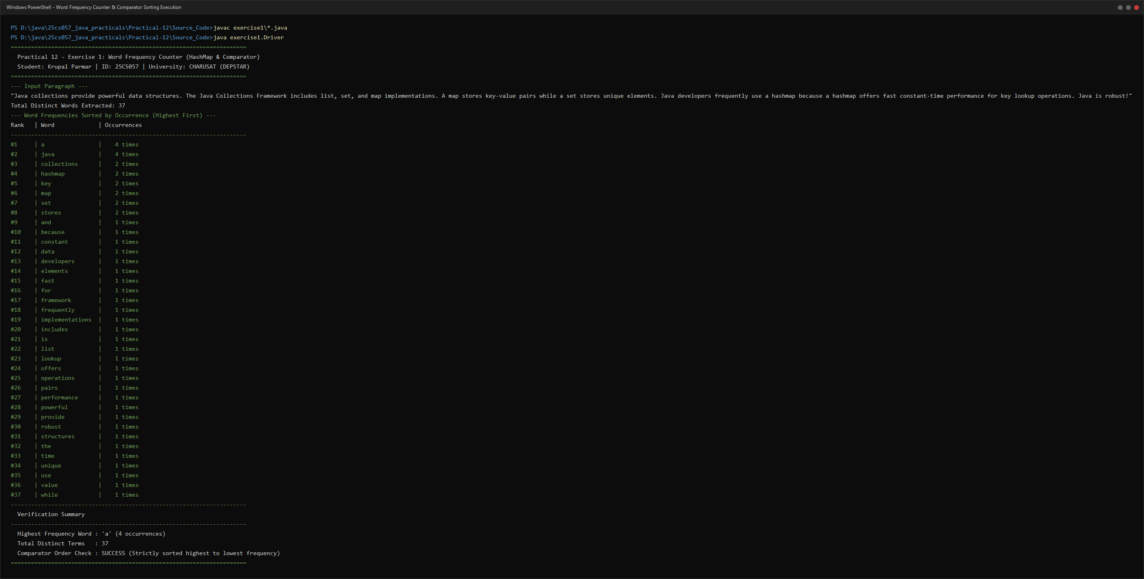

Exercise 2: Unique Visitors (HashSet vs LinkedHashSet)
Problem Statement 2 (Unabridged Syllabus Requirement):
Unique visitors: from a list of login names with repeats, use a HashSet to count unique users and a LinkedHashSet to keep first-seen order; print the unique count and the first three distinct names.

Source File 1: VisitorTracker.java (HashSet Deduplication & LinkedHashSet First-Seen Order Extractor)
package exercise2;

import java.util.ArrayList;
import java.util.HashSet;
import java.util.LinkedHashSet;
import java.util.List;
import java.util.Set;

/**
* Visitor tracker comparing HashSet deduplication with LinkedHashSet insertion-order retention.
*
* @author Krupal Parmar (25CS057)
*/
public class VisitorTracker {

/**
* Deduplicates login entries using HashSet (fast, unordered hash bucket storage).
*/
public static Set<String> countUniqueUsers(List<String> rawLogins) {
return new HashSet<>(rawLogins);
}

/**
* Deduplicates login entries using LinkedHashSet (preserves exact first-seen insertion order).
*/
public static Set<String> getFirstSeenUniqueUsers(List<String> rawLogins) {
return new LinkedHashSet<>(rawLogins);
}

/**
* Extracts the first N distinct users based on insertion order.
*/
public static List<String> getFirstNDistinct(Set<String> orderedSet, int count) {
List<String> result = new ArrayList<>();
int index = 0;
for (String user : orderedSet) {
if (index++ < count) {
result.add(user);
} else {
break;
}
}
return result;
}
}

Source File 2: Driver.java (Login Sequence Simulation, Set Order Comparison & First 3 Names Extractor)
package exercise2;

import java.util.List;
import java.util.Set;

/**
* Driver demonstrating HashSet uniqueness verification and LinkedHashSet first-seen ordering.
*
* @author Krupal Parmar (25CS057)
*/
public class Driver {
private static final List<String> RAW_LOGINS = List.of(
"kparmar",
"alice_w",
"bob_builder",
"kparmar", // Duplicate #1
"charlie_dev",
"alice_w", // Duplicate #2
"diana_prince",
"kparmar", // Duplicate #3
"edward_snow",
"bob_builder", // Duplicate #4
"frank_castle",
"alice_w" // Duplicate #5
);

public static void main(String[] args) {
System.out.println("======================================================================");
System.out.println(" Practical 12 - Exercise 2: Unique Visitors (HashSet vs LinkedHashSet)");
System.out.println(" Student: Krupal Parmar | ID: 25CS057 | University: CHARUSAT (DEPSTAR)");
System.out.println("======================================================================\n");

System.out.println("--- 1. Raw Login Access Sequence (With Repeats) ---");
System.out.println("Total raw login events recorded: " + RAW_LOGINS.size());
for (int i = 0; i < RAW_LOGINS.size(); i++) {
System.out.printf(" Event #%02d: %s%n", (i + 1), RAW_LOGINS.get(i));
}

// 2. Count unique users using HashSet
Set<String> hashSetUsers = VisitorTracker.countUniqueUsers(RAW_LOGINS);
System.out.println("\n--- 2. Unordered Deduplication via HashSet ---");
System.out.printf("Unique Visitor Count (HashSet.size()): %d%n", hashSetUsers.size());
System.out.println("HashSet Elements (Hash bucket order): " + hashSetUsers);

// 3. Preserve first-seen order using LinkedHashSet
Set<String> linkedSetUsers = VisitorTracker.getFirstSeenUniqueUsers(RAW_LOGINS);
System.out.println("\n--- 3. Insertion-Order Retention via LinkedHashSet ---");
System.out.printf("Unique Visitor Count (LinkedHashSet.size()): %d%n", linkedSetUsers.size());
System.out.println("LinkedHashSet Elements (First-seen order) : " + linkedSetUsers);

// 4. Retrieve the first three distinct names
List<String> firstThree = VisitorTracker.getFirstNDistinct(linkedSetUsers, 3);
System.out.println("\n--- 4. First Three Distinct Visitors (First-Seen Order) ---");
for (int i = 0; i < firstThree.size(); i++) {
System.out.printf(" #%d: %s%n", (i + 1), firstThree.get(i));
}

System.out.println("\n----------------------------------------------------------------------");
System.out.println(" Verification Summary");
System.out.println("----------------------------------------------------------------------");
System.out.printf(" Total Raw Login Events : %d%n", RAW_LOGINS.size());
System.out.printf(" Unique Users Verified : %d distinct users%n", hashSetUsers.size());
System.out.printf(" Duplicates Eliminated : %d redundant events%n",
RAW_LOGINS.size() - hashSetUsers.size());
System.out.printf(" First 3 Distinct Names List : %s%n", firstThree);
System.out.printf(" First 3 Expected Match : %s%n",
firstThree.equals(List.of("kparmar", "alice_w", "bob_builder"))
? "CONFIRMED (Exact first-seen sequence verified)"
: "FAIL");
System.out.println("======================================================================");
}
}

Execution Screenshot — Exercise 2 (PowerShell Live Terminal)


