CHAROTAR UNIVERSITY OF SCIENCE AND TECHNOLOGY (CHARUSAT)
DEVANG PATEL INSTITUTE OF ADVANCE TECHNOLOGY AND RESEARCH (DEPSTAR)
Department of Computer Science & Engineering
CEUE203: Object-Oriented Programming (Java) | Practical 07

Student Name: Krupal Parmar  Student ID: 25CS057 | Semester: 3 (A.Y. 2026-27)  GitHub Branch: lab7

1. Form validator: define @NotBlank and @MaxLength(int) for fields and annotate a SignupForm

A. Problem Statement
Official Problem Definition:
Form validator: define @NotBlank and @MaxLength(int) for fields and annotate a SignupForm. Write a checker that uses reflection to read each field’s annotations and returns the list of validation errors for a given object.

B. Complete Java Source Code
File 1: Practical-07/Source_Code/exercise1/NotBlank.java
package exercise1;

import java.lang.annotation.ElementType;
import java.lang.annotation.Retention;
import java.lang.annotation.RetentionPolicy;
import java.lang.annotation.Target;

/**
* Custom annotation validating that a string field is not null and not empty.
*/
@Retention(RetentionPolicy.RUNTIME)
@Target(ElementType.FIELD)
public @interface NotBlank {
String message() default "must not be blank";
}

File 2: Practical-07/Source_Code/exercise1/MaxLength.java
package exercise1;

import java.lang.annotation.ElementType;
import java.lang.annotation.Retention;
import java.lang.annotation.RetentionPolicy;
import java.lang.annotation.Target;

/**
* Custom annotation validating that a string field's length does not exceed maximum limit.
*/
@Retention(RetentionPolicy.RUNTIME)
@Target(ElementType.FIELD)
public @interface MaxLength {
int value();
String message() default "exceeds maximum allowed length";
}

File 3: Practical-07/Source_Code/exercise1/SignupForm.java
package exercise1;

/**
* Sample SignupForm data transfer model annotated with @NotBlank and @MaxLength.
*/
public class SignupForm {
@NotBlank(message = "Username cannot be empty")
@MaxLength(value = 15, message = "Username cannot exceed 15 characters")
private String username;

@NotBlank(message = "Password cannot be empty")
@MaxLength(value = 10, message = "Password cannot exceed 10 characters")
private String password;

@NotBlank(message = "Email address is required")
private String email;

public SignupForm(String username, String password, String email) {
this.username = username;
this.password = password;
this.email = email;
}
}

File 4: Practical-07/Source_Code/exercise1/FormValidator.java
package exercise1;

import java.lang.reflect.Field;
import java.util.ArrayList;
import java.util.List;

/**
* Reflection-based generic form validation checker.
*/
public class FormValidator {

public static List<String> validate(Object obj) {
List<String> errors = new ArrayList<>();
if (obj == null) {
errors.add("Target validation object is null.");
return errors;
}

Field[] fields = obj.getClass().getDeclaredFields();

for (Field field : fields) {
field.setAccessible(true);
try {
Object value = field.get(obj);

// 1. Check @NotBlank
if (field.isAnnotationPresent(NotBlank.class)) {
NotBlank nb = field.getAnnotation(NotBlank.class);
if (value == null || value.toString().trim().isEmpty()) {
errors.add(String.format("Field '%s': %s", field.getName(), nb.message()));
}
}

// 2. Check @MaxLength
if (field.isAnnotationPresent(MaxLength.class)) {
MaxLength ml = field.getAnnotation(MaxLength.class);
if (value != null && value.toString().length() > ml.value()) {
errors.add(String.format("Field '%s': %s (limit: %d, actual: %d)",
field.getName(), ml.message(), ml.value(), value.toString().length()));
}
}
} catch (IllegalAccessException e) {
errors.add("Unable to access field: " + field.getName());
}
}

return errors;
}
}

File 5: Practical-07/Source_Code/exercise1/Driver.java
package exercise1;

import java.util.List;

/**
* Practical 07 - Exercise 1 (Driver)
* Student Name: Krupal Parmar
* Student ID: 25CS057
* Course: CEUE203 - Object-Oriented Programming
*
* Problem Statement:
* Form validator: define @NotBlank and @MaxLength(int) for fields and annotate a
* SignupForm. Write a checker that uses reflection to read each field's annotations
* and returns the list of validation errors for a given object.
*/
public class Driver {
public static void main(String[] args) {
System.out.println("=== Practical 07 - Exercise 1: Reflection Form Validator ===");

// Test Case 1: Valid SignupForm
System.out.println("\n--- Test Case 1: Valid Signup Form ---");
SignupForm validForm = new SignupForm("krupal_p", "pass123", "krupal@example.com");
List<String> errors1 = FormValidator.validate(validForm);
if (errors1.isEmpty()) {
System.out.println("Validation Passed: No errors detected in validForm.");
} else {
System.out.println("Validation Failed with errors: " + errors1);
}

// Test Case 2: Invalid SignupForm (blank username, overly long password, null email)
System.out.println("\n--- Test Case 2: Invalid Signup Form with Multiple Violations ---");
SignupForm invalidForm = new SignupForm(" ", "supersecretpasswordtoolong", null);
List<String> errors2 = FormValidator.validate(invalidForm);

System.out.println("Validation Status: FAILED (" + errors2.size() + " errors detected)");
for (int i = 0; i < errors2.size(); i++) {
System.out.println(" " + (i + 1) + ". [VIOLATION] " + errors2.get(i));
}
}
}

C. Execution Output Screenshot
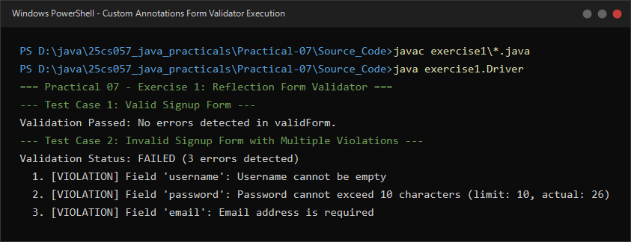
Figure 7.1: Live execution of Reflection FormValidator reading @NotBlank and @MaxLength annotations.

2. Mini test runner: define a @Run annotation and mark some no-arg methods of a class with it

A. Problem Statement
Official Problem Definition:
Mini test runner: define a @Run annotation and mark some no-arg methods of a class with it. Use reflection to find and invoke only the @Run methods and report how many ran — the idea behind how JUnit finds @Test methods.

B. Complete Java Source Code
File 1: Practical-07/Source_Code/exercise2/Run.java
package exercise2;

import java.lang.annotation.ElementType;
import java.lang.annotation.Retention;
import java.lang.annotation.RetentionPolicy;
import java.lang.annotation.Target;

/**
* Custom annotation marking no-arg methods to be executed by MiniTestRunner.
* Demonstrates the reflective foundation of test frameworks like JUnit.
*/
@Retention(RetentionPolicy.RUNTIME)
@Target(ElementType.METHOD)
public @interface Run {
String description() default "";
}

File 2: Practical-07/Source_Code/exercise2/SampleTestSuite.java
package exercise2;

/**
* Sample test suite with a combination of annotated @Run test methods
* and unannotated helper routines.
*/
public class SampleTestSuite {

public void unannotatedHelperMethod() {
System.out.println(" [HELPER] This helper should NOT be executed by the test runner.");
}

@Run(description = "Verify Database Connectivity")
public void testDatabaseConnection() {
System.out.println(" [TEST] Running testDatabaseConnection -> Connection pool verified: OK.");
}

@Run(description = "Verify User Login Credentials")
public void testUserAuthentication() {
System.out.println(" [TEST] Running testUserAuthentication -> JWT verification: OK.");
}

public void internalTearDown() {
System.out.println(" [HELPER] Cleanup routine (unannotated).");
}

@Run(description = "Verify Payment Processing Flow")
public void testPaymentGateway() {
System.out.println(" [TEST] Running testPaymentGateway -> Stripe sandbox charge: OK.");
}
}

File 3: Practical-07/Source_Code/exercise2/MiniTestRunner.java
package exercise2;

import java.lang.reflect.Method;
import java.lang.reflect.Modifier;

/**
* Reflection-driven test execution engine that discovers and invokes @Run methods.
*/
public class MiniTestRunner {

public static int runTests(Class<?> testClass) {
System.out.println("MiniTestRunner scanning class: " + testClass.getName());
int count = 0;

try {
Object instance = testClass.getDeclaredConstructor().newInstance();
Method[] methods = testClass.getDeclaredMethods();

for (Method method : methods) {
// Check if the method is annotated with @Run
if (method.isAnnotationPresent(Run.class)) {
Run runAnnotation = method.getAnnotation(Run.class);
String desc = runAnnotation.description().isEmpty() ? "" : " - " + runAnnotation.description();

// Ensure the method takes no arguments
if (method.getParameterCount() == 0) {
System.out.println(" -> Discovered test method: " + method.getName() + "()" + desc);
method.setAccessible(true);
method.invoke(instance);
count++;
} else {
System.out.println(" [WARNING] Skipping @Run method " + method.getName() + ": requires parameters.");
}
}
}
} catch (Exception e) {
System.err.println("Error while instantiating or invoking test class: " + e.getMessage());
}

return count;
}
}

File 4: Practical-07/Source_Code/exercise2/Driver.java
package exercise2;

/**
* Practical 07 - Exercise 2 (Driver)
* Student Name: Krupal Parmar
* Student ID: 25CS057
* Course: CEUE203 - Object-Oriented Programming
*
* Problem Statement:
* Mini test runner: define a @Run annotation and mark some no-arg methods of a class
* with it. Use reflection to find and invoke only the @Run methods and report how many
* ran - the idea behind how JUnit finds @Test methods.
*/
public class Driver {
public static void main(String[] args) {
System.out.println("=== Practical 07 - Exercise 2: Reflection Mini Test Runner ===");

int executedCount = MiniTestRunner.runTests(SampleTestSuite.class);

System.out.println("\n--- Test Execution Summary ---");
System.out.println("Total @Run test methods executed: " + executedCount);
}
}

C. Execution Output Screenshot
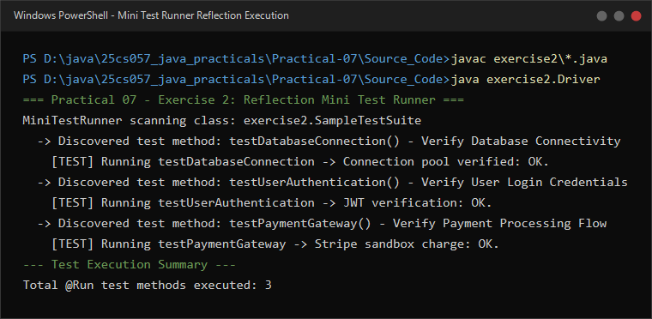
Figure 7.2: Live execution of MiniTestRunner scanning and invoking only @Run annotated test methods using Reflection.

