CHAROTAR UNIVERSITY OF SCIENCE AND TECHNOLOGY (CHARUSAT)
DEVANG PATEL INSTITUTE OF ADVANCE TECHNOLOGY AND RESEARCH (DEPSTAR)
Department of Computer Science & Engineering
CEUE203: Object-Oriented Programming (Java) | Practical 06

Student Name: Krupal Parmar  Student ID: 25CS057 | Semester: 3 (A.Y. 2026-27)  GitHub Branch: lab6

1. Remote control: an interface Switchable with on()/off() and a default toggle(); Fan and Light implement it

A. Problem Statement
Official Problem Definition:
Remote control: an interface Switchable with on()/off() and a default toggle(); Fan and Light implement it. Loop over a Switchable[] toggling each. Then add a functional interface that decides, given a device and an hour, whether it may switch on, and supply it once as an anonymous class and once as a lambda.

B. Complete Java Source Code
File 1: Practical-06/Source_Code/exercise1/Switchable.java
package exercise1;

/**
* Practical 06 - Exercise 1 (Switchable Interface)
* Student Name: Krupal Parmar
* Student ID: 25CS057
* Course: CEUE203 - Object-Oriented Programming
*
* Interface with on(), off(), state checking, and a default toggle() method.
*/
public interface Switchable {
void on();
void off();
boolean isOn();
String getName();

// Default method to toggle state
default void toggle() {
if (isOn()) {
off();
} else {
on();
}
}
}

File 2: Practical-06/Source_Code/exercise1/Fan.java
package exercise1;

public class Fan implements Switchable {
private final String name;
private boolean state;

public Fan(String name) {
this.name = name;
this.state = false;
}

@Override
public void on() {
this.state = true;
System.out.println(" [ACTION] " + name + " is now spinning ON.");
}

@Override
public void off() {
this.state = false;
System.out.println(" [ACTION] " + name + " is now powered OFF.");
}

@Override
public boolean isOn() {
return state;
}

@Override
public String getName() {
return name;
}
}

File 3: Practical-06/Source_Code/exercise1/Light.java
package exercise1;

public class Light implements Switchable {
private final String name;
private boolean state;

public Light(String name) {
this.name = name;
this.state = false;
}

@Override
public void on() {
this.state = true;
System.out.println(" [ACTION] " + name + " is now illuminated ON.");
}

@Override
public void off() {
this.state = false;
System.out.println(" [ACTION] " + name + " is now turned OFF.");
}

@Override
public boolean isOn() {
return state;
}

@Override
public String getName() {
return name;
}
}

File 4: Practical-06/Source_Code/exercise1/DeviceScheduler.java
package exercise1;

/**
* Functional Interface to evaluate whether a device is permitted to turn on
* during a specific hour of the day (0-23).
*/
@FunctionalInterface
public interface DeviceScheduler {
boolean canSwitchOn(Switchable device, int hour);
}

File 5: Practical-06/Source_Code/exercise1/Driver.java
package exercise1;

/**
* Practical 06 - Exercise 1 (Driver)
* Student Name: Krupal Parmar
* Student ID: 25CS057
* Course: CEUE203 - Object-Oriented Programming
*
* Problem Statement:
* Remote control: an interface Switchable with on()/off() and a default toggle();
* Fan and Light implement it. Loop over a Switchable[] toggling each. Then add a
* functional interface that decides, given a device and an hour, whether it may
* switch on, and supply it once as an anonymous class and once as a lambda.
*/
public class Driver {
public static void main(String[] args) {
System.out.println("=== Practical 06 - Exercise 1: Remote Control Devices ===");

Switchable[] devices = new Switchable[] {
new Light("Study Desk Lamp"),
new Fan("Ceiling Fan"),
new Light("Corridor Night Light")
};

System.out.println("\n--- Step 1: Looping over Switchable[] and Toggling Each ---");
for (Switchable dev : devices) {
System.out.println("Device: " + dev.getName() + " | Initial State: " + (dev.isOn() ? "ON" : "OFF"));
System.out.println("Executing default toggle():");
dev.toggle(); // Calls default method in interface
System.out.println("New State: " + (dev.isOn() ? "ON" : "OFF") + "\n");
}

System.out.println("--- Step 2: Supplying Functional Interface via Anonymous Class ---");
// Anonymous class implementation: Evening lighting rule (allow Lights between 18:00 and 23:00)
DeviceScheduler eveningLightRule = new DeviceScheduler() {
@Override
public boolean canSwitchOn(Switchable device, int hour) {
if (device instanceof Light) {
return hour >= 18 && hour <= 23;
}
return true; // Other devices unrestricted
}
};

int testHour1 = 20; // 8 PM
int testHour2 = 14; // 2 PM
System.out.println("Evening Lighting Rule (Anonymous Class):");
System.out.println(" Can '" + devices[0].getName() + "' switch on at " + testHour1 + ":00? -> " +
eveningLightRule.canSwitchOn(devices[0], testHour1));
System.out.println(" Can '" + devices[0].getName() + "' switch on at " + testHour2 + ":00? -> " +
eveningLightRule.canSwitchOn(devices[0], testHour2));

System.out.println("\n--- Step 3: Supplying Functional Interface via Lambda Expression ---");
// Lambda implementation: Energy saver cooling rule (allow Fans only between 11:00 and 17:00)
DeviceScheduler energySaverFanRule = (device, hour) -> {
if (device instanceof Fan) {
return hour >= 11 && hour <= 17;
}
return true;
};

int testHour3 = 13; // 1 PM
int testHour4 = 22; // 10 PM
System.out.println("Energy Saver Fan Rule (Lambda Expression):");
System.out.println(" Can '" + devices[1].getName() + "' switch on at " + testHour3 + ":00? -> " +
energySaverFanRule.canSwitchOn(devices[1], testHour3));
System.out.println(" Can '" + devices[1].getName() + "' switch on at " + testHour4 + ":00? -> " +
energySaverFanRule.canSwitchOn(devices[1], testHour4));
}
}

C. Execution Output Screenshot
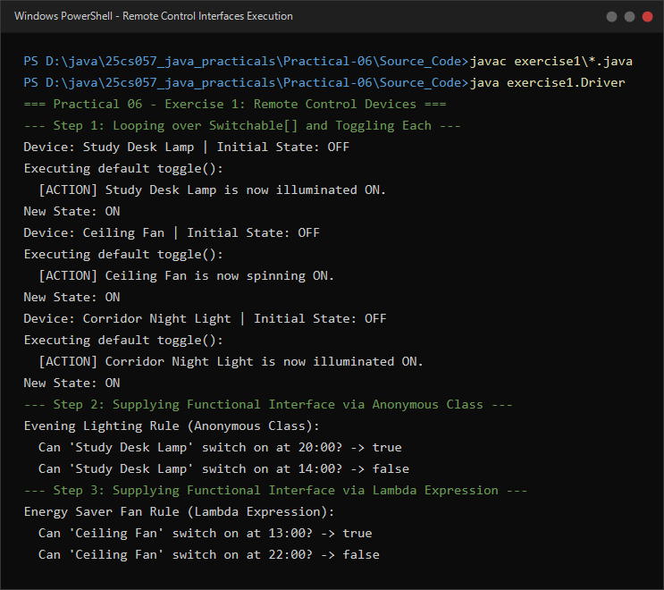
Figure 6.1: Live execution of Switchable interface toggle() and DeviceScheduler implemented as anonymous class and lambda.

2. Notification senders: a functional interface Notifier with send(String); make email and SMS senders as lambdas, hold them in an array, and broadcast one message through all. Add a marker interface Urgent and send twice for senders marked urgent

A. Problem Statement
Official Problem Definition:
Notification senders: a functional interface Notifier with send(String); make email and SMS senders as lambdas, hold them in an array, and broadcast one message through all. Add a marker interface Urgent and send twice for senders marked urgent.

B. Complete Java Source Code
File 1: Practical-06/Source_Code/exercise2/Notifier.java
package exercise2;

/**
* Practical 06 - Exercise 2
* Student Name: Krupal Parmar
* Student ID: 25CS057
* Course: CEUE203 - Object-Oriented Programming
*
* Functional Interface representing an outbound communication notifier.
*/
@FunctionalInterface
public interface Notifier {
void send(String message);
}

File 2: Practical-06/Source_Code/exercise2/Urgent.java
package exercise2;

/**
* Marker Interface indicating an urgent delivery requirement.
* Contains no methods.
*/
public interface Urgent {
}

File 3: Practical-06/Source_Code/exercise2/UrgentPushNotifier.java
package exercise2;

/**
* High-priority push notifier implementing both Notifier and the Urgent marker interface.
*/
public class UrgentPushNotifier implements Notifier, Urgent {
private final String channelName;

public UrgentPushNotifier(String channelName) {
this.channelName = channelName;
}

@Override
public void send(String message) {
System.out.println("[PUSH NOTIFICATION - " + channelName + "] ALERT: " + message);
}
}

File 4: Practical-06/Source_Code/exercise2/Driver.java
package exercise2;

/**
* Practical 06 - Exercise 2 (Driver)
* Student Name: Krupal Parmar
* Student ID: 25CS057
* Course: CEUE203 - Object-Oriented Programming
*
* Problem Statement:
* Notification senders: a functional interface Notifier with send(String); make
* email and SMS senders as lambdas, hold them in an array, and broadcast one message
* through all. Add a marker interface Urgent and send twice for senders marked urgent.
*/
public class Driver {
public static void main(String[] args) {
System.out.println("=== Practical 06 - Exercise 2: Notification Broadcast System ===");

// Email sender defined as a lambda expression
Notifier emailSender = message ->
System.out.println("[EMAIL GATEWAY] Sending to user@example.com: " + message);

// SMS sender defined as a lambda expression
Notifier smsSender = message ->
System.out.println("[SMS GATEWAY] Dispatching to +91-9876543210: " + message);

// Urgent push notification channel implementing the Urgent marker interface
Notifier urgentPushSender = new UrgentPushNotifier("Ops-Critical-Line");

// Hold all senders in an array
Notifier[] channels = new Notifier[] {
emailSender,
smsSender,
urgentPushSender
};

String broadcastMessage = "Critical server temperature alert - immediate action required!";
System.out.println("\nBroadcasting Message: \"" + broadcastMessage + "\"\n");

for (int i = 0; i < channels.length; i++) {
Notifier sender = channels[i];
System.out.println("Channel " + (i + 1) + " [" + sender.getClass().getSimpleName() + "]:");

// Check if sender implements the Urgent marker interface
if (sender instanceof Urgent) {
System.out.println(" (URGENT MARKER DETECTED: Dispatching high-priority redundancy - Sending 2 times)");
sender.send(broadcastMessage);
sender.send(broadcastMessage);
} else {
sender.send(broadcastMessage);
}
System.out.println();
}

System.out.println("Broadcast completed across all channels.");
}
}

C. Execution Output Screenshot
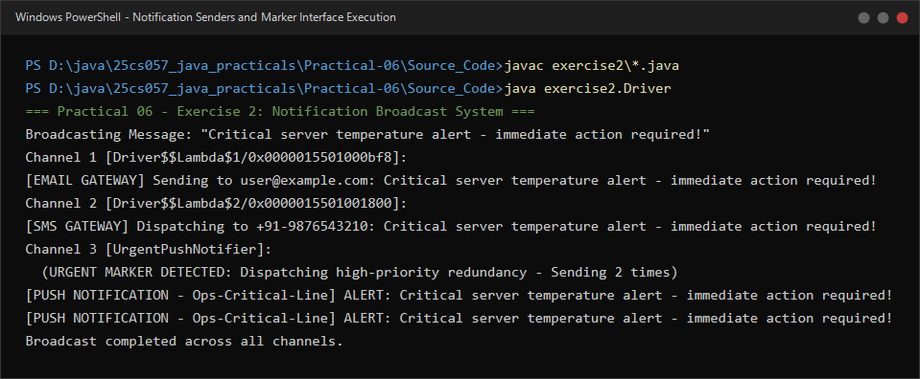
Figure 6.2: Live execution of Notification broadcast showing lambda senders and duplicate dispatch on Urgent marked channels.

